Create and share your project on GitHub

## Accept the GitHub classroom assignment

For this project, we will use GitHub classroom to host your source code. We created a GitHub assignment. In the first step, accept the assignment we have created for you. Go to <https://classroom.github.com/a/HVsevDM7>

After accepting the assignment, a repository within the classroom will be created for your team. An URL to this repository will be presented (you might need to refresh the page). Copy this URL.

## Create a Spring Boot Project in VS Code

Install in VS Code the extension “Spring Boot Extension Pack”.

Open VS Code. Click on the Explorer-icon and choose “Java Project”.

A pop up will appear. Choose in sequence “Spring Boot”, “Maven”, “3.1.3” (or other version), “Java” in sequence.

Choose “be.ucll” as Input Group Id.

Name the Artifact name_firstname (e.g. jan_janssens). Small dashes as “-“ are not allowed.

Choose “Jar” as packaging type and specify the Java version (minimal Java 17).

Add following dependencies:

* Spring Web



* Spring Boot DevTools



Click “Enter” to continue.

Choose a directory on your laptop where you want to locate your project and let VS Code generate your project.

Open the project. The page “Getting Started” gives you some links to documentation.

Now you can create new packages in the folder “java/be/ucll/jan_janssens” (replace “jan_janssens” by the name of your team).

## Push the project to your repo

Push the project to the repo in the classroom.

Open a terminal, navigate into the directory of your project and execute the commands from the GitHub web page in your terminal. Commands look like

git init

git add *

git commit -m "first commit"

git branch -M main

git remote add origin https://github.com/UCLL-BackEndDevelopment-2223-students/project-book-reeks9-9.git

git push -u origin main

## Periodically commit your work to GitHub

When finishing a lesson, or preferably multiple times during a lesson, commit your work to GitHub so you have a backup and version history of your work.

You can do this directly in Visual Studio Code via the “Source Control”: select files to commit, add a message, click “Commit” and “Push”.

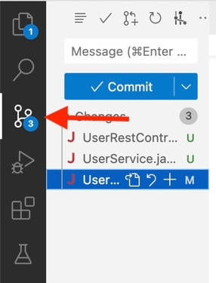

Or you can do it command-line. Execute the following commands from your working directory:

git add *

git commit -m “Your commit message”

git push origin main