Installation Guide

|  |  |
| --- | --- |
| Place in the OPO | Setting up the coding environment |
| Documentation | Course Notes sections 1.1 Introduction -> 1.2 Integrated Development Environment |
| Prerequisites | You have a GitHub account. |
| Learning Goals |  |
| Product Goals | * Your coding environment is set up as asked below * You can run the main method of the demo 01_users_model * You have created repo’s for labo User and Project Book (GitHub Assignment). |

## Java

To be able to write and execute Java code you need to install a JDK (Java Development Kit). We need minimum version 17. Depending on your operating system you can use the following tutorials:

* Mac: <https://java.tutorials24x7.com/blog/how-to-install-java-17-on-mac>
* Windows: <https://java.tutorials24x7.com/blog/how-to-install-java-17-on-windows>

## Visual Studio Code

We use Visual Studio Code as IDE (Integrated Development Environment). If you don’t have installed Visual Studio Code (VSC), install it now.

<https://code.visualstudio.com/download>

You also need to install some plugins. Open VSC, open the Extension Toolbar and search for the required plugins (see list below the figure).

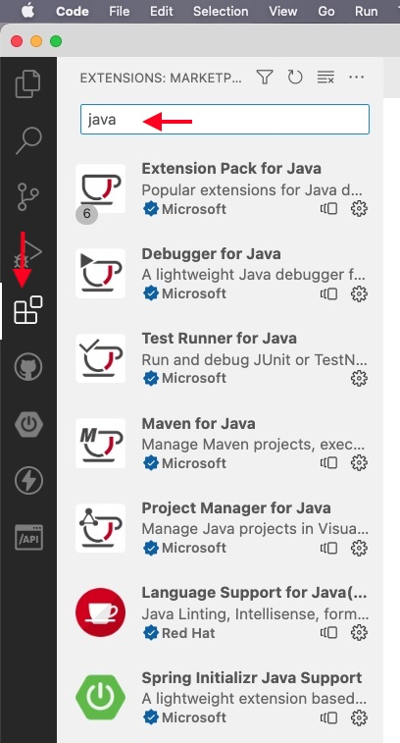

* *Afbeelding met logo, symbool, Lettertype, ontwerp

  Automatisch gegenereerde beschrijvingExtension pack for Java*
* *Afbeelding met clipart

  Beschrijving automatisch gegenereerd met gemiddelde betrouwbaarheidSpring Boot Extension Pack*
* Afbeelding met symbool, cirkel

  Automatisch gegenereerde beschrijving*GitLens – Git supercharged*
* Afbeelding met logo, symbool, clipart, Graphics

  Automatisch gegenereerde beschrijving*GitHub Pull Requests and Issues*
* Afbeelding met symbool, logo, Graphics, cirkel

  Automatisch gegenereerde beschrijving*Thunder Client*

## Demo Code

The demo code for this course is available from GitHub <https://github.com/UCLL-AO-BackEnd-CourseMaterial/AO-demo>. **Download** the code (do not clone!). The GitHub repo contains several projects that must be run individually.

**2**

**1**

Try your coding environment:

* Open in Visual Studio Code the first demo (folder 01_users-model)
* Open the file “src/main/java/be/ucll/backend/users/MainMethod.java”.
* Run the file as described in section 1.4, figure 1.4 in the course notes.

## GitHub Assignment

Sometimes students want to share code with the lecturer. To facilitate this in a uniform way, we work with a GitHub assignment. This has several advantages:

* the lecturer can easily provide starter code;
* each student creates his own repository accessible only to himself and the lecturer;
* the student can take regular backups of his code;
* the student can easily share the code with the lecturer;
* through versioning, the result can be easily marked and submitted.

Although we strongly recommend it, it is not mandatory to use the provided repos (unless for downloading starter code). You can always submit your result as a zip.

We provide two assignments: one for the lab user and a second for the project Book.

* Labo User: <https://classroom.github.com/a/mdHc6tel>
* Project Book: <https://classroom.github.com/a/HVsevDM7>

Click on the links and accept the assignments. Two projects will be created on your device. The assignment Labo User contains some demo code so that you are ready to start the first exercises. The Project Book is an empty repository.

We advise to [create a release](https://docs.github.com/en/repositories/releasing-projects-on-github/managing-releases-in-a-repository) when a module is finished. That way, you can easily go back to a particular point in the lab and (re)practice the material from there.

## Start code for labo User and project Library

Some labo exercises require additional code. You can find those in the repo <https://github.com/UCLL-AO-BackEnd-CourseMaterial/AO-startercode>. Each exercise tells you which files you need and what to do with it.

## Understanding your Coding Environment

1. What does it mean when we say that Java is a compiled language?
2. What is the difference between JDK, JRE and JVM?