# Project Description

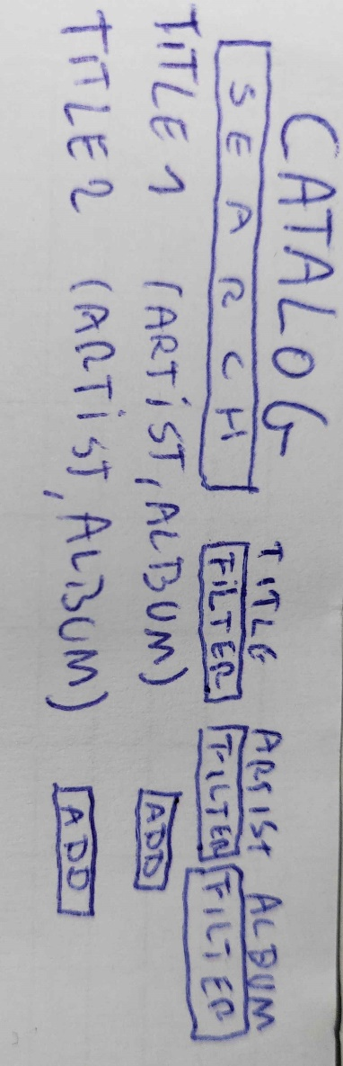 The project is a music management application where users can manage playlists. They can add and remove songs and also edit the title of the playlists. Additionally, they have an overview of the songs and the albums with the associated songs. Admins have the ability to manage everything. They can do everything a user can. Furthermore, they can add a playlist for users to continue working with. An artist can only view playlists but cannot edit them. The system supports a one-to-many relationship between songs, artists, and albums, and a many-to-many relationship between users, playlists, and songs.

# Story 1:

As a user and admin, I want to browse a catalog of playlists and available songs so that I can add them to a playlist.

**Wireframe:**

**Acceptance Criteria:**

The playlists are displayed in a list or table sorted by title, user and songs in the playlists.

There is a button so you can choose between the playlists.

There is a button so you can choose between the songs.

Clicking on a add button adds the song to the playlist.

Each song in the playlists has a button so you can remove it from the playlist.

# Story 2:

As an admin, I want to create and delete new playlists so that I can manage music collections for users to add songs to.

**Wireframe:**

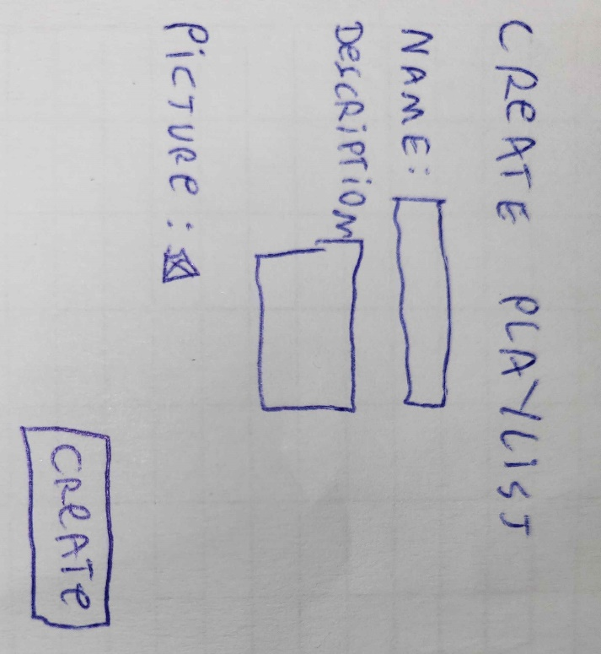

**Acceptance Criteria:**

Given that the form is filled out correctly, a new playlist is created with a title and description.

A playlist can have multiple songs (one-to-many relationship between playlist and songs).

Only admins can create or delete playlists.

A message confirms the playlist creation or deletion.

# Story 3:

As an user of the site, I want to see an overview of the songs so I can see the all the songs that are available for the users

**Wireframe:**

**Acceptance Criteria:**

Admins, users and artists can see an overview of the available songs.

The songs are sorted by title, genre, release date, length and album.

# Story 4:

As an user of the site, I can login so that I can manage my account on the music management application.

**Wireframe:**

**Acceptance Criteria:**

A User can login with username and password.

A role is related with the account.

# Story 5:

As a new user, I want to create an account so I can use the music management application.

**Wireframe:**

**Acceptance criteria:**

There is a signup page.

You can get there with a link on the login page.

There is a form with username, email and password.

The role is always user.

# Story 6:

As a user with a other language, I want to translate the pages so I can use an easier language for me.

**Wireframe:**

**Acceptance criteria:**

There is a button with the available languages.

The pages translate when you choose another language.

# Story 7:

As a user of the site, I want to see an overview of the albums so I can see witch albums exists and what songs they have.

**Wireframe:**

**Acceptance criteria:**

There is a table with albums

They are sorted by title and total songs

It needs to be clickable to see the songs