**Robin De Koninck**

**Group 5-3**

**Project Description:**

Title: Event Planner

Description: With the event planner, users will be able to register and see an overview of events. Users can create an event of their choice. For each event, an overview of additional information about the event is being shown.

**User story mapping:**

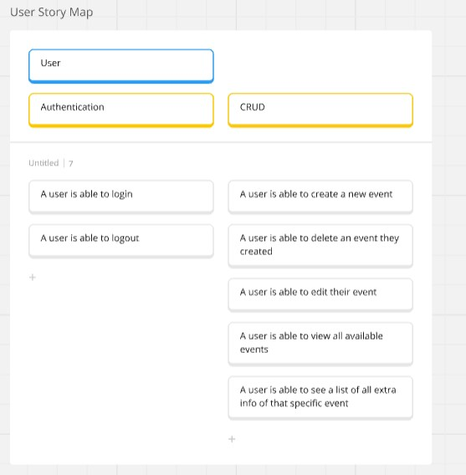

**User stories:**

# Story edit event

As a user

I want to edit my event.

So that I can edit information about the event.

Wireframes:

Acceptance criteria:

* From the overview, I should be able to click on an edit button which lets me edit an event.
* A user can edit their title and description.
* All fields are mandatory.
* EventID stays untouched.
* After the form is submitted, the overview is shown.

# Story Delete event

As a user

I want to delete an event.

So that I can delete an event that I created.

Wireframes:

Acceptance criteria:

* From the overview, I should be able to click on a delete button which redirects me to a delete confirmation.
* A user can confirm to delete an event the user created.
* A user can cancel the deletion.
* After the form is submitted, the overview is shown, and the event is deleted.

# tory Create event

As a user

I want to create an event.

So that I can read it in the lists of events.

Wireframes:

Acceptance criteria:

* From the Add event, I should be able to click on an add event button which lets me add an event.
* A user can add their title and group.
* All fields are mandatory.
* EventID stays untouched.
* After the form is submitted, the overview page is shown.

# Story Overview event

As a user

I want to see a lists of all events.

So that I can see which events there are.

Wireframes:

Acceptance criteria:

* From the overview, I should be able to see all events.
* Each event has all information linked to it, shown in the overview.
* If there is additional information, you can click on the event and this will be displayed
* When there are no events, following text should be displayed “No events exist”

# Story Overview extra information of an event

As a user

I want to see a lists of all additional info of an event.

So that I can see additional info of that specific event.

Wireframes:

Acceptance criteria:

- If you click on the event, a list with additional info like the location and category will be displayed.

# story login

As a user

I want to be able to login.

So that I can use the website as a user.

Wireframes:

Acceptance criteria:

* I should be able to login as a user if you are one.
* Username and password must be correct, else there will be an error message shown.

# story Logout

As a user

I want to be able to logout.

So that I can log out of the website as a user.

Wireframes:

Acceptance criteria:

* I should already be logged in.
* I should only be able to logout when I’m logged in.

**Domain Model:**

**Conceptual Model:**

**Logical Model:**

