Story 1

Story 2

Story 3

Story 4

Story 5

Story 6

Story 7

Story 8-9

Story 10

Story 11

Story 12

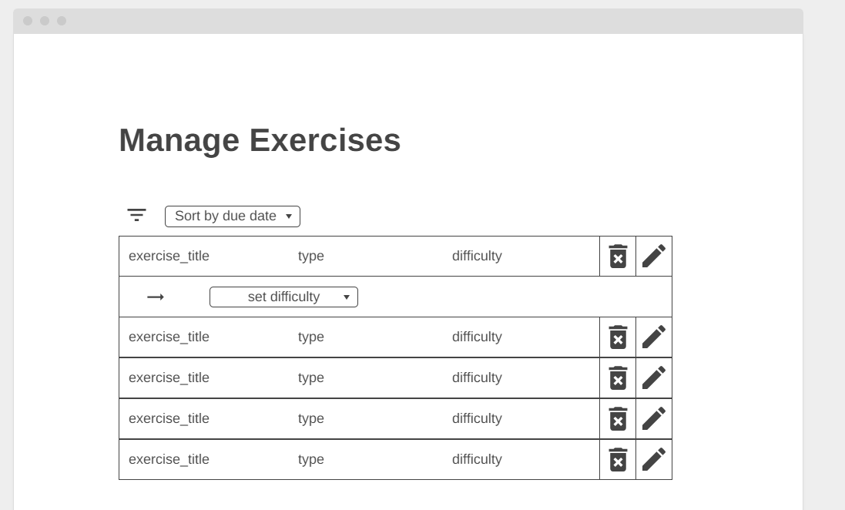

Story 13

Story 14

Story 15

Story 16

Story 17

Story 18

Story 19

Story 20

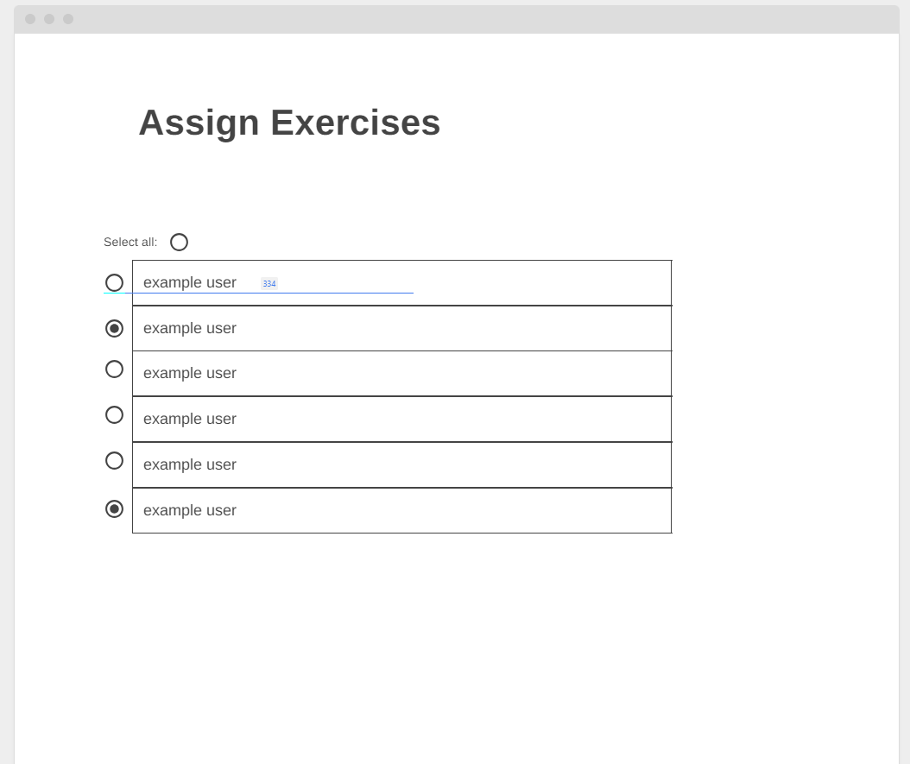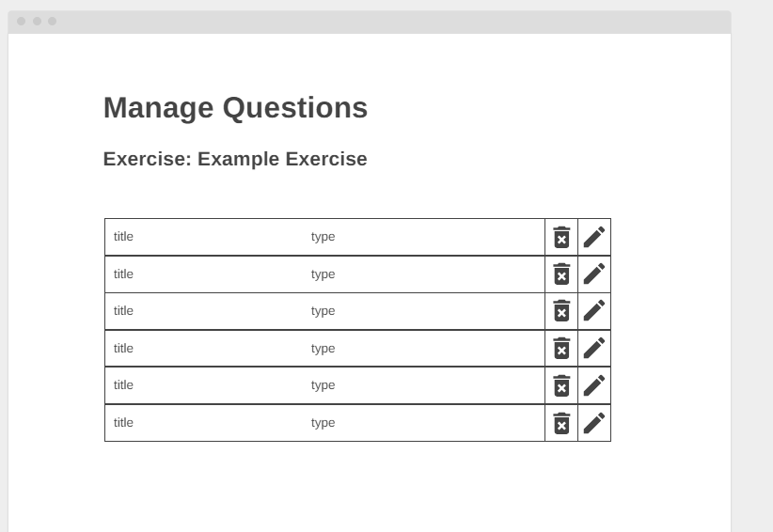

Story 21

Story 22

Story 23

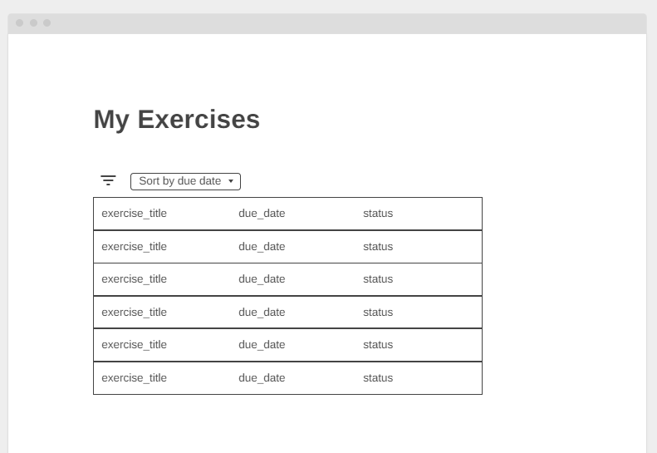

type

type

type

type

type

type

difficulty

difficulty

difficulty

difficulty

difficulty

difficulty

Story 24



type

type

type

type

type

type

difficulty

difficulty

difficulty

difficulty

difficulty

difficulty

Story 25

Story 26

Story 27

Story 28

Story 29

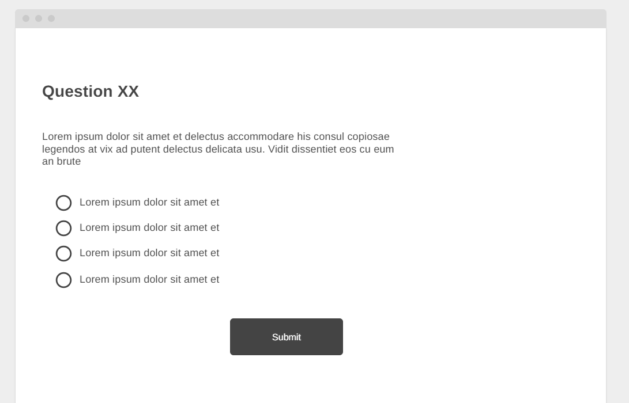

Correct answer

Story 30



type

type

type

type

type

type

difficulty

difficulty

difficulty

difficulty

difficulty

difficulty

Story 31

