Project Analysis

Group 2-12

# Project description

Title: Brol.com

Description: With the Brol.com app we want customers to be able to register and  
buy products digitally. Customers can add and remove products to the cart and order them. Admin can create and delete products.

# User stories

## Story Register Customer

As a user

I’m able to register an account

So that I can buy products digitally

### Wireframe

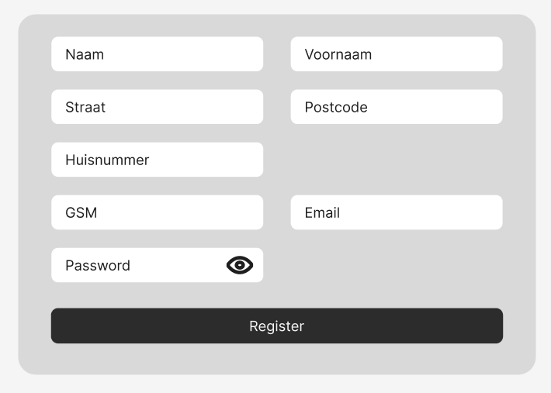

### Acceptance criteria

* A register form is displayed
* A customer can register
* Error messages will be displayed

## Story Products

As an administrator

I’m able to add and remove products

So that I can manage the products

### Wireframe

### Acceptance criteria

* A product display form is displayed
* An admin can add and change products
* Error messages will be displayed