**STORY - USER PROFILE CREATION**

**As a** student,  
**I'm able to** create a user profile with personal information and kot details,  
**So that I can** interact with other users, share my kot, and review others’ kots,

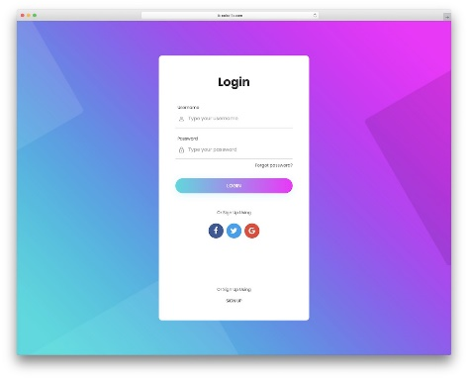**Wireframe**

Something similar to the image.

Source: <https://colorlib.com/wp/wp-content/uploads/sites/2/free-html5-and-css3-login-forms.jpg>

**STORY - ADD POST**

**As a** user,  
**I'm able to** add a post with images and descriptions of my kot,  
**So that I can** share my kot with other users,

**Wireframe:**

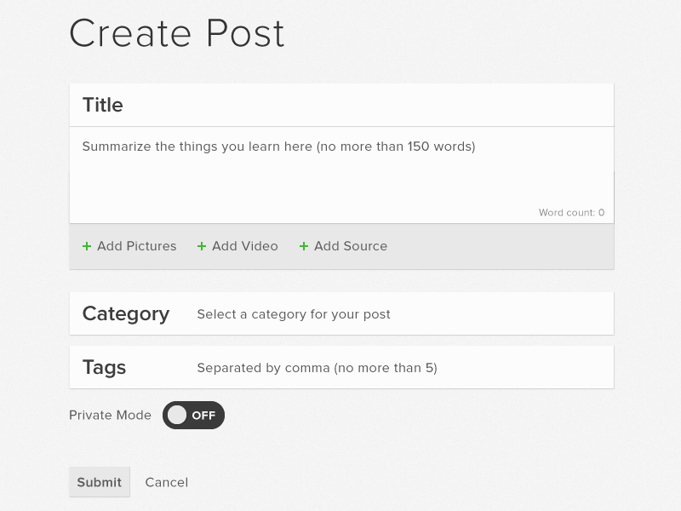Source:https://i.pinimg.com/originals/be/7d/a7/be7da7f24f6c8d9a4cc2391f4469b057.png

**Acceptance Criteria**

* The user can upload images and add descriptions.
* A successful post shows up in the user’s feed.
* Incomplete fields prevent post submission and display an error.

**STORY - VIEW OTHER USERS’ POSTS**

**As a** user,  
**I'm able to** view posts by other users,  
**So that I can** browse different kot listings and reviews,

**Wireframe:**

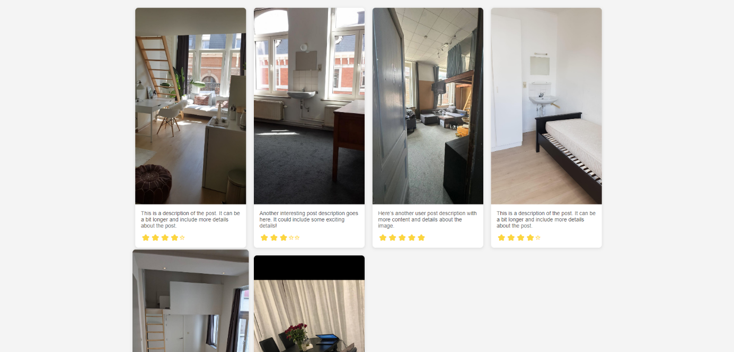

**Acceptance Criteria:**

* The posts show up in a list or grid format.
* Clicking on a post opens it in detail, showing more images and the full description.
* The post's owner and contact information are visible if the post is for a rental listing.

**STORY - RATE & REVIEW OTHER KOTS**

**As a** user,  
**I'm able to** rate and review another user’s kot,  
**So that I can** share my experience and help others make informed decisions,

**Wireframe:**

**Acceptance Criteria:**

* A rating system is available with a 1–5 scale.
* A text area is provided for writing a review.
* Upon submission, the review and rating are saved and displayed on the post.

**STORY - KOT RENTAL POSTING**

**As a** kot owner,  
**I'm able to** post my kot as available for rent,  
**So that I can** find potential renters,

**Wireframe**

(A form to list kot details: location, price, availability, and images)

**Acceptance Criteria**

* The form includes fields for the price, location, and images of the kot.
* The post displays "Available for rent" with contact information.
* Users can view available kots and contact the owner via direct messaging or external links.

**STORY - MODERATOR POST REMOVAL**

**As a** moderator,  
**I'm able to** remove inappropriate posts,  
**So that I can** ensure the platform maintains quality content,

**Wireframe:**

(A post management interface with a "Remove Post" button for moderators)

**Acceptance Criteria:**

* A "Remove" button is visible only to moderators.
* Clicking the button prompts a confirmation dialog.
* Once confirmed, the post is removed from public view and stored in the admin dashboard for review.

**STORY - MODERATOR USER BAN**

**As a** moderator,  
**I'm able to** temporarily ban users who violate the platform’s rules,  
**So that I can** keep the community safe and enforce guidelines,

**Wireframe:**

(A user management interface with ban options)

**Acceptance Criteria:**

* A "Ban User" button is visible only to moderators.
* A dialog allows moderators to specify the ban duration.
* Temporarily banned users cannot access the platform during the ban period.

**STORY - ADMIN PERMANENT BAN AND USER MANAGEMENT**

**As an** admin,  
**I'm able to** permanently ban users and manage all accounts,  
**So that I can** maintain order on the platform and manage user privileges,

**Wireframe:**

(An admin dashboard with user management options, including permanent bans)

**Acceptance Criteria:**

* An admin can permanently ban users, which removes all their posts and restricts account access.
* Admins can promote or demote users to moderators.
* A user list allows admins to view, search, and manage all registered accounts.