# Story 01. Person overview

As a user   
I want to be able to see the overview of persons   
so that I can see who is registered

## Wireframes:

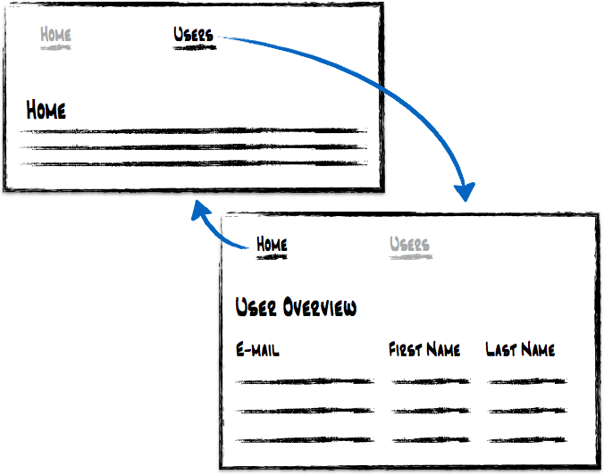

## Acceptance criteria:

* From the home page, I should be able to navigate to the user overview page
* From the overview page, I should be able to navigate back to the home page
* In the overview, a line is shown for each registered user
* For each user, following fields should be visible: email, firstname and lastname

## Remark

* The registered persons are the users of your application