# Story W02. Register User

As a user   
I want to register   
so that I’ll be able to use the application

## Wireframes:

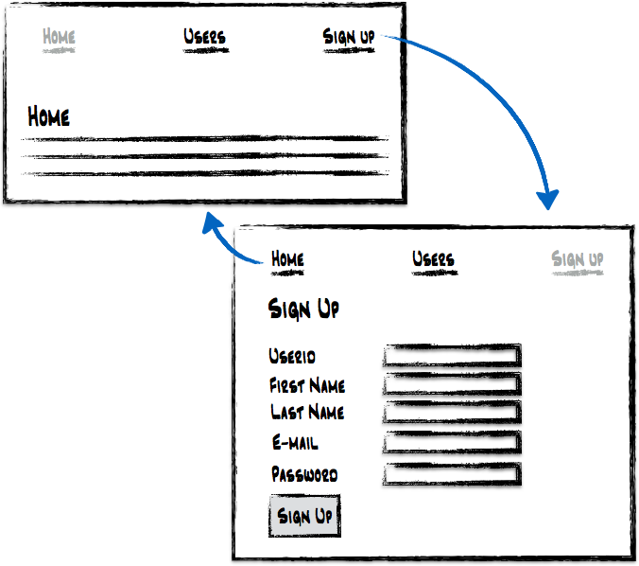

## Acceptance criteria:

* From the home page, I should be able to navigate to a person form
* A user can enter a userid, his/her firstname, last name, email address and password
* All fields are mandatory
* If a mandatory field is not filled in or a field contains invalid information, the form is shown again with an error message (server side validation). Correct fields stay filled in. It is not necessary to mark invalid fields by a colour.
* After the form is submitted, the home page is shown