
A Holistic Approach to Sustainable, Digital EU Agriculture, Forestry, Livestock and Rural Development based on Reconfigurable Aerial Enablers and Edge Artificial Intelligence-on-Demand Systems

CHAMELEON Bundle User Manual. Crop water stress due to drought
Work package | WP4: CHAMELEON Solution for multi-purpose onboarding.
Bundle | Crop water stress due to drought
Authors | Miguel A. Moreno – UCLM, David Hernández – UCLM, Rocío Ballesteros – UCLM
Dissemination level | Public (PU)
Status | Draft
Due Date | 17/07/2024
Document date | 31/10/2024
Version number | 0.1
 | Funded by the European Union. Views and opinions expressed are however those of the author(s) only and do not necessarily reflect those of the European Union or the European Research Executive Agency. Neither the European Union nor the European Research Executive Agency can be held responsible for them.

Revision and history chart
Version | Date | Main author | Summary of changes
0.1 | 29/05/2024 |  | Draft outline
0.2 | DD/MM/YYYY
0.3 | DD/MM/YYYY
0.4 | DD/MM/YYYY
0.5 | DD/MM/YYYY
0.6 | DD/MM/YYYY
0.7 | DD/MM/YYYY
0.8 | DD/MM/YYYY
0.9 | DD/MM/YYYY
0.10 | DD/MM/YYYY
0.11 | DD/MM/YYYY
0.12 | DD/MM/YYYY
Etc. | DD/MM/YYYY |  | (Delete unused lines)
1.0 | DD/MM/YYYY |  | Final submitted version
1.1 | DD/MM/YYYY |  | Revisions after submission (if required)
1.2 | DD/MM/YYYY
2.0 | DD/MM/YYYY |  | Revised submitted version (if required)

Table of contents, select style H1 no ToC
Glossary of terms, Section_Header 3
List of abbreviations and acronyms, Section_Header 3
1 Executive Summary 5
Exec Sum 5
2 Introduction 6
2.1 Purpose and scope 6
2.2 Approach 6
2.2.1 USER INTERFACE OF PAFYC TOOLS AND MAIN PARAMETERS 6

Index of figures
Figure 1. Graphical representation of the determination of CWSI 6
Figure 2. PAFyC tools gui with the bundle selected. 7
Figure 3. List of parameters to be selected in the tool 7
Figure 4. Example of canopy segmentation using k-means and temperature information. 8
Figure 5. Report of the execution 8
Figure 6. Results included in the output shapefile 9
Figure 7. Thematic map of CWSI 9

Index of tables
Table 1: Table caption, left justified, above the table ¡Error! Marcador no definido.

Glossary of terms
Term | Description

List of abbreviations and acronyms
Abbreviation | Meaning
CWSI | Crop Water Stress Index
Tc | Canopy Temperature
Ta | Ambient temperature
RH | Relative humidity

Executive Summary

Exec Sum

This document describes how to calculate the Crop Water Stress Index (CWSI) using thermal orthomosaic data and climatic data (air temperature and relative humidity) to monitor vine water stress. The main advance compared with existing procedures is that it calculate the index for each individual plant. The user must configure relevant parameters, including air temperature, relative humidity, and date extraction, and select the appropriate input files such as the vines frames shapefile and thermal orthomosaic. It can generate thematic maps of stress and also generate alarms choosing the preferable segmentation method (k-means or percentile). The output, containing CWSI and temperature values of well illuminated vegetation, can then be loaded into QGIS or any WEBGIS viewer for detailed visualization and analysis, aiding in the assessment of crop water stress.

Introduction

Purpose and scope
Crop Water Stress Index using Thermal orthomosaic

The main objective is to calculate and analyse the Crop Water Stress Index (CWSI) for each individual vine using thermal orthomosaic data. This involves configuring parameters, selecting appropriate input files, and using segmentation methods to generate detailed CWSI and temperature values. The final output is CWSI index raster that can be visualized in QGIS or any WEBGIS viewer.
The CWSI is based on the determination of the canopy temperature and its difference with air temperature (Tc-Ta). Also, it requires the calculation of the vapor pressure deficit from air temperature and relative humidity. The threshold of stressed and non-stressed vines is defined by the upper baseline and lower baseline, respectively. These baselines are specific for each species and even for each variety of the same species. To feed the tool, a literature review was performed to determine the most appropriate values for vineyard, but it can be accommodated by the user based on their own experience. The CWSI is calculated for each individual vine in the vineyard. Thus, thematic maps and alarm generation can be performed.
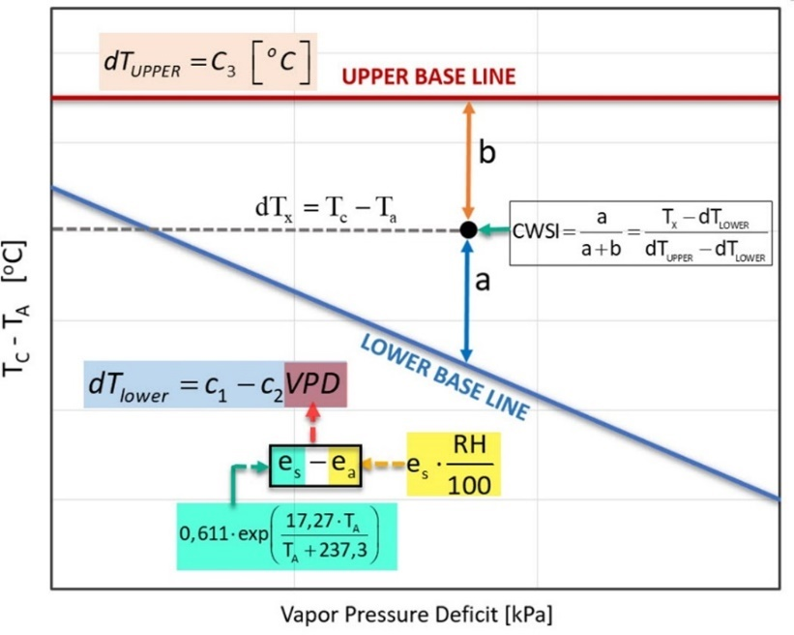
Figure 1. Graphical representation of the determination of CWSI

Approach

USER INTERFACE OF PAFYC TOOLS AND MAIN PARAMETERS
The user should select Crop Water Stress Index using Thermal orthomosaic in the tool (Fig. 1).

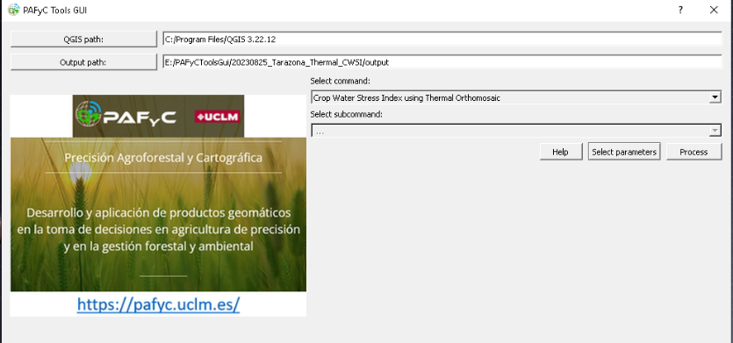
Figure 2. PAFyC tools gui with the bundle selected.

After select the parameters for this command, the following parameters should be defined (Fig. 2.)
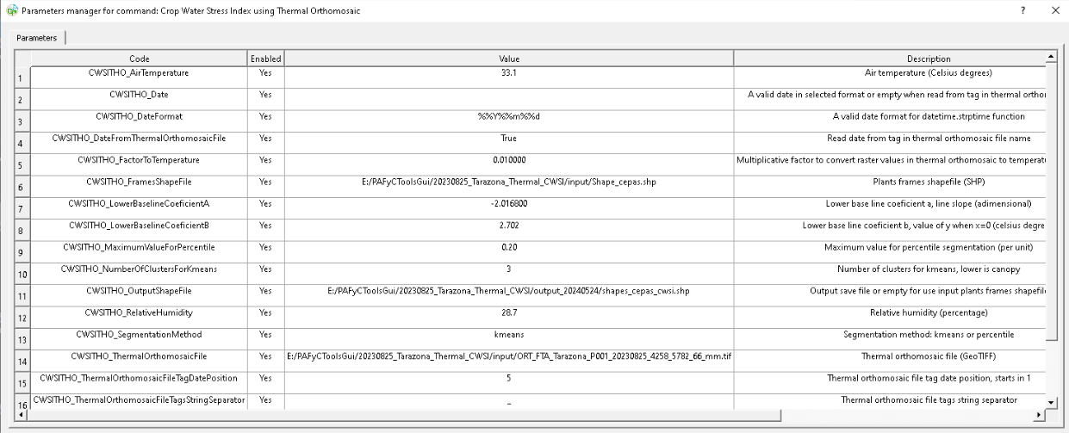
Figure 3. List of parameters to be selected in the tool

The user should configure the necessary parameters for the command. This includes selecting and adjusting all relevant parameters. Also, the user should ensure that the air temperature is set correctly. It is crucial to read the date from the orthomosaic, especially if an orthomosaic file is being used as input data. The date must be in the correct position between the defined tag (“_” in this case) within the file name, so that the tool can identify it correctly. Additionally, if the temperature is multiplied by 100 in the raster layer, convert it to degrees Celsius by dividing by 100 (FactortoTemperature parameter set to 0.01). Also, the user should select the input shapefile which contains the definition of the vine frames, and the raster orthomosaic which contains the temperatures.
After that and with the aim to perform vegetation segmentation, the user should select the number of clusters for kmeans, by setting the value to 3 (calibrated with field data). The cluster with the lower temperature value will be considered vegetation (soil temperature is always values of each plant.

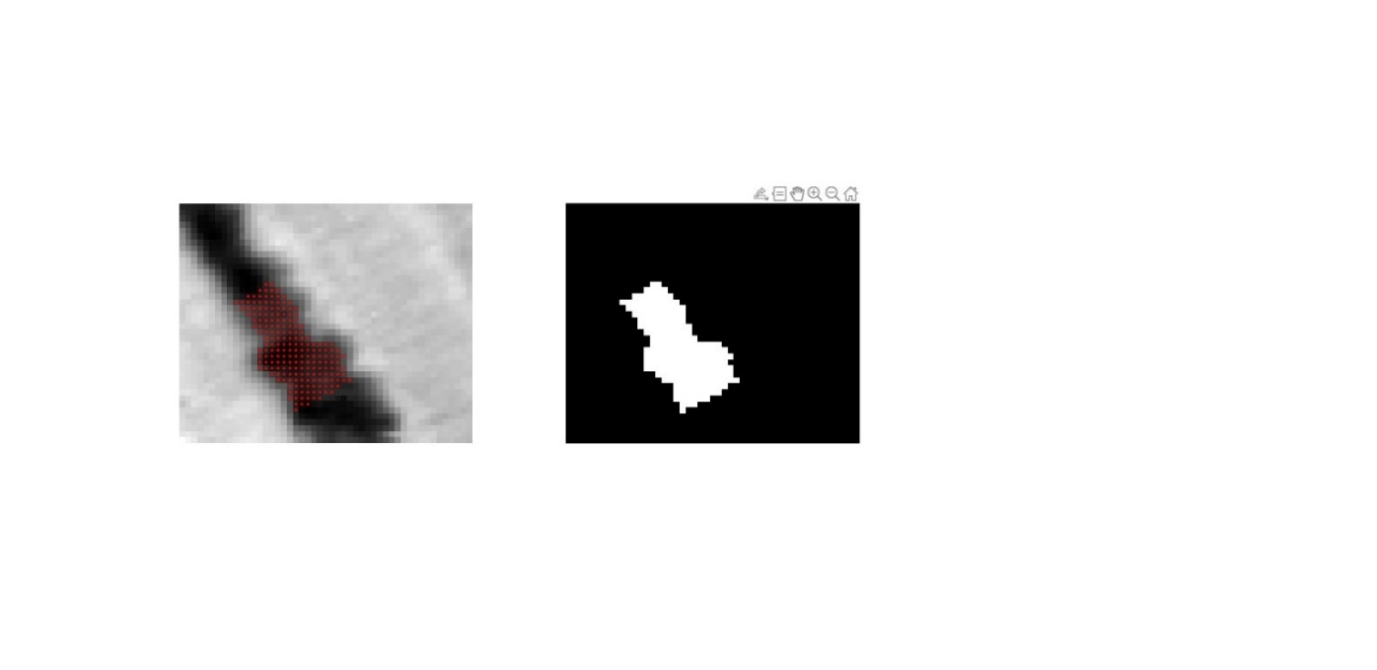
Figure 4. Example of canopy segmentation using k-means and temperature information.
Next, the user should configure the output shapefile. By selecting the output file path and ensuring that the output file name is correctly placed in the designated path.
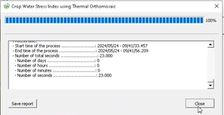
Figure 5. Report of the execution

The output file contains calculated values of the Crop Water Stress Index CWSI (mean(ck), maximum (cxk), and minimum (cnk)) and temperature (mean (tmk), standard deviation,(tsk), and the number of pixels segmented as vegeation (nvs)).
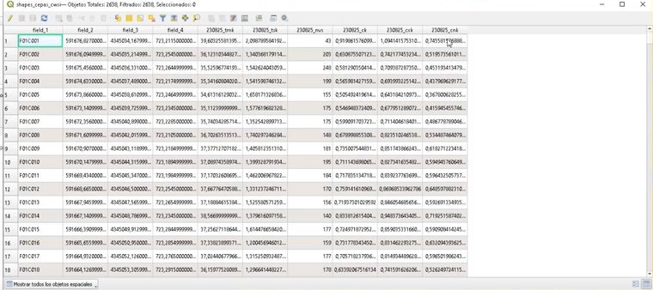
Figure 6. Results included in the output shapefile

With this information, thematic maps can be generated (Fig. 7)
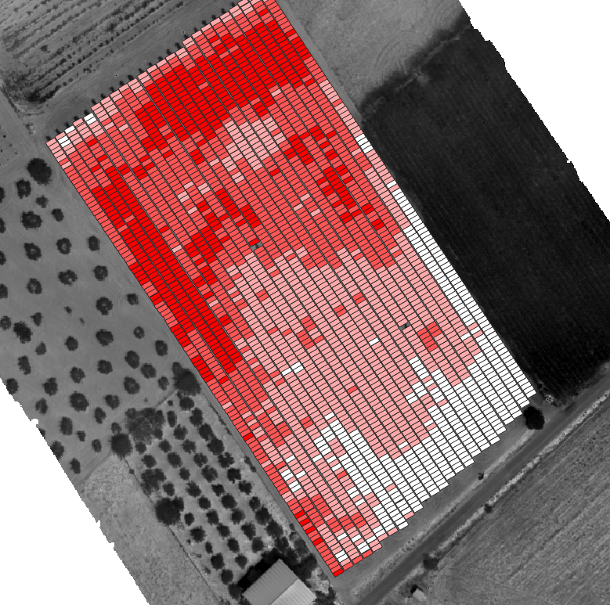
Figure 7. Thematic map of CWSI

To generate alarms for the most stressed vines, the user should select the segmentation method, which can be Kmeans or percentile. If the user selects Kmeans, user should select the number of clusters and the tool will set an alarm for those vines that belongs to the group with higher CWSI values. In the case of using percentiles, the user should specify the percentage of vines with higher CWSI values, i.e. if the user selects 1%, the tools will set an alarm for the 1% of the vines with higher CWSI values.

List of parameters
Crop Water Stress Index using thermal orthomosaic
 | Parameter | Type | Value list | Max | Min | Default value | Description
1 | CWSITHO_AirTemperature | Double |  | 60.00 | 0.00 |  | Air temperature (Celsius degrees) obtained during flight operation.
2 | CWSITHO_Date | Text |  |  |  |  | A valid date should be introduced (i.e. 20220705) or empty if the date is obtained from the thermal orthomosaic.
3 | CWSITHO_DateFormat | Text |  |  |  | %%Y%%m%%d | Date format (i.e. 20220705) 5th July 2022.
4 | CWSITHO_DateFromThermal  OrthomosaicFile | Value list | True; false |  |  |  | The user decides if obtaining the date from the thermal orthomosaic file name or introduce the date in the previous parameter.
5 | CWSITHO_FactorToTemperature | Double |  | 100000.00 | 0.000001 | 0.01 | Multiplicative factor to convert raster values in thermal orthomosaic to temperature (Celsius degrees). If the orthomosic supplies the values directly in temperature, it is 1.
6 | CWSITHO_FramesShapeFile | File |  |  |  |  | The path of the shape file that contains the frame that delimit the region of interest of each vine. The path should not have spaces or special characters.
7 | CWSITHO_LowerBaseline  CoeficientA | Double |  | 10000.00 | -10000.00 | -2.016800 | Lower base line coefficient A, line slope (adimensional).
8 | CWSITHO_LowerBaseline  CoeficientB | Double |  | 100.00 | -100.00 | 2.702 | Lower base line coefficient B, value of y when x=0 (Celsius degrees).
9 | CWSITHO_MaximumValueFor  Percentile | Double |  | 1.00 | 0.01 |  | Percentile value above which the plant's water status is considered anomalous.
10 | CWSITHO_NumberOfClusters  ForKmeans | Int |  | 50.00 | 2.00 |  | Number of groups in which the program will classify the plants based on their CWSI.

Copyright © 2022. All rights reserved.


A Holistic Approach to Sustainable, Digital EU Agriculture, Forestry, Livestock and Rural Development based on Reconfigurable Aerial Enablers and Edge Artificial Intelligence-on-Demand Systems

The Members of the CHAMELEON Consortium:
 |  |  |  | 
 |  |  | 
 |  |  | 
Contact:
Project Coordinator: Pantelis Velanas  Acceligence Ltd. | pvelanas@accelligence.tech

Disclaimer
Funded by the European Union. Views and opinions expressed are however those of the author(s) only and do not necessarily reflect those of the European Union or the European Research Executive Agency. Neither the European Union nor the European Research Executive Agency can be held responsible for them.

