Final Project Report

Part A – Data Construction:

Discuss advice 2:

CA can contain null columns, this can be alleviated with adding small epsilon when constructing the normalized version of CA. See code for more details

Show two clean images and their corresponding noisy and corrupted versions

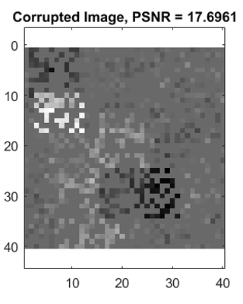

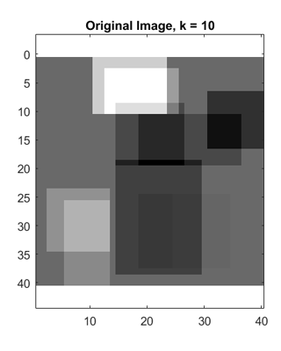

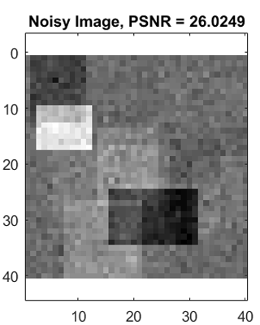

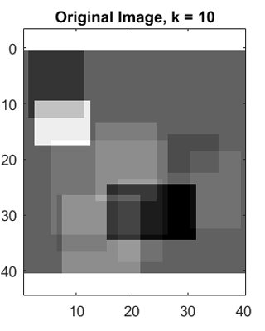

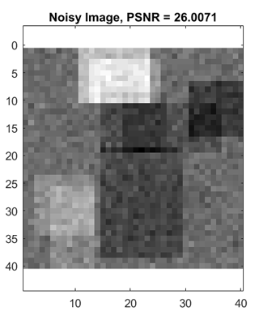

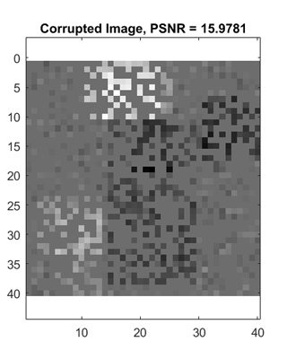

Part B – Inpainting by the Oracle Estimator

43.449

Insert average PSNR result of the Oracle estimator:

Show clean, noisy, corrupted and Oracle-based reconstruction:







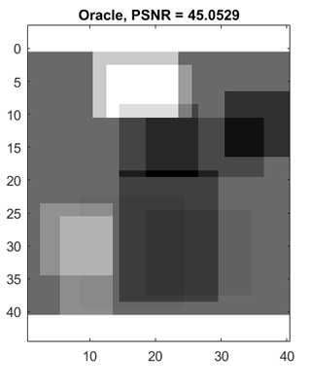

Part C – Inpainting by Greedy Pursuit

36.565

Insert average PSNR result of OMP:

Show clean, noisy, corrupted and OMP-based reconstruction:







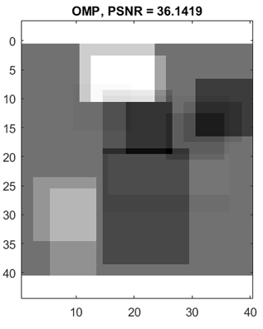

Compare between Oracle and OMP reconstructions:





Discuss results of OMP and compare to Oracle performance:

Oracle reconstruction is quite good, compared to OMP. Oracle knows the true support, so it just can compute the best solution approximation.

Show average PSNR of OMP as a function of

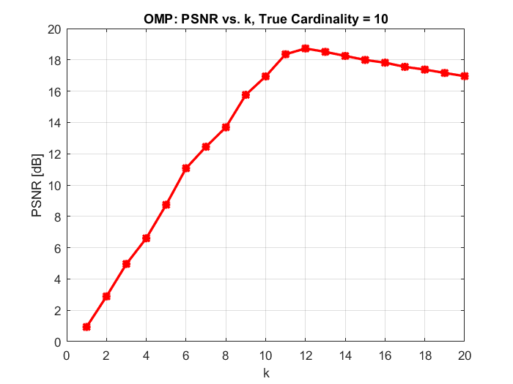

OMP can quite successfully reconstruct the image close to the true cardinality.

The best result is obtained around the true support + standard expected deviation, around 2 in our case, so 12. If we do not know the true support we can run the algorithm for k_max iterations and make the function of the residuals of two iterations t(k) = norm(rk) / norm (rk-1); the true support is the minimum of t(k). The rationale is:

Case A: If rk and rk-1 contain signal + noise then it is not likely that t(k) is close to zero

Case B: First time when rk gets only noise the residual will be small, but rk-1 is not, then t(k) gets close to zero.

Case 3: rk and rk-1 contain only noise terms, then t(k) will not be close to zero

Discussion regarding the average PSNR as a function of :

Part D – Inpainting by Basis Pursuit

34.928

Insert average PSNR result of Basis-Pursuit:

Show clean, noisy, corrupted and BP-based reconstruction:







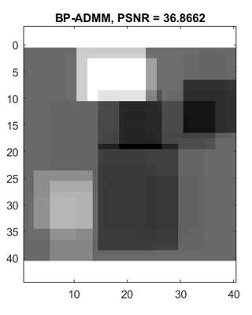

Compare between Oracle and OMP and BP reconstructions:







Discuss results of BP and compare to greedy methods and to the oracle performance:

Average BPADMM performance is about the same as OMP in our case. However BPADMM is computationally more expensive.

Show PSNR as a function of :

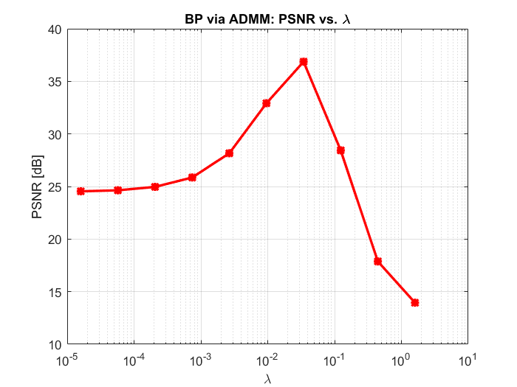

Discuss how affects BP reconstruction:

Looks like there is only one lambda value that gets the best PSNR for reconstruction. We can try to choose lambda as a rule of thumb like the ratio of sigma (noise standard deviation) and expected non zeroes of the true solution standard deviation. The result depends on the noise standard deviation. In our case 0.05/ 2.0. Lambda stays in the same boundaries as far as the support and the noise do not move.

Part E – Effect of Parameters

Show MSE as a function of and :

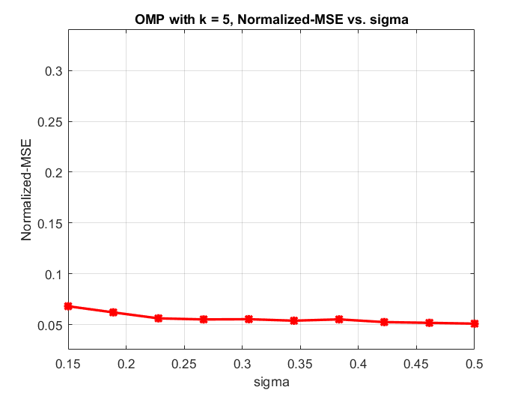

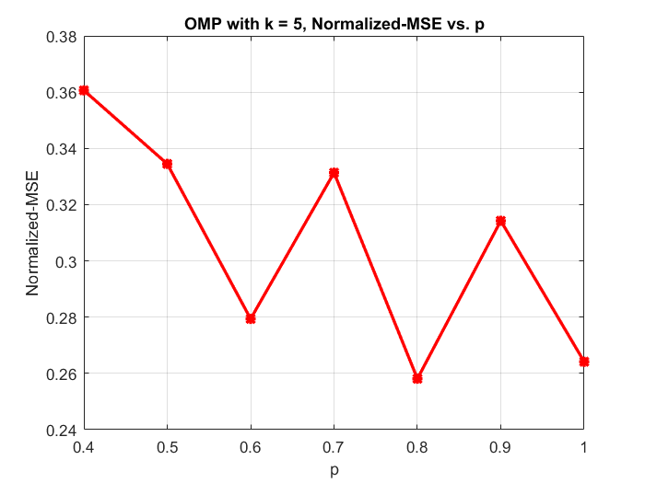

Discuss the effect of :

As more and more pixels remain in the corrupted image, the reconstruction improves.

For different images the results differ, but the tendency is the same. 0.4 we have bigger error, which goes to zero when p goes to 1

Discuss the effect of :

The variance of the noise does not have a big impact over the reconstruction errors. Effect of the noise over the support of these reconstructions is bigger though. They get denser for the same mse.