Mid Project Report

Part C – Analyzing the results:

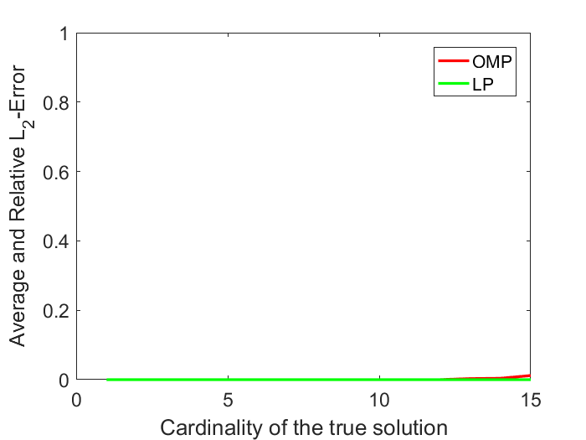

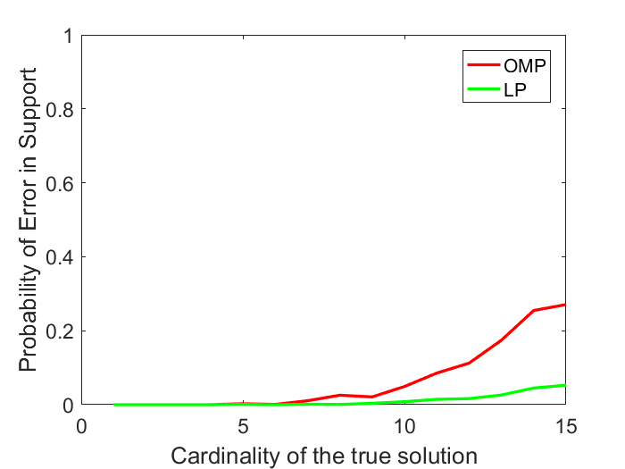

Discuss the results below:

The algorithms behave well on low-cardinalities. The BP algorithm performs much better than the OMP algorithm. Here we can see that when the cardinality increases the support error increases much faster than the error in the found solution. So we may find solutions which are denser than the true solution, but with the same norm, so only the sparisity is off a little.