GAIT on Linux

1. Intro

This documentation will help you to install GAIT on Linux. I did it with Ubuntu 16.04.

2. JDK Installation

GAIT is written in Java. First of all, we need to install Java Development Kit. The one we have to install is Java SE Development Kit 8u251. You can find it at this address: <https://www.oracle.com/java/technologies/javase-jdk8-downloads.html>

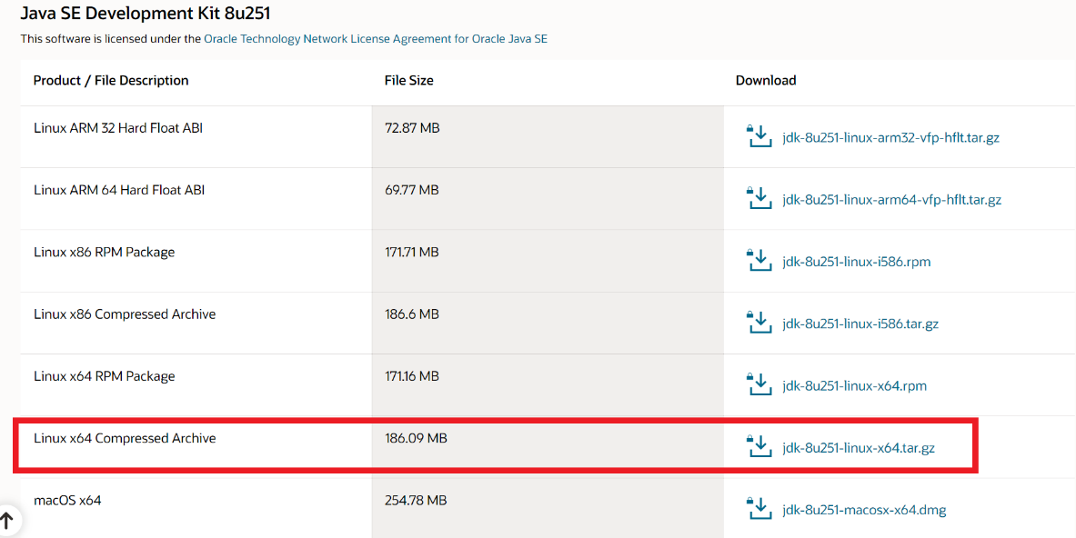

Select the Linux x64 Compressed Archive.

Saisir son login et mot de passe oracle. (en créer un si nécessaire), puis sauvegarder le fichier.

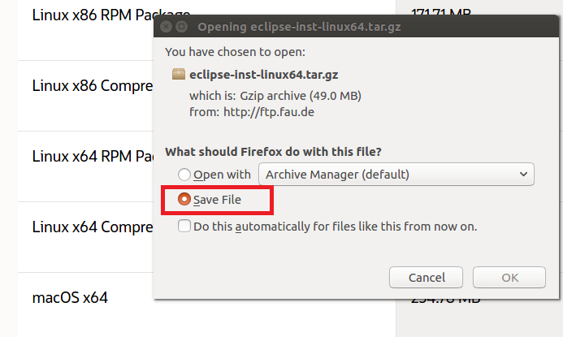

By default, system will select “Open with…”. Please select “Save File”.

When the file is downloaded, open a terminal (CTRL + ALT + T) and go to your downloads folder. You will find your JDK archive. You can extract it.

Commands:

Go to Downloads folder 🡪

$ cd Downloads/

Check your JDK archive 🡪

$ ls

Extract it 🡪

$ tar -zxvf jdk-8u251-linux-x64.tar.gz

Now, you have to put your extracted folder in the right place. For that, please check that a file named “java” is in your extracted JDK folder. If not, (and probably not) you need to create it.

Commands:

Check your extracted JDK folder 🡪

$ ls

Got to the right place 🡪

$ cd /usr/lib

Check whether a “java” folder already exists here 🡪

$ ls java



IF NOT: Create it 🡪

$ sudo mkdir java

Return to your Downloads folder 🡪

$ cd ~/Downloads

Move your extracted folder in the folder you just created 🡪

$ mv jdk1.8.0_251 /usr/lib/java/

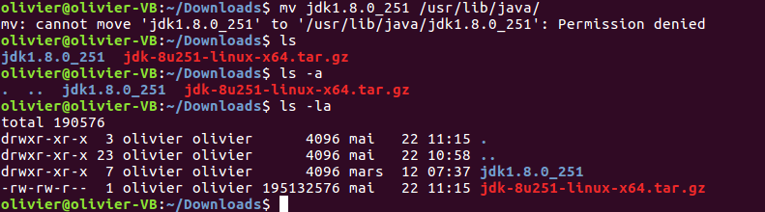

J’ai fait

$ sudo mv jdk1.8.0_251 /usr/lib/java/

Go into the “bin” folder of your extracted file 🡪

$ cd /usr/lib/java/jdk1.8.0_251/bin

Normally, you will find a lot of files in here. Please verify that a “java” file and a “javac” file are here.

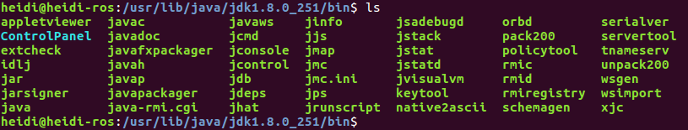

3. JDK Setting Up

Now, you will be setting up java for updates and packages management.

Go back in your jdk folder 🡪

$ cd ..

Write these three commands one by one 🡪

$ sudo update-alternatives --install "/usr/bin/java" "java" "/usr/lib/java/jdk1.8.0_251/bin/java" 1

$ sudo update-alternatives --install "/usr/bin/javac" "javac" "/usr/lib/java/jdk1.8.0_251/bin/javac" 1

$ sudo update-alternatives --install "/usr/bin/javaws" "javaws" "/usr/lib/java/jdk1.8.0_251/bin/javaws" 1

WARNING! Don’t forget to replace jdk1.8.0_251 by the version you downloaded.

Now, you need to edit your .bashrc file and to add some lines.

Let’s return to your home 🡪

$ cd ~

Run gedit to edit your .bashrc file 🡪

$ gedit .bashrc

Add the following lines to the end of your .bashrc file:

#JAVA HOME directory setup

export JAVA_HOME=/usr/lib/java/jdk1.8.0_251

export PATH="$PATH:$JAVA_HOME/bin"

To verify that our installation works, we will test it with the following command:

First, close and reopen your terminal

Write:

$ java

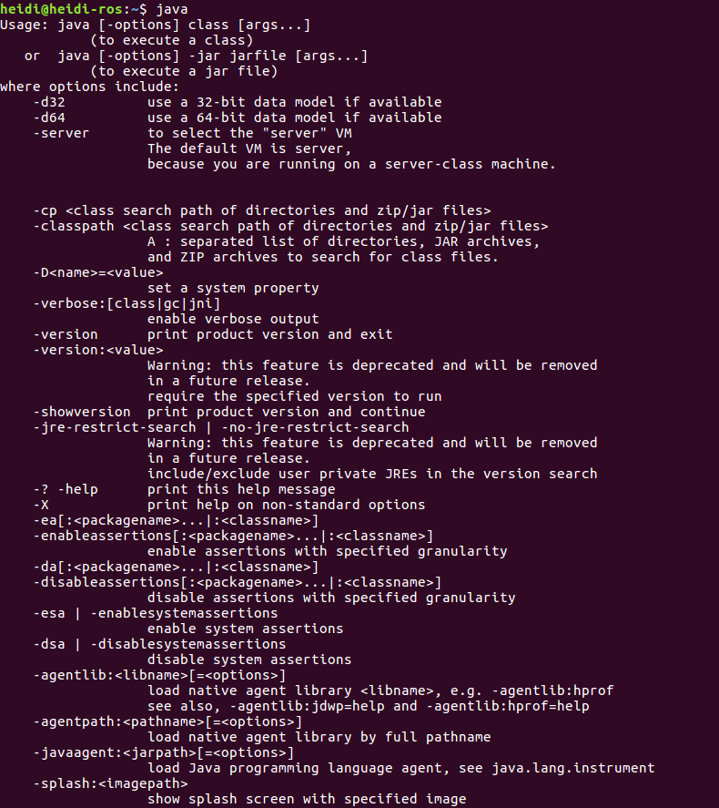

You should have that in your terminal.

Write:

$ javac

You should have a similar thing as above

Write:

$ java -version

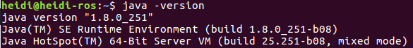

Good Job! You installed Java for Linux!

tar -zcvf eclipse-inst-linux64.tar.gz

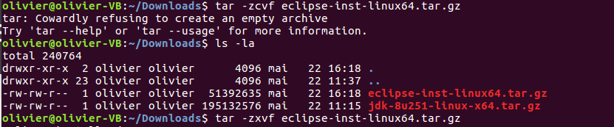

Changer en

tar -zxvf eclipse-inst-linux64.tar.gz

If you check your files, you can see that you have now a file named “eclipse-installer”

Changer en

If you check your folders, you can see that you have now a folder named “eclipse-installer”.

Mon installation folder par défaut n’ets pas le meme :

/home/Olivier/eclipse/java-2020-03

Et non

/home/Olivier/eclipse/java-2020-032

6. GAIT Importation in Eclipse

How do i start eclipse ?

Dans ~/eclipse/java-2020-03/eclipse

Double cliquer sur eclipse

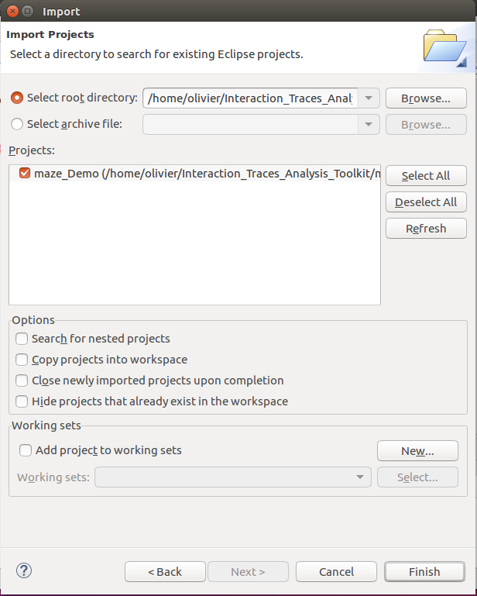

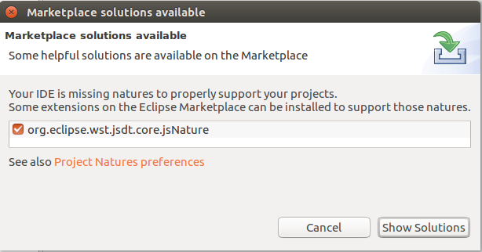

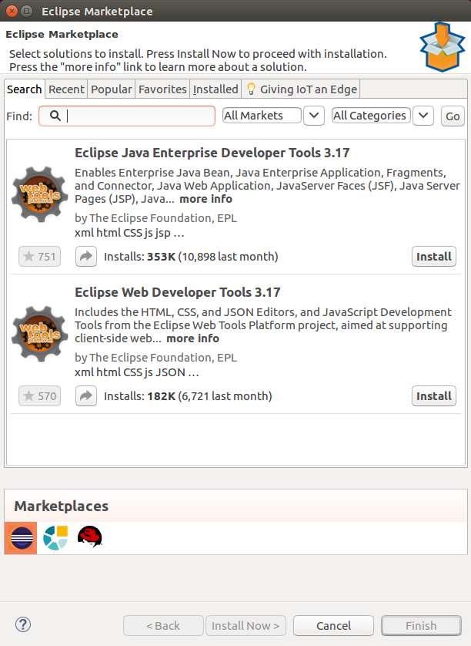

Install Java Enterprise Developer tools

I clicked on the « Java EE » button but no “server window” appeared.

Click the “Java EE” Button to show the “Servers” panel

Browse to find the location where you downloaded the server named \apache-tomcat-

9.0.17" (Figure 23), make sure the server is checked, then hit \Finish".

Figure 23: Finish importing the server.

2.3.4 Deployment the project in the Server

Right click