**Programming 3**

UCN – Computer Science - C#

_________________________________________________________________________________________

Dealing with errors

# Background

### About windchill factor

”The windchill factor is the temperature that a person feels because of the wind. For example, if a thermometer reads 35 degrees Fahrenheit outside and the wind is blowing at 25 miles per hour (mph), the windchill factor causes it to feel like it is 8 degrees F. In other words, your 98-degree body loses heat as though it is 8 degrees outside.”

Source: https://science.howstuffworks.com/nature/climate-weather/atmospheric/question70.htm

We will use these resources:

* Online calculation: <https://www.weather.gov/epz/wxcalc_windchill>
* Formula: <https://www.weather.gov/media/epz/wxcalc/windChill.pdf>

The formula is complicated and you don't really need it for this exercise.

According to the first link the calculation is only valid for certain temperatures and wind speeds!

Try to use the online calculation!

Example:

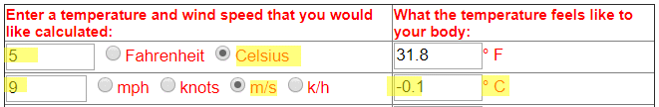

### Getting started

Get hold of the Exercise_DebugAndTest.zip file file from Canvas.

Unpack the file at your preferred location and open the VS solution.

Build to be sure everything is ok.

# Code and debug

Code the TestChill class – you must use the Meteorology project. *)  
Output should be similar to this:

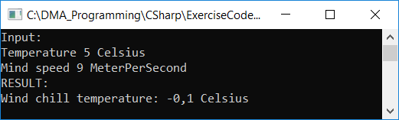

That is, display the input values and the result in the console.

Use the online calculation to check the result.

**Debug to find errors!**

*) Start in this way:

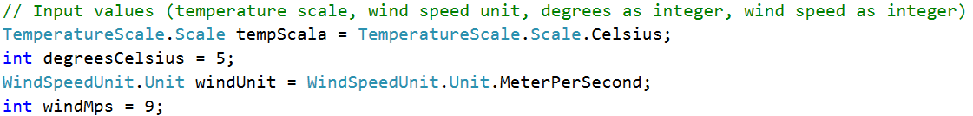

# Code and unit test

Add a test project:



Test methods from the WindChillFactor class:

* ConvertCelsiusToFahrenheit
* ConvertFahrenheitToCelsius
* ConverMilesPerHourToMeterPerSecond
* ConverMeterPerSecondToMilesPerHour
* CalulateChillFactorTemperature

*Example:*

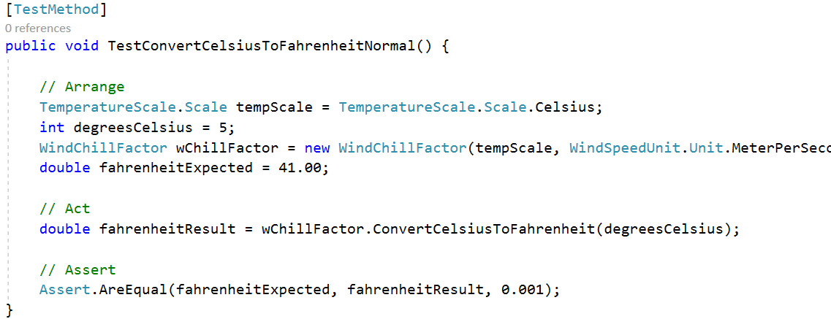

# Handle invalid values (extra)

Enhance the Meteorology project to handle values outside the boundaries incl. return appropriate values to clients of the code.

Create test methods to verify correctness.