Precision by Experimental Group and Temperature
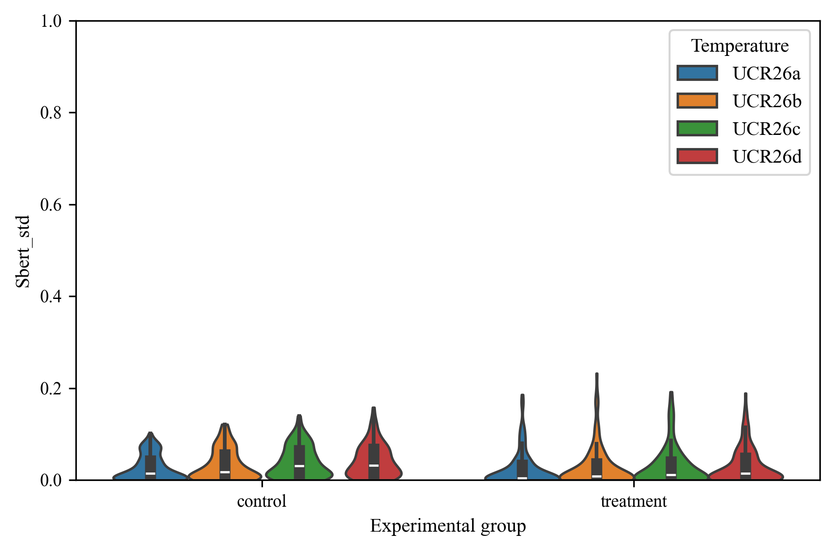

Precision By Temperature
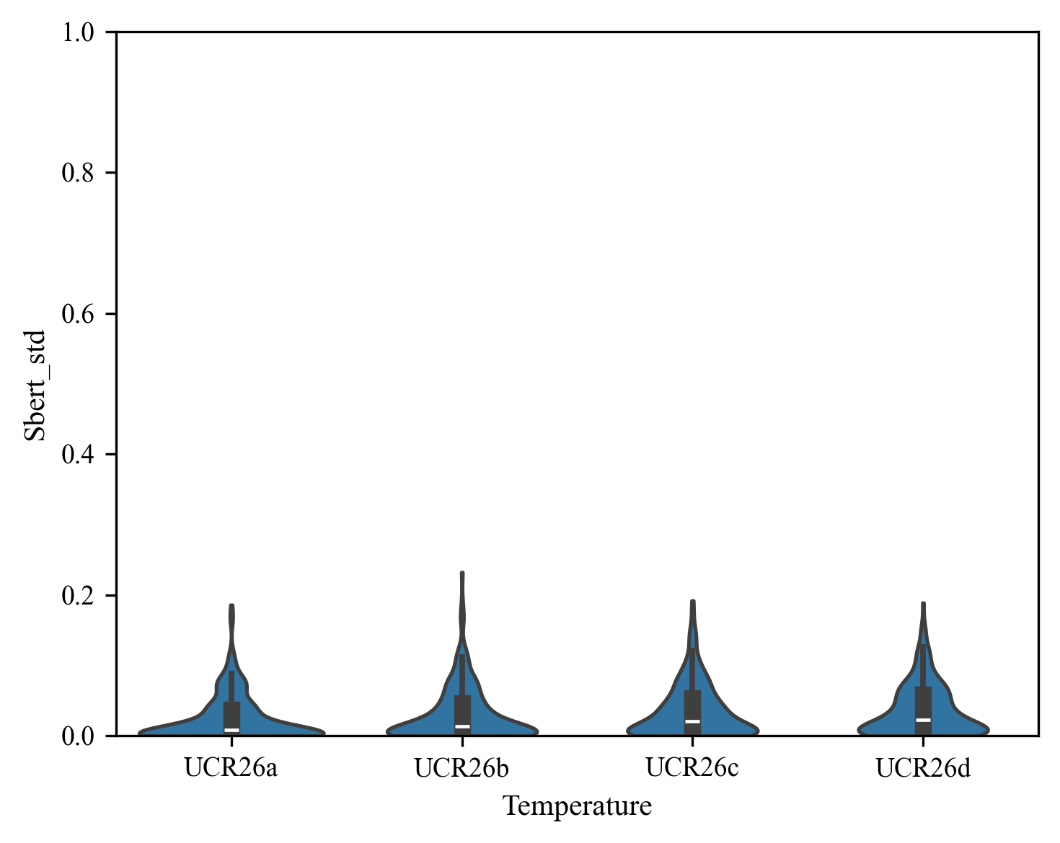

Precision by Experimental Group
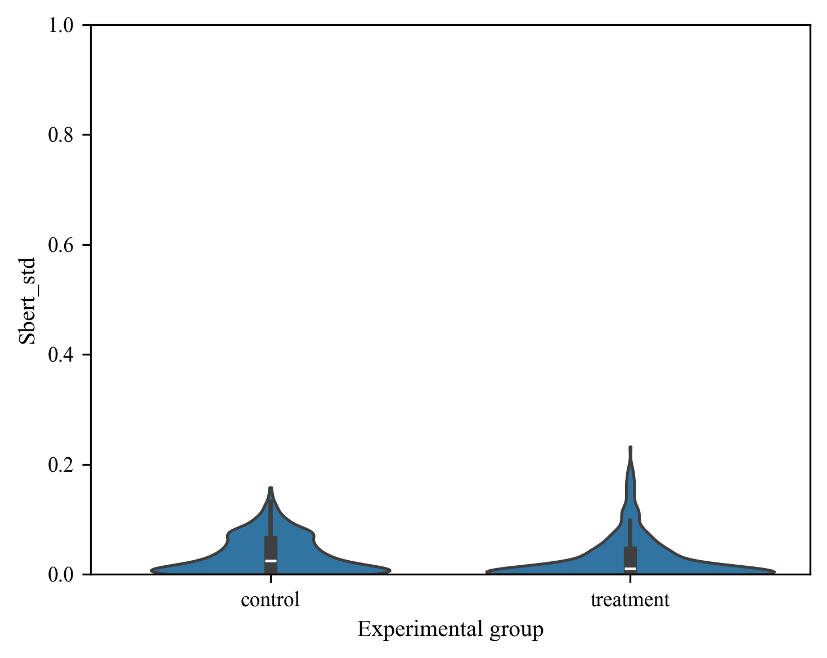

Accuracy by Experimental Group and Temperature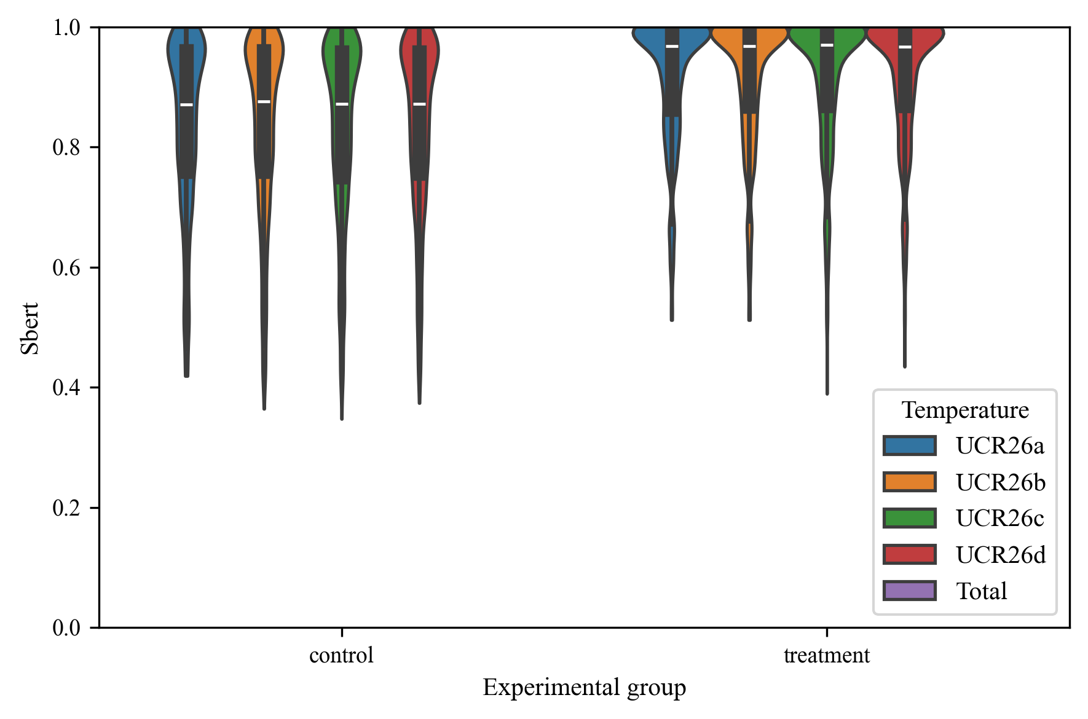

Accuracy by Experimental Group and Temperature (Aggregated)
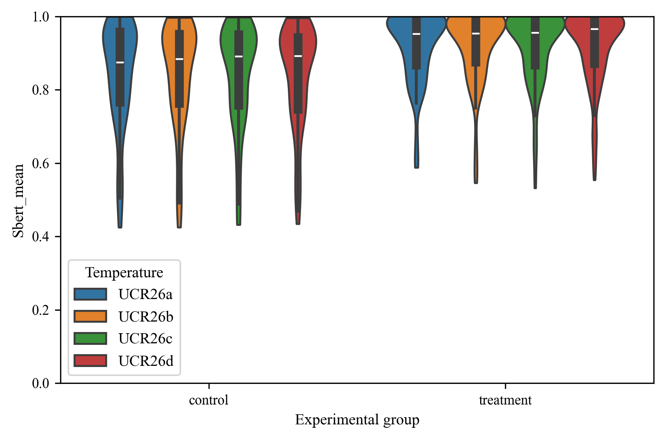

Accuracy by Temperature

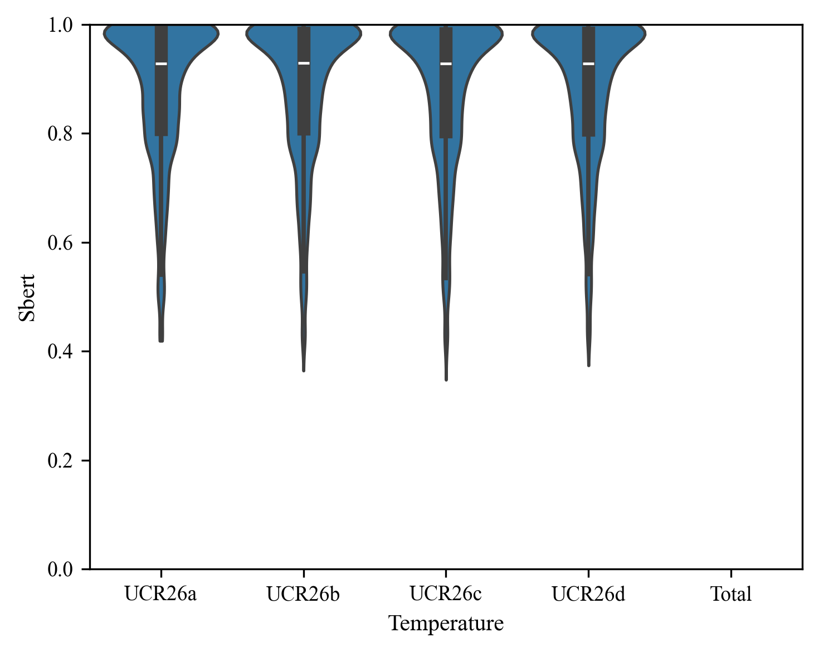

Accuracy by Temperature (Aggregated)

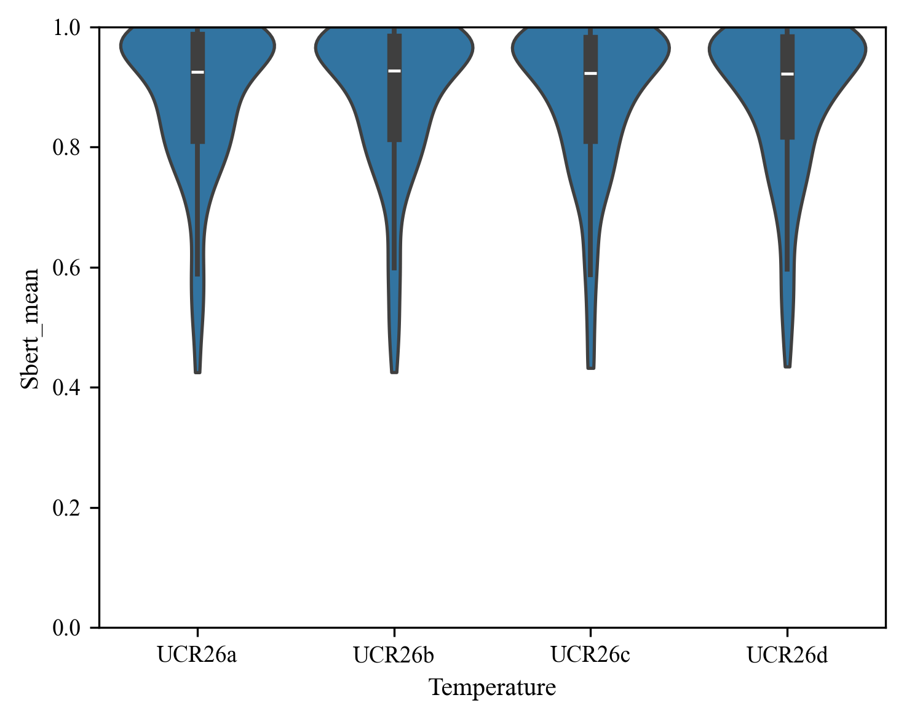

Accuracy by Experimental Group

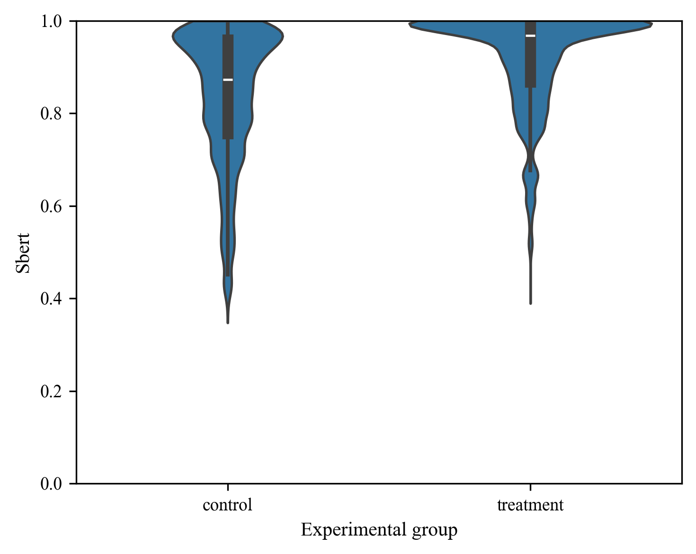

Accuracy by Experimental Group (Aggregated)
