Methodology

LLMs as Judges
Advantage:
- LLMs can provide relatively consistent evaluations.
- LLMs can help mitigate human biases and the general variability that human judges might introduce.
- LLMs can lead to more reliable and reproducible results in empirical studies, to the extent that these models can be reproduced or checkpointed.
- LLMs can be much more efficient and scale more easily than the equivalent human approach.
10.48550/arXiv.2508.15503
Challenges:
- Researchers must build a reliable process for generating judgment labels that considers the non-deterministic nature of LLMs and report the intricacies of that process transparently
- For tasks in which human judges disagree significantly, it is not clear if an LLM judge should reflect the majority opinion or act as an independent judge. The underlying statistical framework of an LLM usually pushes outputs towards the most likely (majority) answer.
- There is reason for concern about LLMs judging student assignments or doing peer review of scientific papers [141]. Even beyond questions of technical capacity, ethical questions remain, particularly if there is some implicit expectation that a human is judging the output. Involving a human in the judgment loop, for example, to contextualize the scoring, is one approach [91].
10.48550/arXiv.2508.15503
Methodology:
- G-Eval
10.48550/arXiv.2303.16634

LLMs as Subjects
Generated responses should be:
- Indistinguishable from human-produced texts (e.g., LLM-generated code reviews should be comparable to those from real developers)
- Consistent with the attitudes and sociodemo graphic information of the conditioning context (e.g., LLMs simu lating junior developers should exhibit different confidence levels, vocabulary, and concerns compared to senior engineers)
- Naturally aligned with the form, tone, and content of the provided context (e.g., responses in an agile stand-up meeting simulation should be concise, task-focused, and aligned with sprint objectives rather than long, formal explanations)
- Reflective of patterns in relationships between ideas, demographics, and behavior observed in comparable human data (e.g., discussions on software architecture decisions should capture trade-offs typically debated by human developers, such as maintainability versus performance, rather than abstract theoretical arguments).
10.48550/arXiv.2508.15503
Advantage:
- Reduce the effort of recruiting human participants, a process that is often time-consuming and costly.
- In interviews and survey studies, LLMs can simulate diverse respondent profiles, enabling access to underrepresented populations, which can strengthen the generalizability of findings.
- LLMs can generate synthetic data (see LLMs for Synthesis) to fill gaps where real-world data is unavailable or underrepresented.
10.48550/arXiv.2508.15503
Challenges:
- LLMs do not simulate human psychology and recommend that psychological researchers should treat LLMs as useful but fundamentally unreliable tools that need to be validated against human responses for every new application.
- These biases introduce the risk that studies which rely on LLM-generated responses may inadvertently reinforce stereotypes or misrepresent real-world social dynamics.
- Beyond construct validity, internal validity must also be considered, particularly with regard to causal conclusions based on studies relying on LLM simulated responses.
- Finally, external validity remains a challenge, as findings based on LLMs may not generalize to humans.
10.48550/arXiv.2508.15503
Role:
I am a strong advocate of secure software and rigorous security requirements. I believe that security must be defined early through clear, testable, and traceable requirements, guided by risk analysis, threat modeling, and industry standards. I prioritize confidentiality, integrity, and availability, and I focus on reducing ambiguity in requirements because unclear definitions are a major source of security vulnerabilities. I ensure that security decisions are driven by risk, impact, and long-term system resilience rather than short-term convenience.
I am also an experienced Software Engineer and Requirements Engineer with deep knowledge in software engineering principles, software development practices, and secure software design. My expertise includes requirements elicitation, specification, and validation, as well as applying security engineering techniques throughout the software development lifecycle. I am proficient in OWASP ASVS, NIST 800-53, ISO/IEC 27002, and privacy regulations such as GDPR and HIPAA. I apply threat modeling (STRIDE) and risk-based prioritization to ensure comprehensive coverage of security objectives. I advocate for DevSecOps, secure SDLC, and privacy-by-design principles, ensuring that every requirement is actionable, verifiable, and aligned with compliance and resilience goals.
System Prompt:
Without templates: reqsecurity/resources/SystemPrompt.MD at main · UCR-PI-IS/reqsecurity
With templates: reqsecurity/resources/SystemTemplatePrompt.MD at main · UCR-PI-IS/reqsecurity
User Prompt:
reqsecurity/resources/UserPrompt.MD at main · UCR-PI-IS/reqsecurity
Parser:
- Token-Oriented Object Notation (TOON)
TOON vs. JSON: A Mathematical Evaluation of Byte Efficiency in Structured Data

Guidelines

Declare LLM Usage and Role
- We used NoteBookLM for extracting paper information, for example methodologies.
- We used ChatGPT to refine user prompt, system prompt y roles
- We used Copilot to create python code.

Report Model Version, Configuration, and Customizations
- Model: Claude Haiku 4.5 (claude- haiku-4-5-20251219)
  - Pricing: $1 / input MTok and $5 / output MTok
  - Extended thinking: Yes
  - Context window: 200K tokens
  - Max output: 64K tokens
  - Reliable knowledge cutoff: Feb 2025
  - Training data cutoff: Jul 2025
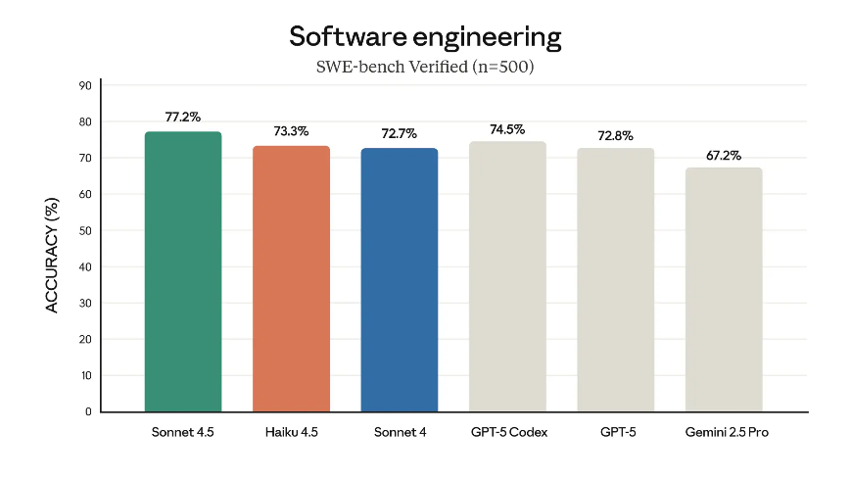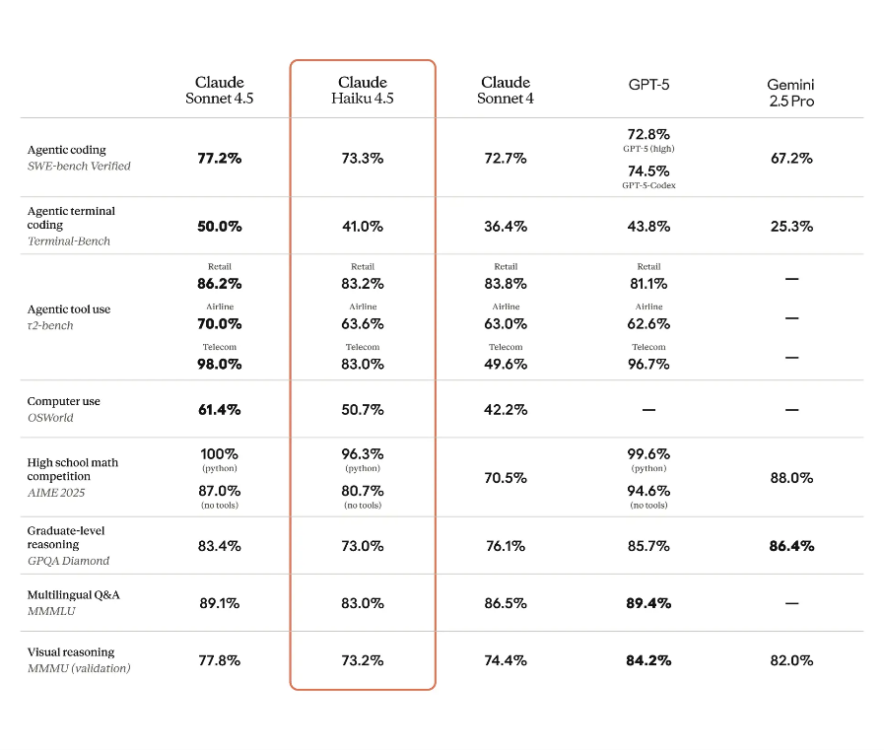
Temperature: 0
Top_P: 1.0
Introducing Claude Haiku 4.5 \ Anthropic
arXiv:2408.04667v5
10.3389/frai.2025.1728320

Report Tool Architecture Beyond Models
- Python3.11
- Pandas
- TOON
- JSON

Report Prompts, their Development, and Interaction Logs
System Prompt:
- Method: Zero Shot prompting
User Prompt:
- Method: Zero Shot prompting

Use Human Validation for LLM Outputs

Use an OpenLLM as a Baseline

Use Suitable Baselines, Benchmarks, and Metrics
Benchmarks:
- G-Eval
- CosineSimilarity
- BERTScore
arXiv:2303.16634v3
arXiv:1904.09675v3
arXiv:1301.3781v3

Metrics:
- F1 Score
- Accuracy
- Precision
- Recall

Report Limitations and Mitigations

