 | Project Final Report
 | Unit Name | Technology Project PG
 | Unit Number | 9786

Project Details
PROJECT NAME | BODYLINE AUTOMATION – BAXTER TIC TAC TOE
STUDENT NAME | YANG YE
STUDENT ID | U3161437
SUPERVISOR | DAMITH HERATH
NOTES: This document describes important details of your project final report. You should follow the guidelines herein when writing the final report. The report and other supporting material including this page (cover page) must be submitted through the Unit Moodle site before the due date. Late
submissions will incur penalty unless an exception has been granted by the project supervisor/s
. This report carries a 40% weighted mark towards your final aggregated unit score. Please refer to the Unit Outline for full assessment details. If this is a group project each individual student must complete his/her own INDIVIDUAL report detailing your OWN contribution to the project.

Total Marks (out of 100%)

Introduction

This Unit started as a manufacture automation project to replace human labour in the sewing process of bras. The original goal of my study is to build a configurable robotic simulation environment for Bodyline Company to evaluate the automation solution using Baxter robot. Due to the change in the external environment and prioritising current projects portfolio, the focus of my study has been shifted to another project called Baxter Tic Tac Toe, which aims to make a physical Baxter robot to play Tic Tac Toe game with human player in an interactive way. Even if the Bodyline simulation project has been suspended, the simulation environment as an outcome of this project worked as a development tool for the Tictactoe project. The simulation environment provides a way to development code without interrupting the work on the physical robot.
The Baxter Tictactoe project was based on a ROS package maintained by Scaz Lab in Yale University, USA¹. This package is still under incremental development so it’s under documented and contains unidentified bugs. Besides that, the Yale package is also based on third party packages, which may have further effect on the final outcome. Sou ser should exert reasonable caution in development based on this package. Besides that, I’ve integrated more third party open-source packages and tools into the current working repository to suit our needs. Given the short time for calibration, some features are either disabled or unintegrated, so further work is still needed.

Literature review
Given the scope of the project and the fast changing nature, literatures are grouped by area below. Most of the information is presented as website.
Robotic basics:
- Introduction to Homogeneous Transformations & Robot Kinematics.
Robot often has many moving joints and the technique to find the pose of given part of robot in certain reference frame knowing the joint status is called Forward Kinematics. This article takes reader through basics of spatial transformations. It introduces the representation of objects, the reference frames and the traditional way of doing transform in Cartesian space called homogenous transform matrix. The developers need to understand the FK concept since pose of an object in ROS environment is expressed as Cartesian coordinates and rotation in certain reference frame. However they don’t need to write code doing homogenous matrix computation as both roscpp and rospy libraries provide utility functions to handle this part.
https://pdfs.semanticscholar.org/4b6e/a546637a86030b43a7d5ed5873a67d451b4f.pdf
- Representing Position & Orientation & State
A shorter and easier introduction to Forward Kinematics could be found on web page of ITEE faulty in University of Queensland.
http://robotics.itee.uq.edu.au/~metr4202/lectures/L2.Frames.pdf
- Quaternions and Rotations
The roscpp and rospy libraries provide wrapper functions to take homogenous transform matrix. User specifies the rotation angles around x, y, or z axle to do the transform. However the actual transform in ROS is done through a technique called quaternion transform since the homogenous transform matrix has a problem called “Gimbal Lock”. The quaternion transform also provides smoother motion planning as it’s embedded with a interpolation technique called Spherical LERP rather than LERP. ROS libraries give user choice to use quaternion representation or not. Developer should read this part only when they are interested in quaternion. This article introduces quaternion representation and rotation for both computer simulation and robotics as they share this knowledge.
http://run.usc.edu/cs520-s12/quaternions/quaternions-cs520.pdf
- Inverse Kinematics
Inverse Kinematics is far more complicate than Forward Kinematics and it worth many papers to clarify. The developers should not focus on IK algorithms but should understand the basics when they are dealing with already made IK functions. This is a quick introduction to IK and worth to read.
http://wiki.roblox.com/index.php?title=Inverse_kinematics
ROS systems:
- Core ROS Tutorials
ROS is an open source project for robotic programming. It’s maintained by a group of contributors. Hence the ROS Tutorial is the best gateway into ROS World. For this project, developer should go through all tutes at Beginner Level and tute 3, 4, 5 at Intermediate level.
http://wiki.ros.org/ROS/Tutorials
- ROS Concepts
This page explains many basic ideas including: How ROS system are organized in file system. What are ROS nodes and how do they cooperate to work. What’s the naming convention and how do we refer them. This is a MUST read for future developer.
http://wiki.ros.org/ROS/Concepts
- API reference of rospy and roscpp
There are a few core packages in ROS system but the “rospy” and “roscpp” packages are the most important ones for ROS developers. These two packages provide access to the underlying ROS functions from Python and C++ respectively. They are equivalent to each other and future developers are expected to refer to both as the current code is a combination of these two languages.
http://docs.ros.org/kinetic/api/roscpp/html/namespaceros.html
http://wiki.ros.org/rospy
- URDF Tutorials
URDF is a variant of XML language used to describe a linked structure with rotational joints. With URDF model, it's then possible to apply IK or simulate robot in virtual world. In URDF, a robot model is described as a tree of links. A link represent a segment of robot body. It can have one parent and multiple children and there has to be a single joint between each link. This document includes a step-by-step tutorial to walk reader through.
http://wiki.ros.org/urdf/Tutorials
Baxter specific packages:
- Workstation setup
This is a step-by-step guide to install Baxter development environment for the project.
http://sdk.rethinkrobotics.com/wiki/Workstation_Setup
- Simulator Installation
As Rethink released Baxter SDK with a special version of Gazebo, the simulation environment for Baxter could be setup following this tutorial. Developer need to manually edit the baxter.sh script if they want switch between physical baxter and the simulation environment.
http://sdk.rethinkrobotics.com/wiki/Simulator_Installation
- Baxter hardware specifications
This page describes the hardware specs in baxter. Developer will need this in coding and calibration. The joint name and rotation value range are especially useful.
http://sdk.rethinkrobotics.com/wiki/Hardware_Specifications
- Baxter SDK API Document (Python Only)
This page contains Baxter interface API used to access controller in the robot. It also contains the ROS message definition used by the APIs. Unfortunately Baxter SDK is provided in Python only. However developers are free to create their C++ API for Baxter based on message, service and action service. The Python code can serve as an example for the C++ interface APIs. Later in the Baxter tictactoe code, there is a robot_interface class implemented to serve the same purpose.
http://api.rethinkrobotics.com/

Additional ROS tools:
- Gazebo ROS integration overview
This page describes the dedicated Gazebo version for ROS simulation. While this project uses a more specialized version called baxter_gazebo, this document is still useful to understand the simulation environment.
http://gazebosim.org/tutorials?tut=ros_overview
- MoveIt Tutorial
MoveIt comes as a wide used ROS package to provide a range of solutions for route/motion planning. It’s especially useful when we want to find a trajectory for baxter arms from point A to point B while having obstacles in between. It also comes with additional IK algorithms to choose from.
http://sdk.rethinkrobotics.com/wiki/MoveIt_Tutorial#baxter_interface_APIs
- ROS shell environment variables
ROS system depends on a set of environment variables to config its environment. The most important ones are ROS_MASTER_URI, ROS_ROOT, and ROS_PACKAGE_PATH. This document explains how do they work with ROS.
http://wiki.ros.org/ROS/EnvironmentVariables
- RSDK Shell
Baxter comes with a tool script called baxter.sh to setup the needed ROS environment in an easier way. However developers are expected to customise this script to suit their needs. This document explains how to do this.
http://sdk.rethinkrobotics.com/wiki/RSDK_Shell
- ROS Command-line tools
ROS comes with a set of basic command line tools. They provide basic functions to start, inspect and debug ROS node and internal message communications. This document explains how to use them.
http://wiki.ros.org/ROS/CommandLineTools
ROS packages used:
- Baxter Face Animation package
This GITHUB web page contains the source code of this package. It runs in a separated node and sends animation frames to baxter display topic in a timed manner.
https://github.com/h2r/baxter_face_animation
- Baxter Collaboration package
This GITHUB web page contains the source code of baxter_collaboration package. The baxter tictactoe package is built on this package.
https://github.com/ScazLab/baxter_collaboration
- Baxter Tictactoe package
This GITHUB web page contains the source code of this package. It's the implementation of the game logic.
https://github.com/ScazLab/baxter_tictactoe
- Sound Play package
This is a ROS package which plays back synthesised human voice according to text string.
https://github.com/ScazLab/baxter_tictactoe
Other utility libraries and IDEs:
- Eclipse CDT for ROS C++
This is the guidelines for Eclipse CDT installation and Catkin project setup.
http://wiki.ros.org/IDEs#Eclipse
- PyCharm for ROS Python
This is the guidelines for PyCharm installation and setup.
http://wiki.ros.org/IDEs#PyCharm_.28community_edition.29
- Create a workspace for catkin
Guide to create catkin workspace
http://wiki.ros.org/catkin/Tutorials/create_a_workspace

Project Implementation

Building system setup
In general, ROS project and it's associated user packages should be placed in one directory called work space. There are two options available in general. They are rosbuild and catkin tools. In this project, I chose to use catkin tools for its popularity among the community. Hence all project files are organised in a file system structure called catkin workspace.
There are two catkin tools worth to mention:
1. catkin_make – Build all package in this the working space and generate target files and setup.bash script in /devel directory. Run this command tool as long as any change has been made to C++ files or ROS message/service definition files. There is no need to run this tool if changes are made to Python files or Launch files.
2. catkin make install – Copy target files into ROS pacakge installation directories. This project currently runs off the executables in /devel/lib directory, so it's not necessary but safer to run catkin_make install after catkin_make as some third party packages could expect executables in other installation directories.
Another powerful tool comes with catkin build is C++ header/Python module automatic generation for user message/service definition. ROS developers are not supposed to compose or change C++ header files/Python modules for user defined ROS message/service data structure. Instead, developers should create ROS message definition files in PACKAGE_DIR/PACKAGE_msgs/msg directory and ROS service definition files in PACKAGE_DIR/PACKAGE_msgs/srv directory.
A message definition goes like. The first column is the member type while the second column is the member name that can be refereed in Python and C++:
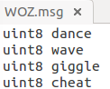

A service definition goes like, where the part above “---” defines service request while the part below defines the service response:
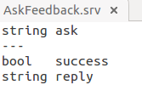

After adding new ROS message/service, developer has to check two files in Package_name.msgs directory. The CmakeLists.txt file has to include new message definition files as new building dependencies. Also check package.xml file to confirm it has three elements as:
<depend>geometry_msgs</depend>
<build_depend>message_generation</build_depend>
<exec_depend>message_runtime</exec_depend>
Then developer should run catkin_make command and the generated Python modules can be imported from “package_name.msgs.msg” and “package_name.msgs.srv”. The generated C++ headers are located in /devel/include directory.
Development environment setup and tool chain configuration.
Two IDEs has been set up to facilitate this project. They are recommended for the further development.
For C++ development: Eclipse v3.8.1 + CDT
To set up, check the literature review section above. Besides that, following steps are needed.
1. The Eclipse project has to be converted to a C++ project.
2. In project->properties->C/C++ General->Preprocessor Includes->Providers, enable language settings providers for this project
3. Enable the following
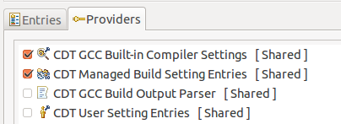

4. In project->properties->C/C++ General->Path and Symbols, make sure GNU C++ Includes tab has ROS installation directory and devel/include directory. For example:
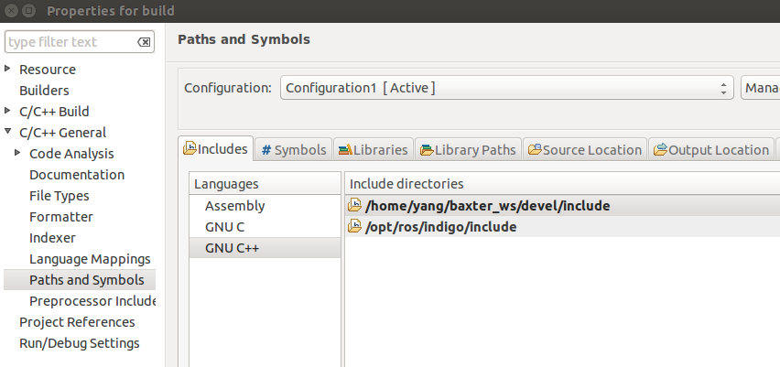

For Python development: PyCharm Community 2017
To set up, check the literature review section above. Besides that, following steps are needed.
1. go to settings->Project:scripts->Project Interpreter
2. in the drop down menu, choose “Show All”
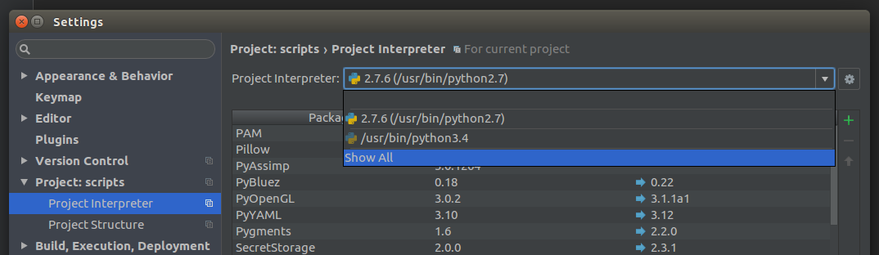
3. choose Python 2.7 interpreter and click “show pathes for selected interpreter” on the right.
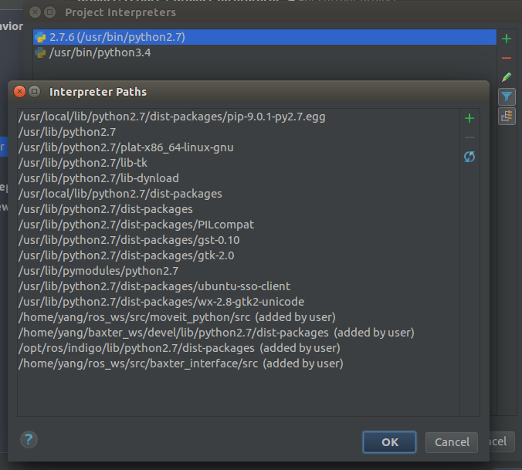

4. add at least “/opt/ros/indigo/lib/python2.7/dist-packages” and “CATKIN_WORKSPACE/devel/lib/python2.7/dist-packages”. They are the ros specific Python modules and catkin generated Python modules.
Other tools like GIT GUI are of personal choice. Eclipse and PyCharm both have plugins to have build-in GIT GUI. I used SmartGit but future developer are free to make their choice.
Simulation system setup
There are two popular simulator in ROS community: Gazebo and RVIZ. To be precise, Gazebo is a visualiser and physical simulator while RVIZ is just the visualiser. Gazebo is a quicker and safer way to test code without real robot. There will not be no competition for the robot among developers and jobs can be done at home.
Rethink provides a Baxter simulator package including the robot simulator, the robot mesh for visual display and the URDF model. The URDF definitions are provided in the form of .xacro files, which are assembled at compile time to make a single baxter.urdf file for simulation.
To start a basic simulation environment, user need to:
1. Load URDF descriptions into parameter server
2. Load the an empty world in Gazebo with empty_world.launch
3. Optional, publish a static transform from the world to the base of the robot in the robot is not at the origin of the world frame. The base of Baxter is used as the origin when Cartesian coordinates are used for robot control in this project. For instance, anywhere below Baxter base point would have a negative Z value. In case that the coordinates in World frame are desired, the static transform has to be published to let Baxter figure out the final position in its base reference frame.
4. Run a python script to the send a service call to gazebo_ros to spawn a URDF robot.
5. Launch the Baxter controller simulator to present baxter interface for user code.
All of the steps above can be placed in a launch script file to automate the process and it will be explained in the next section.
It's possible to create primitive shapes or load another URDF model in the loaded Gazebo world. Each URDF model contains the visual model and collision model. Anything in the world with collision model are touchable by robot and interacts with other objects. There are many to learn in the URDF topic along and I won't elaborate here as it's less relevant to this project.
Once we are happy with the world we build, the current world can be saved in Gazebo into a SDF file. It's worth to mention that URDF can't be used to save the world as each link in this format has up to 1 parent and don't support loop structure. SDF doesn't have these problem. However, SDF is too complex to manage without Gazebo, I would suggest to load multiple URDFs into Gazebo for simple project like this.
RVIZ is the native visualisation tool for ROS and its utilised as the visualiser for MoveIt package. If physical factors and complex environment objects don't matter, RVIZ is easier and better choice over Gazebo.
To make MoveIt, RVIZ and Gazebo work together, a timed launch script is needed. I would add one to the attachment of this report.
Launch files system
The launch script system provides an automatic way to start multiple ROS nodes in one terminal. It's also the place to:
1. Rename a node in the ROS master
2. Remap a topic in the ROS master
3. Load parameters to parameter server
4. Calling another launch script and pass in arguments.
The main launch script for this project is called tictactoe.launch. Call it by typing “rosrun baxter_tictactoe tictactoe.launch”, then the ROS tool would look into the /launch directory in the package for the launch file. This script would call board_sensor.launch to start any nodes specified in that file, and then load parameters in parameter server, and then start other nodes in turn. After running this script, these nodes should be running:
1. usb_cam
2. board_state_sensor
3. baxterDisplay
4. game_view
5. camera_view
6. tictactoe_brain
7. animator
8. soundplay_node
They can be confirmed with “rosnode list” tool.
Integration of additional ROS packages
Look at the list of nodes above, the baxterDisplay, tictactoe_brain and board_state_sensor come from the core source code of the tictactoe package. To make Baxter speak, listen, seeing and showing animated expressions, additional package from third parties have to cooperate with tictactoe to make things happen. In fact, the tictactoe core are written in C++ while some package, for example animator, are written in Python. They typically run in separate processes and the ROS system has to facilitate the communications between nodes. There are three way to do so: bare ROS message/topics, ROS server and ROS Action Server.
The animator uses the bare ROS message. It listens to /emotion topic for expression command and sending particular image set to /robot/xdisplay as ROS image message. It also publish its internal counter on /confusion/value/state topic and in expression state on /confusion/emotion/state topic. The tictactoe_brain node simple send command to the /emotion topic without testing the internal state and counter. Further development is needed to synchronise the body gestures with expression animation based on its internal counter.
The sound_play node provides two way of communication: bare message and simple action server. This node listens to /robotsound topic for command. It also present an action server named as “sound_play”. The tictactoe node calls to a wrapper function based on the message mode and simply wait a fixed amount of time allowing the speech to complete. Further development is need to use the simple action server and synchronise the speech with other Baxter actions.
There is a usb camera needed by tictactoe core. A usb_cam node is created to send ROS images to /usb_cam/image_raw topic. Board_state_sensor node listent to this topic to obtain chessboard image.
Check the “anatomy of the project” section for more details.
Changes to original Tictactoe
Fixed bugs in original code:
1. Fixed a build target conflict for gtest in Cmakefile.
2. Fixed a bug that the code trying to lock “_mutex_brain”, which is a pthread mutex, before its initialisation in the tictactoeBrain class constructor. This bug causes the tictactoeBrain node to stop in it's constructor on a random basis. Quote: “If mutex does not refer to an initialized mutex object, the behavior of pthread_mutex_lock(), pthread_mutex_trylock(), and pthread_mutex_unlock() is undefined”.
More details can be found here: http://pubs.opengroup.org/onlinepubs/9699919799/functions/pthread_mutex_lock.html
Added tools
1. Added a Python script to record joints states and gripper states in text file. It's called waypoint_recorder.py in baxter_example package. Press navigate button on left arm to record a way-point. Press cuff button to close and open gripper. Easy to change control to right arm.
Changes to original code
1. Changed the game to let user make the first move.
2. Added ROS timer to say something inviting user to play.
3. Make Baxter wait until table is cleaned and restart the game
4. Change the number of game in each Match to 1, easy to set the number in tictactoe.launch now.
5. Added new Brain state and make board_state_sensor work with new state.
6. Added emotion control to the tictactoeBrain.
7. Modified launch file and baxterDisplay to display the dynamic game state on ROS PC instead of baxter head screen
8. Added non-blocking gesture replaying for both arms. The joint way points has been hard coded at the beginning of TTTController.cpp file.
9. Make Baxter using right arm to play instead of left.
10. Make Baxter picking and dropping tokens from storage cells instead of a stack of tokens. The dropping function is currently unused.
11. Added table cleaning function, but disable currently due to the poor precision of pick action.
12. Added WOZ control to tictactoeBrain. See the section below for details.

Wizard of OZ remote control GUI
WOZ control was built on top of ROS topics instead of ROS service to achieve a non-blocking behaviour. I created a user message type called WOZ in baxter_collaboration package and registered 2 topics called “woz_st” and “woz_cmd”. TictactoeBrain listens to the woz_cmd topic for instructions to update its internal control status. It also publishes the internal status on “woz_st” topic periodically.
The WOZ client GUI was implemented as a Python script with Tkinter library support. The GUI runs in a separate node and listens to “woz_st” to update its internal statue. The internal status are displayed in the GUI. The GUI composes a a WOZ message based on it's internals status and user action, then publishes to the “woz_cmd” topic.
Current settings and the expectations
The current code has board cleaning function disabled due to poor precisions on pick up action. There are some code left in the legacy mode in original Baxter tictactoe package but don't use them. First of all, it's written for suction cup while we use finger gripper. Second, I've talked to the author of the package and was advised of the unreliability in the algorithm. I'll put suggestions in the discussion.
The tictactoe repository also comes with a package called ros_speech2text. It provides the voice recognition support for Baxter. It's unused in the project but would be useful if voice instruction is desired for Baxter.
Voice invitation from Baxter has been implemented but disabled.
The current social actions including arm gestures, voice and animations are not synchronised. It's possible to know the current animation frame by polling the /confusion/value/state topic. It's also possible to know the current status of gesture action by polling the internal “state” member of the RosInterface class. The author of Tictactoe package and I have agreed an ROS action server would be better idea to do the job. Once they've convert the arm action service into an action server, we should merge it into our code.

Analysis and Discussion
The anatomy of the project
This project is based on the Baxter_tictactoe package from ScazLab of Yale university. It's important to understand their software stack structure.
The core of the package is the tictactoeBrain node. It contains the game state machine and two instances of ttt_controller member class to communicate with Baxter interface. The relationship among some key classes in the stack are shown below.
Both tictactoeBrain and ttt_controller class are basically ROSThread, which added common ROS features to a POSIX thread or pthread for short. The internal thread function starts when “startInternalThread()” is called on it. The game state machine is implemented as the internalThreadEntryFunc in the tictactoeBrain class.
Each tictactoeBrain instance has two TTTController members for left and right arms. TTTController implements tictactoe specific arm actions and helper functions. The TTTController class has a parent called ArmCtrl, which manages the actions implemented in TTTController and presents them as ROS services. It's also implements the internal thread function for arm controller. Besides ROSThread, ArmCtrl class has another parent called RobotInterface. As ReThink doesn't provide Baxter interface APIs for roscpp, this class is written to facilitate the message communications between C++ code and node groups running in Baxter. It's basically the equivalent of BaxterInterface in Python.
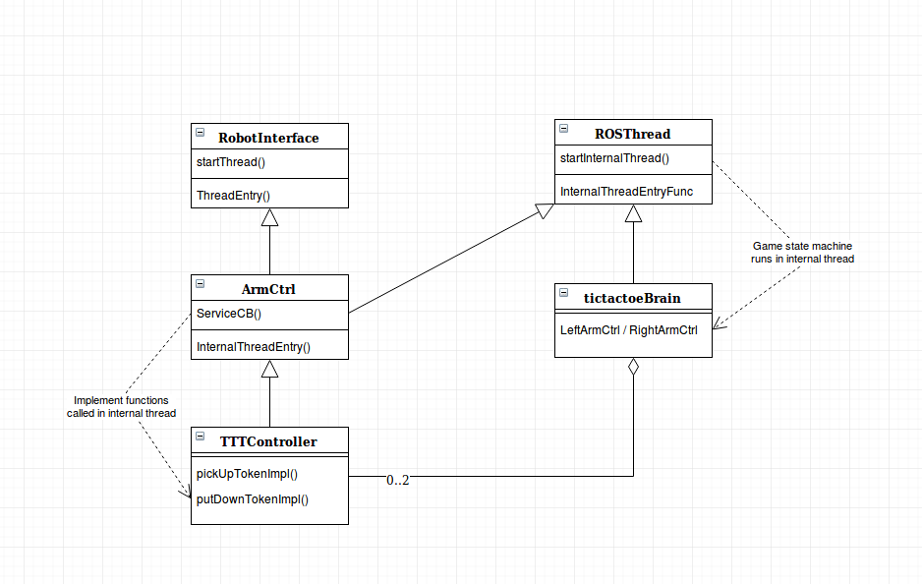
Look at the diagram showing the big picture of the project below. The software system is basically a group of interoperating threads known as ROS nodes. The cubes represent the nodes, and rectangles represent topics. The arrows denotes the direction of message flow.

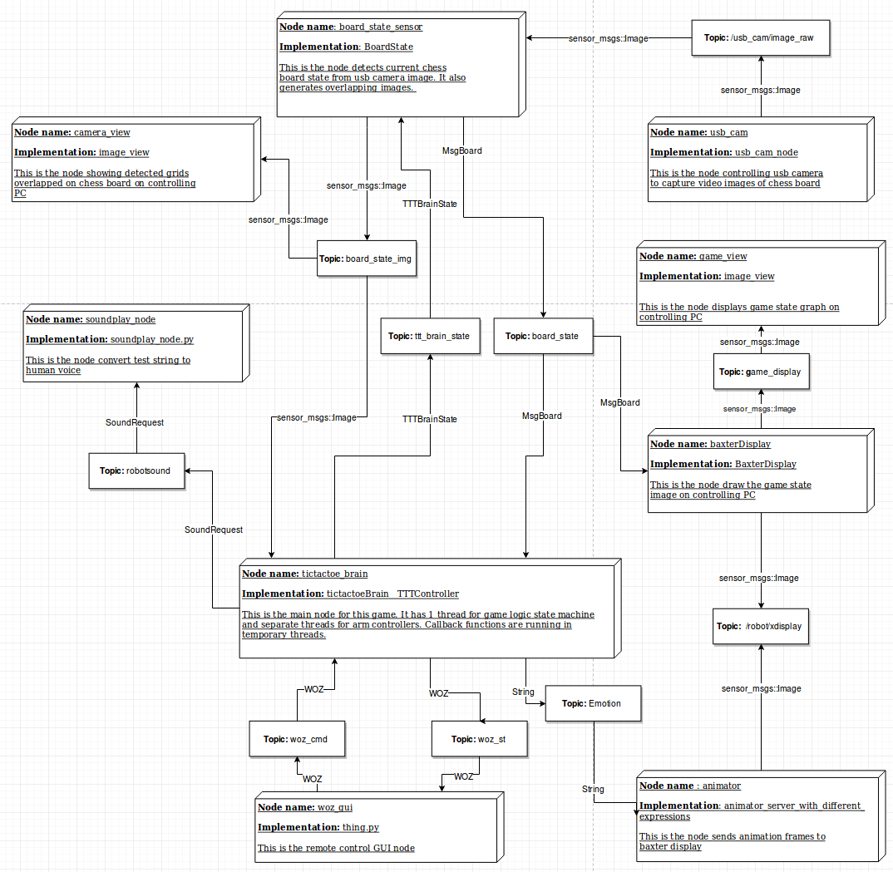
The problem of IK and discussion
IK is an algorithm used to find the joint states given the start and goal position. There is no guarantee a call to computeIK() would return a valid joint motion within limited attempts and time. It's also impossible to find a joint motion if the goal pose is out of reachable region. So it's a good idea to check the reach-ability and plan error recovery action when deal with IK. Even if a pose is reachable, there still are two facts about IK needed to be considered.
1. The IK allows certain amount of positional error in each computation. The resulted gripper position may not be exactly the goal position.
2. The IK is lazy, it always choose the motion with less joint rotation effort.
This two points together creates a problem during pick up action. After hovering the gripper above the target token, the code tells Baxter to lower it's arm straight down in a loop until IR sensor says it's low enough. It works well where token is located in a “comfortable zone” for Baxter. That means not to far neither too close to Baxter. As the token getting closer to the Baxter body, the arm doesn't go down straight, instead the gripper is pointed towards the Baxter body. The reason is that the computeIK() function is called 100 times per second and the gripper goes down only few millimetres in each step. Large number of errors could be allowed in this process. As bending towards Baxter body results in less joint rotation effort, IK always prefers it. So the errors can't cancel each other and accumulates. The phenomenon is not noticeable when joints don't need to work hard to reach the goal pose or the moving distance of each step is large. However it would result in drift if the position is hard to reach and each step is tiny.
Check the issue I raised and following discussion on GitHub: https://github.com/ScazLab/baxter_tictactoe/issues/23
The thread competition issue in the GUI development
This issue arises as Tkinter was chosen to provide GUI support in Python. There has to be two long running threads in GUI application: the mainloop of Tkinter and the rosSpin of rospy. The mainloop handles the scheduled GUI events and user triggered callbacks. The rosSpin handles the ROS message queue and callbacks. It natural to assume the GUI callbacks should be called from ROS callback when message received in the queue. However the Tkinter doesn't like this idea even if it's said to be thread safe. It's actually thread safe by preventing user changing any internal GUI states from another thread.
Solution 1: Swap Tkinter with mtTkinter, which supports mulit-threading access. The pre-existing GUI code has to be rewritten to suit the new framework.
Solution 2: Make the two threads work in an asynchronous way and facilitate the inter-thread communication through a thread safe data container. I used Python Queue, which is designed to be thread safe, as the data container. A new state change request is added to the queue by ROS subscriber callback functions from rosSpin thread. The mainloop thread keeps polling the queue and consume any element in the queue once it's available.
There is no issue with ROS publisher.
The communications between tictactoe brain and WOZ GUI
The team wanted a synchronous inter-operation between WOZ GUI and tictactoeBrain initially. The subscriber callback in tictactoeBrain should update the internal states once a new WOZ message received at woz_cmd topic. I soon realised this idea could be dangerous since the control change could happen in any Brain state and even in the middle of this action. It could easily break the integrity of internal state machine. Since then the design was changed to be asynchronous. The WOZ callback updates the WOZ control state whenever it's called. The tictactoeBrain poll and change these WOZ states only when it has to. The WOZ state in tictactoeBrain is published periodically and the WOZ GUI should listen to woz_st topic to determine the real state in brain node.
The gesture playback and thread blocking issue
We want to make gestures with both arms of Baxter. However the original arm control is provided as a ROS service in ArmCtrl class. A ROS service is blocking by definition that a call to a ROS service will return when a the requested action is done. That means we have to move one arm after another with ROS service.
It's worth to note that Baxter SDK expect to receive joint control command 5 times per second, otherwise SDK will exit joint control mode and the joints will stay where they are. So it's impossible to send a single command to Baxter in service callback function and return.
What I did is a temporary patch up to make the request to server return ASAP by making the service callback function return ASAP. It's not non-blocking but quite close. The user code checks the internal controller state in RobotInterface class later to determine the current state of the service and joins worker threads. My fix is definitely undesirable and only works where arm controller and tictactoeBrain are running in the same node.
The author of tictactoe package agree with me that an action server is the better way to go in the future. The change need to be merged into our code once they are available.
Check this issue to follow the discussion:
https://github.com/ScazLab/baxter_tictactoe/issues/24

The lesson I learn from the bug in the original code about mutex locking.
There is a tricky bug in the original code. After the very first run in the terminal, the tictactoeBrain node randomly gets stuck in its the constructor and the process doesn't exit gracefully after Ctrl-c is pressed.
The problem is that the "setBrainState()" function tries to lock "_mutex_brain", which is a pthread mutex, in the class constructor before it's properly initialized.
The pthread document reads as "If mutex does not refer to an initialized mutex object, the behavior of pthread_mutex_lock(), pthread_mutex_trylock(), and pthread_mutex_unlock() is undefined." ²
Since the undefined behaviour, the lock to an uninitiated mutex could succeed, but it may break the internal state in mutex destruction. As mutex is just a reference to the mutex object in memory, the mutex destruction would not destroy the mutex object, but restore it to uninitiated state and it will be reused when the application is launched in the same terminal next time. Then suddenly the mutex can't be locked again due to improper destruction and the node is frozen and won't respond to Ctrl-C.
Quote: “The pthread_mutex_destroy() function shall destroy the mutex object referenced by mutex; the mutex object becomes, in effect, uninitialized. An implementation may cause pthread_mutex_destroy() to set the object referenced by mutex to an invalid value. A destroyed mutex object can be reinitialized using pthread_mutex_init(); the results of otherwise referencing the object after it has been destroyed are undefined. ”³
The lesson is never try to lock a mutex before initialisation. Even if there is no problem in the first place, it could cause problem down the stream as mutex object will be reused.
The fine adjustment by hand camera
The cells in the chessboard and storage pool are larger than tokens, so the token moves slightly in x-y plane. The playing table is prone to move during the game to make the total token offset considerable.
In the original code, there are some deprecated code to adjust the gripper position in x-y plane to match the poistion of target token. It uses the image from Baxter hand camera to figure out where the token is. From the conversation I had with the package author, I think there are two reasons not to use their legacy code.
1. Their code work 85% of the time.
2. They uses suction cup as end effector, which blocks the camera view at the centre of token. That stops them using the white “O” or “X” to find the centre of token. Instead, they look for the pixels with either maximum or minimum x-y value to reconstruct the rectangle containing the token. This method is sensitive to the noise in image processing.
I've created a small project to find an alternative algorithm detecting the centre of token. It basically tries to find the white pixels in the blue rectangle. Then the centre of mass of the “X” is treated as the centre of token. The number of pixels between the estimated centre and the gripper centre could be used to estimate the actual token offset in the x-y plane. The images below illustrate the estimated centre of token and the offset.
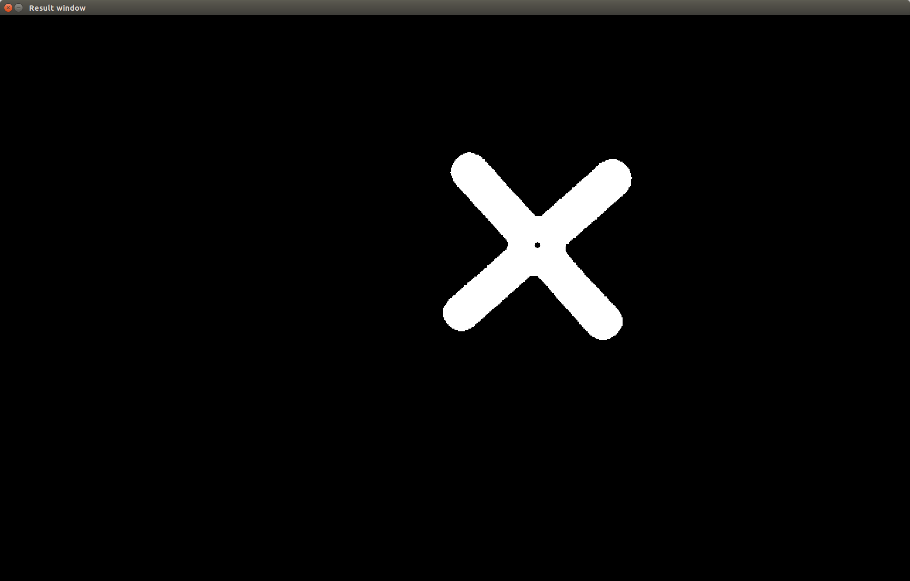
This is the “X” detected in image and the black dot denotes the centre of mass

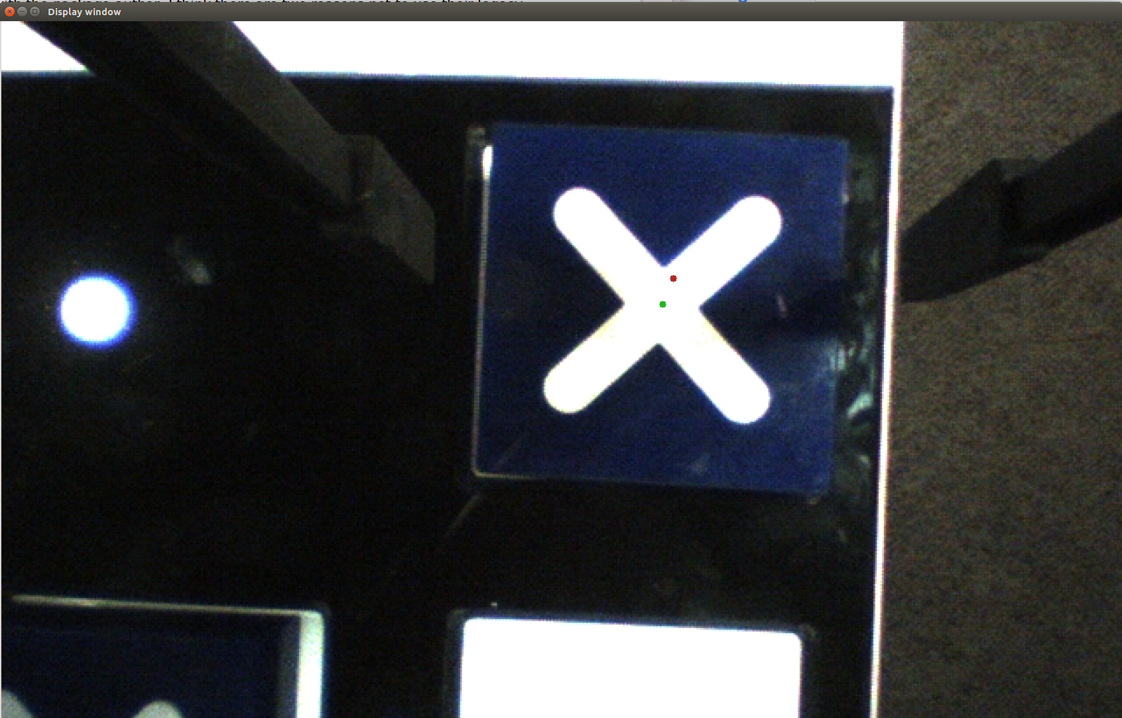
The green dot is the estimated centre of token. The red dot is the estimated gripper centre. The offset in this image is 42 pixels. The code will be submitted with this report.

Conclusion
The first stage of this project has been concluded by the show in Questacon. On this stage, we've verified and updated the software structure in the original package. The stack structure and node organisation works well in our experiment. We also built and tested the development tools, which can be reused for the future work. All of these provide a sound ground to build more advanced features on.
Whilst the show has been considered successful, there were some compromises being made to ensure the robust performance. The show also largely depends on on-site calibration and prone to changes in the environment, including lighting condition and drift in the relative position. On the next stage, the software needs to be able to sense more changes in its environment and being more adaptive.

References
1. GITHUB repository of Baxter-Tictactoe from ScazLab, Yale University, USA: “https://github.com/ScazLab/baxter_tictactoe/graphs/contributors”

2. The Open Group Base Specifications Issue 7
IEEE Std 1003.1-2008, 2016 Edition http://pubs.opengroup.org/onlinepubs/9699919799/functions/pthread_mutex_lock.html
3. The Open Group Base Specifications Issue 7
IEEE Std 1003.1-2008, 2016 Edition
http://pubs.opengroup.org/onlinepubs/9699919799/functions/pthread_mutex_destroy.html

Attachment list
1. Complete workspace containing the test project for token centre estimation
2. Launch files for gazebo and moveit as example.

