The Impact of Wolf Reintroduction on Aspen Population (2019-2021)

Context
Alex, a former grad student, studied whether wolf reintroduction helped aspen trees recover by reducing elk grazing. Alex graduated two years ago. We need to reproduce their main bar chart for a presentation. Here is their project folder.
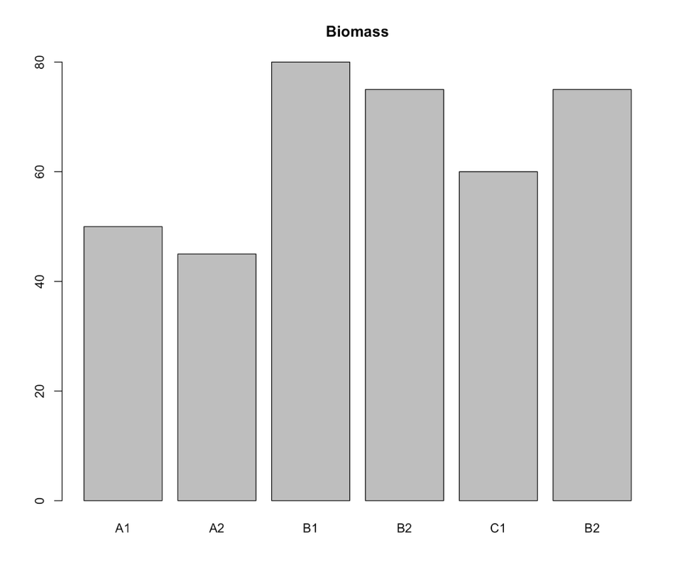

Project file structure
Project_aspen_wolf
├── analysis.R
├── data_2019.csv
├── data_2020_new.csv
├── data_combined_FINAL_v2.csv
├── data_combined_FINAL.csv
├── Figure 1.png
├── IMG_0023.JPG
├── keys.qmd
├── manuscript_draft_v4.docx
├── Old stuff
│ ├── backup_data.xlsx
│ └── test-analysis.R
├── project_aspen_wolf.Rproj
├── raw_data.csv
├── README.md
└── S0378112725004499.bib

Prompts
- Restructure:
  - Improve the directory structure
  - Apply a consistent naming convention
  - Should we delete data_clean.csv or archive it?
- Update the R Script as needed
- Document:
  - Update the README.txt to explain the new file structure
  - Improve the metadata by adding a data dictionary
- Bonus: Any thoughts on the data model itself?

Hints for README

File structure info
- Project Name: [e.g., Trophic Cascades in Aspen Recovery
- Data Collector(s): [Name, Email, ORCID]
- Date of Collection: [YYYY-MM-DD to YYYY-MM-DD]
- Location: [Site Name, Lat/Long, or Bounding Box]
- License/Usage: [e.g., Creative Commons CC0]

File Naming Convention
e.g., site_date_description.csv

Data Dictionary
Variable Name | Description | Units | Data Type | Accepted Values / Range | Missing Data Code
site | Unique identifier for the study plot
date
height_cm
biomass_g | Total above-ground biomass | Grams | Numeric | > 0 | NA
notes | Field observations |  |  | Free text

References
- Changing aspen stand structure following large carnivore restoration in Yellowstone, https://doi.org/10.1016/j.foreco.2025.122941
- Return of wolves to Yellowstone has led to a surge in aspen trees unseen for 80 years https://www.livescience.com/animals/land-mammals/return-of-wolves-to-yellowstone-has-led-to-a-surge-in-aspen-trees-unseen-for-80-years

