**CSE 125 Lab 2: Finite State Machines**

**Date: 04/21/2020**

**Name: Zhongming Liao, Chuanshi Zhu**

**Lab Group: 20**

1. **Regular Expression Checker**
2. FSM

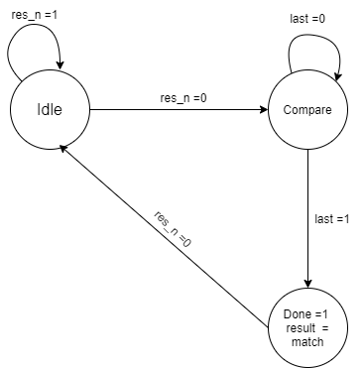

Figure 1. main running of FSM

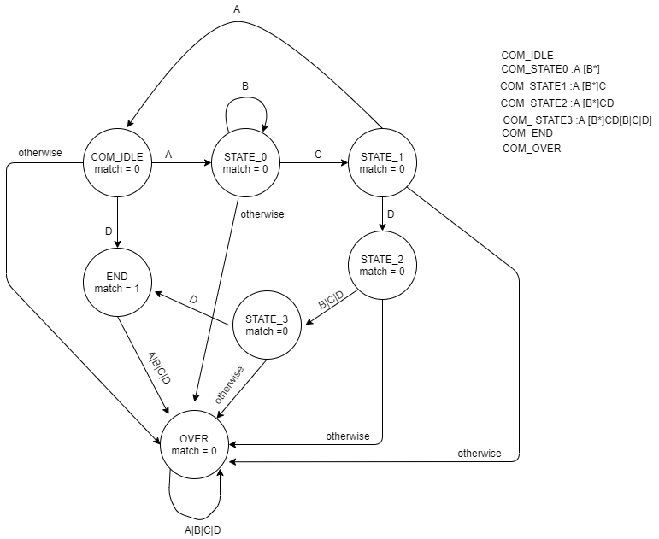

Figure 2. signal comparing of FSM

1. 7 clock cycles screenshot

Figure 3. 7 clock cycles for input ABCDD

1. Synthesis result

Figure 4. Synthesis result

Figure 5. Design Timing summary

Figure 6. clock summary

As we see, the Design Timing summary, WNS = 8.551ns, so

$FMAX = 1/(T-WNS)= 1/(20ns -8.551ns) =0.08734×{10}^{9}Hz$

$FMAX=87.34MHz$

1. **Timing**
2. Identify the critical path

The critical paths :

G1->R1->G2->G4->R2

G1->R1->G3->G4->R2

1. Maximum clock rate

Max clock period = min delay in gates + min delay in clock pulse + setup time

= 3*70ps + 2*30ps + 2*35ps + 40ps

= 415ps

max clk freq = 1/period = 1/415ps = $2.4×{10}^{9}Hz$

=2.4GHz

1. Register hold times

The register hold times couldn’t be violated, since

Propagation min delay + Clk-to-Q min delay > Hold Time;

each register input is previous gate output, and propagation min delay + Clk-to-Q min delay is bigger than hold time delay which 30ps + 70ps > 35ps