|  |  |  |
| --- | --- | --- |
| Part# | # | Purchasing links |
| Deans Style Connectors | 1x | <https://www.servocity.com/html/ultra_connectors.html> |
| Wired Tamiya Connectors | 2x | <https://www.servocity.com/html/tamiya_connector.html> |
| B.E.C Connectors | 1x | <https://www.servocity.com/html/b_e_c__connectors.html> |
| Servo Connectors | 1x | <https://www.servocity.com/html/servo_connectors___pins.html> |
| 50ft. Super-Duty Twisted Servo Wired | 1x | <https://www.servocity.com/html/servo_wire__bulk_.html> |
| 12v to 3v 3A Converter | 1x | <http://www.ebay.com/itm/12V-To-3-7V-3A-11W-DC-DC-Buck-Converter-Step-Down-Car-Power-Supply-Module-/151106856831?pt=US_Power_Inverters_&hash=item232eaba77f> |
| 2 Function Joystick | 2x | http://www.servocity.com/html/2_function_joystick__ball_stic.html#.U9Ar2ZUg9rQ |
| Arduino | 1x | <http://www.amazon.com/Arduino-UNO-board-DIP-ATmega328P/dp/B006H06TVG/ref=sr_1_1?ie=UTF8&qid=1409342160&sr=8-1&keywords=arduino+uno> |
| R3 Arduino Motor Shield | 1x | http://www.amazon.com/Arduino-Motor-Shield-R3/dp/B006UTE70E/ref=sr_1_1?ie=UTF8&qid=1406659499&sr=8-1&keywords=arduino+uno+motor+shield |
| E-Bro Adjustable Voltage Regulator | 1x | <http://www.amazon.com/E-Bro-Adjustable-Regulator-Experimental-Converter/dp/B00KW6GT9I/ref=sr_1_10?ie=UTF8&qid=1408739859&sr=8-10&keywords=12+to+4v+regulator> |
| Perforated prototyping board | 1x | <http://www.radioshack.com/product/index.jsp?productId=2103804> |
| 50k Potentiometers | 1x | <http://www.radioshack.com/product/index.jsp?productId=2062355> |
| VGA Connectors | 2x | <http://www.mcmaster.com/#rca-jacks/=thsmde> |
| 10pin mini-USB Connector | 1x | http://www.readymaderc.com/store/index.php?main_page=product_info&products_id=2561 |

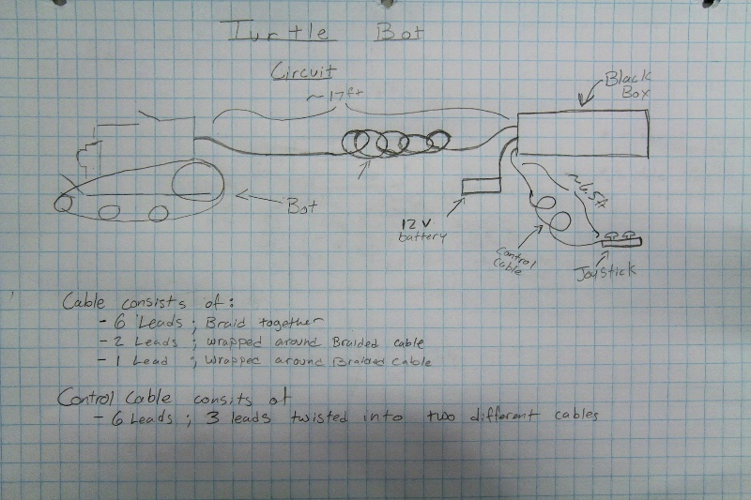

The basic overview of the System.

* Bot is tethered by 17ft. of wire and cable.
* A 12v Battery, or power, source is needed
* There is a 6.5ft cable that is used to control the bot via two 2-axis joystick.
* All of the electrical components are housed inside a “black box.”

The Bot:

* There is a hacked battery Terminal that we used to power the go pro throught the tether via B.E.C. Connect
* 10-pin mini-USB is used to hack into the gopro to get a live feed and it is delivered through an RCA connector.
* Motor A(leftside) has a female tamiya connection and Motor B(rightside) has a male connection in order to prevent confustion when plugging the bot into the tether.
* The L.E.D. has a servo connection to the cable.

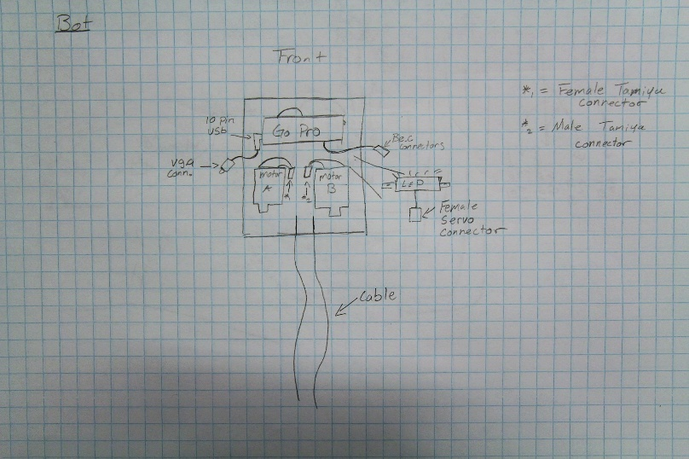

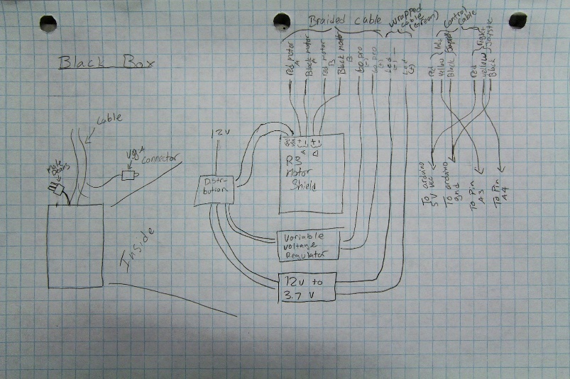

Within Black Box:

* Power
* The Arduino, Pre-loaded with Tank Drive code and R3 Motor control, is powered by 12v volts through a DC connectors.
* E-Board adjustable is given 12 volts that are screwed into the board. (Refer to setup)
* The 12v to 3.7v is given 12v via soldered wire
* Cable Locations
* Refer to Picture

Arduino Code:

The purpose of the Arduino code is to give operator control of speed and direction of the chain individually. Two potentiometers are connected to pins A3 and A4. They are power with 5V from the Arduino power pins. The rest of the pin assignments are based off of the specs for the R3Motor shield. (http://www.arduino.cc/en/Main/ArduinoMotorShieldR3)