- Place the lid on the chamber and press the interlock button
- Open new crylas software ("C:\Program Files (x86)\CB_Control_HP\CB_Control_HP.exe")
- Press “connect” at the top

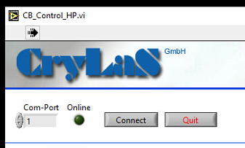

- Turn “Closed Loop Control” on
- Set trigger rate to 100Hz
- Turn laser “On’
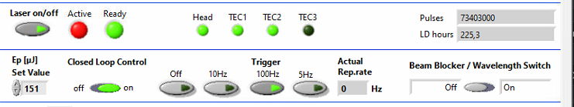
- Enable Photomanupulation in Calibration tab
- Turn on shutter
- Turn on Crylas 532nm laser
- Set laser to 20%
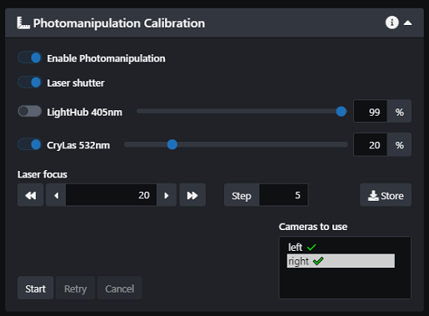
- Set camera to area mode
- Set exposure to 500ms
- Select BP580-627 filter
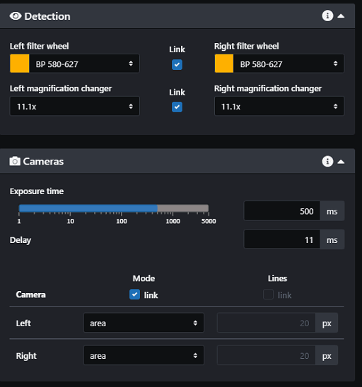\
- Go live
- Select right camera and begin calibration

