PickyRTL

Overview

Folder Structure

Running the Program

Parsing the File
To run detection on a file, you must first parse an HDL file into a JSON AST. First, start the program and use the arrow keys to select “Parse” and then press “Enter”.
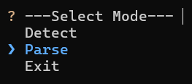
You will see the folder structure under the “Examples” directory, something similar to this:
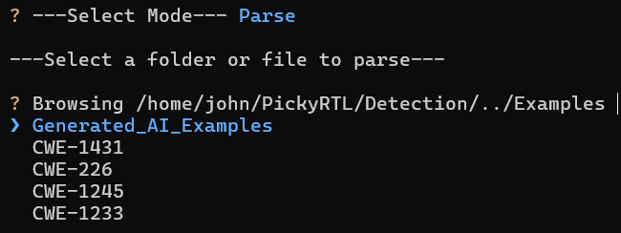
Then you can use the arrow keys to traverse the directories and select a file to parse.

Running Detection

Output Format and how to interpret

Capabilities

Limitations/Future Work

Creating an Example with AI

