

**Accessing the Research Computing Center Resources**

To connect to the midway compute cluster to access your home directory and the macs60000 storage space, and utilize the HPC resources, you will either use a terminal client (with or without X11 forwarding capabilities) or the Linux remote desktop server software client (Thinlinc) to connect to the midway cluster. To submit jobs, monitor jobs, browse directories or do other computing you will need to connect through either the terminal or remote desktop. Setup and utilization of these clients will be discussed below in the context of your local platform’s architecture.

# **SSH Client Setup & Remote Desktop Server**

**Macintosh/Linux User SSH Clients**

* Macintosh users will have a terminal client installed by default.

It is located in Applications à Utilities à Terminal.

Verify you can locate the terminal client and add it to your dock. You can easily locate the terminal from the LaunchPad icon located in your Dock. Click the LaunchPad icon and search “terminal”. Drag the terminal icon into your dock and close LaunchPad.

* Other client terminals for Mac exist, but will require the user to install them. For example the [iterm2](https://www.iterm2.com/) terminal client is an alternative option.
* Mac does not come with X11 server preinstalled. In order to be able to display remote graphical processes from the terminal client, you will need to install X11 server and client libraries, which can be downloaded from the [XQuartz](https://www.xquartz.org/) project page. If you would like to connect via ssh and be able to render graphics (e.g. use a GUI) with any programs you will need to install X11 server or alternatively use the remote desktop server ThinLinc client discussed below. NOTE: If users intend to use OpenGL applications, they should install the older 2.7.8 version of XQuartz

**Windows User SSH Clients**

Windows users should install [MobaXterm](http://mobaxterm.mobatek.net/) even if you have previously used Putty.

MobaXterm is a more full-featured terminal client that comes integrated with X11 server

to allow rendering graphics through X windows on a remote server. MobaXterm also has

an sftp tab built in to the client permitting ease of file transfer from remote to local machine. Follow the instructions below for installing the MobaXterm client on your

windows machine.

*MobaXterm Install for Windows users*

* Go to The MobaXterm site, and click either the **Download Tab** at the top or the **Get MobaXterm button** on the middle of the page to redirect to the Download page.
* Choose the Free Home Edition of MobaXterm.
* Download the MobaXterm Home (Installer edition) zip file.
* Extract the contents of the zip file by right clicking it and choosing **extract**.
* Locate the MobaXterm_installer.msi file and double click it to install.
* MobaXterm will now be accessible from your Startup menu.

**Remote Desktop Client: ThinLinc (Mac/Windows/Linux)**

[ThinLinc](https://www.cendio.com/) is a remote desktop server that can be used to connect to a remote compute cluster

to start a remote graphical user interface or other graphical display. To use ThinLinc to connect to midway, one can either use their web browser or download and install the ThinLinc desktop client.

*Using web browser client*

* Point your browser to either:

http://midway.rcc.uchicago.edu (for midway)

http://midway2.rcc.uchicago.edu/ (for midway2)

* Proceed to login with your CNet_ID and password.

*Using desktop client*

Alternatively, you can install the client on your local machine.

* Download and install the ThinLinc client for your particular platform here:

<https://www.cendio.com/thinlinc/download>

* Open the ThinLinc client and use the following information to set up your connection for

Midway1 or Midway2.

Server: midway.rcc.uchicago.edu (for midway1)

Server: midway2.rcc.uchicago.edu (for midway2)

Username: CNetID

Password: CNetID password

**Connecting to RCC resources**.

To connect to the remote compute cluster, follow the procedure for your particular platform. Further details on connecting to RCC resources can be found in the [RCC User Guide](https://rcc.uchicago.edu/docs/connecting/).

**Mac/Linux users**

* Open your terminal client (drag to your dock for future ease of locating).
* If you have XQuartz installed, you can start an –X11 enabled ssh session to midway:

ssh –Y CNetID@midway.rcc.uchicago.edu (for midway logins)

ssh –Y CNetID@midway.rcc.uchicago.edu (for midway2 logins)

* Alternatively, you can connect without X11 enabled ssh:

ssh CNetID@midway.rcc.uchicago.edu (for midway logins)

ssh CNetID@midway2.rcc.uchicago.edu (for midway2 logins)

**Windows users**

* Open your terminal client (MobaXterm) and click on the Sessions icon at upper left hand corner of the client.
* Then perform the following numbered steps, illustrated in the figure below.

1. Click the SSH tab to expand the SSH login options.
2. In the **Remote host** field input either:

**midway.rcc.uchicago.edu** (to connect to midway cluster)

**midway2.rcc.uchicago.edu** (to connect to midway2 cluster)

1. Select the **Specify username** button and input your CNetID (e.g. butcher)
2. Proceed to login by clicking the **OK** button.

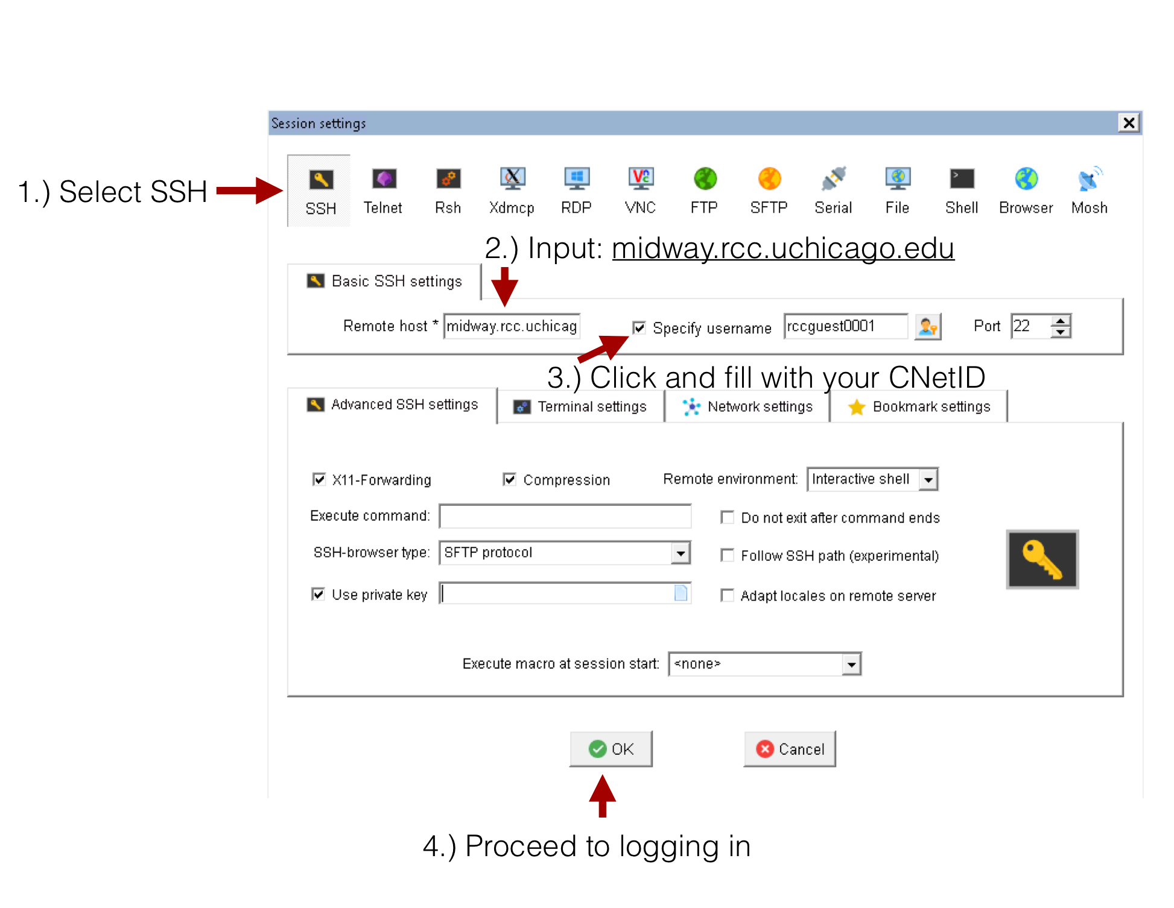

# **Data Storage Partitions and Allocations on Midway**

**Storage Spaces (home, project2, and scratch)**

* Upon connecting to midway, you will land in your home directory. Your home folder has a 30GB quota. If you exceed this quota you will be unable to write any new files to your home until you fall below the quota. For reading/writing/storing larger amounts of data you can either use the class’s project folder or your scratch folder, both discussed next.
* The class has a project folder with a 500 GB quota. This is a shared space amongst all students in the macs6000 course. To access this shared space simply change directory to it.

cd /project2/macs6000

* Each user also has their own scratch space with a 100GB soft limit and a 5TB hard limit. A user can go over the 100GB soft limit, but they can not exceed the 5TB hard limit. When a user exceeds the 100GB soft limit they are given 30 days to fall below the soft limit. If they do not fall back below the soft limit within 30 days they will be unable to write to their scratch folder until they do so. To access your scratch space, use the environment variable $SCRATCH

cd $SCRATCH

* To check your current storage utilization on midway, you can issue the quota command from the command line:

quota

**Service Unit (SU) Allocation**

* The macs6000 course has been provisioned an allocation of service units (SUs).
* To check your current balance of compute hours, use the following command:

accounts balance

* Service Units are charged differently depending on the partition that is used on midway. See the following page for an explanation of how service units are charged:

<https://rcc.uchicago.edu/getting-started/calculations-service-units>

* There are several communal compute partitions on midway. The two main partitions are the ‘sandyb’ and ‘broadwl’ partitions. Both partitions are named after the microarchitecture of the compute nodes (sandybridge and broadwell). The sandybridge partition is part of the older midway1 cluster and the broadwl partition is part of the midway2 cluster. There are other partitions for GPU resources (gpu, gpu2) or for large memory jobs (bigmem, bigmem2). To learn more about the partitions see the [RCC User Guide on compute resources](https://rcc.uchicago.edu/docs/using-midway/#types-of-compute-nodes).

**Transferring files into the shared space**

On **MAC** or **Linux** computers using the terminal run the following commands, replace CNetID with you Uchicago user name:

To copy a file from your local computer to your home directory on midway:

scp local_file CNetID@midway.rcc.uchicago.edu:~/

To copy a directory from your local computer to your home directory on midway:

scp local_folder -r CNetID@midway.rcc.uchicago.edu:~/

To copy a file from your home directory on midway to your local computer:

scp CNetID@midway.rcc.uchicago.edu:~/file /local_directory_path

To copy a folder from your home directory on midway to your local computer:

scp -r CNetIDXXXX@midway.rcc.uchicago.edu:~/folder /local_directory_path

On **Windows**, **MAC**, or **Linux** you can use also a GUI-based client tool such as [FileZilla](https://filezilla-project.org/) or [Cyberduck](https://cyberduck.io/?l=en). Make sure when connecting, that you specify the location of the private ssh-key. MobaXterm has an sftp panel that allows you to drag and drop files between the remote server and your local machine. Note: Windows users that are using the MobaXterm client have an sftp tab already built into the client that allows them to drag and drop files.

### **The configuration for FileZilla (available for MAC, Linux, and Windows) is provided below and illustrated in the figure that follows.**

* Host: midway.rcc.uchicago.edu
* Username: <CNet_ID>
* Port: 22
* Provide your passowrd in the Password field and then connect.

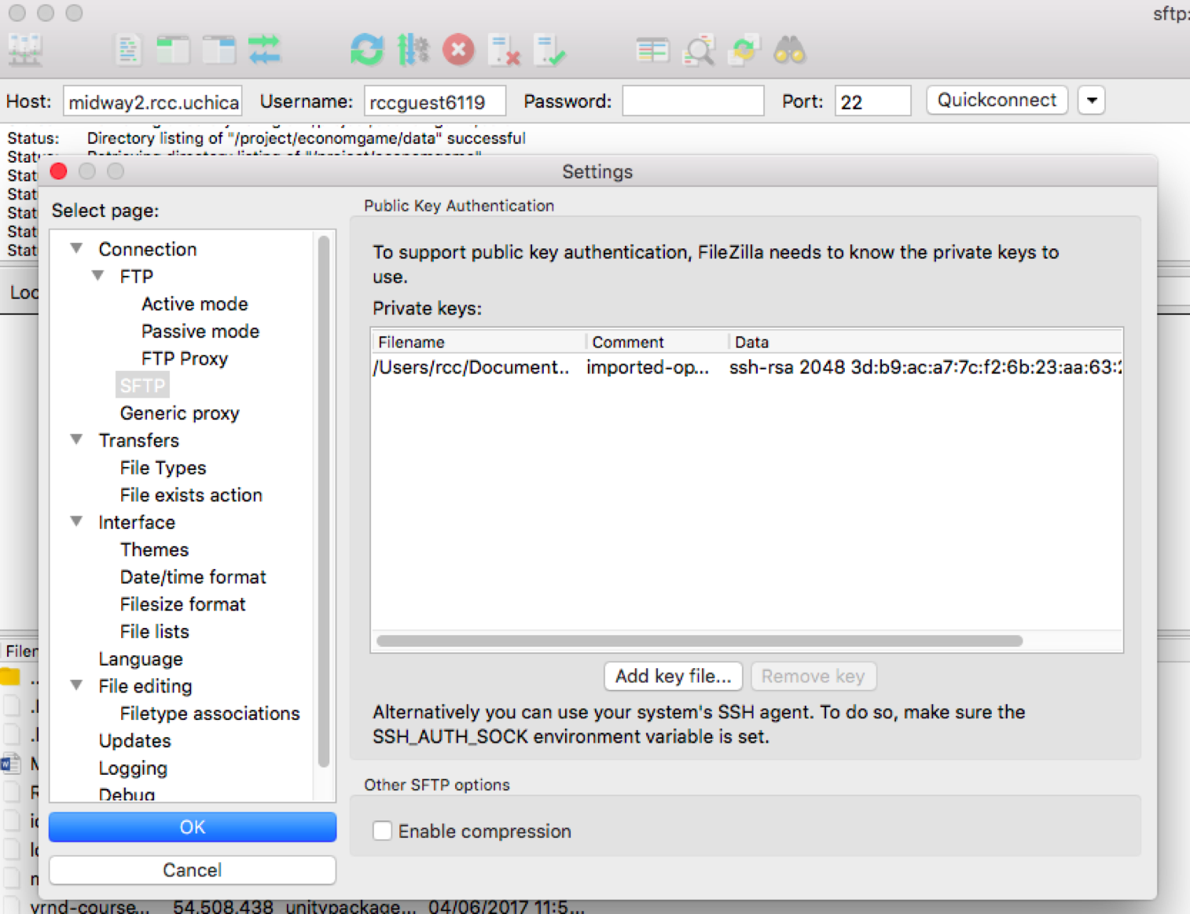

More information about data transfer on Midway can be found [here](https://rcc.uchicago.edu/docs/data-transfer/index.html).

**Overview of the Module System**

Software on midway is managed by a module system. In order to use a particular software package you need to load the corresponding module. See [here](https://rcc.uchicago.edu/docs/software/modules) a full list of the software modules available on the RCC cluster. Note that presently that the Midway1 and Midway2 have two separate software module systems. Sometimes you may find that a particular package is installed in the Midway1 module system, but not in the Midway2 module system. You need to be mindful of whether you are logging in to Midway1 logins (midway-login1 or midway-login2) or the Midway2 cluster (midway2-login1 or midway2-login2).

Show the list of the modules you currently have loaded:

module list

To show the list of all available software modules (will show every version of software installed on midway):

module avail

A common programming language used on midway is python. The system path python (python 2.6.6) does not have any additional python packages installed like numpy, scipy, etc. To use python you should load the appropriate python module (there are many in the module system). To show the list of all available modules for a specific software you are interested (e.g., python):

module avail python

Show more information about a specific software package:

module show python/3.5.2+intel-16.0

Load a specific software package version into your environment:

module load python/3.5.2+intel-16.0

Unload a specific software package version into your environment:

module unload python/3.5.2+intel-16.0