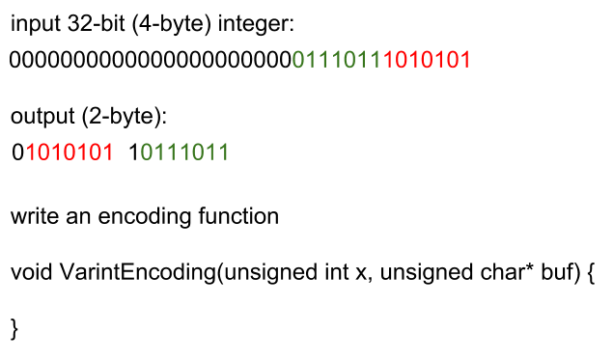

void VarintEncoding(unsigned int x, unsigned char *buf) {

int num_bits_in_int = 8 * sizeof(int); // 32

int i_x_iter_max = ceiling(num_bits_in_int / 7); // ceiling(4.5) == 5

int i_buf_highest_order = 0;

int i_buf_out = 0;

int i_x_iter = 0;

for (int i_x_iter = 0 ; i_x_iter < i_x_iter_max ; i_x_iter++) {

int x_sub_curr = (x >> (i_x_iter*7)) & 127;

int x_sub_rest = (x >> (i_x_iter*7));

// break condition

if (x_sub_rest == 0) break;

buf[i_buf_out] = x_sub_curr | (i_buf_highest_order << 7);

i_buf_highest_order = i_buf_highest_order == 0 ? 1 : 0;

}