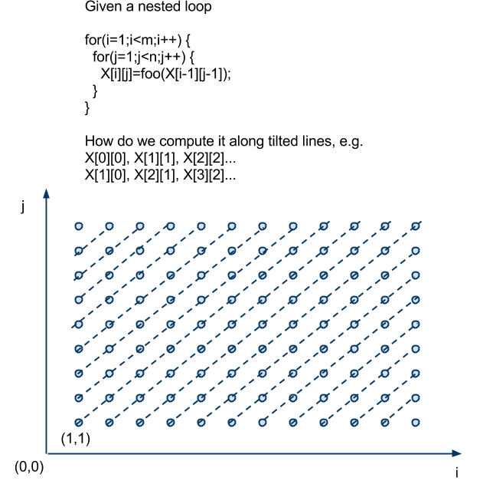

int v_start = 1;

X[0][0] = v_start;

// go along i-axis

for (int i_start = 1 ; i_start < m ; i_start++) {

int i = i_start;

int j = 1;

while (i < m && j < n) {

X[i][j] = X[i-1][j-1];

i++;

j++;

}

}

// go along j-axis

for (int j_start = 2 ; j_start < n ; j_start++) {

int j = j_start;

int i = 1;

while (i < m && j < n) {

x[i][j] = X[i-1][j-1];

i++;

j++;

}

}