**Protective Capacity of S Antibody Levels Across Different Age Groups Based on Nationwide Community Surveillance Data in South Korea**

**Abstract**

**Yifan Zhang**

Department of Statistics, University of Connecticut [zfrank](mailto:zfranky6@uconn.edu)[y6@uconn.edu](mailto:y6@uconn.edu)

**Youngji Jo**

Department of Public Health Sciences, UConn Health

This study evaluates the protective efficacy of hybrid-induced immunity and vaccine-induced immunity against SARS-CoV-2, focusing on changes in spike (S) antibody levels. Utilizing na- tionwide community-based surveillance data from South Korea, we analyzed a cohort of 10,000 individuals across 258 public health centers and 113 private medical facilities. Our findings in- dicate that hybrid-induced immunity offers superior and more durable protection compared to vaccine-induced immunity. This research highlights the necessity of ongoing immunization strategies and personalized vaccination approaches to maintain high S antibody levels and sus- ~~tain long-term immunity against COVID-19.~~

**Keywords:** ~~keyword1, keyword2, keyword3, keyword4~~

# Introduction

Natural SARS-CoV-2 infection and vaccination against COVID-19 both contribute to building the population’s immunity. Immune responses are multifaceted but single components that are easy to measure such as antibodies are used in epidemiological studies to answer emerging questions such as what is the percentage of the population lacking antibodies, their characteristics, and the longevity of antibody responses induced after infection and/or vaccination. However, estimating the magnitude and durability of this protection in the population has become a challenge because of the surge in the omicron (B.1.1.529) variant, which has resulted in many individuals with hybrid immunity (immunity developed through a combination of SARS-CoV-2 infection and vaccination), varying rates and timings of past infection and vaccination, multiple types of vaccination and numbers of doses, and variants of concern that can escape pre-existing immunity.3,4 Studies of COVID-19 vaccines have shown waning immunity over time (after 2 doses), as measured by primarily decreasing antibody titers and vaccine effectiveness (breakthrough infections) [9, 10]. Most seroepidemiological studies conducted after COVID-19 vaccine administration began have focused on specific groups (e.g., healthcare workers) [1, 2]. The durability of antibody responses after infection and/or vaccination is less well explored within the general population [8].

Systematic reviews of SARS-CoV-2 vaccine effectiveness studies have provided clarity on the durability of protection for different variants of concern.5,6 These studies have compared protection among vaccinated individuals to that in unvaccinated individuals and compared protection between different numbers of doses. Another recent systematic review estimated the durability of protection conferred by hybrid immunity[ref] and previous infection alone against multiple clinical outcomes of SARS-CoV-2 infection caused by the omicron variant. This systematic review and meta-regression found that both previous infection alone and previous infection combined with previous vaccination (ie, hybrid immunity) conferred rapidly waning protection against SARS-CoV-2 infection with the omicron variant, but high and sustained protection against hospital admission or severe disease due to the omicron variant. Previous infection was found to provide higher protection against reinfection and more sustained protection against hospital admission or severe disease than vaccination alone. This pattern might be explained by natural infection invoking a more diverse immune response to multiple antigenic sites on the virus compared to the immunity developed through vaccines that target only spike antigens. However, individuals with hybrid immunity had the highest magnitude and durability of protection against all outcomes, emphasising the importance of providing vaccination to previously infected individuals. Protection from previous infection should not detract from the need for vaccination. Infection-induced protection against reinfection wanes rapidly, and vaccination 564 increases durability.—lack of evidence in age specific sub group analyses by different conditions…

In South Korea with high vaccination, majority population is hybrid and vaccine induced immunity and there are only few people with previous infection alone. In this study, we directly compared anti-S levels and the relative breakthrough infection events in the nationwide community based cohort which enables large scale population follow-up with repeated testing of antibodies over time in a population with detailed demographic and clinical characterisation and long term follow-up. To achieve this aim we examine three research questions. First, how does anti-S waning vary after the last immunological events across age groups between hybrid and vaccine group. Second, what is the total effect of anti-S level on risk of SARS-CoV-2 infection against omicron variants in South Korea. Third, what are the risk factors and risk probability of remaining infection-free across age groups between hybrid and vaccine groups.[1]

The global health crisis precipitated by SARS-CoV-2 has underscored the crucial role of neutralizing antibodies in conferring immune protection against COVID-19. Previous studies, notably by Khoury et al. (2021), have elucidated that neutralizing antibody levels are highly predictive of immune protection from SARS-CoV-2 infection. Additionally, Feng et al. (2021) have quantified the levels of antibody protection required to prevent COVID-19, emphasizing the critical role of the immune response in controlling the pandemic.

Despite the initial high efficacy observed in neutralizing antibody responses, the durability of spike (S) protein antibody-mediated protection remains a significant concern. Longitudinal studies have documented a decline in antibody levels over time, necessitating booster doses to sustain immunity (Levin et al., 2021). This temporal decline in antibody titers underscores the importance of ongoing immunization strategies, particularly in the context of emerging variants of concern (VOC).

The intricate relationship between S antibody levels and immune protection against SARS- CoV-2 underscores the need for comprehensive research to optimize vaccination strategies. Ongoing efforts to understand the dynamics of antibody responses, especially in the face of emerging variants, are critical to sustaining long-term immunity and controlling the COVID-19 pandemic.

This study evaluates the protective efficacy of hybrid-induced immunity versus vaccine- induced immunity and compares immune responses across different age groups. By examining these aspects, the research aims to optimize vaccination strategies and develop robust long-term

protection against SARS-CoV-2. The findings highlight the importance of effective immune responses, as measured by S antibody levels, in providing protection against COVID-19. Ad- ditionally, monitoring population-level S antibody thresholds can help tailor vaccination sched- ules to different age groups, enhancing protective efficacy. This research offers valuable insights into antibody-mediated immunity, informing targeted immunization programs to maximize pro- tection across diverse demographics.

# Materials and Methods

## Sample Collection and Definitions

From August to December 2022, during the 6th and 7th peaks of COVID-19 in South Korea, a nationwide community-based surveillance study was conducted. This study involved 258 public health centers and 113 private medical facilities across 259 cities and counties. A representative sample of 10,000 individuals aged 5 and older was randomly selected from 5,000 households. Data collection was conducted through one-on-one interviews by trained surveyors using tablets to ensure accuracy.

To verify reported COVID-19 cases, individual responses were corroborated with S and N antibody activity. According to Khoury et al. (2021) and Feng et al. (2021), SARS-CoV-2 infection activates both N and S antibodies, whereas COVID-19 vaccination primarily induces S antibody activity. Therefore, the presence of N antibodies indicates infection. Infection status was confirmed based on N antibody activity, providing a reliable assessment and correcting for potential inaccuracies in self-reported data.

From an immunological perspective, the population can be classified into four distinct groups: hybrid-induced immunity (S+N+), vaccine-induced immunity (S+N-), infection-induced immunity (S-N+), and naive (S-N-). This classification is consistent with current immunolog- ical understanding and aligns with findings from related studies (Levin et al., 2021; Garcia- Beltran et al., 2021).

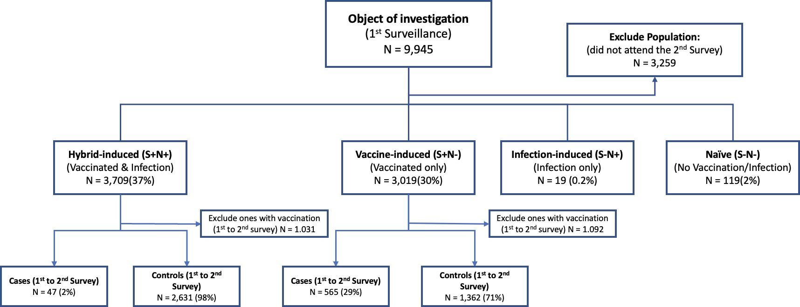

Figure 1: Flow Chart Illustrating the Cohort Study Design

## Cohort Study Design and Regression Model

To investigate changes in S antibody levels, a cohort study design was implemented (Figure 1). Unlike the case-control study design, which tracks confirmed infection records, this cohort study began with four distinct immunity types: hybrid-induced immunity (*S*+*N* +),

vaccine-induced immunity (*S*+*N−*), infection-induced immunity (*S−N* +), and naive (*S−N−*). The outcome measurements in this study were the S antibody levels at the second surveillance point, while the exposure measurements included S antibody levels at the first surveillance point, immunity type, and immunological events occurring between surveillance points. Par- ticipants who did not participate in the second survey were excluded, resulting in a cohort of 6,686 participants.

Notably, the hybrid-induced and vaccine-induced immunity groups comprised over 98% of the cohort population. Consequently, subsequent research focused primarily on these two groups. To compare the protective capacity of these two main groups, Kaplan-Meier survival analysis was applied, focusing on the probability of remaining free from COVID-19 infection following the first surveillance. It is important to note that individuals who received the COVID- 19 vaccine or booster were excluded from this survival analysis.

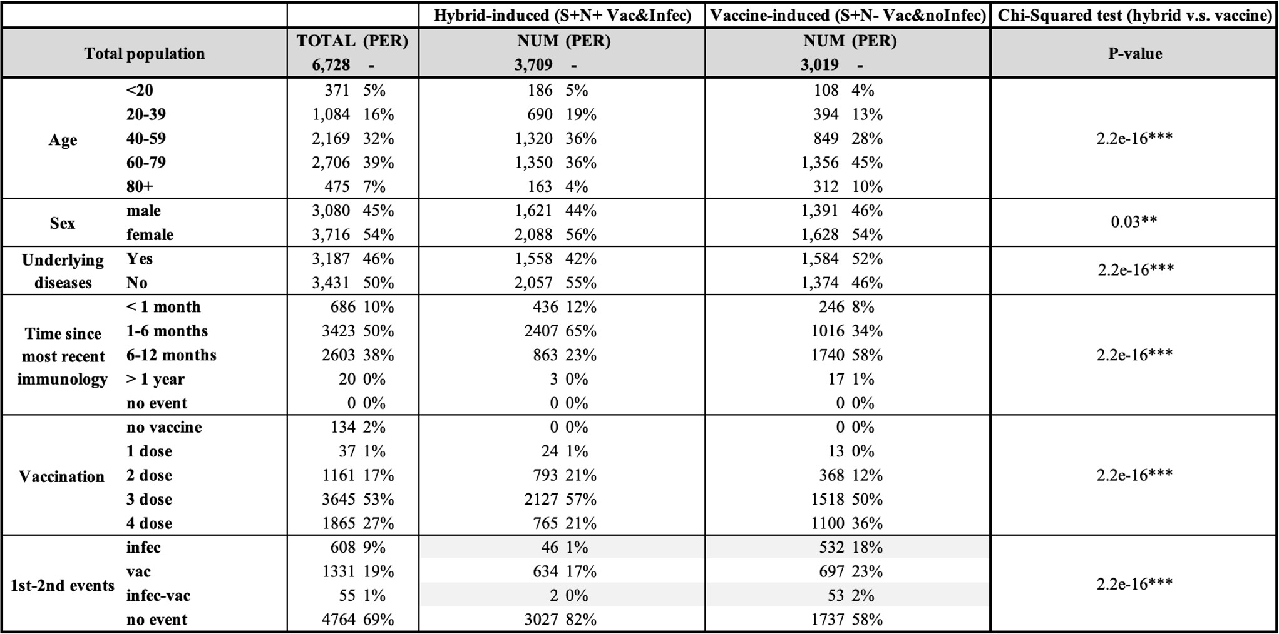

Table 1: Summary table of cohort study design

Within each immunity group, the outcome measurement was defined as infection status during the first and second surveillance periods, while the exposure measurement was the S antibody level recorded during the first surveillance. To accurately assess the impact of S an- tibody levels on COVID-19 protection, specific exclusions were applied. Individuals who did not participate in the second survey were excluded due to untracked infection status. Addi- tionally, those who received a vaccination between the two surveillance periods were excluded from both the case and control groups, as their initial S antibody levels would no longer be valid indicators. Following these criteria, the case group comprised 612 individuals (14%), and the control group included 3,993 individuals (85%).

The imbalance in the case-control cohort posed significant challenges for the regression model using the least squares method. To address this issue and mitigate the impact of con- founders, we employed the nested case-control (NCC) technique (Pearce, 2016; Richardson, 2004). This approach involves selecting a matched subset of controls from the same cohort for each case based on relevant characteristics, thereby ensuring comparability and enhancing the validity of the results.

# Results

## Survival Analysis of Immunity Types Across Age Groups

The Kaplan-Meier survival analysis (Figure 3) illustrates the survival probabilities, inter- preted as being free from COVID-19 infection, over time for populations with vaccine-induced and hybrid-induced immunity in our study. The analysis reveals significant differences in sur- vival probabilities between these two immunity types across various age groups. Individuals with hybrid-induced immunity consistently exhibit higher survival probabilities compared to those with vaccine-induced immunity. Specifically, after one and a half years, the survival probability for hybrid-induced immunity is 98%, whereas it is approximately 60% for vaccine- induced immunity. This trend is particularly pronounced in the younger age group (*<* 20), where the survival probability for vaccine-induced immunity shows a steep decline starting around 5 months. In contrast, the hybrid-induced immunity group maintains a much more sta- ble survival curve throughout the entire observation period.

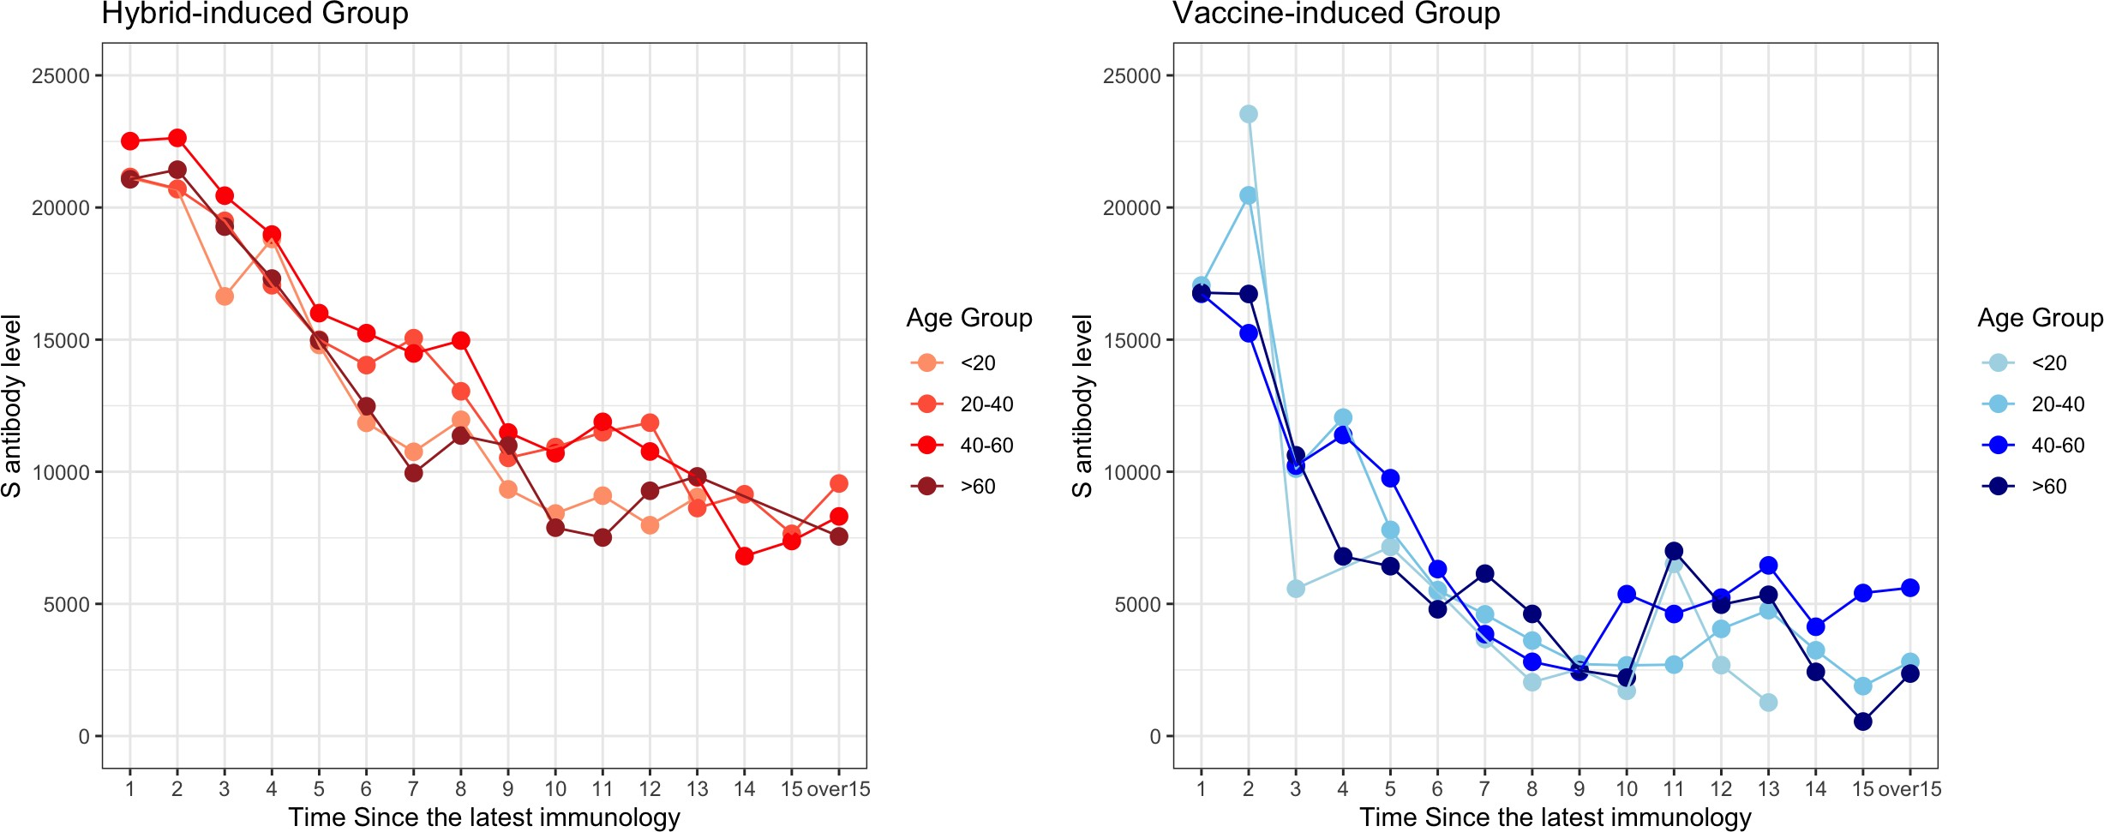

Figure 2: Trajectory plot for different age group

To provide a more detailed analysis of the declining patterns in the vaccine-induced im- munity groups, both the “ *<* 20” and “ 20 60” age cohorts exhibited comparable trends. They maintained a high level of survival probability during the first six months, which began to decline subsequently. Ultimately, the survival probabilities of these two groups dropped to 60% and then stabilized after one and a half years. These findings suggest that tailored vaccina- tion strategies, considering age-specific immune responses, are crucial for enhancing long-term protection against COVID-19.

*−*

To better understand the reasons behind the survival probabilities of different immunity groups as well as age subgroups, we construsted the trajectory plot to track the average change of S antibody levels after the immunological events. Overall, hybrid-induced immunity can sus- tain a high level of S antibody (over 10,000) for one year before decreasing to 7,000, while the S antibody level in the vaccine-induced only group falls below the 5,000 threshold six months post-vaccination. These patterns align with the survival curves mentioned above, as the prob- ability of survival in vaccine-induced groups decreases rapidly after six months. The plots demonstrate a high correlation between individual survival probability and S antibody levels.

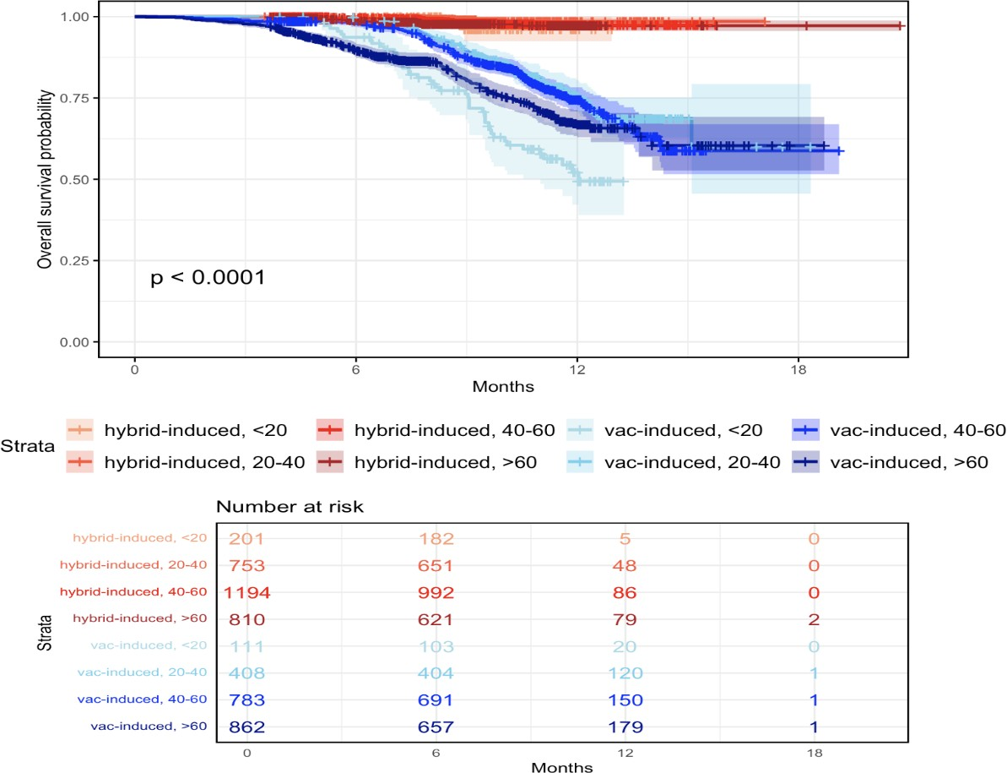

Figure 3: Survival Plot for Hybrid-induced and Vaccine-induced Groups

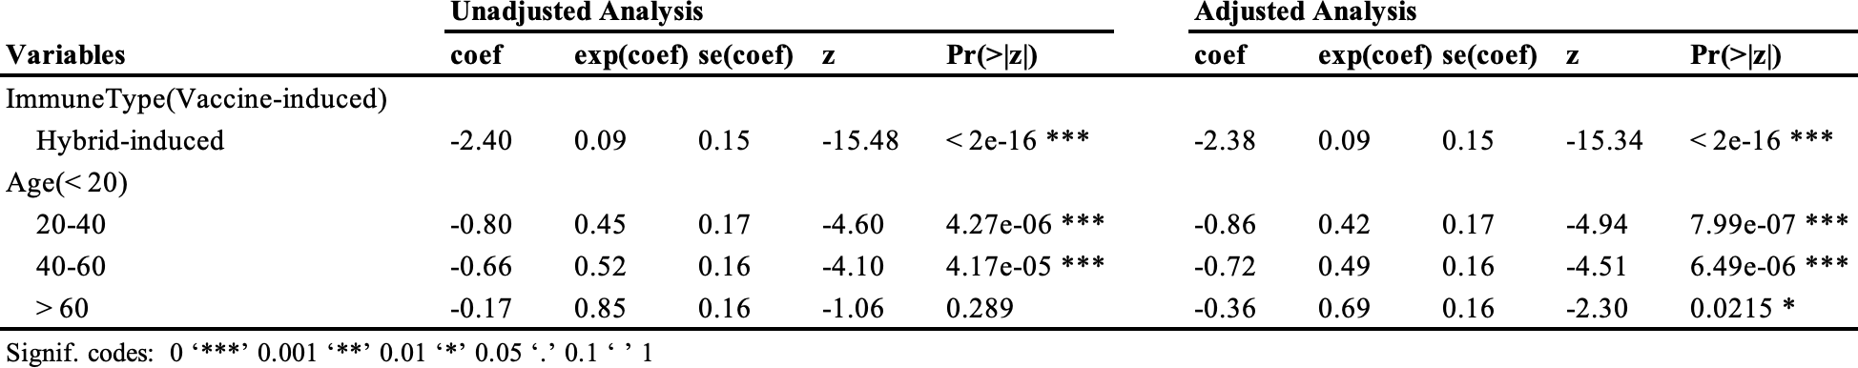

Table 2: Cox Proportional Hazards Regression Results

After performing a Kaplan-Meier survival analysis and observing significant differences in survival probabilities between different groups, we also conducted a Cox proportional haz- ards regression to examine of the effect of multiple variables on survival time, adjusting for confounding factors, and providing a more comprehensive understanding of the risk factors involved.

The coefficient for hybrid-induced group is -2.38, indicating a substantial reduction in the hazard of infection or death for individuals with hybrid-induced immunity compared to those with vaccine-induced immunity. The hazard ratio (exp(coef)) is 0.09, meaning hybrid-induced immunity reduces the risk to approximately 9% of that for vaccine-induced immunity. The result is highly significant.

For the age category 20-40, the coefficient is -0.86with a hazard ratio of 0.42, indicating a 42% risk relative to those under 20 (p = 7.99e-07). For ages 40-60, the coefficient is -0.72 with

a hazard ratio of 0.49, reflecting a 49% risk compared to those under 20 (p = 6.49e-06). For individuals over 60, the coefficient is -0.36 with a hazard ratio of 0.69, indicating a 69% risk relative to those under 20 (p = 0.0215).

## Infection Risk Factors Analysis

Among the cohort, the participants’ age ranged from 5 to 99 years (median 52 years; in- terquartile range [IQR], 37–52 years) and 2106 (43%) were male and 2762 (57%) were female. Briefly, the median age was 53 years (IQR, 35–68) for the case group, 51 years (IQR, 37–64) for the control group.

Statistical significance was determined using nonparametric tests: the Mann-Whitney U test and Kruskal-Wallis test with Dunn’s multiple comparison for independent samples, and the Wilcoxon signed-rank test for dependent samples. To ensure robustness, logistic regression was employed to quantify the probability dynamics of remaining infection-free, relating these changes to S antibody levels and age groups (*<* 20*,* 20 40*,* 40 60*,>* 60).

*− −*

According to the cohort design results, the primary infection risk concerns (with waning immunity) are likely to originate from the vaccine group. To identify specific risk factors within this group, a forest plot was constructed (Figure 3). All available characteristics were converted to categorical variables, with the first subgroup designated as the reference category. This al- lowed for the calculation of log odds ratios, where a higher log odds ratio indicates a greater infection risk compared to the reference group. A log odds ratio of zero signifies equal risk with the reference group.

Among all characteristics, age and S antibody level demonstrated the most significant association with individual infection status, exhibiting clear patterns and non-overlapping con- fidence intervals. Notably, the youngest group exhibited the highest individual infection risks. Except for the youngest group, there was a positive correlation between age and infection risk, indicating that risk increases with age. Given the assumptions of the linear model, only age and S antibody level were included in the final model.

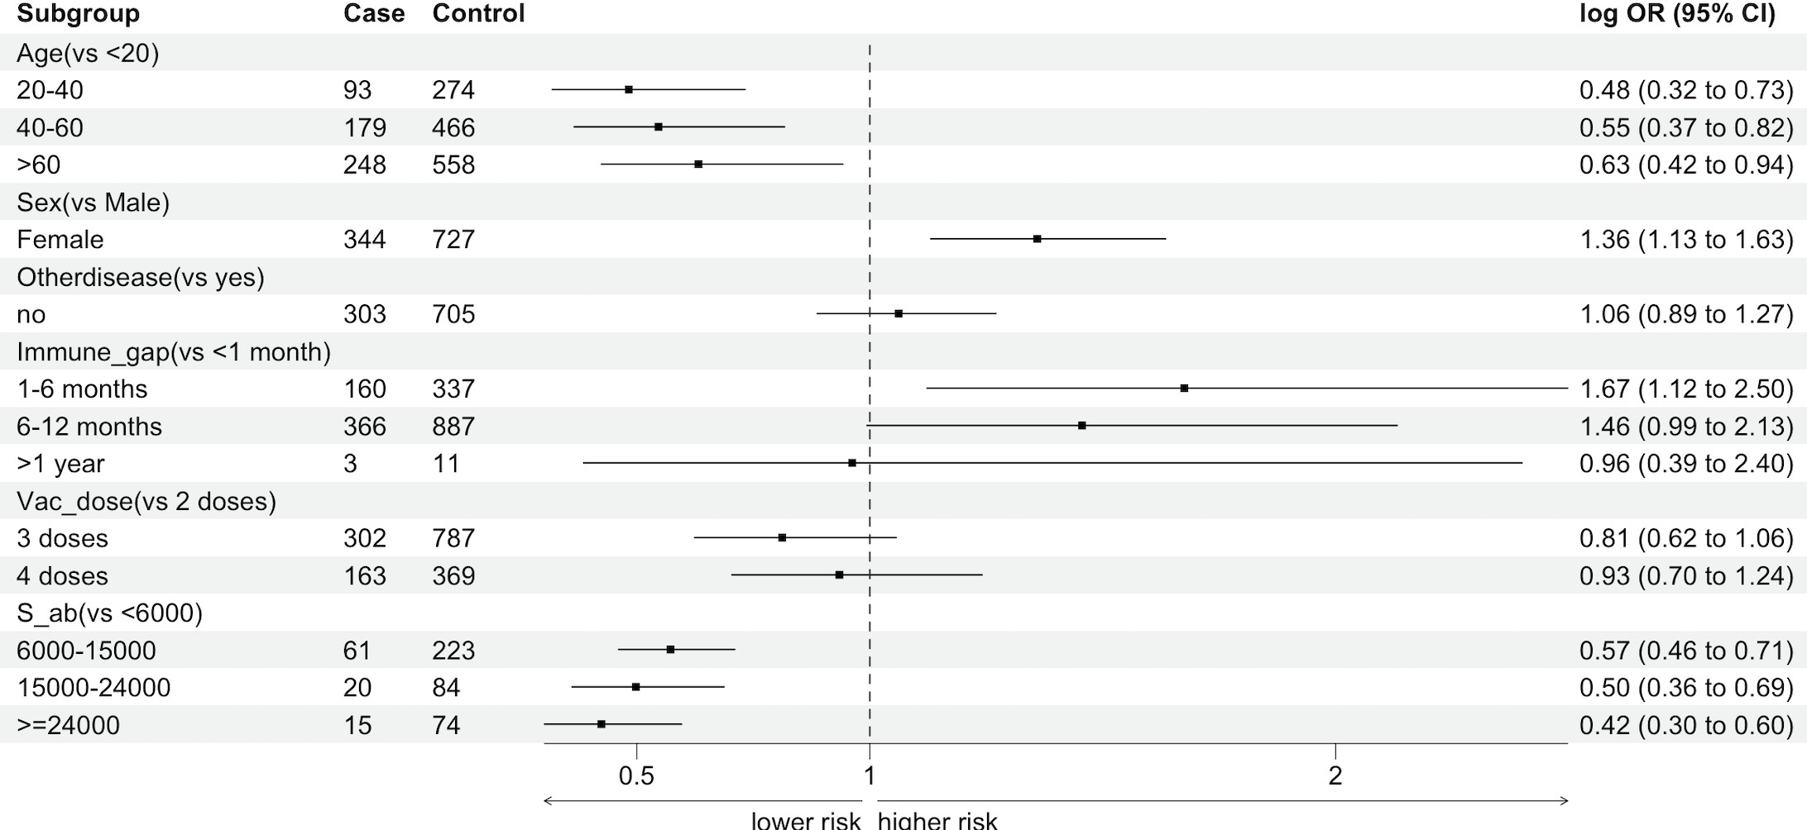

* + 1. Vaccine-induced group

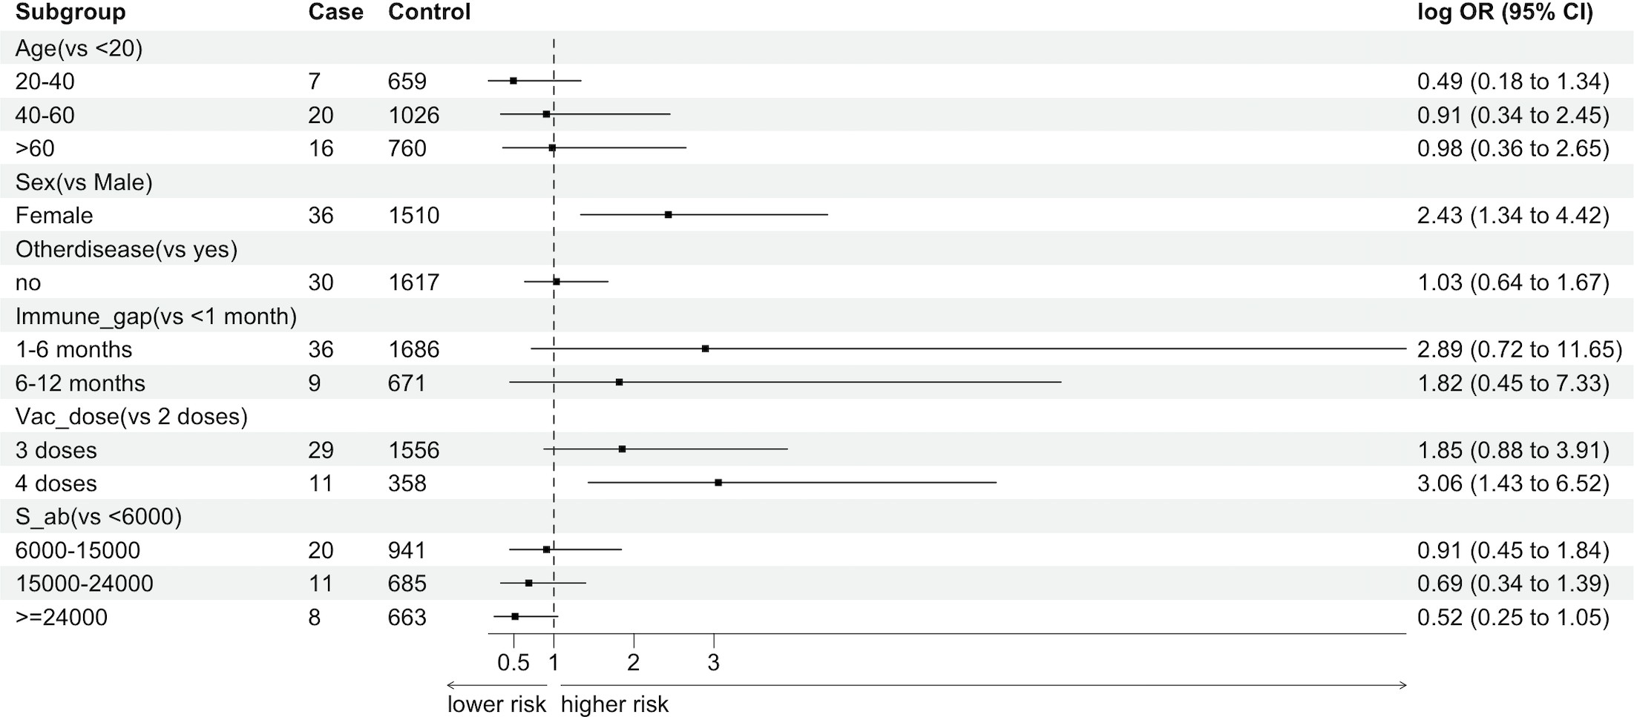

* + 1. Hybrid-induced group

Figure 4: Forest plot displaying characteristic patterns: Top - Vaccine-induced group; Bottom - Hybrid-induced group

## Logistic Regression Model

In the previous section, we addressed the issue of imbalanced case-control data, as well as the impacts of confounders, by employing the R package Epi (Carstensen et al., 2021). In the original cohort, the ratio between case and control samples was approximately 1:6. To achieve a balance between statistical power and practical feasibility, as suggested by Pearce (2016), the matching ratio was set to 1:3 in our research.

Based on the preceding analysis, only age and S antibody levels were incorporated as predictors in the regression model. All other characteristics were considered confounders and were consequently selected as matching factors in the nested case-control (NCC) method, en- suring adequate control of potential confounders. Since in the previous section the patterns of hybrid-induced group and vaccine-induced group are different, two separate models were fitted.

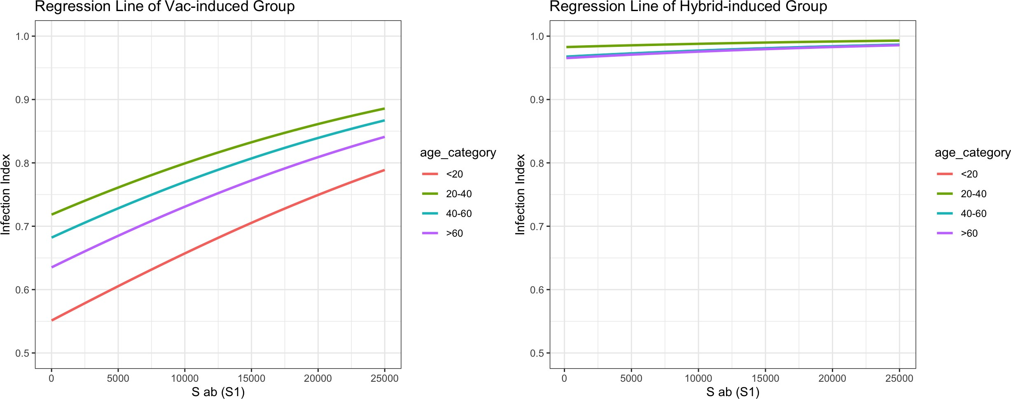

Figure 5: Regression line comparison for vaccine-induced (left) and hybrid-induced (right) groups

The logistic regression analysis reveals significant differences in the probability of re- maining free from COVID-19 infection between vaccine-induced and hybrid-induced immunity across various age groups. In the vaccine-induced group, the probability of remaining infection- free decreases with higher S antibody levels and increasing age. Younger individuals (*<* 20) exhibit the highest probability of avoiding infection, while those aged 20 39 show the lowest probability for any given S antibody level. For instance, at an S antibody level of 6000, the probability of remaining infection-free is approximately 0.62 for the *<* 20 age group compared to about 0.77 for the 20 39 age group. This indicates that within the vaccine-induced group, younger individuals are at a higher probability of avoiding infection than older individuals, even with the same antibody levels.

*−*

*−*

In contrast, the hybrid-induced group shows a consistently high probability of remaining infection-free across all age groups and antibody levels. The probability remains nearly con- stant and very close to 1.0, indicating that hybrid-induced immunity provides robust and stable protection against COVID-19 regardless of age or antibody level. This highlights that while vaccine-induced immunity varies in effectiveness, hybrid-induced immunity offers a more reli- able protective effect, emphasizing its superior efficacy in maintaining long-term immunity.

# Discussion

In addition to assessing the risk of infection, we also investigated the risk of severe symptoms among those infected. Our analysis indicates that the risk of severe symptoms in the vaccine- induced group is approximately 1.6 times higher than that in the hybrid-induced group. Notably, within the vaccine-induced group, nearly 70% of severe cases occur in individuals over the age of 40. However, the incidence of severe symptoms following infection with the Omicron variant is notably low in our dataset, particularly within the hybrid-induced group, which includes only 3 cases. This limited sample size precludes more detailed statistical analysis.

Our study highlights significant differences in the efficacy of hybrid-induced and vaccine- induced immunity in preventing COVID-19 infections across various age groups. The findings reveal that hybrid-induced immunity consistently provides robust and stable protection across all age groups and antibody levels, maintaining a nearly constant high probability of remaining infection-free. Conversely, the vaccine-induced group demonstrates a decline in infection-free probability with increasing S antibody levels and age, indicating a more variable protective

effect. Younger individuals (*<* 20) in the vaccine-induced group exhibit the highest infection risk and require significantly higher antibody thresholds to achieve comparable protection levels to older age groups. These results underscore the importance of considering age and antibody levels in vaccination strategies to enhance long-term immunity, suggesting that hybrid-induced immunity may offer superior long-term protection across diverse demographics.

From the perspective of immune type, both vaccine-induced and hybrid-induced groups show that the youngest population faces the highest infection risk. Specifically, within the vaccine-induced group, to achieve an 80% probability of remaining free from COVID-19 in- fection, the S antibody threshold for the youngest age group must exceed 25,000, which is significantly higher than the threshold for the 20-39 age group, set at 9,000. This disparity emphasizes the need for tailored vaccination strategies that address the unique immunological requirements of different age groups to ensure optimal protection against COVID-19.

Our results align with previous studies showing that immune system efficiency decreases with age, a phenomenon known as immunosenescence. This decline results in slower and less effective responses to infections, including COVID-19. Additionally, the production of new T cells decreases with age, weakening the body’s ability to combat the virus (BMJ, 2020). This may explain why younger individuals in our research face a lower risk of COVID-19 infection despite having similar levels of S antibodies.

Moreover, older adults have demonstrated higher mobility resilience compared to younger individuals (Va¨isa¨nen & Toivonen, 2021), leading to a lower exposure risk for the elderly. This variation in exposure risk explains why the protective efficacy of a fixed S antibody level does not strictly increase with decreasing age in our study.

One notable limitation of this study is the potential bias in comparing the increased spike

1. antibody titer levels themselves due to diagnostic and data collection issues. The variabil- ity in diagnostic accuracy and data quality across different surveillance points may introduce inconsistencies in the measurement of antibody titers. This could affect the reliability of direct comparisons between hybrid-induced and vaccine-induced immunity groups based solely on S antibody titer levels.

To mitigate this bias, we recommend focusing on the ”infection averting efficacy” as- sociated with S antibody levels between the comparison groups. This approach allows for a more robust assessment of immune protection by evaluating the ability of different immunity types to prevent SARS-CoV-2 infection, rather than solely relying on changes in antibody titers. By emphasizing the efficacy of infection prevention, we aim to provide a more accurate and meaningful comparison of hybrid-induced and vaccine-induced immunity, despite the inherent challenges in antibody titer measurement.

Despite these limitations, the study offers important implications. If the survey had been conducted in the early stages of the COVID-19 pandemic, it would have been possible to ana- lyze the effectiveness of vaccines against various variants of the virus, not just Omicron. More- over, more frequent and continuous surveillance data would enable a more precise quantification of the protective efficacy of infection and vaccination by measuring S antibody levels.

# References

* 1. Khoury, D. S., et al. (2021). Neutralizing antibody levels are highly predictive of immune protection from symptomatic SARS-CoV-2 infection. *Nature Medicine*, 27(7), 1205-1211.
  2. Feng, S., et al. (2021). Correlates of protection against symptomatic and asymptomatic SARS-CoV-2 infection. *Nature Medicine*, 27(11), 2032-2040.
  3. Suthar, M. S., et al. (2021). COVID-19 vaccination-induced immunity: Mechanisms and challenges. *Cell*, 184(4), 1043-1050.
  4. Levin, E. G., et al. (2021). Waning immune humoral response to BNT162b2 COVID-19 vaccine over 6 months. *New England Journal of Medicine*, 385(24), e84.
  5. Garcia-Beltran, W. F., et al. (2021). mRNA-based COVID-19 vaccine boosters induce neutralizing immunity against SARS-CoV-2 Omicron variant. *Cell*, 185(3), 457-466.e4.
  6. Liu, C., et al. (2021). Reduced neutralization of SARS-CoV-2 B.1.617 by vaccine and convalescent serum. *Cell*, 184(16), 4220-4236.e13.
  7. Earle, K. A., et al. (2021). Evidence for antibody as a protective correlate for COVID-19 vaccines. *Vaccine*, 39(32), 4423-4428.
  8. Dan, J. M., et al. (2021). Immunological memory to SARS-CoV-2 assessed for up to 8 months after infection. *Science*, 371(6529), eabf4063.
  9. Pearce, N. (2016). Analysis of matched case-control studies. *BMJ*, 352, i969.
  10. Richardson, D. B. (2004). An incidence density sampling program for nested case-control analyses. *Occupational and Environmental Medicine*, 61(12), e59.
  11. Carstensen, B., Plummer, M., Laara, E., Hills, M. (2021). Epi: A Package for Statistical Analysis in Epidemiology. *R package version 2.44*.

# Appendix

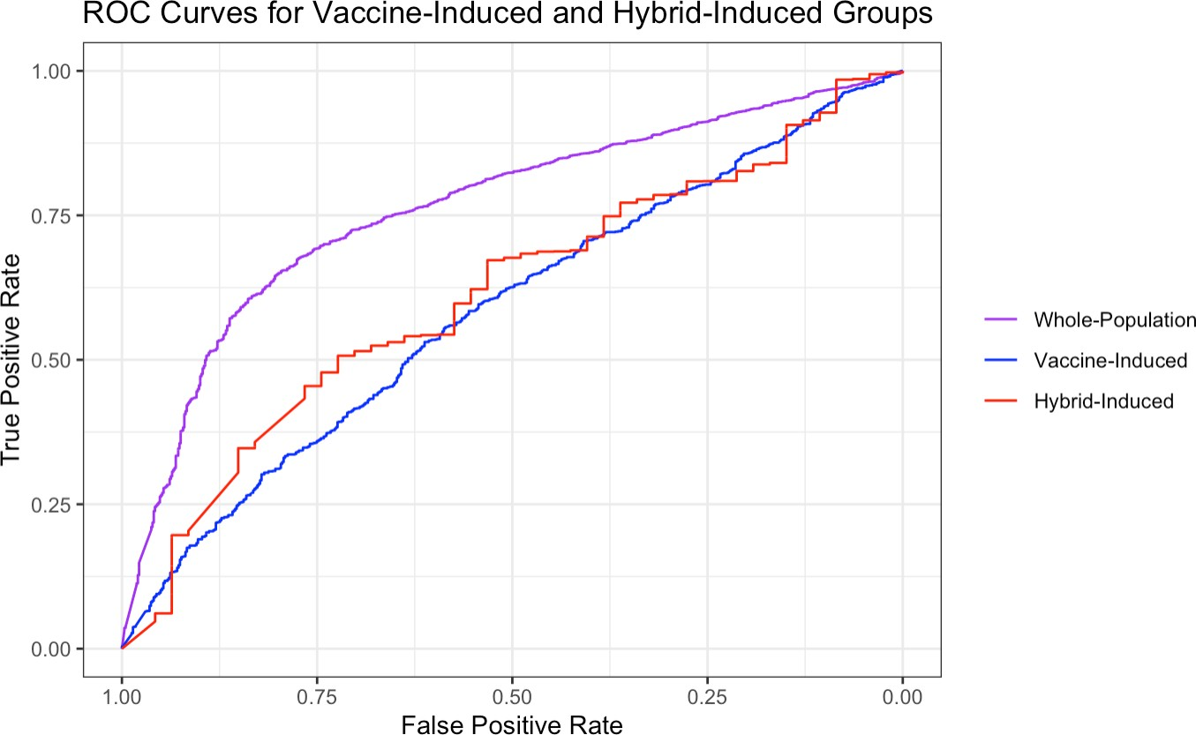

Figure 6: ROC curves for logistic regression models

1. https://doi.org/10.1038/s41467-022-32265-5