**Protective Capacity of S Antibody Levels Across Different Age Groups Based on Nationwide Community Surveillance Data in South Korea**

**Yifan Zhang**

Department of Statistics, University of Connecticut [zfrank](mailto:zfranky6@uconn.edu)[y6@uconn.edu](mailto:y6@uconn.edu)

**Youngji Jo**

Department of Public Health Sciences, UConn Health

**Abstract**

**Background.** Our study examined the protective effectiveness of COVID-19 infection across age groups between hybrid and vaccine-induced in the general population based on community-based nationwide surveillance.

**Methods:** We defined the hybrid and vaccine group based on information from serology (S and N status) and self-reporting on previous vaccination and testing as accurately as possible, avoiding many sources of bias that would lead to differential misclassification of people as infected. We illustrated the S antibody level and associated protective efficacy against breakthrough infection over time by age group and immunity status. Based on the identified risk factors by the immunity groups, we quantified the probability of free from infection risk by age group so it can guide the specific vaccine prioritization and interval for age groups.

**Results:** We showed that S ab waning and risk infection trends are highly correlated; hybrid group resulted in higher and longer-lasting antibody responses compared to vaccination alone, in the long term as well. In terms of age groups in vaccine group, <20 group show the greatest infection risk following >60, 40-60 and 20-40. All these differences accounted for heterogeneous individual vaccine responses and individual levels of exposure. Importantly, antibody decay was clearly observed after 6th month from the last immunological events for the vaccine group (more quickly for the>60 age group but greater magnitude for the <20 group) compared to hybrid groups.

**Conclusion**: Our results indicate that vaccination campaigns should be tailored according to individual immune status, previous history of SARS-CoV-2 infection, and characteristics of the population risk factors (age, gender) to achieve optimal responses and protection across individuals.

**Introduction**

Natural SARS-CoV-2 infection and vaccination against COVID-19 both contribute to building the population’s immunity. Immune responses are multifaceted, but single components that are easy to measure, such as antibodies, are used in epidemiological studies to characterize the population-level immunity and the longevity of antibody responses induced after infection and/or vaccination. Studies of COVID-19 vaccines have shown waning immunity over time (after 2 doses), as measured by primarily decreasing antibody titers and vaccine effectiveness (breakthrough infections) [9, 10]. However, estimating the magnitude and durability of this protection in the population has become a challenge because of the surge in the omicron (B.1.1.529) variant, which has resulted in many individuals with hybrid immunity (immunity developed through a combination of SARS-CoV-2 infection and vaccination), varying rates and timings of past infection and vaccination, multiple types of vaccination and numbers of doses, and variants of concern that can escape pre-existing immunity.3,4 Moreover, most existing seroepidemiological studies have focused on specific groups (e.g., healthcare workers) [1, 2], and the durability of antibody responses after infection and/or vaccination is less well explored within the general population [8].

Systematic reviews of SARS-CoV-2 vaccine effectiveness studies have provided clarity on the durability of protection for different variants of concern.5,6 These studies have compared protection among vaccinated individuals to that in unvaccinated individuals and compared protection between different numbers of doses. Another recent systematic review estimated the durability of protection conferred by hybrid immunity[ref] and previous infection alone against multiple clinical outcomes of SARS-CoV-2 infection caused by the omicron variant. This systematic review and meta-regression found that both previous infection alone and previous infection combined with previous vaccination (ie, hybrid immunity) conferred rapidly waning protection against SARS-CoV-2 infection with the omicron variant, but high and sustained protection against hospital admission or severe disease due to the omicron variant. The study also determined that previous infection was found to provide higher protection against reinfection and more sustained protection against hospital admission or severe disease than vaccination alone. Such pattern might be explained by natural infection invoking a more diverse immune response to multiple antigenic sites on the virus compared to the immunity developed through vaccines that target only spike antigens. However, individuals with hybrid immunity had the highest magnitude and durability of protection against all outcomes, emphasising the importance of providing vaccination to previously infected individuals. Infection-induced protection against reinfection wanes rapidly, and vaccination 564 increases durability.

In South Korea, with high vaccination, the majority of the population is hybrid and vaccine-induced immunity, and there are only a few people with previous infection alone. In this study, we directly compared anti-S levels and the relative breakthrough infection events between hybrid and vaccine-induced immunity groups. We used the data obtained from the nationwide community-based cohort, which enables large-scale and various age subgroup populations to follow up with repeated testing of antibodies two times in August and December 2022 with detailed demographic and clinical characterization. The objectives of the research are three folds: First, we assessed how does anti-S waning vary after the last immunological events across age subgroups between hybrid and vaccine induced immunity groups. Second, we assessed the protective efficacy of the two groups over time, focusing on the probability of remaining free from COVID-19 infection. Third, we assessed the total effect of anti-S level on the risk probability of remaining infection-free by S ab levels across age groups between hybrid and vaccine groups.[1]

# Methods

## 

## Sample Collection and Definitions. A nationwide community-based surveillance study was conducted from August to December 2022, during the 6th and 7th epidemic peaks of COVID-19 in South Korea. This study involved 258 public health centers and 113 private medical facilities across 259 cities and counties. A representative sample of 10,000 individuals aged 5 and older was randomly selected from 5,000 households. Data collection was conducted through one-on-one interviews by trained surveyors using tablets to ensure accuracy. More detailed descriptions of the cohort study design and data collection methods are published elsewhere (REF).

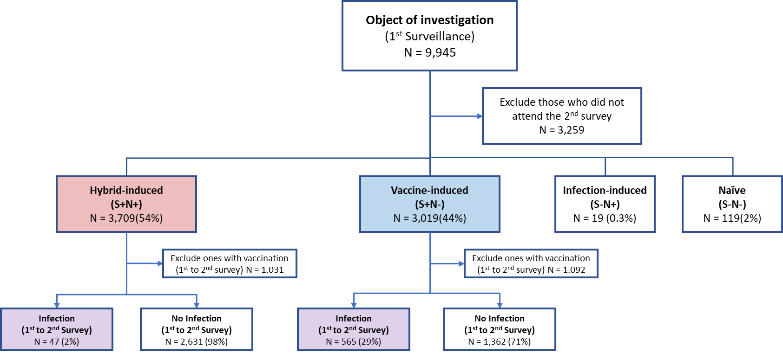

Figure 1: Flow Chart Illustrating the Cohort Study Design

**Inclusion/Exclusion and matching criteria.** In this analysis, we defined the cohort by the following four distinct immunity types: hybrid-induced immunity (*S*+*N* +), vaccine-induced immunity (*S*+*N−*), infection-induced immunity (*S−N* +), and naive (*S−N−*) (Levin et al., 2021; Garcia- Beltran et al., 2021). Notably, the hybrid-induced and vaccine-induced immunity groups comprised over 98% of the cohort population (Fig 1). Consequently, subsequent research focused primarily on these two groups. The demographic and clinical characteristics of the two groups are described in Table 1. We assessed the two outcome measurements including the S antibody levels measured at the first and second surveillance points (Figure 2) and the infection events between the first and second surveillance points (Figure 3).

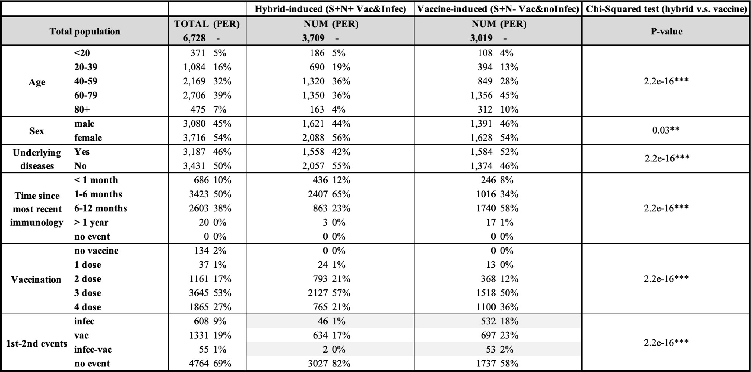

Table 1: Summary table of cohort study design

To accurately assess the impact of S an- tibody levels on COVID-19 protection (Fig 3), specific exclusions were applied in these cohorts. First, individuals who did not participate in the second survey were excluded due to untracked infection status. Second, those who received a vaccination between the two surveillance periods were excluded from both the case and control groups, as their initial S antibody levels would no longer be valid indicators. Third, we employed the nested case-control (NCC) technique (Pearce, 2016; Richardson, 2004) to match the observation time between those who have infection event and no infection. This approach involves selecting a matched subset of controls from the same cohort for each case based on relevant characteristics, thereby ensuring comparability and enhancing the validity of the results. Based on the preceding analysis (Appendix Figure S2), only age and S antibody levels were incorporated as predictors in the logistic regression model. All other characteristics were considered confounders and were consequently selected as matching factors in the nested case-control (NCC) method, en- suring adequate control of potential confounders.

**Statistical analyses**. First, we constructed the descriptive analyses to generate trajectory plots to track the average change of S antibody levels after the immunological events by different immunity groups and age subgroups. Second, we conducted Kaplan-Meier survival analysis to compare the protective efficacy of these two main groups, focusing on the probability of remaining free from COVID-19 infection following the first surveillance. Within each immunity group, the outcome measurement was defined as infection status during the first and second surveillance periods. Through NCC, we adjusted the imbalanced case-control data, as well as the impacts of confounders, by setting a matching ratio to 1:3 from 1: 6 from the original cohort between case and control samples to achieve a balance between statistical power and practical feasibility, as suggested by Pearce (2016). We also conducted a Cox proportional hazards regression to examine the effect of multiple variables on survival time, adjusting for confounding factors and providing a more comprehensive understanding of the risk factors involved. Third, we conducted logistic regression models to assess protective efficacy (free from infection event) by S ab level across immunity and age subgroups. Statistical significance was determined using nonparametric tests: the Mann-Whitney U test and Kruskal-Wallis test with Dunn’s multiple comparison for independent samples, and the Wilcoxon signed-rank test for dependent samples. We conducted the statistical analyses by employing the R package Epi (Carstensen et al., 2021).

**Results**

S ab trajectory plots show that the overall S ab level is higher among hybrid-induced immunity group than vaccine group and it can sustain a high level of S antibody (over 10,000) for one year in the hybrid group, while the S antibody level in the vaccine-induced only group falls below 5,000 in six months post-vaccination. Within hybrid group, S ab is slightly lower for age <20 and age >60 compared to age 20-60, while there was no clear difference across age group for vaccine group.

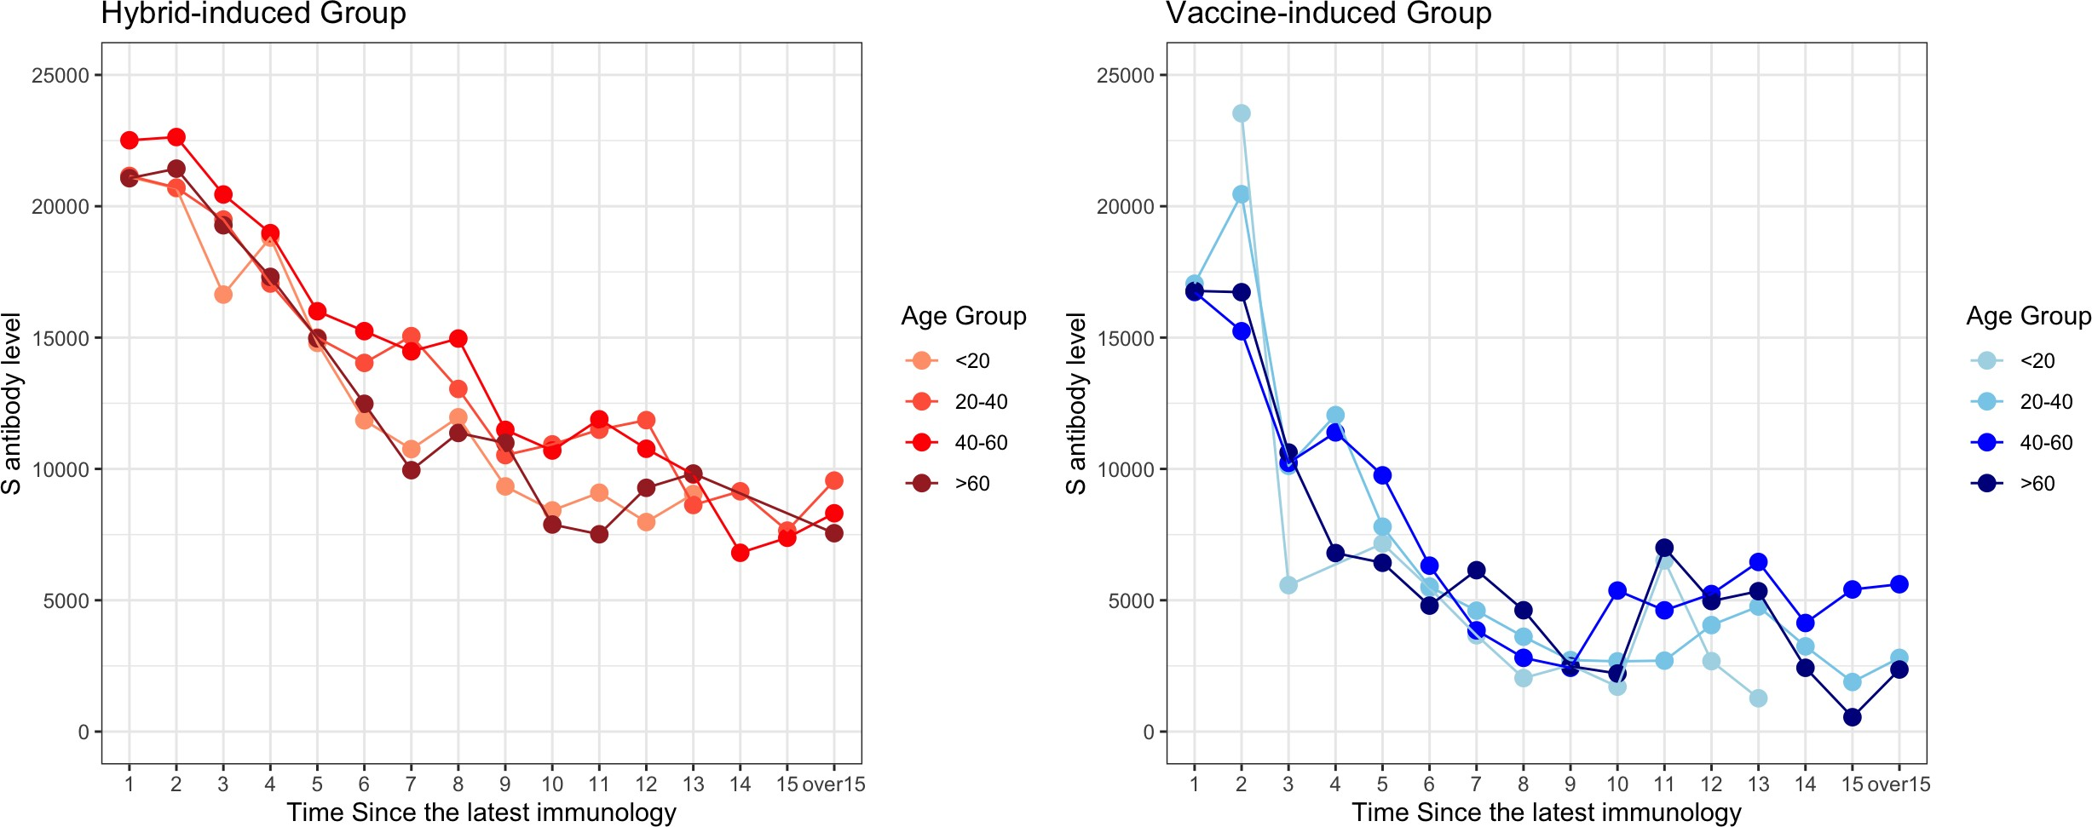Figure 2: Trajectory plot for different age groups

The Kaplan-Meier survival analysis (Figure 3) illustrates the survival probabilities, inter- preted as being free from COVID-19 infection, over time for populations with vaccine-induced and hybrid-induced immunity in our study. The analysis reveals significant differences in sur- vival probabilities between these two immunity types across various age groups. Individuals with hybrid-induced immunity consistently exhibit higher survival probabilities (remain 98% over a year) compared to those with vaccine-induced immunity (decreases to 50-60% over a year). Antibody decay was clearly observed after 6th month from the last immunological events for the vaccine group (more quickly for the>60 age group but greater magnitude for the <20 group) compared to hybrid groups.

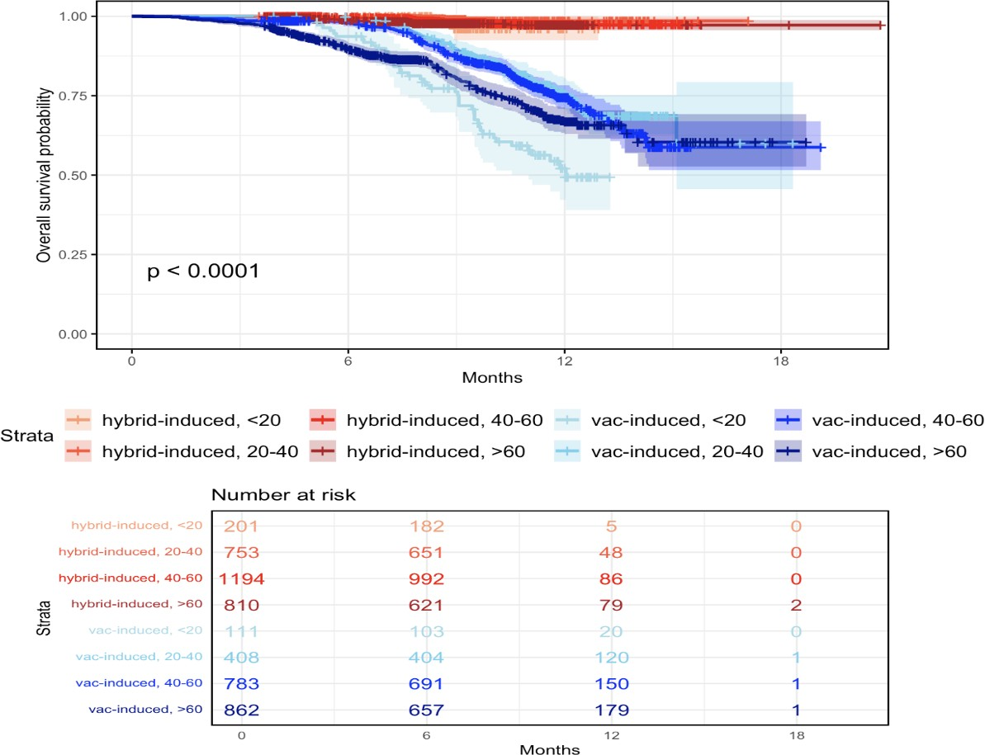

Figure 3: Survival Plot for Hybrid-induced and Vaccine-induced Groups

The hazard ratio (exp(coef)) for hybrid group is significantly low as 0.09, indicating hybrid-induced immunity reduces the risk to approximately 9% of that for vaccine-induced immunity. For the, a hazard ratio of age groups>20 show 42-69% lower risk of infection than age <20 group with increasing risk trends with older age groups.

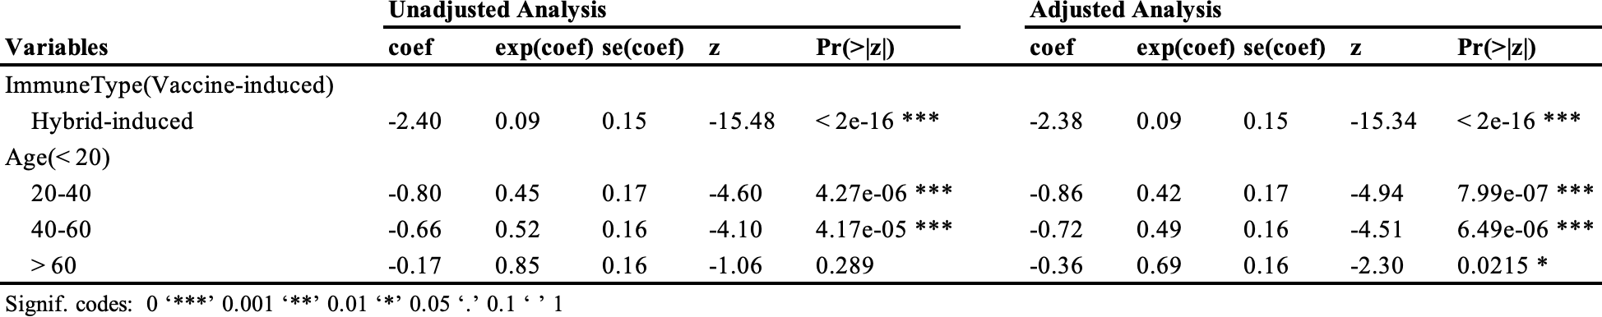

Table 2: Cox Proportional Hazards Regression Results

The probability of remaining infection-free by S ab levels across immunity/age groups shows similar risk trends by immunity/age groups with the survival analyses. In the vaccine-induced group, the probability of remaining infection-free decreases with higher S antibody levels across age groups, demonstrating the highest risk for age <20 (60% of remaining infection-free with S ab level 5000 to 80% with 250,000) following >60, 40-60, and 20-40 groups (75% of remaining infection-free with S ab level 5000 to 90% with 250,000 for age 20-40 as the lowest risk group). In other words, to have an 80% probability of remaining infection-free, age 20-40 requires an S ab level of at least 10,000, 40-60 groups as 150,000, and >60 as 20,000 and <20 as 250,000.

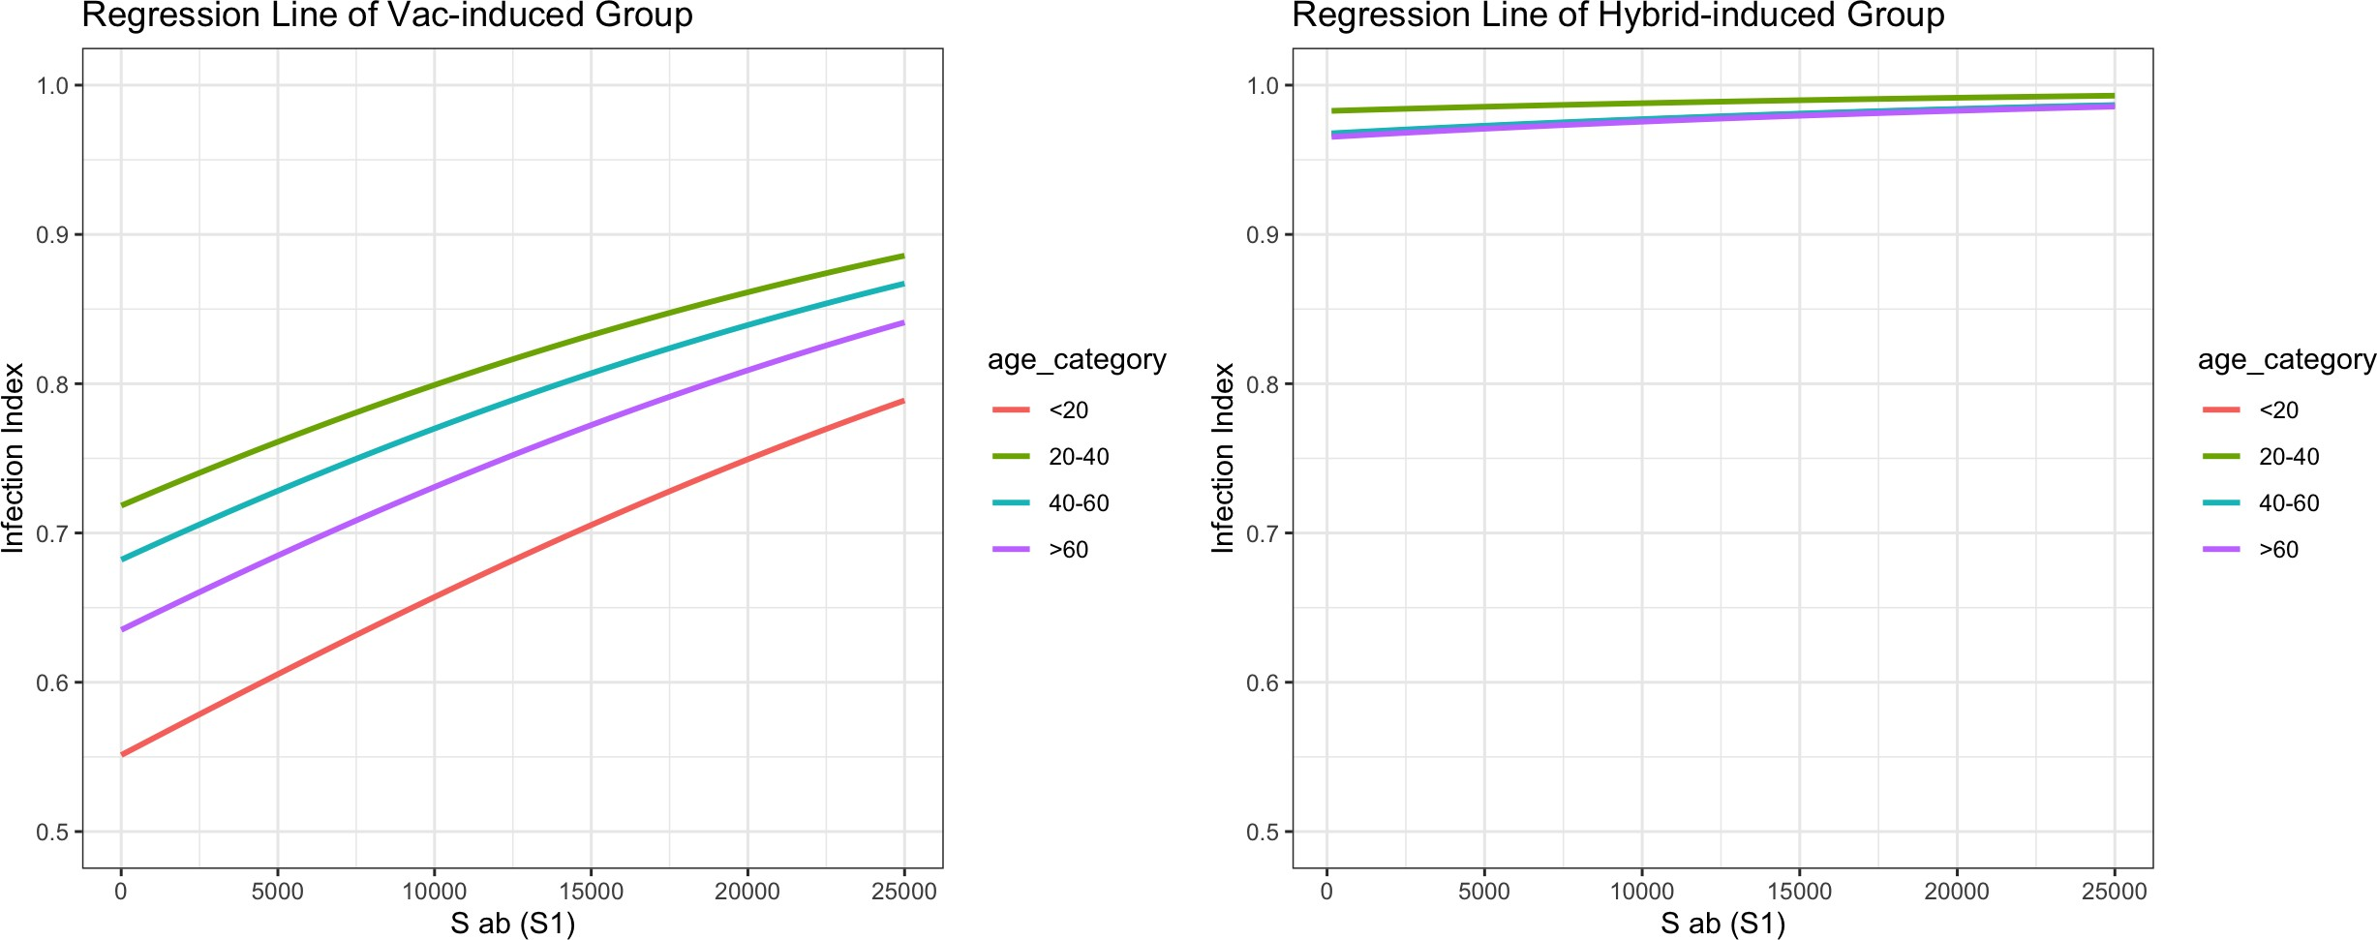

Figure 4: Regression line comparison for vaccine-induced (left) and hybrid-induced (right) groups

# Discussion

Our study examined the protective effectiveness of COVID-19 infection across age group between hybrid and vaccine-induced in general population based on community-based nationwide surveillance. In this study, we utilized nationwide community-based surveillance data (large sample sizes and wide age spectrums) from South Ko- rea, involving 10,000 participants, with detailed demographic information and serological assessment twice after an epidemic wave of omicron variants. We defined the hybrid and vaccine group based on information from serology (S and N status) and self-reporting on previous vaccination and testing as accurately as possible, avoiding many sources of bias that would lead to differential misclassification of people as infected. We illustrated the S antibody level and associated protective efficacy against breakthrough infection over time by age group and immunity status. Based on the identified risk factors by the immunity groups, we quantified the probability of free from infection risk by age group so it can guide the specific vaccine prioritization and interval for age groups.

Our study highlights significant differences in the efficacy of hybrid-induced and vaccine induced immunity in preventing COVID-19 infections across various age groups, which correlated with higher initial S antibody levels; After the Omicron wave, our data shows the highest breakthrough infection risk is younger (<20 age) vaccine group, following >60, 40-60 and 20-40. The high risk for younger (<20 age) may be due to the increased exposure/contacts after omicron waves with the lift of the social distancing policy. This suggests that under new variants with the relaxation of measures across many countries, groups previously less exposed, for example, due to shielding guidance, may become more at risk. In addition to assessing the risk of infection, we also investigated the risk of hospitalization among those infected. While the hospitalization events were quite small (which limited sample size precludes more detailed statistical analysis), the result indicates that the Infection hospitalization risks are higher for vaccines especially for age > 60 after omicron waves. (Appendix Table S1) The high risk for older (>60 age) may be due to the decreased immune system efficiency with age (as known as immunosenescence). Previous studies showed individuals 60 years or older had lower antibody levels after vaccination compared to younger participants and increased age has been associated with reduced vaccine responses in a number of studies irrespective of vaccine type. (BMJ, 2020). A similar effect has been seen with antibody responses after infection. On the other hand, another study showed no consistent associations of lower antibody levels with age, but a very strong age gradient (lower incidence with older age) of post-vaccination infection based on cross-sectional samples from Apr 2021-Jan 2022 before omicron wave. Overall, these results are consistent with the risk of infection being a complex combination of SARS-CoV-2 case prevalence, individual immune response to vaccination, and individual level of exposure. (Va¨isa¨nen & Toivonen, 2021)

At the individual level, our results show that the need for and optimal timing of the booster dose might be different in an individual with hybrid immunity compared to an individual with vaccine immunity. This suggests that subsequent doses of vaccination may be delayed by 6 months for individuals with hybrid immunity while still maintaining high levels of protection against severe disease. On a population level, the optimal number of vaccine doses and the inter-dose interval might differ in settings with various degrees of vaccine-induced versus infection-induced immunity. This suggests that the need for further booster doses should take into consideration both vaccine doses and infections and also the clinical characteristics during infections. Further research is warranted to understand the interplay between natural and vaccine-induced immunity, the role of exposure to specific variants and the interval between exposures (vaccination doses and infection). Future follow-up of our population will allow us to assess the risk and severity of breakthrough infections in people with different vaccine responses covering also dynamic aspects of multiple isotype and antigen responses. Policy makers can use these findings to project population protection from local vaccination and seroprevalence rates, helping to inform the use and timing of COVID-19 vaccination as an important public health tool.

Our study has some limitations. Our analysis did not incorporate the sequence permutations of and timing between vaccination and previous infection for hybrid immunity. Our results (relative protection level of S ab waning of hybrid vs. vaccine group) may thus differ by the subgroup distribution, and calendar time (variants types and epidemic stage). We measured binding but not neutralizing antibodies, which is arguably a better surrogate of immune protection. The available antibody assays were developed before the VoCs emerged and whether the use of antibody assays based on the original Wuhan-Hu-1 strain accurately captures infections with other variants should be evaluated in ongoing seroepidemiological studies. Potential sources of misclassification bias may include N ab decay, sensitivity/specificity of ab testing, and the timing of the ab testing (relative to infection and vaccination). Unmeasured bias in exposure may be from the observational study in which persons elected to have previous infections and received a vaccine at different times, and there was no control for the probable differences in healthcare–seeking or risk-averse behavior of individual persons.

**Conclusions**

In summary, in this large cohort study, we compared the antibody responses and their infection risks induced by different COVID-19 immunity statuses (hybrid and vaccine) across age groups. We showed that S ab waning and risk infection trends are highly correlated; hybrid group resulted in higher and longer-lasting antibody responses compared to vaccination alone, in the long term as well. In terms of age groups in vaccine group, <20 group show the greatest infection risk following >60, 40-60 and 20-40. All these differences accounted for heterogeneous individual vaccine responses and individual levels of exposure. Importantly, antibody decay was clearly observed after 6th month from the last immunological events for the vaccine group (more quickly for the>60 age group but greater magnitude for the <20 group) compared to hybrid groups. In the hybrid group, however, 4th booster vaccines have a significantly higher infection risk than the primary vaccine group, highlighting the continuous vaccine compliance in this group.) Moreover, in addition to the S ab level and infection risk trend over time by age group, we quantified the probability of free from infection risk by age group so it can guide the specific vaccine prioritization and interval for age groups. Taken together, our results indicate that vaccination campaigns should be tailored according to individual immune status, previous history of SARS-CoV-2 infection, and characteristics of the population risk factors (age, gender) to achieve optimal responses and protection across individuals.

# References

* 1. Khoury, D. S., et al. (2021). Neutralizing antibody levels are highly predictive of immune protection from symptomatic SARS-CoV-2 infection. *Nature Medicine*, 27(7), 1205-1211.
  2. Feng, S., et al. (2021). Correlates of protection against symptomatic and asymptomatic SARS-CoV-2 infection. *Nature Medicine*, 27(11), 2032-2040.
  3. Suthar, M. S., et al. (2021). COVID-19 vaccination-induced immunity: Mechanisms and challenges. *Cell*, 184(4), 1043-1050.
  4. Levin, E. G., et al. (2021). Waning immune humoral response to BNT162b2 COVID-19 vaccine over 6 months. *New England Journal of Medicine*, 385(24), e84.
  5. Garcia-Beltran, W. F., et al. (2021). mRNA-based COVID-19 vaccine boosters induce neutralizing immunity against SARS-CoV-2 Omicron variant. *Cell*, 185(3), 457-466.e4.
  6. Liu, C., et al. (2021). Reduced neutralization of SARS-CoV-2 B.1.617 by vaccine and convalescent serum. *Cell*, 184(16), 4220-4236.e13.
  7. Earle, K. A., et al. (2021). Evidence for antibody as a protective correlate for COVID-19 vaccines. *Vaccine*, 39(32), 4423-4428.
  8. Dan, J. M., et al. (2021). Immunological memory to SARS-CoV-2 assessed for up to 8 months after infection. *Science*, 371(6529), eabf4063.
  9. Pearce, N. (2016). Analysis of matched case-control studies. *BMJ*, 352, i969.
  10. Richardson, D. B. (2004). An incidence density sampling program for nested case-control analyses. *Occupational and Environmental Medicine*, 61(12), e59.
  11. Carstensen, B., Plummer, M., Laara, E., Hills, M. (2021). Epi: A Package for Statistical Analysis in Epidemiology. *R package version 2.44*.

# Appendix

Based on the key demographic characteristics (Table 1), we conducted logistic regression to determine specific risk factors on infection events for hybrid and vaccine groups, respectively. All available characteristics were converted to categorical variables, with the first subgroup designated as the reference category. This al- lowed for the calculation of log odds ratios, where a higher log odds ratio indicates a greater infection risk compared to the reference group. A log odds ratio of zero signifies equal risk with the reference group.

Among all characteristics, age and S antibody level demonstrated the most significant association with individual infection status, exhibiting clear patterns and non-overlapping con- fidence intervals. (Figure S1) Notably, the youngest group exhibited the highest individual infection risks. Except for the youngest group, there was a positive correlation between age and infection risk, indicating that risk increases with age. In order to determine the risk probability of remaining infection-free by S antibody levels across age groups, we constructed logistic regression including age only based on the finding. (Figure 4 and S2)

* + 1. Hybrid-induced group

* + 1. Vaccine-induced group

Figure S1: Forest plot displaying characteristic patterns: Top - Vaccine-induced group; Bottom - Hybrid-induced group

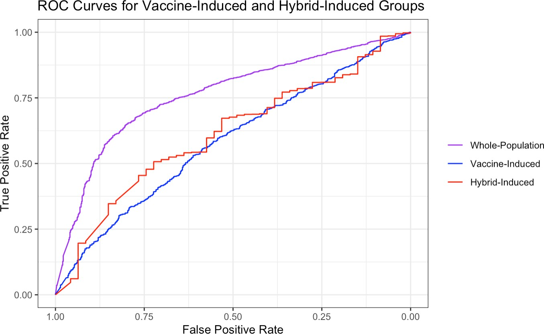

Figure S2: ROC curves for logistic regression models

|  |  |  |  |  |  |  |
| --- | --- | --- | --- | --- | --- | --- |
|  | | <20 | 20-40 | 40-60 | >60 | Total |
| Hybrid | Infections | 4 | 7 | 20 | 14 | 45 |
| Hospitalization | 0 | 0 | 0 | 2 | 2 |
| Infection hospitalization risk | **0.00** | **0.00** | **0.00** | **0.14** | **0.04** |
| Vaccine | Infections | 44 | 92 | 176 | 238 | 550 |
| Hospitalization | 1 | 1 | 3 | 10 | 15 |
| Infection hospitalization risk | **0.02** | **0.01** | **0.02** | **0.04** | **0.03** |

Table S1. Infection hospitalization risks by immunity status and age groups.

1. https://doi.org/10.1038/s41467-022-32265-5