Appendix
- Proportional Hazard (PH) Assumption Test
Fitting the varying coefficient models for both the conservative and inclusive cohorts reveals violations of the PH assumption. In the Schoenfeld residual test, a p-value less than 0.05 indicates a violation of this assumption. For both cohorts, the PH assumption is not satisfied, suggesting that the Cox proportional hazards model is not appropriate for comparing different immunity types in this context.

Table S1: Schoenfeld residual test for proportional hazards assumption

 | Chi-square | df | p
Conservative Model
ImmuneType | 13.10 | 1 | <0.001 ***
GLOBAL | 13.10 | 1 | <0.001 ***
Inclusive Model
ImmuneType | 155.45 | 1 | <0.001 ***
GLOBAL | 155.45 | 1 | <0.001 ***
Signif. codes: 0 ‘***’ 0.001 ‘**’ 0.01 ‘*’ 0.05 ‘.’ 0.1 ‘ ’ 1

- Time-varying Cox Hazard Model
We fitted time-varying coefficient Cox models under both the inclusive and conservative outcome definitions to assess how the effects of vaccine- and infection-induced immunity on the hazard of infection evolve over time. In both models, immune status covariates were interacted with log-transformed time to allow their effects to vary continuously throughout follow-up. Under the inclusive definition, the fitted model is given by:
$$h(t)=h_{0}\left(t\right)⋅exp⁡\{3.00⋅Immune_{vac}+ 0.77⋅Immune_{infec}+0.30⋅Age_{<20}-0.13⋅Age_{20-39}-0.08⋅Age_{40-59}+0.20⋅Female-0.48⋅Immune_{vac}⋅\log\left(t\right)-0.34⋅Immune_{infec}⋅log⁡(t)\}$$
Under the conservative definition, the fitted model is shown below:
$$h(t)=h_{0}\left(t\right)⋅exp⁡\{1.37⋅Immune_{vac}+ 0.89⋅Immune_{infec}-0.20⋅Age_{<20}-0.13⋅Age_{20-39}-0.08⋅Age_{40-59}+0.25⋅Female-0.90⋅Immune_{vac}⋅\log\left(t\right)-1.04⋅Immune_{infec}⋅log⁡(t)\}$$
where $t$ represents time since the start of the first survey, with the hybrid-induced group as the reference category. The regression results are shown in Table S2.
Table S2. Time-varying Cox hazard model results

Variable |  | logHR | LCI | UCI | p
Immune Types | Vaccine-induced | 3.00 | 2.63 | 3.38 | <0.001
 | Infection-induced | 0.78 | 0.22 | 1.34 | 0.006
 | Hybrid-induced | Reference
Immune Types *log(time) | Vaccine-induced | -0.48 | -0.88 | -0.07 | 0.021
Immune Types *log(time) | Infection-induced | -0.34 | -0.88 | 0.21 | 0.223
 | Hybrid-induced | Reference
Age | <20 | 0.30 | 0.03 | 0.58 | 0.030
 | 20-39 | -0.13 | -0.33 | 0.07 | 0.191
 | 40-59 | -0.08 | -0.25 | 0.09 | 0.374
 | ≥60 | Reference
Sex | Female | 0.20 | 0.05 | 0.35 | 0.010
 | Male | Reference
logHR: Log Hazard ratio, LCI: lower limit of 95% confidence interval, UCI: upper limit of 95% confidence interval
- Conservative outcome definition

Variable |  | logHR | LCI | UCI | p
Immune Types | Vaccine-induced | 1.37 | 1.19 | 1.55 | <0.001
 | Infection-induced | 0.89 | 0.57 | 1.21 | <0.001
 | Hybrid-induced | Reference
Immune Types *log(time) | Vaccine-induced | -0.90 | -1.10 | -0.69 | <0.001
Immune Types *log(time) | Infection-induced | -1.04 | -1.32 | 0.78 | <0.001
 | Hybrid-induced | Reference
Age | <20 | -0.20 | 0.44 | 0.05 | 0.113
 | 20-39 | -0.13 | -0.39 | 0.02 | 0.082
 | 40-59 | -0.08 | -0.21 | 0.05 | 0.225
 | ≥60 | Reference
Sex | Female | 0.25 | 0.13 | 0.36 | 0.009
 | Male | Reference
logHR: Log Hazard ratio, LCI: lower limit of 95% confidence interval, UCI: upper limit of 95% confidence interval
- Inclusive outcome definition
- Comparison of Vaccine and Infection-Only Immunity
Figure S1 compares vaccine-induced and infection-induced immunity using time-varying Cox log-HR. Under the conservative outcome definition (Panel A), vaccine-induced immunity shows consistently higher infection risk than infection-induced immunity throughout the four-month period. Under the inclusive definition (Panel B), this difference narrows markedly, with vaccine-induced immunity approaching comparable protection by month 4, while infection-induced immunity remains slightly more protective. These findings provide the direct vaccine-only versus infection-only comparison that complements the main text.
Figure S1: Time-varying Cox Log HR for Vaccine-Immunity Groups Against Infection-Only Immunity Group, August 2022 to December 2022
- Conservative outcome definition | - Inclusive outcome definition
Table 3. Monthly Log HR Estimated from Time-varying Cox Regression for Vaccine and Infection Only-Immunity Groups Against Hybrid Immunity Group, August 2022 to December 2022
 | Log-HR (Conservative) | Log-HR (Inclusive)
Time (month) | Vaccine-induced (log HR, 95% CI) | Vaccine-induced (log HR, 95% CI)
0 | 2.55 (1.80, 3.30) | 0.05 (-0.15, 3.30)
1 | 2.30 (1.70, 2.90) | 0.30 (0.10, 0.55)
2 | 2.15 (1.58, 2.68) | 0.45 (0.20, 0.70)
3 | 2.05 (1.55, 2.65) | 0.55 (0.30, 0.80)
4 | 2.00 (1.45, 2.55) | 0.65 (0.35, 0.99)

- Landmark Analysis by Monthly Intervals
The tables summarize the month-by-month risk of infection over a four-month period following the first serological survey, stratified by immune type (hybrid-, vaccine-, and infection-induced). For each group and month, the number at risk, number of events, estimated hazard rate, survival probability, and the HR relative to hybrid-induced immunity are reported. HRs were calculated by comparing the event rates of vaccine- and infection-induced groups against the hybrid-induced group, with corresponding p-values derived from Fisher’s Exact Test. This descriptive analysis offers a simplified landmark-style assessment of short-term comparative risk across immune groups under two outcome definitions.

Table S3: Landmark analysis of infection risk by immunity group based on an inclusive outcome definition
Immune Type | Month |  | Number at Risk | Number of events | Hazard Rate | Survival Probability |  | Hazard Ratio |  | Fisher's Exact Test
Immune Type | Month |  |  |  |  |  |  | vs. Hybrid |  | p
Hybrid-induced | 1 |  | 3,977 | 12 | 0.00 | 1.00 |  | - |  | -
Hybrid-induced | 2 |  | 3,965 | 9 | 0.00 | 0.99 |  | - |  | -
Hybrid-induced | 3 |  | 3,956 | 21 | 0.01 | 0.99 |  | - |  | -
Hybrid-induced | 4 |  | 3,935 | 20 | 0.01 | 0.98 |  | - |  | -
Hybrid-induced | 5 |  | 199 | - | 0.00 | 0.98 |  | - |  | -
Infection-induced | 1 |  | 756 | 10 | 0.01 | 0.99 |  | 4.38 |  | 0.001 **
Infection-induced | 2 |  | 746 | 4 | 0.01 | 0.98 |  | 2.36 |  | 0.137
Infection-induced | 3 |  | 742 | 9 | 0.01 | 0.97 |  | 2.28 |  | 0.218
Infection-induced | 4 |  | 733 | 10 | 0.01 | 0.96 |  | 2.68 |  | 0.019 *
Infection-induced | 5 |  | 41 | - | 0.00 | 0.96 |  | - |  | -
Vaccine-induced | 1 |  | 3,371 | 339 | 0.10 | 0.90 |  | 33.33 |  | < 0.001 ***
Vaccine-induced | 2 |  | 3,032 | 135 | 0.04 | 0.86 |  | 19.62 |  | < 0.001 ***
Vaccine-induced | 3 |  | 2,897 | 209 | 0.07 | 0.80 |  | 13.59 |  | < 0.001 ***
Vaccine-induced | 4 |  | 2,688 | 137 | 0.05 | 0.76 |  | 10.03 |  | < 0.001 ***
Vaccine-induced | 5 |  | 120 | 1 | 0.01 | 0.75 |  | - |  | -
Signif. codes: 0 ‘***’ 0.001 ‘**’ 0.01 ‘*’ 0.05 ‘.’ 0.1 ‘ ’ 1
- Conservative outcome definition

Immune Type | Month |  | Number at Risk | Number of events | Hazard Rate | Survival Probability |  | Hazard Ratio |  | Fisher's Exact Test
Immune Type | Month |  |  |  |  |  |  | vs. Hybrid |  | p-value
Hybrid-induced | 1 |  | 3,078 | 91 | 0.03 | 0.97 |  | - |  | -
Hybrid-induced | 2 |  | 2,987 | 86 | 0.03 | 0.94 |  | - |  | -
Hybrid-induced | 3 |  | 2,901 | 243 | 0.08 | 0.86 |  | - |  | -
Hybrid-induced | 4 |  | 2,658 | 143 | 0.05 | 0.82 |  | - |  | -
Hybrid-induced | 5 |  | 160 | - | 0.00 | 0.82 |  | - |  | -
Infection-induced | 1 |  | 410 | 44 | 0.11 | 0.89 |  | 3.63 |  | <0.001 ***
Infection-induced | 2 |  | 366 | 21 | 0.06 | 0.84 |  | 1.99 |  | 0.008 **
Infection-induced | 3 |  | 345 | 26 | 0.08 | 0.78 |  | 0.90 |  | 0.681
Infection-induced | 4 |  | 319 | 6 | 0.02 | 0.76 |  | 0.35 |  | 0.006 **
Infection-induced | 5 |  | 28 | - | 0.00 | 0.76 |  | - |  | -
Vaccine-induced | 1 |  | 2,502 | 417 | 0.17 | 0.83 |  | 5.64 |  | < 0.001 ***
Vaccine-induced | 2 |  | 2,085 | 193 | 0.09 | 0.76 |  | 3.22 |  | < 0.001 ***
Vaccine-induced | 3 |  | 1,892 | 230 | 0.12 | 0.66 |  | 1.45 |  | 0.001 **
Vaccine-induced | 4 |  | 1,662 | 119 | 0.07 | 0.62 |  | 1.33 |  | 0.027 *
Vaccine-induced | 5 |  | 97 | - | 0.00 | 0.62 |  | - |  | -
Signif. codes: 0 ‘***’ 0.001 ‘**’ 0.01 ‘*’ 0.05 ‘.’ 0.1 ‘ ’ 1
(b) Inclusive outcome definition
In the landmark analysis stratified by discrete monthly follow-up intervals, substantial differences in early infection risk were observed across immunity groups. At baseline, the vaccine-only cohort exhibited the highest hazard of infection (0.17), followed by the infection-only group (0.11), with the hybrid immunity group showing the lowest risk (0.03). Although the hybrid and infection-only groups had similar durations since their last immunological event, the infection-only group demonstrated a markedly elevated hazard in the first month (0.11 vs. 0.03). By the third month, hazard rates had increased across all groups, with the hybrid group in particular experiencing a notable rise from 0.03 to 0.08. This upward trend coincided with both natural waning of immunity and increased transmission associated with the seventh epidemic wave, which began in November 2022 and peaked in mid-December.
- Selection of Log Ratio Criteria for Inclusive Outcome Cohort

To define the inclusive outcome cohort, we applied different criteria for the hybrid and vaccine groups. For the vaccine immunity group, infections were identified based on a transformation in N status from negative to positive between the first and second survey. For the hybrid immunity group, infections were defined as an increase in N status, specifically cases where the ratio N₂/N₁>1 across the two surveys, where N₁ and N₂ are the N antibody level at the 1st and 2nd survey. Regarding the choice of the threshold for the log ratio $\log\left(N_{2}/N_{1}\right)$ for the hybrid immunity group and infection-only group, we evaluated both specificity (correct identification of non-infections) and sensitivity (correct identification of infections) using data from the KDCA cohort, with confirmed infection records serving as the reference standard. By integrating the KDCA infection status with anti-N titer levels from the Wave 1 and Wave 2, we estimated specificity and sensitivity across a range of log-ratio thresholds, as shown in Figure S1. We applied the criteria of specificity > 90% (i.e., Type I error rate α < 0.10) and sensitivity > 80% (i.e., Type II error rate β < 0.20 or power > 80%). As the threshold for defining a “significant increase” (N2/N1) rises, the sensitivity for detecting true infections increases while the risk of falsely classifying non-infected individuals as infected decreases. Log-ratio values meeting these criteria are highlighted with a grey ribbon in the figure, spanning a range from −0.32 to 0.39 for hybrid immunity group (Panel A) and from −0.38 to -0.27 for infection-only group (Panel B). Specificity and sensitivity stratified by before and after 6 months since the latest immunological event, showing the acceptable threshold ranges are −0.51 to 0.12 and −0.29 to 0.06 for hybrid groups, respectively (Data not shown). These results are generally consistent, which strongly supports the use of N2/N1 > 1 as a threshold for identifying so-called unconfirmed infections.

Figure S2: Sensitivity and specificity of N titer increase thresholds.

A. Hybrid immunity group | B. Infection-only immunity group
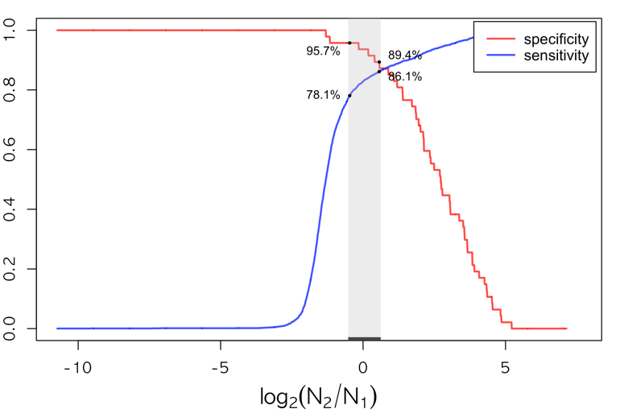 | 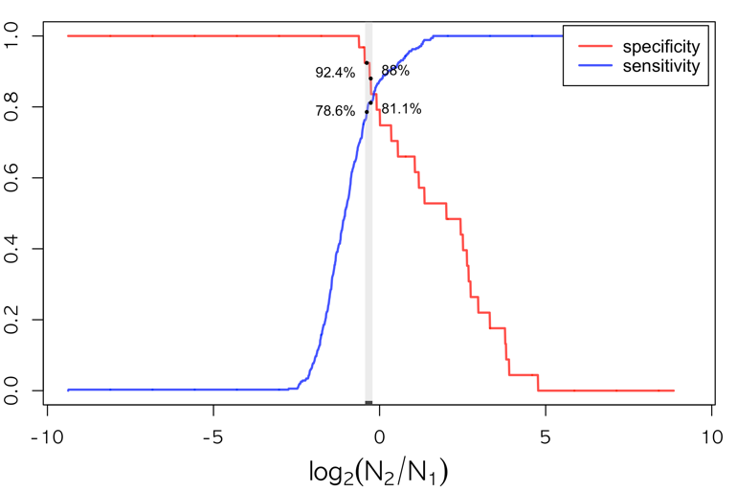
Note: The grey ribbon marks the threshold range −0.32 to 0.39 for the hybrid immunity group and −0.38 to -0.27 for the infection only group with specificity >90% and sensitivity >80%.

