Protective effectiveness of SARS-CoV-2 infection risk among hybrid, vaccine, and infection-induced immunity against the omicron variant, K-SEROSMART

Authors: Yifan Zhang¹, Won Chang^{2, 3}, Kevin Dieckhaus⁴, Suyoung Jo⁵, Jina Han⁶, Hye Jin Baek⁶, Eunbi Noh⁷, Kyuhyun Yoon⁵, Jung Ae Kim⁸, Jaehun Jung⁹, Kyong Ran Peck¹⁰, Hye-Sook Jeong¹¹, June-Woo Lee¹¹, Ah-Ra, Kim¹¹, Hyeon Nam Do¹¹, Youngji Jo¹²*, Dong-Hyun Kim^{13,14}*

Affiliations
- Department of Statistics, University of Connecticut, CT, USA
- Department of Statistics, Seoul National University, Seoul, Korea
- Institute for Data Innovation in Science, Seoul National University, Seoul, Korea
- Departments of Medicine, School of Medicine, UConn Health, CT, USA
- Institute of Health and Environment, Seoul National University, Seoul, Korea
- Department of Preventive Medicine and Public Health, Ajou University School of Medicine, Suwon, Korea
- National Radiation Emergency Medical Center, Korea Institute of Radiological and Medical Sciences, Seoul, Korea
- College of Nursing, Kyungbok University, Namyangju-si, Korea
- Department of Preventive Medicine, School of Medicine, Korea University, Seoul, Korea
- Division of Infectious Diseases, Samsung Medical Center, Sungkyunkwan University School of Medicine, Seoul, Korea
- Division of Clinical Research for Vaccine, Center for Vaccine Research, National Institute of Infectious Diseases, National Institute of Health, CheongJu, Korea
- Departments of Public Health Sciences, School of Medicine, UConn Health
- Department of Social and Preventive Medicine, Hallym University College of Medicine, Chuncheon, Korea
- Institute of Social Medicine, Hallym University College of Medicine, Chuncheon, Korea

Corresponding Authors:
Dong-Hyun Kim: dhkims@hallym.ac.kr
Youngji Jo jo@uchc.edu

ORCID ID
Yifan Zhang, Department of Statistics, University of Connecticut, CT, USA <zfranky6@uconn.edu> ORCID ID

Won Chang, Department of Statistics, Seoul National University, Seoul, Korea; Institute for Data Innovation in Science, Seoul National University, Seoul, Korea <wonchang@snu.ac.kr> ORCID ID

Kevin Dieckhaus, Departments of Medicine, School of Medicine, UConn Health, CT, USA, ORCID ID

Suyoung Jo, Institute of Health and Environment, Seoul National University, Seoul, Korea, <josuyoung1@gmail.com> https://orcid.org/0000-0001-7790-0160

Jina Han: Department of Preventive Medicine and Public Health, Ajou University School of Medicine, Suwon, Korea / <gkswlsdk1984@hanmail.net> / https://orcid.org/0000-0002-4649-0012

Hye Jin Baek: Department of Preventive Medicine and Public Health, Ajou University School of Medicine, Suwon, Korea / <hyejin2126@naver.com> / https://orcid.org/0000-0001-8900-5542

Eunbi Noh: National Radiation Emergency Medical Center, Korea Institute of Radiological and Medical Sciences, Seoul, Korea / <enbi104@gmail.com> / https://orcid. org/0000-0002-9867-127X

Kyuhyun Yoon: Institute of Health and Environment, Seoul National University, Seoul, Korea / <swnknh@snu.ac.kr> / https://orcid.org/0000-0001-7017-1145

Jung Ae Kim: College of Nursing, Kyungbok University, Namyangju-si, Korea / <ds2qzt@gmail.com> / https://orcid.org/0000-0002-7715 5372

Jaehun Jung, Department of Preventive Medicine, Korea University College of Medicine, Seoul, Korea <eastside1st@gmail.com> ORCID ID

Kyong Ran Peck, Division of Infectious Diseases, Samsung Medical Center, Sungkyunkwan University School of Medicine, Seoul, Korea, <krpeck@skku.edu> 0000-0002-7464-9780

Hye-Sook Jeong, Division of Clinical Research for Vaccine, Center for Vaccine Research, National Institute of Infectious Diseases, National Institute of Health, CheongJu, Korea; https://orcid.org/0000-0009-0006-
9819-2398 <jeongnih@korea.kr>

June-Woo Lee, Division of Clinical Research for Vaccine, Center for Vaccine Research, National Institute of Infectious Diseases, National Institute of Health, CheongJu, Korea; https://orcid.org/0000-0002-
2923-5597 <junewoo1213@korea.kr>

Ah-Ra, Kim, Division of Clinical Research for Vaccine, Center for Vaccine Research, National Institute of Infectious Diseases, National Institute of Health, CheongJu, Korea; https://orcid.org/0000-0001-5610-3787 <kara9251@korea.kr>

Hyeon Nam Do, Division of Clinical Research for Vaccine, Center for Vaccine Research, National Institute of Infectious Diseases, National Institute of Health, CheongJu, Korea; https://orcid.org/0000-0002-9337-8859 <hndo@korea.kr>

Youngji Jo*, Departments of Public Health Sciences, School of Medicine, UConn Health <jo@uchc.edu> http://orcid.org/0000-0002-1440-2786

Dong-Hyun Kim*, Department of Social and Preventive Medicine, Hallym University College of Medicine, Chuncheon, Korea <dhkims@hallym.ac.kr> https://orcid.org/0000-0002-1492-5253

Words count: 3,431

Abstract
Background: Evaluating infection risk after the Omicron wave is challenging due to unconfirmed infections. We compared the risks of SARS-CoV-2 breakthrough infections among individuals with hybrid, vaccine-only, and infection-only immunity in South Korea, incorporating both laboratory-confirmed and serology-inferred infections.
Methods: Using nationwide surveillance data (August and December 2022), we defined immunity status as hybrid (infection plus vaccination), vaccine-only, and infection-only based on spike (S) and nucleocapsid (N) antibody profiles and vaccination history. Outcomes were analyzed under two definitions: conservative (laboratory-confirmed cases) and inclusive (laboratory-confirmed plus serology-inferred infections signaled by rising N-antibody titers). For unconfirmed events, infection dates were imputed by predictive mean matching, enabling Kaplan–Meier survival curves. Time-varying Cox models produced log hazard ratios (log-HRs).
Results: Incorporating serology increased estimated four-month infection probabilities from 2% to 20% (hybrid), 4% to 24% (infection-only), and 30% to 40% (vaccine-only). The relative advantage of hybrid immunity diminishes substantially. Under the conservative definition, log-HRs declined from 4.10 to 2.34 for hybrid vs. vaccine-only and 1.56 to 0.31 for hybrid vs infection-only. Under the inclusive definition, they fell from 3.44 to 0.13 for vaccine-only and reversed from 3.31 to –0.56 for infection-only.
Conclusions: Since laboratory-confirmed cases primarily reflect symptomatic disease, vaccination appears to confer added protection against severe infection, yet this benefit fades within a few months. The rapid decline of hybrid immunity and the high burden of unconfirmed infections underscore the need for routine serological monitoring to curb silent transmission and for timely booster campaigns to prevent severe infections in Omicron-driven epidemics.

Introduction
Both natural SARS-CoV-2 infection and COVID-19 vaccination jointly shape play crucial roles in developing population-level immunity [1]. While immune responses are complex and multifaceted, epidemiological studies often rely on measurable indicators like antibodies to assess population immunity and the durability of antibody responses following infection and/or vaccination [2]. Several epidemiological studies show that hybrid immunity (a result of both infection and vaccination) had the highest magnitude and durability of protection against all outcomes, emphasizing the importance of providing vaccination to previously infected individuals as infection-induced protection against reinfection wanes rapidly, but vaccination further increases durability [3,4]. However, the extent and duration of hybrid immunity’s waning—especially following Omicron infections—remain largely uncharacterized. The widespread rise of the Omicron (B.1.1.529) variant, which has led to a significant number of individuals possessing hybrid immunity, complicates efforts to measure and compare this protection. Disparate rates and timings of past infections, variations in vaccine types and number of doses, and evolving variants of concern capable of evading existing immunity present additional challenges in estimating the overall magnitude and durability of this protection [5].

Recent systematic reviews and meta-analyses have provided more comprehensive evidence regarding the durability and efficacy of hybrid immunity during the Omicron period. A 2023 systematic review by Bobrovitz et al., synthesizing data from over 65 studies, found that hybrid immunity provides significantly stronger and longer-lasting protection compared to vaccination or prior infection alone. Protection against severe disease remained high (>95%) at 12 months post-exposure, while protection against reinfection declined to approximately 41.8% over the same period[6]. A recent study found that hybrid immunity, especially with booster vaccination, provided the strongest protection against SARS-CoV-2 reinfection—reducing risk by up to 57% compared to natural immunity alone and by 65% compared to complete vaccination alone—with effectiveness highest shortly after boosting and gradually waning over time [7,8]. However, much of the existing research on SARS-CoV-2 seroprevalence-based immunity has focused on specific groups—such as healthcare workers or immunocompromised individuals[9]), leaving the magnitude and durability of immune protection in the general population less thoroughly explored[10,11]. Moreover, most large-scale seroprevalence studies across various countries primarily account for laboratory-confirmed infections, overlooking a potentially sizable number of unreported or asymptomatic cases[12–14]. These findings highlight that while hybrid immunity provides the strongest protection against severe outcomes during the Omicron era, continuous surveillance remains essential as new immune-evasive variants emerge and population immunity profiles evolve.[15]

The nationwide Korea Seroprevalence Study of Monitoring of SARS-CoV-2 Antibody Retention and Transmission (K-SEROSMART) was launched in August 2022, to examine the extent of COVID-19 infections—including unconfirmed cases—across local communities through longitudinal cohort surveillance [3]. Baseline findings revealed that most individuals had SARS-CoV-2 antibodies and uncovered a substantial number of previously undetected cases. With new Omicron sub lineages continually challenging existing vaccines, there remains a knowledge gap regarding how vaccination and infection influence long-term protection across diverse immunity groups, respectively. Our study compared the risks of SARS-CoV-2 breakthrough infections among individuals with hybrid, vaccine‑only, and infection‑only groups, counting both laboratory‑confirmed and serology‑inferred events. By shedding light on which populations are most susceptible to breakthrough infections and the relative risk and durability of hybrid, vaccine and infection-induced protection, these findings provide valuable evidence for tailoring targeted interventions and optimizing long-term immunization strategies in diverse community settings.

Methods

Participants. K-SEROSMART Wave 1 fieldwork, conducted from August 12 to September 5, 2022, enrolled 9,945 individuals from 5,041 households in 258 communities, representing every basic local government in South Korea. During face-to-face household interviews, participants reported health, demographic, and socioeconomic data during household interviews and provided blood samples at nearby health centers or clinics. Four months later, in Dec 2022, the subsequent second survey (Wave 2) revisited the same cohort—shortly after the Omicron BA.5 summer peak—to track shifts in immunity, reinfection rates, and COVID‑19 vaccine effectiveness. December was chosen because a mild winter resurgence driven by BA.5 sub‑lineages BF.7 and BQ.1 coincided with rollout of Korea’s bivalent booster, offering an ideal window to observe short‑term antibody dynamics and community reinfections [16]. Of 8,826 eligible individuals, 7,528 completed Wave 2. Detailed sampling and laboratory protocols are available elsewhere [17]. All public health centers and medical institutions in Korea are required to report the results of rapid antigen tests and reverse transcription polymerase chain reaction (RT-PCR) screening tests for newly confirmed COVID-19 cases to the COVID-19 information management system of the Korea Disease Control and Prevention Agency (KDCA) within 24 hours. For consenting participants, identifiers (name, sex, birth date, home address) linked survey responses to KDCA records of confirmed infections and vaccination history [17].

Sample collection and cohort definitions. The serum samples were analyzed for SARS-CoV-2 antibodies using the Elecsys Anti-SARS-CoV-2 test (Roche). Blood samples were analyzed for anti-spike (anti-S) and anti-nucleocapsid (anti-N) antibodies using an electrochemiluminescence immunoassay. Anti-S results were numerical, positive if the cut-off index was ≥0.80 U/mL, indicating antibodies from infection or vaccination. [18]. Anti-N assay results were classified as non-reactive or reactive, using a cut-off index of ≥ 1.0 for reactivity. A reactive result indicates the presence of anti-N antibodies formed from a prior natural infection.[18]. The cohort was divided into four immunity types: hybrid-induced (S+N+ with vaccination), vaccine-induced (S+N− with vaccination), infection-only (S−N+, S+N−, or S+N+ without vaccination), and naive (S−N−) [19,20] (Figure 1). After the Omicron wave in South Korea, 90% had hybrid or vaccine-induced immunity, 8% infection-induced, and 2% no immunity as of August 2022.

COVID-19 infection outcomes: We evaluated two outcome types: 1) conservative outcomes (laboratory confirmed infections) and 2) inclusive outcomes (confirmed and unconfirmed infections) between K-SEROSMART Waves 1 and 2. Confirmed infections were identified through positive test results recorded in the KDCA database. Unconfirmed infections, without a corresponding COVID-19 diagnosis in KDCA records, were identified serologically by anti-N status or titer changes between Wave 1 and 2. In the vaccine group, undiagnosed infections were identified by a change in anti-N status from nonreactive at Wave 1 to reactive at Wave 2. In the hybrid and infection-only groups, undiagnosed infections were defined by a statistically significant increase in anti-N titer level between Waves 1 and 2—based on criteria of sensitivity >80% and specificity >90% (Figure S1). Because N-antibodies typically appear one to two weeks (or sometimes longer) after the onset of infection, this approach balances the risk of misclassification. Unconfirmed infections in the hybrid and infection-only cohorts were classified when the follow-up-to-baseline anti-N ratio exceeded a threshold (N2/N1 > 1), a cut-off chosen to keep the false-positive rate below 10 %.

To ensure the validity of our assessment of infection risk differences by immunity status at Wave 1, we applied the following exclusion criteria: First, for conservative outcome definition, we excluded participants vaccinated before confirmed infections (e.g., N=761, hybrid group) based on the exact timing of vaccination and confirmed infection from the KDCA database. We included those who have confirmed infection records from the KDCA database (e.g., N=62 for the hybrid induced group) between Waves 1 and 2, regardless of participation in Wave 2. Second, for the inclusive outcome definition, we excluded those who did not participate in Wave 2 (e.g. loss to follow up, N=898 for the hybrid induced group) because their change in anti-N status could not be assessed. We also excluded participants who received any vaccination during the interval between Waves 1 and 2, as vaccination alters antibody profiles, and the exact timing of unconfirmed infection is unknown (e.g. N=762 for the hybrid induced group).

Figure 1: Cohort Classification and Outcome Determination Based on Vaccination and Infection Status, using data from K-SEROSMART Waves 1 and 2, and KDCA from August 2022 to December 2022

A. Conservative outcome
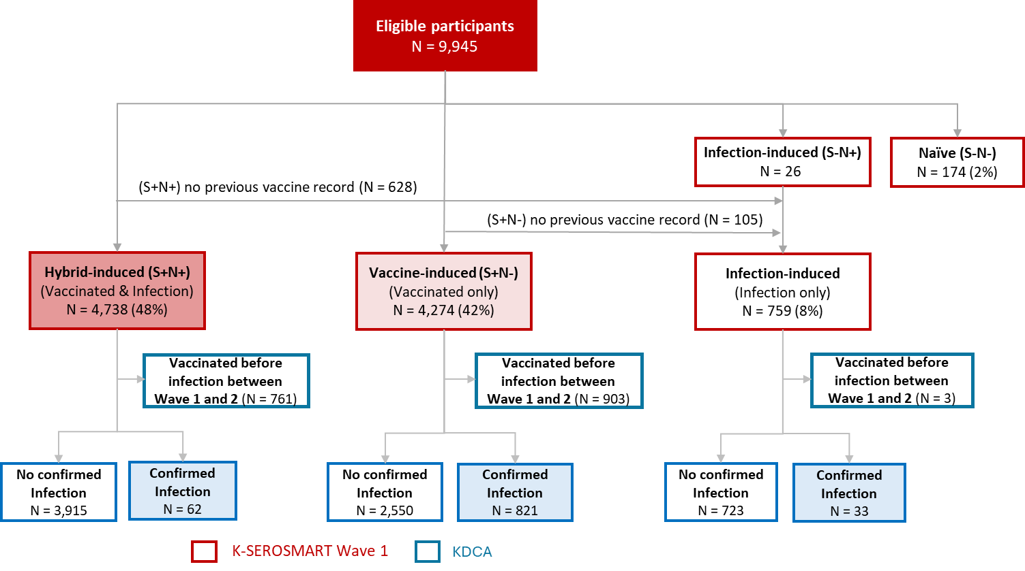
B. Inclusive outcome
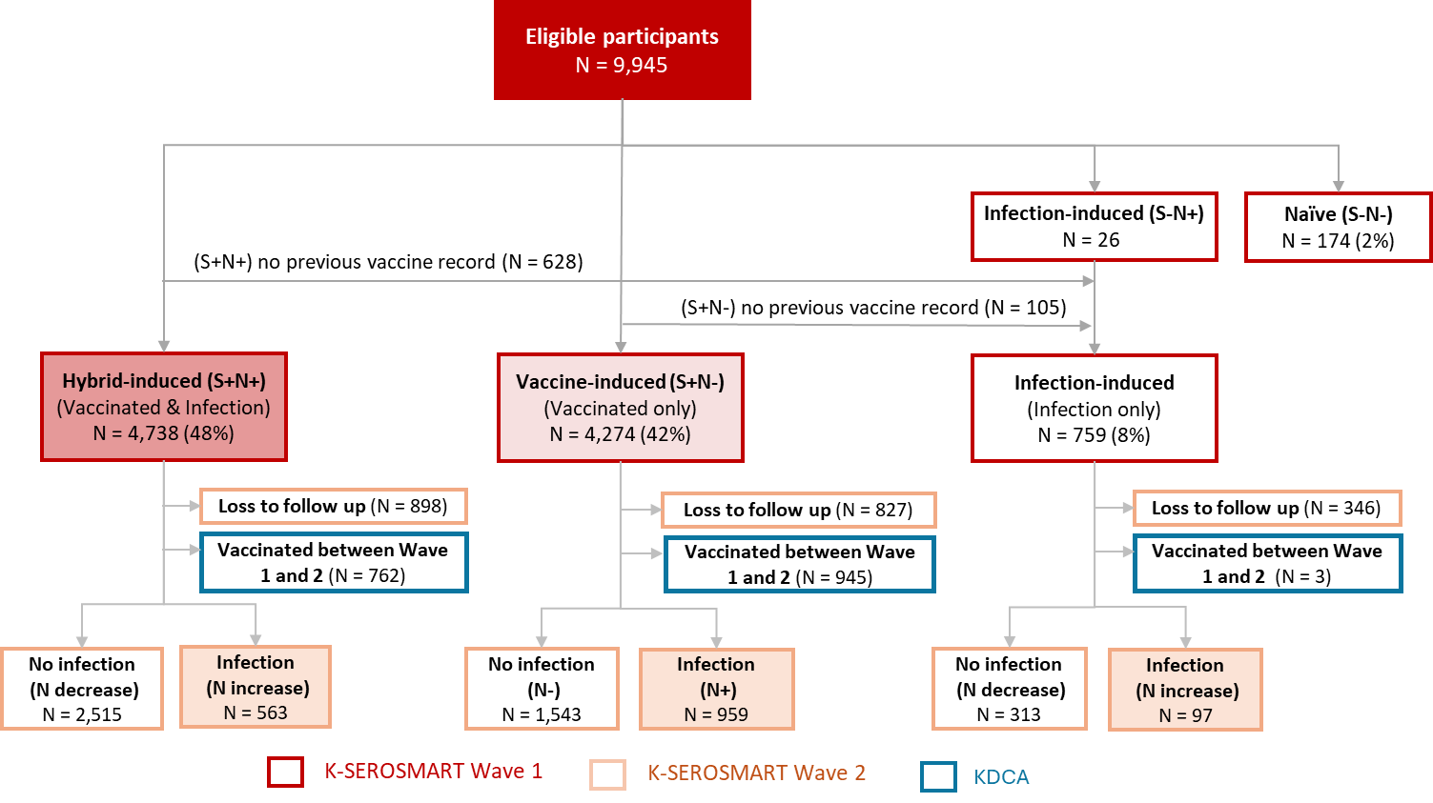

Statistical analysis. We performed survival analyses for conservative and inclusive outcomes across three immunity groups. Missing infection dates for unconfirmed cases were multiply imputed under the missing-at-random assumption using the {mice} R package with predictive mean matching (PMM). [21]. Dates were expressed as time gaps from the first surveillance, with epidemic-wave indicators to preserve calendar-time structure. Gaps for confirmed cases were estimated from a regression model with demographic (age, sex), clinical (vaccine doses, comorbidities, time since last immunological event), and serological variables (anti-S, anti-N levels). Donor pools were stratified by age and vaccination status, and PMM sampled from the 5–10 nearest neighbors to retain variability and avoid over-smoothing [22]. Fifty imputations were generated, incorporating all covariates from the survival model. Imputed and observed dates showed similar epidemic timing, and delta-adjusted shifts of ±14 days confirmed robustness. Survival probabilities were compared across hybrid, vaccine-induced, and infection-induced groups using age-standardized Kaplan–Meier curves (Figure 2).

We used a time-varying Cox model with log-transformed time interactions because Schoenfeld residual tests indicated proportional hazards violations in both the conservative and inclusive cohorts, rendering the standard model unsuitable. (Table S1 and S2). Vaccine- and infection-induced immunity effects were modeled as functions of log(time), allowing hazard ratios to vary continuously while maintaining interpretability[23,24]. Log-transformed time effectively captured gradual changes in covariate effects[25]. Similar approaches have modeled time-varying effects in epidemiological studies[26,27], providing flexibility for non-proportional hazards. We fitted a full model with age, sex, and BMI, but only age and sex were significant. Time since the last immunological event was excluded due to missing prior infection dates in the infection-induced group. Comorbidity burden was not significantly associated with infection risk and was excluded from final models. The final model is specified as follows. Let $t$ denote time in months and let $h(t)$ represent the hazard function at time $t$. The baseline hazard function is denoted by $h_{0}(t)$. The covariates $Immune_{vac}$ and $Immnue_{infec}$ are binary indicators for vaccine-induced and infection-induced immunity, respectively, with hybrid-induced immunity serving as the reference category. Age and sex are similarly included as categorical indicator variables. The hazard function is expressed as:

$$h(t)=h_{0}\left(t\right)⋅exp⁡\{β_{1}⋅Immune_{vac}+ β_{2}⋅Immune_{infec}+β_{3}⋅Age_{<20}+β_{4}⋅Age_{20-39}+β_{5}⋅Age_{40-59}+β_{5}⋅Sex_{Female}+ γ_{1}⋅Immune_{vac}⋅\log\left(t\right)+ γ_{2}⋅Immune_{infec}⋅log⁡(t)\}$$

To validate the time-varying Cox model, we conducted a landmark analysis, dividing follow-up into monthly intervals to estimate observed hazard ratios (Table S3). This enabled comparison of model-based estimates with empirical trends. Similar strategies have been used in previous studies to assess the adequacy of time-varying effects and support model validation through interval-specific estimates [28,29]. Within each interval, Fisher’s Exact Test evaluated infection risk differences across immunity groups, suitable for binary outcomes and small event counts in later periods.

Results.

Table 1: Descriptive Characteristics of the Study Population by Immunity Type (Hybrid-, Vaccine-, and Infection-induced), August 2022 to December 2022.
Note: The sum of the proportion of the infection-induced group in time since the most recent immunological event is not 100% because some individuals do not have the last confirmed infection records or vaccination records.

Table 1 shows significant demographic and clinical differences among hybrid-induced (S+N+), vaccine-induced (S+N–), and infection-induced immunity groups. The infection-only group was notably younger (68.2% aged <20 vs. 8.4% hybrid, 5.9% vaccine). Hybrid and infection-only groups had more recent immunological events (74% and 66% within 6 months, vs. 37% vaccine). The hybrid had fewer four dose vaccination before Wave 1 (13% vs. 25% vaccine). Across both outcome definitions, the hybrid group had the lowest infection rates: under the conservative definition, 2% vs. 4% (infection-only) and 21% (vaccine-only); under the inclusive definition, 12% vs. 14% and 24%, respectively.

Table 2: Characteristics of Participants of Breakthrough Infection Events by Immunity Type (Hybrid-, Vaccine-, and Infection-induced) and Outcome Definition (Conservative vs. Inclusive), August 2022 to December 2022
Note: confirmed infections and N increase cases are defined according to the conservative and inclusive cohorts outlined in Figure 1. The N increase but not confirmed cases group is a subset of the ‘N increase’ group, excluding individuals with confirmed infections. In the hybrid group, 563 participants showed an N-titer rise between Wave 1 and 2; Among these participants, 520 lacked laboratory‑confirmed infection dates, whereas 43 had dates recorded in the KDCA database—forming part of the 62 confirmed cases. The remaining 19 missed Wave 2 but were still counted in the conservative outcome because their infection dates were confirmed in the KDCA database.

Table 2 shows notable differences in the estimated number of unconfirmed infections between conservative and inclusive outcomes across immunity groups. Under the inclusive criteria, the number of potential infections is substantially higher than in the conservative approach (e.g., 563 vs. 62 in the hybrid group; 959 vs. 821 in the vaccine group; 97 vs. 33 in the infection only group), because it includes “N increase/positive but not confirmed” cases. This pattern is further reflected in the confirmation status distribution: 92% (520 out of 563) of infections within the hybrid-induced group not receiving laboratory confirmation, and 81% (79 out of 97) in infection-only group, while 50% (477 out of 959) of infections in the vaccine-induced immunity group.

The discrepancy between conservative and inclusive outcomes stem from the interval since the most recent immunological event and the participants’ age distribution. At Wave 1, the inclusive criteria classified 33 % of hybrid-immunity cases as < 1 month post-immunological event, versus 4 % under the conservative criteria. Similarly, among vaccine-only cases, the inclusive definition captured 19 % that were < 1 month post-immunological event, compared with 5 % under the conservative definition. Anti-N threshold analyses suggest a 10% false-positive error (Figure S1), especially for unconfirmed cases within 1 month post-immunological event with delayed N-titer rise (e.g., 10% of 181 hybrid, 24 infection-only). Age impacts outcomes: adults 40–59 dominate unconfirmed infections in hybrid (37%) and vaccine-only (45%) groups, while those <20 dominate infection-only (69%).

Figure 2: Kaplan-Meier Survival Curves by Immunity Type (Hybrid-, Vaccine-, and Infection-induced) and Outcome Definition (Conservative vs. Inclusive), August 2022 to December 2022
- Conservative outcome definitions | - Inclusive outcome definitions
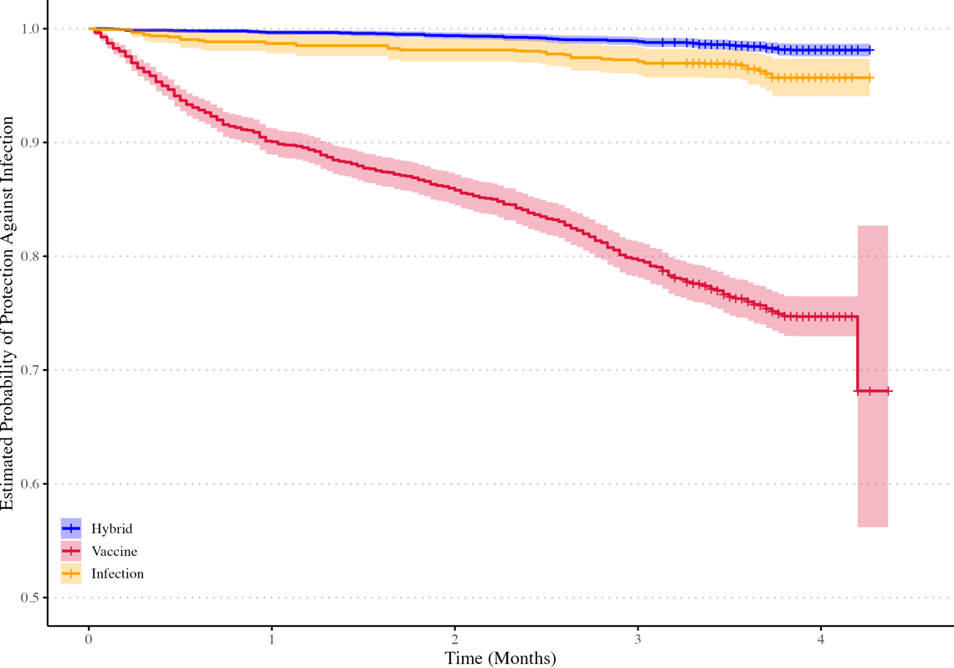 | 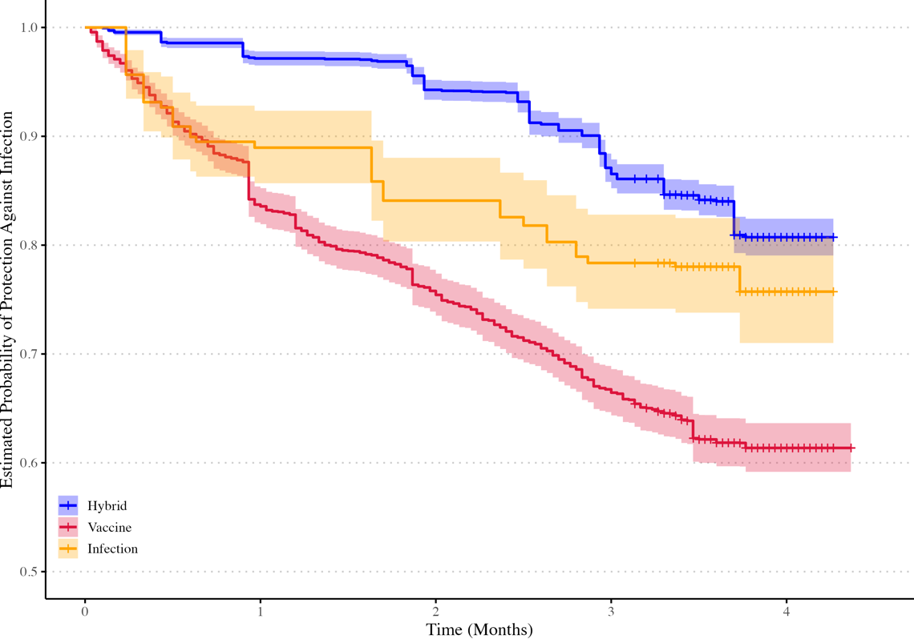

Figure 2 shows Kaplan-Meier survival curves for remaining COVID-19 infection-free over 4 months between Waves 1 and 2, using conservative (Panel A) and inclusive (Panel B) outcome definitions. It compares hybrid, vaccine, and infection-induced immunity groups. By month 4, the conservative outcome definition yielded infection risks of 2 % (95 % CI 1.3%–1.9%) for the hybrid-immunity, 4% (2.3%-5.6%) in the infection only, and 30 % (17.3%–41.8%) in the vaccine-only; under the inclusive outcome definition, these rose to 20 % (18.1%–19.9%), 24% (19.6%-29.1%) and 40 % (36.3%–43.5%) respectively.

Figure 3: Time-varying Cox Log Hazard Ratios for Vaccine and Infection Only-Immunity Groups Against Hybrid Immunity Group, August 2022 to December 2022
- Conservative outcome definition | - Inclusive outcome definition
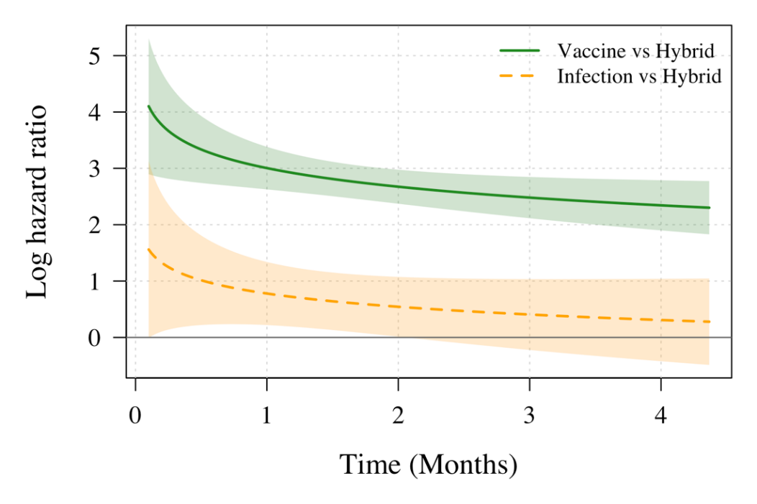 | 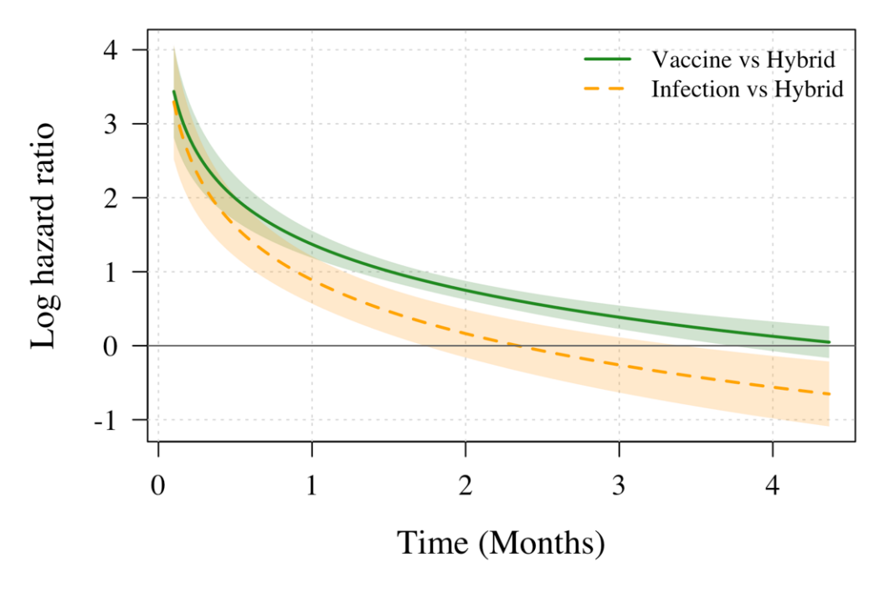
Table 3. Monthly Log Hazard Ratios Estimated from Time-varying Cox Regression for Vaccine and Infection Only-Immunity Groups Against Hybrid Immunity Group, August 2022 to December 2022
- Conservative outcome definition | - Inclusive outcome definition
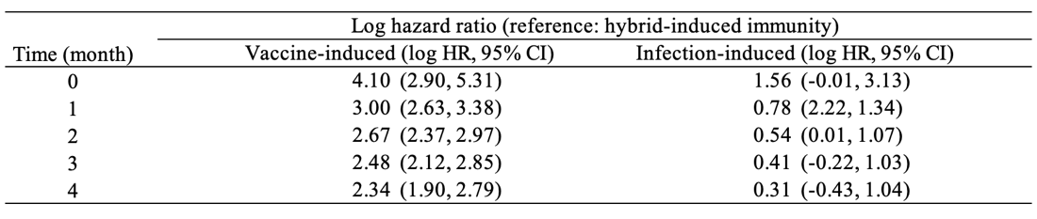 | 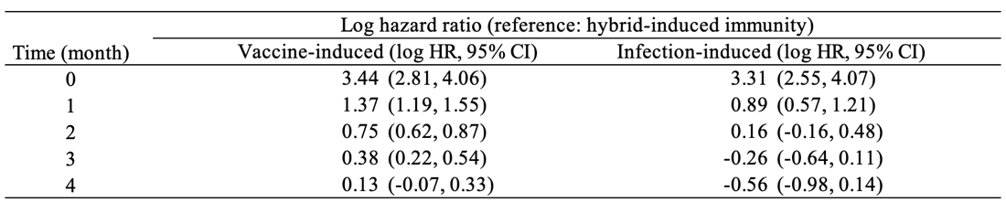

Figure 3 displays time-varying log hazard ratios from Cox regression models, comparing vaccine- and infection-induced immunity to hybrid-induced immunity using log-transformed time interactions. Conservative (Panel a) and inclusive (Panel b) definitions show notable differences in vaccine-induced immunity’s baseline log hazard ratios. As shown in Table 3, under conservative outcomes, hybrid immunity had the lowest log hazard ratios for lab-confirmed COVID-19 over four months. Vaccine-only immunity had the highest excess risk, with log hazard ratios vs. hybrid falling from 4.10 (95% CI: 2.90, 5.31) at baseline to 2.34 (1.90, 2.79) at month 4, remaining significant. Infection-only immunity started at 1.56 (-0.01, 3.13), dropping to 0.78 at month 1 and 0.31 by month 4, with confidence intervals overlapping the null from month 3, indicating convergence with hybrid immunity.

Under the inclusive outcome definition, the vaccine-induced group initially showed a higher infection risk, with log hazard ratios of 3.44 (2.81, 4.06) compared to the hybrid-induced immunity group. By month 4, this dropped to 0.13 (–0.07, 0.33), indicating near-equal protection. The infection-induced group started with log hazard ratios of 3.31 (2.55, 4.07), but by month 2, it fell below zero, suggesting greater protection than hybrid immunity. By month 4, its confidence interval was –0.56 (–0.98, –0.14), showing significant protection. Table S3 confirms these trends, with hazard ratios for hybrid vs. vaccine-induced dropping from 5.64 to 1.33, and hybrid vs. infection-induced from 3.63 to 0.35, indicating hybrid immunity’s advantage wanes over four months.

Discussion

Using nationwide, community-based surveillance conducted after South Korea’s Omicron wave, we compared infection risks among hybrid, vaccine-only, and infection-only immunity groups. Hybrid immunity showed the lowest log hazard ratios for both inclusive and conservative outcomes over four months. Including unconfirmed infections reduced hybrid immunity’s protective benefit, with infection risk rising from 2% to 20% in the hybrid group, altering comparative hazard ratios. The hybrid vs. vaccine-only log hazard ratio fell from 3.44 to 0.13, and the hybrid vs. infection-only reversed from 3.31 to –0.56 under inclusive outcomes. Several factors may contribute to these trends, including differences in the time since the last immunological event and variations in cohort demographic profiles across the immunity groups. Under the conservative outcome definition, the log hazard ratio of hybrid vs. vaccine-only immunity dropped from 4.10 to 2.34, and that of hybrid vs. infection-only immunity dropped from 1.56 to 0.31.

To our knowledge, this study is the first to systematically evaluate efficacy using both conservative (PCR-confirmed) and inclusive (serology-detected) definitions of breakthrough infection. PCR-based outcomes primarily capture protection against symptomatic disease—events critical for healthcare capacity—while serology reveals broader, often undiagnosed infections that better quantify immunity’s role in preventing transmission. Evidence from 2022–2024 [33–36] shows Omicron subvariants (BA.1, BA.2, BA.5) increased mild or asymptomatic breakthroughs, with hybrid immunity providing robust yet time-waning protection, especially against severe disease. Our findings indicate that even long-ago vaccination, combined with hybrid immunity, prevents symptomatic illness effectively, outperforming vaccine-only and infection-only groups for at least four months. However, hybrid immunity against all infections declines more quickly, dropping below the infection-only group within 2–4 months. This result aligns with Bobrovitz et al.[6] that the protective advantage of hybrid immunity over infection-only immunity wanes over time, with estimates converging by around 4–6 months. These findings underscore that the definition of a study's endpoint reveals the groups vulnerable to silent infection and the duration of its outcome for targeted and timely booster campaigns.

Our study employs a robust approach to quantify and compare infection risks across immunity groups by estimating infection timing (via PMM) for survival analysis and quantifying uncertainty around N-antibody titer thresholds to define infections. We applied a time-varying Cox proportional hazards model to mitigate survival bias in calendar-time follow-up. Yet, residual survival bias may persist due to unequal times since the last immunological event. At baseline, time-varying hazard ratios show higher infection risks in the vaccine-only group, likely due to the majority of their last immune event occurring ≥6 months prior, leading to antibody titer decline against Omicron sub-variants. This bias likely underestimates later risks in the vaccine-only group, as higher early hazards in the vaccine-only group disproportionately remove highly susceptible individuals (who are likely older population and with a longer time since the last immunological event), leaving a less susceptible "survivor" subset. This narrows the apparent risk gap with the hybrid immunity group, even if underlying protection is not truly superior, emphasizing the need for timely boosters and non-pharmaceutical precautions in this group. The infection-only group, despite the majority of <6-month immune event gaps, also has elevated initial risk, suggesting qualitative differences in protection beyond timing. Natural infection may induce a broader but less consistent immune response compared to vaccines, influenced by infecting strain, disease severity, and host factors, potentially resulting in weaker or narrower immunity in some individuals, increasing early reinfection risk [30,31]. Nevertheless, we think our findings remain robust, demonstrating that hybrid immunity offers superior but rapidly waning protection—approaching the risk of vaccine-only group and turning inferior to the infection-only group by the fourth month under an inclusive infection definition.

Our study has limitations. First, lacking symptom-level data for Waves 1 and 2, we treated infection as a binary event, unable to assess if hybrid, vaccine-only, or infection-only immunity differently protects against severe COVID-19. Future studies should combine N-antibody surveillance with clinical endpoints (symptom severity, hospitalization) to evaluate waning patterns for severe outcomes, refining booster timing. Second, the loss to follow-up in Wave 2 (19%, 19%, and 46% for the hybrid, vaccine, and infection groups, respectively) for the inclusive outcome may slightly bias the estimated infection risks. While a small proportion of those lost to follow-up (2%, 22%, and 2% for the hybrid, vaccine, and infection groups) were confirmed infected in the KDCA database, their true infection status cannot be fully determined. Assuming random loss to follow-up with similar underlying risk across groups, our key finding remains unchanged: hybrid immunity shows the highest—but steadily declining—risk relative to other groups when infections are defined inclusively rather than conservatively. Third, Anti-N assays based on the Wuhan-Hu-1 antigen may under-detect Omicron infections, waning titers and sampling timing further compound misclassification. Although our sensitivity analyses confirmed stable N titer cut off for infection outcome in hybrid and infection-only groups, very recent infections (≤1 month) were under-powered, possibly obscuring delayed seroconversion. Larger cohorts, stratified by age, infection recency, and vaccination status, are needed to refine N titer thresholds, especially in pediatric and older adults. Fourth, Anti-N identifies exposure but not protective immunity; S-titer better predicts risk via neutralizing capacity. Our reliance on N-titer alone limited our ability to assess functional protection. Future studies with larger sample size could stratify individuals by S-titer levels (high, medium, low) based on protective thresholds derived from neutralization studies or incorporate additional markers such as mucosal IgA and SARS-CoV-2-specific T-cell assays to distinguish immune imprinting—where prior exposure biases responses toward ancestral epitopes—from recent Omicron exposure. Such multi-analyte profiling could clarify whether the rapid decline in immunity is driven by biological factors (e.g., waning kinetics, immune imprinting) or behavioral factors (e.g., differential exposure, testing-seeking practices), informing targeted vaccination and surveillance strategies. Finally, unmeasured confounders (e.g., occupation, healthcare-seeking behavior) may affect breakthrough infection estimates. Nevertheless, by integrating quantitative serology with registry data, our study quantified the relative risk and durability of hybrid, vaccine‑only, and infection‑only immunity and identified groups vulnerable to silent infection and targeted for timely booster campaigns.

Conclusions

K-SEROSMART surveillance post-South Korea’s Omicron wave shows that hybrid immunity’s initial lower infection risk fades when including anti-N-detected, unreported infections. Inclusive definitions raise risk estimates: hybrid from 2% to 20%, infection-only from 4% to 24%, vaccine-only from 30% to 40%, compared to conservative definitions. Hybrid immunity’s advantage wanes under inclusive definitions, with vaccine-induced log hazard ratio dropping from 3.44 to 0.13 and infection-induced from 3.31 to –0.56 by month 4. High unconfirmed infection rates (92% hybrid, 50% vaccine-only, 81% infection-only) reveal surveillance gaps skewing protection comparisons. The rapid decline of hybrid immunity and the high burden of unconfirmed infections underscore the need for routine serological monitoring to curb silent transmission and for timely booster campaigns to prevent severe infections in Omicron-driven epidemics.

List of abbreviations
- Anti-N – Anti-nucleocapsid protein
- Anti-S – Anti-spike protein
- CI – Confidence interval
- COVID-19 – Coronavirus disease 2019
- HR – Hazard ratio
- K-SEROSMART – Korea Seroprevalence Study of Monitoring of SARS-CoV-2 Antibody Retention and Transmission
- KDCA – Korea Disease Control and Prevention Agency
- SARS-CoV-2 – Severe acute respiratory syndrome coronavirus 2

Declarations
Ethical approval and consent to participate
The Institutional Review Board of the KDCA exempted this survey from review, in accordance with Article 36 of the Bioethics Act, Article 33 of the Enforcement Rules, and Article 2 of the Bioethics Act. The study was deemed necessary for urgent public health action and was conducted directly or commissioned by the state or local government to review and evaluate public welfare or service programs (2022-11-02-PE-A). All participants provided informed consent.

Consent for publication
Not applicable.

Availability of data and materials
All the processed data and code can be found at GitHub Link: https://github.com/UConn-Health-Disease-Modeling/2023_South_Korea_Seroprevalence.git

Competing Interests
The authors declare that they have no competing interests.

Funding
This work was supported by the National Institutes of Health of the Korea Disease Control and Prevention Agency grant number 2022-ER2603-00, the National Research Foundation of Korea (NRF) grant funded by the Korea Ministry of Science and ICT (MSIT) (grant number RS-2025-00523567) and New Faculty Startup Fund from Seoul National University (grant number 326-20240027).

Author Contributions
DHK, YJJ, YZ, and WC conceptualized the study. YZ performed the data analysis and visualization. YZ and YJJ completed the first draft of the manuscript. DHK and SJ had directly accessed and verified the underlying data. KD, SJ, WC, JJ, KRP, and DHK interpreted the results and critically revised the manuscript. DHK supervised the project administration. DHK, YJJ, YZ, JJ, and SJ had full access to all the data in the study and accepted responsibility to submit for publication. All authors read and approved the submitted version.

Acknowledgments
Not applicable.

References

1. Gazit S, Saciuk Y, Perez G, et al. Hybrid immunity against reinfection with SARS-CoV-2 following a previous SARS-CoV-2 infection and single dose of the BNT162b2 vaccine in children and adolescents: a target trial emulation. Lancet Microbe. Elsevier; 2023; 4(7):e495–e505.
2. Karachaliou M, Moncunill G, Espinosa A, et al. SARS-CoV-2 infection, vaccination, and antibody response trajectories in adults: a cohort study in Catalonia. BMC Med. Springer Science and Business Media LLC; 2022; 20(1):347.
3. Andeweg SP, Gier B de, Eggink D, others. Protection of COVID-19 vaccination and previous infection against Omicron BA.1, BA.2 and Delta SARS-CoV-2 infections. Nat Commun. Springer Nature; 2022; 13:4738.
4. Goldberg Y, Mandel M, Bar-On YM, et al. Protection and Waning of Natural and Hybrid Immunity to SARS-CoV-2. N Engl J Med. Massachusetts Medical Society; 2022; 386(23):2201–2212.
5. Andrews N, Stowe J, Kirsebom F, et al. Covid-19 Vaccine Effectiveness against the Omicron (B.1.1.529) Variant. N Engl J Med. 2022; 386(16):1532–1546.
6. Bobrovitz N, Ware H, Ma X, et al. Protective effectiveness of previous SARS-CoV-2 infection and hybrid immunity against the omicron variant and severe disease: a systematic review and meta-regression. Lancet Infect Dis. Elsevier; 2023; 23(5):556–567.
7. Zheng H, Wu S, Chen W, et al. Meta-analysis of hybrid immunity to mitigate the risk of Omicron variant reinfection. Front Public Health [Internet]. Frontiers; 2024 [cited 2025 Apr 10]; 12. Available from: https://www.frontiersin.org/journals/public-health/articles/10.3389/fpubh.2024.1457266/full
8. Suntronwong N, Kanokudom S, Auphimai C, et al. Long-Term Dynamic Changes in Hybrid Immunity over Six Months after Inactivated and Adenoviral Vector Vaccination in Individuals with Previous SARS-CoV-2 Infection. Vaccines. 2024; 12(2):180.
9. Cromer D, Steain M, Reynaldi A, et al. Neutralising antibody titres as predictors of protection against SARS-CoV-2 variants and the impact of boosting: a meta-analysis. Lancet Microbe. 2022; 3(1):e52–e61.
10. Ward H, Whitaker M, Flower B, et al. Population antibody responses following COVID-19 vaccination in 212,102 individuals. Nat Commun. Springer Nature; 2022; 13(1):907.
11. Moncunill G, Aguilar R, Ribes M, et al. Determinants of early antibody responses to COVID-19 mRNA vaccines in a cohort of exposed and naïve healthcare workers. EBioMedicine. Elsevier; 2022; 75:103805.
12. Havers FP, Reed C, Lim T, et al. Seroprevalence of Antibodies to SARS-CoV-2 in 10 Sites in the United States, March 23-May 12, 2020. JAMA Intern Med. 2020; .
13. Pollán M, Pérez-Gómez B, Pastor-Barriuso R, et al. Prevalence of SARS-CoV-2 in Spain (ENE-COVID): a nationwide, population-based seroepidemiological study. Lancet Lond Engl. 2020; 396(10250):535–544.
14. Silveira MF, Barros AJD, Horta BL, et al. Population-based surveys of antibodies against SARS-CoV-2 in Southern Brazil. Nat Med. Nature Publishing Group; 2020; 26(8):1196–1199.
15. Tsagkli P, Geropeppa M, Papadatou I, Spoulou V. Hybrid Immunity against SARS-CoV-2 Variants: A Narrative Review of the Literature. Vaccines. 2024; 12(9):1051.
16. Kim J-A, Kim I-H, No JS, et al. Surveillance and Outbreak Status of SARS-CoV-2 Originated from China. The Korea Disease Control and Prevention Ahency; 2023; 16(8):230–237.
17. Han J, Baek HJ, Noh E, et al. Korea Seroprevalence Study of Monitoring of SARS-COV-2 Antibody Retention and Transmission (K-SEROSMART): findings from national representative sample. Epidemiol Health. Korean Society of Epidemiology; 2023; 45:e2023075.
18. Rashidzadeh H, Danafar H, Rahimi H, et al. Nanotechnology against the novel coronavirus (severe acute respiratory syndrome coronavirus 2): diagnosis, treatment, therapy and future perspectives. Nanomed. Future Medicine Ltd; 2021; 16(6):497–516.
19. Garcia-Beltran WF, Denis KJS, Hoelzemer A, et al. mRNA-based COVID-19 vaccine boosters induce neutralizing immunity against SARS-CoV-2 Omicron variant. Cell. Cell Press; 2022; 185(3):457-466.e4.
20. Steensels D, Pierlet N, Penders J, Mesotten D, Heylen L. Comparison of SARS-CoV-2 Antibody Response Following Vaccination With BNT162b2 and mRNA-1273. JAMA. American Medical Association; 2021; 326(15):1533–1535.
21. Chen S, Xu C. Predictive Mean Matching Imputation Procedure Based on Machine Learning Models for Complex Survey Data. J Data Sci. International Press of Boston; 2024; 22(3):456–468.
22. Morris TP, White IR, Royston P. Tuning multiple imputation by predictive mean matching and local residual draws. BMC Med Res Methodol. BioMed Central; 2014; 14:75.
23. Therneau TM, Grambsch PM. Modeling Survival Data: Extending the Cox Model [Internet]. New York, NY: Springer; 2000 [cited 2025 May 19]. Available from: http://link.springer.com/10.1007/978-1-4757-3294-8
24. Hastie T, Tibshirani R. Varying-Coefficient Models. J R Stat Soc Ser B Methodol. 1993; 55(4):757–779.
25. Grambsch, Patricia M.; Therneau, Terry M. Proportional hazards tests and diagnostics based on weighted residuals. Biometrika. Oxford University Press for the Biometrika Trust; 1994; 81(3):515–526.
26. Ruhe C. Quantifying Change Over Time: Interpreting Time-varying Effects In Duration Analyses. Polit Anal. 2018; 26(1):90–111.
27. Keogh RH, Morris TP. Multiple imputation in Cox regression when there are time-varying effects of covariates. Stat Med. 2018; 37(25):3661–3678.
28. Rizopoulos D, Murawska M, Andrinopoulou E-R, Molenberghs G, Takkenberg JJM, Lesaffre E. Dynamic Predictions with Time-Dependent Covariates in Survival Analysis using Joint Modeling and Landmarking [Internet]. arXiv; 2013 [cited 2025 May 21]. Available from: http://arxiv.org/abs/1306.6479
29. Putter H, Houwelingen HC van. Understanding Landmarking and Its Relation with Time-Dependent Cox Regression. Stat Biosci. 2017; 9(2):489–503.
30. Zhang Q, Jiao L, Chen Q, et al. COVID-19 antibody responses in individuals with natural immunity and with vaccination-induced immunity: a systematic review and meta-analysis. Syst Rev. 2024; 13(1):189.
31. Gazit S, Shlezinger R, Perez G, et al. Severe Acute Respiratory Syndrome Coronavirus 2 (SARS-CoV-2) Naturally Acquired Immunity versus Vaccine-induced Immunity, Reinfections versus Breakthrough Infections: A Retrospective Cohort Study. Clin Infect Dis. 2022; 75(1):e545–e551.
32. Altarawneh HN, Chemaitelly H, Ayoub HH, et al. Effects of Previous Infection and Vaccination on Symptomatic Omicron Infections. N Engl J Med. 2022; 387(1):21–34.
33. Altarawneh HN, Chemaitelly H, Ayoub HH, et al. Effects of Previous Infection and Vaccination on Symptomatic Omicron Infections. N Engl J Med. Massachusetts Medical Society; 2022; 387(1):21–34.
34. Bellusci L, Grubbs G, Zahra FT, et al. Antibody affinity and cross-variant neutralization of SARS-CoV-2 Omicron BA.1, BA.2 and BA.3 following third mRNA vaccination. Nat Commun. Nature Publishing Group; 2022; 13(1):4617.
35. Wang Q, Guo Y, Iketani S, et al. Antibody evasion by SARS-CoV-2 Omicron subvariants BA.2.12.1, BA.4 and BA.5. Nature. Nature Publishing Group; 2022; 608(7923):603–608.
36. Tallei TE, Alhumaid S, AlMusa Z, et al. Update on the omicron sub-variants BA.4 and BA.5. Rev Med Virol. 2023; 33(1):e2391.
37. Jia T, Wang F, Chen Y, et al. Expanded immune imprinting and neutralization spectrum by hybrid immunization following breakthrough infections with SARS-CoV-2 variants after three-dose vaccination. J Infect [Internet]. Elsevier; 2024 [cited 2025 Aug 15]; 89(6). Available from: https://www.journalofinfection.com/article/S0163-4453(24)00297-4/fulltext
38. Chemaitelly H, Ayoub HH, Coyle P, et al. Protection of Omicron sub-lineage infection against reinfection with another Omicron sub-lineage. Nat Commun. Nature Publishing Group; 2022; 13(1):4675.
39. Kerr S, Robertson C, Hillman S, Grange Z, Sullivan C, Sheikh A. Severity of BA.2 variant and vaccine effectiveness against symptomatic disease in Scotland. Lancet Reg Health – Eur [Internet]. Elsevier; 2022 [cited 2025 May 20]; 23. Available from: https://www.thelancet.com/journals/lanepe/article/PIIS2666-7762(22)00229-0/fulltext

