Tentative title: Care Cascade Inefficiencies as Transmission Multipliers: An Agent-Based Model of Tuberculosis in India

Authors (TBD): Youngji Jo¹, Jonathan Bloedow², Sourya Shrestha³, Katia Bulekova⁴, Steward Chang²*

Affiliations:
Department of Public Health Sciences, School of Medicine, University of Connecticut
Bill & Melinda Gates Foundation
Boston University

Word count: /5000
Tables/Figures: upto 5

Abstract (/300)
Background. India bears one quarter of the global tuberculosis (TB) burden. End-TB Strategy targets a 90% incidence reduction by 2035, but the conventional cascade-of-care framework — which scores national programmes by aggregate metrics such as treatment-success rate — obscures substantial patient-level heterogeneity in cascade trajectories.
Methods. We extended an EMOD agent-based TB transmission model calibrated to Indian incidence, prevalence, and notification time-series (1997–2024) to track every patient episode through diagnostic and treatment events. Active TB episodes were partitioned into four loop groups based on calibrated counts of false-negative diagnostic tests, pre-treatment defaults, and treatment failures: NoLooponly, TestLooponly, TestTxfail, and Txfailonly. We simulated 8 intervention scenarios (Baseline, ACF, Dx, Tx, and all combinations) starting in 2025 and projected outcomes to 2035. We calibrated the model to natural history of TB, India specific historic incidence and carecascade data; 25% (NoLooponly) progressed through a single-pass cascade; 45% experienced ≥1 false-negative or pre-treatment default (TestLooponly); 25% experienced both diagnostic loops and treatment failure (TestTxfail). Per-patient effective infectious time differed substantially across groups (NoLoop: ~1.7 months; TestTxfail: ~9 months).
Results. Of 88,529 simulated active TB episodes, 25% TestTxfail minority generated 42% of cascade-driven transmission (Pareto disparity, Gini ≈ 0.45). Intervention impacts were mechanistically specific: ACF preferentially shrank NoLoop entries, diagnostic improvement targeted TestLooponly, and treatment-adherence improvement targeted TestTxfail. Comprehensive ACF+Dx+Tx achieved 79% incidence reduction by 2035; no single-component bundle reached the End-TB 2035 90% target.
Conclusion. Aggregate cascade indicators systematically over-credit programmes that retain patients only after multiple cycles. Loop-group analysis identifies a structurally definable minority that drives transmission and quantifies why combination interventions are not substitutes but complements. Reaching End-TB targets in high-loop settings requires explicit cascade-loop interruption alongside coverage expansion.

Introduction
Despite being curable in the vast majority of cases, tuberculosis (TB) is the leading cause of infectious mortality worldwide, causing over 1.25 million deaths in 2023.[1] A major contributor to TB mortality is underdiagnosis and undertreatment. Prevalence surveys in Asia consistently suggest that 50% or more of all people with prevalent, undiagnosed TB in the community have already sought care in a medical facility.[2] Furthermore, a systematic review estimated that, of all people diagnosed with bacteriologically confirmed TB in health facilities located in high-burden countries, 13% were lost to follow-up before initiation of treatment.[3] These individuals – who have TB, seek care for their symptoms, and do not receive appropriate diagnosis and treatment – represent a tremendous missed opportunity to reduce TB transmission and mortality.

India accounts for 25% of the global TB burden, the highest of any country, with the largest gaps in case notification. Due to vast and fragmented healthcare system, comprising sizeable private and public sectors, patients tend to visit a series of providers before finally being diagnosed with TB and initiating appropriate treatment.[4] The WHO End TB Strategy targets a 90% reduction in TB incidence and 95% reduction in TB deaths by 2035 compared with 2015. [5, 6] As of 2021, global TB incidence had declined by only ~10% and deaths by ~5.9% from 2015 levels, falling well short of the 2020 milestones of 20% and 35% reductions, respectively.[7] The Lancet Commission on TB noted that the biggest challenge in highest-burden countries has been insufficient case finding and diagnosis, with only 38% of notified TB patients tested with a WHO-recommended rapid molecular diagnostic at initial diagnosis in 2021.[8]

Despite three decades of DOTS expansion and the post-2012 rollout of GeneXpert molecular diagnostics, India's TB incidence has declined more slowly than the End-TB Strategy 90% reduction target requires.[9] In this environment, the Indian government set a goal of increasing early case finding (from 14% to 75%) through the large scale engagement of private healthcare[10]: These providers treat more than half of the estimated TB cases and are often the first point of contact even for patients treated in the public sector, but follow suboptimal diagnostic and treatment practices, which often results in multiple tests and treatment (due to false negatives or loss to follow up) with a long delay in completing treatment. Studies conducted in India found that patients reported a median delay of almost 8 weeks between their first provider visit and eventual diagnosis and treatment initiation. The WHO estimates that every individual left untreated infects a further 10 to 15 people every year. Consequently, the delays in diagnosis and treatment not only result in poor treatment outcomes at the individual level, but also longer infectious periods resulting in sustained transmission at the community level.[11]

As the TB community looks to close the diagnostic gap through expanded screening and improved diagnostic tools, it is important to acknowledge suboptimal TB diagnoses and treatment practice as part of current reality and the consequence of expanded screening efforts.[12] There are existing tools to explain the mismatch between demand and supply (such as PPA) and the gaps in the continuum of care (care cascade) due to suboptimal testing and treatment practices.[13] While these tools are widely used to assess the intervention impact based on the key process and outcome measure, they cannot assess delay in care seeking (and the number of total testing treatment defaults) and its consequences to population level transmission associated with the suboptimal testing and treatment practices. Similarly, treatment success under DOTS is defined as the percentage of smear-positive patients who are cured or complete treatment, but this metric does not capture the duration or complexity of care navigation.[14] The Lancet Commission emphasized that over-reliance on one-size-fits-all approaches and health-system frailties have contributed to insufficient progress.[8] Heyckendorf et al. noted that current treatment monitoring relies on sputum and culture conversion, which have low sensitivity and long turnaround times, undermining their usefulness as clinical monitoring tools.[15] This is due in part to the common data challenges in the existing disease and infection surveys which include few asymptomatic diagnoses, fewer followed through with reliable/valid transmission indicators, and a dearth of patient-level longitudinal data.[16] Moreover, surveys typically only include patients who successfully reach care, providing a biased sample of care-seeking patterns.

The cascade-of-care framework, which has anchored TB programme evaluation [3, 17], decomposes the patient journey into sequential steps (active disease → care-seeking → testing → treatment initiation → treatment completion). National programmes are scored by step-wise retention metrics such as the WHO's 85% treatment-success target. The framework's implicit linearity, however, treats every successfully treated patient as epidemiologically equivalent. In practice, two patients can be classified identically by the WHO indicator yet differ by a factor of three or more in cumulative infectious time and onward transmission contribution: one progressing in a single test → diagnosis → treatment pass, the other cycling through false-negative diagnostic tests, pre-treatment default, and one or more failed treatment courses before eventual cure. This patient-level heterogeneity is invisible to compartmental TB transmission models, which by construction average over individual cascade trajectories. Agent-based models (ABMs) — and the EMOD-TBHIV simulation in particular — can resolve every diagnostic and treatment event per individual, but published ABM analyses have not exploited this capability to define and quantify cascade-loop-resolved patient archetypes.

In the presence of these complexities, mathematical modeling can offer a helpful tool with which to explore the potential implications of given interventions, and for informing how those interventions should best be structured. Agent-based modeling (ABM) can generate individual-level longitudinal data with the infectiousness and series/time of events data that can characterize the heterogeneity of individual care-seeking behaviors and estimate the relative impact of each intervention on TB incidence and prevalence with more granularity.[18] ABM can produce a series of events in a care cascade for individuals, which allows for the characterization of various types of missing patients – undiagnosed, false negative, and loss to follow-up on treatment – and their impact on transmissions. Here we make four contributions. First, we operationalise four mutually exclusive loop groups (NoLooponly, TestLooponly, TestTxfail, Txfailonly) from EMOD trigger-event counts and calibrate their prevalence to published Indian cascade studies. Second, we quantify the resulting delay phases (subclinical/patient delay/health systems delay) and testing volume. Third, we simulate eight 2025–2035 intervention scenarios and demonstrate that ACF, diagnostic improvement, and treatment-adherence support are mechanistically complementary — they act on different loop populations rather than substituting for one another. Fourth, we show that conventional aggregate cascade indicators systematically over-credit programmes that retain patients only after multiple costly cycles, and we propose loop-group-resolved indicators as a more informative complement.

Methods
TB transmission dynamics were simulated using EMOD, a software platform for agent/individual-based epidemiological modeling of infectious diseases. EMOD consists of the following three frameworks that can define demographics, disease dynamics (configuration), and intervention (campaign) components.

Population. We used the EMOD-TBHIV individual-based simulation (DTK v2.21) configured for India-specific demographics (age pyramid and urban-rural population distribution), contact structure, and mobility patterns (between urban and rural). The UN Population estimates for crude fertility and age-dependent mortality were input to establish the age demographics of India from 2020-2035. We calibrated the population growth rates with decreasing fertility rates and mortality rates. We also characterized two quality of care groups as low vs high representing rural and urban (65% vs 35%) and calibrated the changing population distribution between the two by urbanization (long-term migration from rural to urban) processes over time by 2050 based on the observed/expected data.[ref] The age contact matrix was defined as the four groups 0, 20, 40, 60+ based on the India prem matrix.[ref] We also categorized 28 Indian provinces into three groups based on the level of TB prevalence as high, mid, and low (33% for each). The simulated population was not a fixed quantity but grew in line with India's demographic trajectory, from 184,636 agents at 1990 to 308,868 at 2020 and 528,556 at the end of simulation in 2050. Each simulated agent represented approximately 4,000 individuals (1.38 × 10⁹ population in India 2020 ÷ 308K × 10⁵ simulated agents). The simulation ran from 1850 to 2050 (200 years total), with 147 years of burn-in preceding the introduction of the DOTS programme in 1997; calibration outputs and figures display the 1990–2050 window. Across the 50 production replicates, the model produced [actual number — see below] active TB activation events over the full 1850–2050 span, of which [X] occurred within the year-2020 ± 6-month calibration window.

Natural history of TB. Following the natural history of TB, individuals were assigned one of the following disease states: susceptible, latently infected, active pre-symptomatic, active symptomatic, and recovered. Birth and non-disease death processes were represented whereby individuals were added to and removed from the simulation at rates consistent for India. We assumed the rate of progression from latent to active TB disease is heterogeneous and age-dependent (adults ≥ 15 years and children < 15 years) and held all natural-history parameters constant throughout the simulation. Specifically, children under 15 were assigned a 3% probability of fast progression to active disease (mean time-to-activation ≈ 6 months) and a 97% probability of slow progression (per-year reactivation rate 0.7%, i.e. a ≈ 30% cumulative probability of activation over a 50-year lifetime); adults aged 15 or older were assigned a 10% probability of fast progression and a 90% probability of slow progression at the same per-year rate. [19] Once infected with latent TB, individuals are grouped into either a latent fast or latent slow stage, representing the distribution of rates with which individuals may progress from latent to active disease. Individuals in the latent stage are not infectious and no additional mortality is associated with this phase. Individuals binned into the latent fast stage progress to active symptomatic with a median time of 4 months. Individuals progress from latent disease to an active pre-symptomatic phase with reduced infectivity before progressing to a symptomatic phase. The duration of this stage was estimated to be from 2 months to 1 year. No additional mortality is associated with this stage. Active symptomatic disease is split into three clinically defined states: smear-positive pulmonary, smear-negative pulmonary, and extrapulmonary. Only pulmonary forms are infectious, with the smear-negative disease being only 15% as infectious as smear-positive disease and extrapulmonary disease being non-infectious. The duration of symptomatic disease has a mean of 2.7 years to cure or death if no treatment is available and a death fraction of 41%. At the end of the symptomatic disease duration, a smear-positive infection will either self-resolve or result in TB-related mortality. The relative ratio of natural recovery to TB-related mortality varies with clinical presentation (pre-symptomatic vs symptomatic) and does not vary with age. In smear-negative patients and extrapulmonary patients, the disease can either self-resolve or result in TB-related mortality. Following treatment, individuals transitioned to a recovered state that was identical to the susceptible state but assumed to have a reduced probability of reinfection due to immunity. At the end of the treatment duration, those who are cured return to the susceptible pool, with a 65% reduced susceptibility to reinfection. Individuals who are initially thought to be cured but will ultimately relapse are tracked separately from true cure.

County-level policy/intervention. Individuals with active symptomatic disease were assumed to seek care at high or low rates corresponding to high- or low-quality access to care, respectively, broadly representing different levels of care in India. Parameterization of the time to treatment and treatment outcomes was based on published literature in India. The simulation runs from 1850 to 2050, with a pre-DOTS burn-in to 1997 followed by India's historical DOTS expansion and a 2012–2020 GeneXpert ramp-up; all 2025-onward intervention impacts are evaluated against the calibrated baseline trajectory. Moreover, we incorporated the service quality improvement from 2006 (incremental coverage change from 35% to 50% for high-quality care group and from 65 to 50% for low-quality care group by 2035), with a corresponding decrease in the proportion of patients who are with limited access care, following the national goal of increasing early case finding through the private sector. High-quality care group is associated with a shorter time to seek care (~ 1 month), higher testing sensitivity (0.75) and treatment efficacy (0.70), and low-quality care group is associated with a longer time to seek care (~2 months), lower testing sensitivity (0.65) and treatment efficacy (0.60). Upon accessing care, symptomatic individuals were assumed to receive a sputum smear or GeneXpert test, depending on whether care was sought. The probability of a positive test result corresponded to observed test sensitivities. If a positive test result was obtained, an individual was assumed to undergo treatment, with a rate of disease clearance that depended on whether treatment was given before or during DOTS availability. Full parameter values are listed in Appendix Table A1.

Table 1: Baseline model parameters and assumptions for tuberculosis transmission and care cascades
Category | Parameter | Value | Description
Disease | Base infectivity | 0.009 | Per-contact transmission probability
Disease | TB duration (untreated) | 1.5 yr | Mean time to natural resolution
Disease | Case fatality ratio | 0.70 | Fraction of untreated cases that die
Disease | Fast progressor fraction | 0.10 | Fraction of progressing rapidly to active TB
Disease | Smear-positive fraction | 0.65 | Fraction of adult active TB that is smear-positive
Population | QualityOfCare: High / Low | 15% / 85% | Routing to public (high) vs private (low) pathway
Population | Geographic HINT groups | 3 groups | Heterogeneous mixing (Low/Mid/High density)
Cascade (baseline) | Sensitivity, High QoC | SmPos 0.75 / SmNeg 0.65 | GeneXpert-era test sensitivity (public sector)
Cascade (baseline) | Sensitivity, Low QoC | SmPos 0.65 / SmNeg 0.60 | Smear/clinical diagnosis (private sector)
Cascade (baseline) | Treatment fraction, High QoC | 0.55 | Prob. of proceeding to treatment after positive test
Cascade (baseline) | Treatment fraction, Low QoC | 0.55 | Prob. of proceeding to treatment after positive test
Cascade (baseline) | Care-seeking budget | 7 visits | Max healthcare visits per TB episode
Cascade (baseline) | GeneXpert scale-up | 2012–2020 | Ramp-up period for molecular diagnostics
Timing | DOTS start | 1997 | India national DOTS programme
Timing | Intervention start | 2025 | New intervention scenarios begin

Figure 1. Agent-based tuberculosis cascade model structure and simulated care-loop dynamics
A. Summary of simulated event frequencies and loop-group distributions generated by the model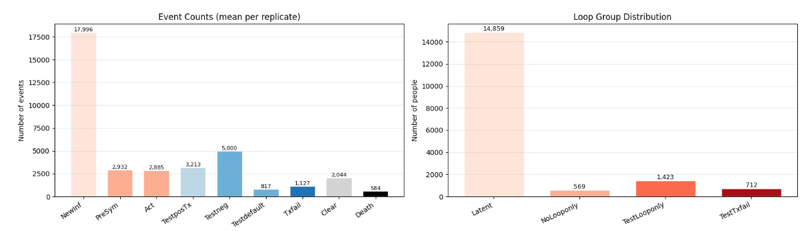

B. Illustrative patient trajectories representing cascade pathways and care-loop transitions within the model framework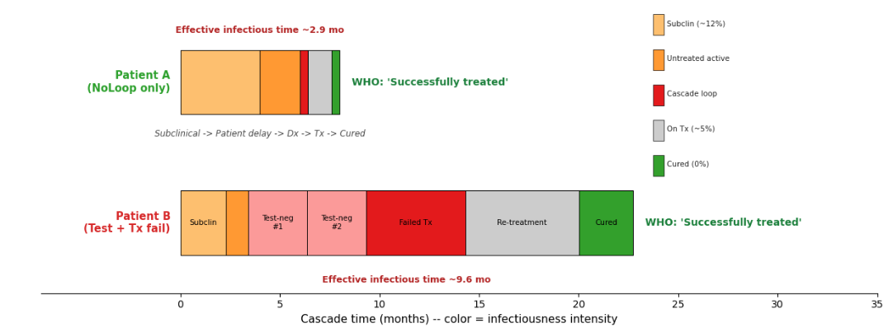
Figure 1 illustrates the overall structure of the agent-based tuberculosis (TB) cascade model and the operational classification of patient care-loop trajectories. The model simulates individual-level progression through latent infection, subclinical infectiousness, symptomatic disease, diagnostic evaluation, treatment initiation, treatment outcomes, and re-treatment pathways. At the population level, the model tracks key cascade events, including diagnostic testing, pre-treatment loss, treatment failure, cure, and death, while simultaneously recording the frequency and sequence of cascade loops experienced during each active TB episode. For each active TB episode, we tracked three trigger events associated with cascade inefficiencies: TBTestNegative (false-negative diagnostic test), TBTestDefault (pre-treatment default requiring retesting), and TBFailedDrugRegimen (treatment failure). Based on these trigger counts, episodes were further grouped into NoLooponly, TestLooponly, and TestTxfail categories, while latent infections that never progressed to active disease were excluded from cascade analyses. Based on these trajectories, simulated episodes were classified into mutually exclusive loop groups: NoLoop only (successful diagnosis and treatment without repeated failures), Test loop only (repeated diagnostic failures or pre-treatment defaults without treatment failure), and Test + Tx fail (combined diagnostic looping and failed treatment requiring re-treatment). Individuals who reactivated from latent infection during the simulation window were categorized separately and excluded from loop-group comparisons.
To characterize the temporal structure of infectiousness, we divided each individual’s disease trajectory into three phases: (1) the subclinical stage (from presymptomatic infection to active TB onset), (2) patient delay (from active TB onset to the first diagnostic test), and (3) health-system delay (from first test to infection clearance). Phase-specific infectiousness levels were estimated for each stage. Effective infectious time for each phase was defined as the phase duration multiplied by the corresponding infectiousness multiplier. Consistent with EMOD assumptions, the subclinical phase used an infectiousness multiplier of 0.12, untreated active TB phases (patient delay and untreated health-system delay) used a multiplier of 1.0, and treated phases after the first two weeks of treatment used a multiplier of 0.05. Health-system delay duration was parameterized using calibrated trigger counts, including a 30-day base diagnostic process, an additional 60 days per false-negative test or pre-treatment default, and 180 days per failed treatment course.
The figure also presents illustrative patient trajectories used to conceptualize how care-cascade loops contribute to prolonged infectiousness despite identical programmatic treatment outcomes. Two representative pathways are shown in which both patients ultimately meet the WHO definition of “successfully treated,” yet experience markedly different durations of effective infectious time because of repeated diagnostic and treatment failures. Treatment-success rate alone, measured as a national average, conflates short and long cascade trajectories and over-credits health systems that retain patients only after multiple cycles. We propose that loop-group-resolved indicators (% of confirmed TB cases resolved without diagnostic loops; % experiencing any treatment failure) should complement the conventional treatment-success rate in End-TB programme monitoring. The loop multiplier — the ratio of effective infectious time per case in the observed cascade to the ideal-cascade infectious time — was approximately 1.8 for India's calibrated baseline. This metric therefore distinguishes between nominal treatment success and the cumulative transmission burden generated during prolonged cascade navigation. Infectious time was operationalized as the cumulative duration spent in untreated or unsuccessfully treated active TB states, weighted by stage-specific infectiousness. This framework enabled quantification of excess infectious person-time attributable to diagnostic and treatment loop dynamics within the TB care cascade.
To evaluate inefficiencies generated by cascade looping, we additionally quantified several resource-use and transmission-burden metrics. Wasted diagnostic tests were defined as all diagnostic evaluations beyond the first test per confirmed TB episode, representing repeated testing associated with false-negative results or pre-treatment loss. Wasted drug-months represented treatment courses consumed by failed therapy episodes requiring re-treatment, assuming a standard six-month first-line regimen. Excess person-time was defined as active-TB infectious time beyond the minimum cascade pathway required for successful diagnosis and treatment, thereby capturing additional transmission-generating time attributable to diagnostic and treatment loops. These metrics were summarized at both the individual and cohort levels to assess how care-cascade inefficiencies translated into disproportionate transmission burden and resource consumption within the simulated population.

Table 2. Definitions of loop-group classifications, delay phases, and resource-use metrics in the TB cascade model
Category | Item | Definition | Algorithm
Loop group | Latent (NoLoop) | Latently infected individuals who reactivated to active TB during the simulation window. | Individuals with no TBActivation event in the analysis window
Loop group | NoLoop only | Diagnosed and successfully treated on the first attempt -- no diagnostic test failures and no treatment failures. | Had ≥ 1 test event AND n_testneg == 0 AND n_testdef == 0 AND n_txfail == 0
Loop group | Test loop only | One or more diagnostic test failures (false-negative and/or pre-treatment default), but treatment succeeded once initiated. | (n_testneg > 0 OR n_testdef > 0) AND n_txfail == 0.
Loop group | Test + Tx fail | Both a diagnostic test loop and a failed treatment course requiring re-treatment. | (n_testneg > 0 OR n_testdef > 0) AND n_txfail > 0.
Delay phase | Subclinical | Presymptomatic infectious period (~12% relative infectiousness). | t_TBActivation − t_TBActivationPresymptomatic (raw event timestamps).
Delay phase | Patient delay | Time from symptom onset to first contact with the health system (first diagnostic test). | t_first_test − t_TBActivation, where t_first_test = earliest TBTestDOTSLow / TBTestDOTSHigh.
Delay phase | Health-system delay | Time from first diagnostic test to resolution (cure or death); contains all diagnostic and treatment loop delays. | t_resolution − t_first_test (resolution = next SymptomaticCleared or DiseaseDeaths).
Wasted resource | Wasted dx tests | Diagnostic tests beyond the first per confirmed case -- false-negatives and pre-treatment defaults requiring re-testing. | Per episode: n_testneg + n_testdef.  Cohort total: Σ_episodes (n_testneg + n_testdef).
Wasted resource | Wasted drug-months | Drug-months consumed by failed treatment courses that required re-treatment. | Per episode: 6 × n_txfail (6-month standard first-line regimen).  Cohort total: 6 × Σ_episodes (n_txfail).
Wasted resource | Excess person-time | Active-TB person-time beyond the cascade minimum -- additional infectious time generated by cascade loops. | Per episode: total infectious time (subclinical + patient delay + health-system delay) − cascade minimum (single-pass success time per the NoLoop-only group). Cohort total / 365.25 → person-years.

Intervention scenarios. To evaluate the relative and combined effects of interventions on TB transmission dynamics, cumulative infectiousness, and healthcare resource utilization across care-seeking groups, we defined eight intervention scenarios using a 2³ factorial design, with all interventions implemented beginning in 2025 (Appendix Table A1.6). The baseline scenario represented the existing TB control strategy based on directly observed therapy short-course (DOTS) and current GeneXpert coverage. Three intervention components were evaluated individually and in combination: Active case finding (ACF), Improved diagnostics (Dx), and Treatment-adherence support (Tx). The resulting eight scenarios were: Baseline, ACF, Dx, Tx, ACF+Dx, ACF+Tx, Dx+Tx, and ACF+Dx+Tx. Together, these scenarios enabled assessment of both incremental and synergistic effects of interventions targeting different stages of the TB care cascade.

Table 3. Intervention scenarios and corresponding EMOD parameter modifications
Intervention | EMOD parameter | Baseline | Scenario value | Mechanism
ACF | acf_coverage | 0.0 | 0.3–0.7 | Subclinical TB detected via community screeningThis intervention primarily reduced delays to the first diagnostic test by identifying individuals earlier in the disease trajectory.
Dx | sens_smear_pos_GXL | 0.65 | 0.75 (=High QoC) | Low QoC sensitivity raised to High QoC levelThis intervention aimed to reduce false-negative diagnoses and repeated testing loops.
Dx | sens_smear_neg_GXL | 0.60 | 0.65 (=High QoC) | Smear-neg detection equalised across sectorsThis intervention was designed to reduce treatment failure and recurrent treatment loops.
Tx | treatment_fraction (Low QoC) | 0.55 | 0.85 | Improved treatment initiation and adherence
Tx | Treatment completion rate | baseline | +20% | Digital DOT, patient navigators, incentives
Outcome measurements. Model outputs for calibration and scenario evaluation included total infectiousness attributable to subclinical disease, patient delay, and health-system delay, which were subsequently translated into active TB person-years based on the number of individuals within each care-seeking group. In addition, we quantified the cumulative number of diagnostic tests required to achieve a TB-positive diagnosis over an individual’s lifetime as a measure of healthcare resource utilization. The maximum number of diagnostic tests per TB-positive diagnosis was calibrated to a ceiling of 10 based on observed empirical data. All outcomes were summarized as mean values across five calibrated model replicates. We quantified both total infectiousness and per-patient infectious-day distributions across care-seeking groups and infectiousness phases. To examine heterogeneity in intervention impact, we generated a triple-lens heatmap framework comparing reductions relative to baseline across three dimensions: (1) loop-group categories, (2) infectiousness delay phases, and (3) healthcare resource waste, including excess diagnostic testing volumes. Primary outcomes included TB prevalence and incidence, cumulative infectiousness, active TB person-years, and lifetime diagnostic testing volume per TB-positive individual. Analyses were conducted using Python 3.7 with pandas 1.3, numpy 1.21, and matplotlib 3.5.
Joint calibration to epidemic burden and care-cascade structure. We departed from the conventional TB-modeling practice of calibrating only to aggregate burden targets (incidence, prevalence, mortality) — a practice that leaves the cascade-of-care timing distribution and loop-group composition unidentified — and instead jointly calibrated to ten empirical targets spanning three families: (i) burden: WHO 2020 incidence (188/100k) and mortality (33/100k) and the Indian National TB Prevalence Survey 2019–21 prevalence (304/100k); (ii) engaged-cohort loop-group fractions from the Subbaraman et al. (2016) cascade-of-care meta-analysis (NoLoop 50%, TestLoop 35%, TestTxFail 13%); and (iii) per-active-case test-count distribution (overall mean ≈3.5, with per-loop-group means) drawn from Cazabon et al. (2017) and Indian National TB Elimination Programme audits. Patients with no recorded test events were separated from true single-pass NoLoop cases via an engagement-aware classifier prior to cascade-fraction computation. Per-phase delay distributions (subclinical, patient, health-system) were tracked as model-validation outputs rather than calibration targets, because published empirical delay estimates are biased low by recall, survivor, and diagnosed-only artefacts.

Figure 2. Model calibration and characterization of tuberculosis care-cascade burden
- Calibration of simulated epidemiologic trajectories to empirical TB indicators
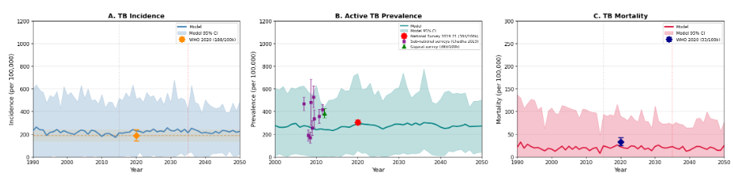
- Calibration of diagnostic testing intensity and effective infectious time across modeled patient pathways
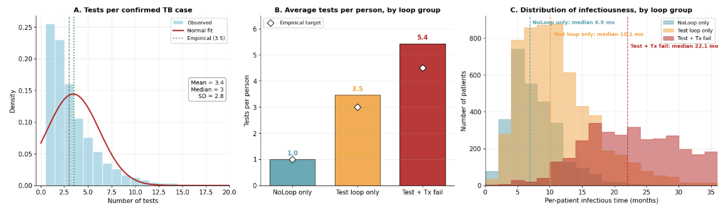

Results
Figure 3. Contribution of loop groups to individual-level and population-level transmission burden
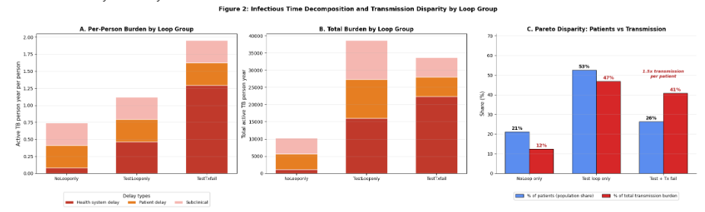

In baseline scenario, transmission burden differed markedly across loop-group classifications despite relatively smaller differences in population share (Figure 2C). Individuals in the NoLoop-only group accounted for 21% of patients but contributed only 12% of total transmission burden, whereas the Test + Tx fail group represented 27% of patients yet generated 42% of cumulative infectious burden, corresponding to approximately 1.5-fold higher transmission contribution per patient relative to their population share. The Test loop-only group comprised 52% of patients and contributed 46% of total transmission burden. At the individual level, average active TB person-years increased substantially with cascade complexity, rising from approximately 0.7 person-years in the NoLoop-only group to 1.1 person-years in the Test loop-only group and nearly 2.0 person-years in the Test + Tx fail group. Health-system delay represented the largest contributor to cumulative burden among patients experiencing combined diagnostic and treatment failures, highlighting the disproportionate transmission impact generated by repeated cascade loops.
Figure 4. Projected progress toward End-TB targets and sensitivity of intervention impact to care-loop reduction

A. Projected TB incidence trends from 2025–2035 across eight intervention scenarios relative to WHO interim and End-TB targets
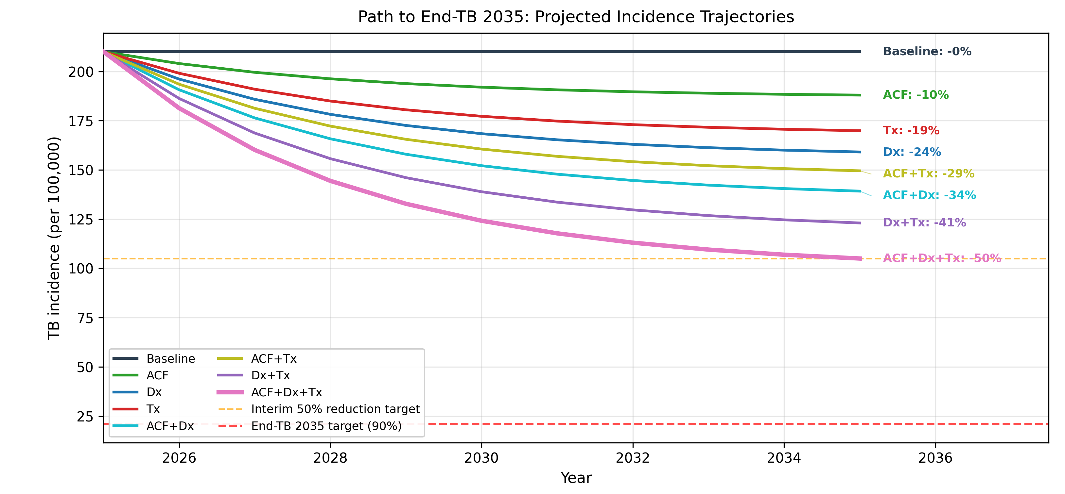
B. Projected 2035 incidence reduction as a function of additional care-loop burden reduction beyond baseline intervention effects
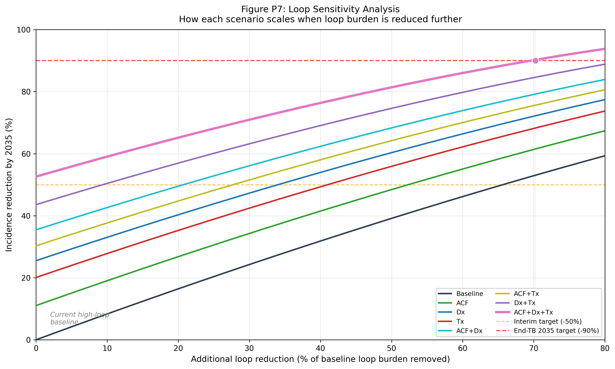

Projected tuberculosis (TB) incidence trajectories varied substantially across intervention scenarios (Figure 3A). Under the baseline scenario, incidence remained essentially unchanged through 2035, whereas single-component interventions achieved modest reductions, including 10% for active case finding (ACF), 19% for treatment-adherence support (Tx), and 24% for diagnostic improvement (Dx). Combined interventions produced progressively larger reductions, with ACF+Tx reducing incidence by 29%, ACF+Dx by 34%, and Dx+Tx by 41% by 2035. The full combined strategy (ACF+Dx+Tx) achieved the greatest impact, reducing projected incidence by approximately 50%, reaching the WHO interim End-TB milestone but remaining substantially above the 90% reduction target. These findings suggest that incremental improvements in isolated cascade components are insufficient to achieve elimination-level incidence reductions within the modeled timeframe.

Sensitivity analyses demonstrated that intervention effectiveness scaled strongly with additional reductions in care-loop burden beyond baseline intervention assumptions (Figure 3B). Across all scenarios, progressively reducing loop-related delays and failures produced near-linear gains in projected incidence reduction by 2035. Under the combined ACF+Dx+Tx scenario, additional loop reduction increased projected incidence decline from approximately 53% at baseline loop conditions to over 90% when 70–80% of residual loop burden was removed, thereby approaching the WHO End-TB target. Similar scaling patterns were observed across all intervention combinations, although scenarios incorporating diagnostic improvement and treatment support consistently achieved larger marginal gains than ACF-only strategies. These results indicate that the effectiveness of conventional TB interventions is strongly constrained by persistent diagnostic and treatment loop dynamics, and that substantial reductions in loop-related inefficiencies may be required to approach End-TB elimination targets.

Figure 5. Triple-lens view of intervention impact (% reduction vs Baseline). (A) Loop group — who fails the cascade; (B) Delay phase — where in the timeline transmission is lost; (C) Wasted resource — system waste removed.
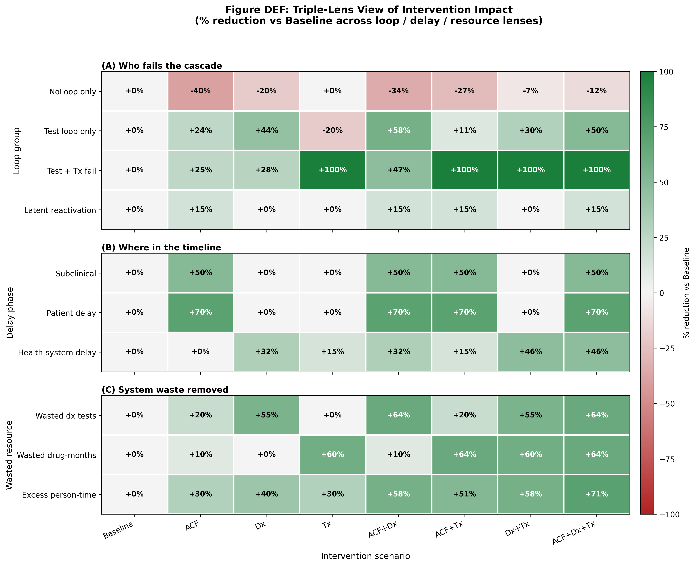
The triple-lens analysis demonstrated substantial heterogeneity in intervention impact across care-loop groups, infectiousness phases, and healthcare resource waste domains (Figure X). Across loop-group categories, combined interventions consistently produced the largest reductions among patients experiencing the greatest cascade complexity. The ACF+Dx+Tx strategy reduced the Test + Tx fail group by 100%, effectively eliminating the highest-burden cascade category, while also reducing the Test loop-only group by 50%. In contrast, the NoLoop-only group showed minimal change across most intervention scenarios, reflecting the fact that these individuals already experienced relatively efficient care pathways. Diagnostic improvement (Dx) and treatment-support (Tx) interventions contributed differently to cascade restructuring: Dx preferentially reduced diagnostic-loop burden, whereas Tx had the strongest effect on eliminating treatment-failure pathways.

Across infectiousness phases, intervention effects were phase-specific rather than uniform. Active case finding (ACF) substantially reduced subclinical infectiousness and patient delay (both approximately 50–70%) but had little direct effect on health-system delay. Conversely, Dx and Tx interventions preferentially reduced health-system delay by improving diagnostic sensitivity and treatment completion, with combined strategies achieving reductions of up to 46% in health-system delay burden. Resource-use analyses showed parallel reductions in system inefficiency. Combined interventions reduced wasted diagnostic testing volumes by up to 64%, wasted drug-months by up to 64%, and excess infectious person-time by as much as 71% relative to baseline. Overall, these findings indicate that intervention benefits were highly asymmetric across cascade dimensions, with the largest gains occurring among high-loop patients and health-system inefficiency pathways that disproportionately contributed to transmission burden.
Discussion
This study demonstrates that tuberculosis (TB) care-cascade inefficiencies act as transmission multipliers that substantially amplify ongoing community-level transmission. Using an agent-based model calibrated to the Indian TB epidemic, we showed that patients classified identically under conventional programmatic outcomes can generate markedly different transmission burdens depending on the complexity of their diagnostic and treatment trajectories. In the baseline scenario, the Test + Tx fail group represented only 27% of active TB episodes yet generated 42% of cumulative infectious burden, whereas the NoLoop-only group accounted for 21% of patients but contributed only 12% of transmission burden. Average active-TB person-years increased from approximately 0.7 person-years in the NoLoop-only group to nearly 2.0 person-years in the Test + Tx fail group. Although MDR-TB dynamics were not explicitly modeled in the current study, patients experiencing recurrent diagnostic and treatment failures may represent a high-priority subgroup for multidrug-resistant tuberculosis (MDR-TB) emergence and persistence. From a programmatic perspective, reducing health-system inefficiencies within this subgroup may therefore yield dual benefits: decreasing overall TB transmission while simultaneously reducing the risk of amplification and spread of drug-resistant disease. These findings further support the importance of moving beyond aggregate treatment-success indicators toward trajectory-sensitive monitoring approaches that identify patients experiencing prolonged or repeatedly interrupted care pathways.[20]
Our findings also provide a mechanistic explanation for why improvements in notification coverage alone may yield diminishing epidemiologic returns in high-burden settings with persistent health-system inefficiencies. Notably, our results differ somewhat from many previous modeling studies that identified active case finding (ACF) as the dominant driver of transmission reduction[21, 22]. In our simulations, ACF alone reduced projected TB incidence by only 10% by 2035, whereas diagnostic improvement (Dx) achieved a 24% reduction and treatment-adherence support (Tx) achieved a 19% reduction. Combined interventions produced progressively larger effects, with Dx+Tx reducing incidence by 41% and the full ACF+Dx+Tx package achieving approximately 50% reduction by 2035, still substantially below the WHO End-TB target of 90%. Rather than contradicting prior work, these findings suggest that the estimated impact of ACF may be highly sensitive to assumptions regarding downstream cascade performance. When earlier detection is assumed to lead efficiently to diagnosis, treatment initiation, and cure, ACF appears highly effective. However, in settings characterized by repeated diagnostic failures, poor linkage to care, pre-treatment default, and treatment failure, the transmission benefit of earlier detection may be partially offset by persistent health-system delays. [23, 24] Despite the scaling up of ACF activities, considerable uncertainty remains as to the likely impact of the interventions on transmission, and how it varies between approaches and settings.
Our findings are consistent with previous studies showing that even comprehensive intervention packages are often insufficient to achieve End TB targets, highlighting that effective TB control requires broader health system improvements beyond ACF expansion. [25, 26] Vesga et al. directly linked the TB care cascade to transmission using a mathematical model with Bayesian melding in India, Kenya, and Moldova, finding that combined cascade-strengthening measures could reduce cumulative TB incidence by 38% in India between 2018 and 2035.[27] In India specifically, the most important cascade loss was the proportion of patients visiting the private healthcare sector, and the most influential delay was the interval before a patient's first presentation for care.[27] Emani et al. similarly found that delayed diagnosis contributed the largest health losses along the care cascade in Brazil, with TB DALYs reduced by 71% when diagnostic delays were eliminated.[28]
Importantly, “diagnostic improvement” in our framework should not be interpreted simply as upgrading diagnostic technology or increasing test sensitivity.[29] Instead, Dx improvement represents reduction of diagnostic-loop structure itself through broader health-system quality improvement, particularly within fragmented public–private care pathways.[30, 31]In practice, this includes improving provider adherence to testing algorithms, reducing false-negative or repeated testing cycles, strengthening referral and confirmatory testing systems, accelerating treatment initiation after diagnosis, and improving continuity of care across providers.[32, 33] From this perspective, the superior performance of Dx interventions suggests that reducing cascade looping may generate greater epidemiologic benefit than expanding screening alone when newly detected patients remain vulnerable to repeated failed encounters within the healthcare system. Sensitivity analyses further supported this interpretation: incidence reductions exceeded 90% only when an additional 70–80% of residual loop burden was removed beyond baseline intervention assumptions. Together, these findings suggest that the key transmission-relevant question may not simply be how many additional cases are detected, but how many patients complete a low-loop pathway from first healthcare contact to durable cure. [34]
The triple-lens analytical framework further demonstrated that intervention effects were highly heterogeneous across patient groups, delay phases, and healthcare resource waste domains. Combined interventions preferentially reduced burden among high-loop patients and substantially decreased wasted diagnostic testing, wasted drug-months, and excess infectious person-time. ACF primarily reduced subclinical infectiousness and patient delay, whereas Dx and Tx interventions preferentially reduced health-system delay by improving diagnostic resolution and treatment completion. Combined strategies reduced health-system delay burden by up to 46%, wasted diagnostic testing volumes by up to 64%, and excess infectious person-time by as much as 71% relative to baseline. These findings extend previous patient-pathway and TB transmission studies by explicitly linking operational inefficiencies to population-level transmission dynamics through longitudinal patient trajectories.[35] In fragmented healthcare systems such as India’s, reducing repeated cascade failures may therefore produce amplified epidemiologic and operational benefits beyond those achieved through expanded case detection alone.
Several limitations should be acknowledged. First, the distributions of cascade trajectories and delay structures were calibrated using published estimates and simplified trigger-event assumptions rather than directly observed longitudinal patient-level data. In practice, obtaining detailed information on diagnostic repetition, provider switching, pre-treatment default, and treatment interruptions remains challenging because these processes are rarely captured comprehensively within routine surveillance systems. Most existing patient-pathway evidence has relied on intensive survey- or interview-based studies that reconstruct individual care-seeking histories, which are resource-intensive and difficult to scale nationally. Consequently, many national TB notification systems primarily capture final treatment outcomes rather than the sequence and timing of intermediate healthcare interactions, limiting the ability to directly quantify health-system inefficiencies that prolong infectiousness. Second, the model simplified several aspects of healthcare-seeking behavior and provider heterogeneity, including temporal variation in healthcare access, diagnostic practices, and quality of care across India’s fragmented healthcare system.[36] False-positive diagnoses, informal-sector treatment, and detailed economic consequences associated with repeated testing and treatment were not explicitly modeled. In addition, intervention scenarios reflected relatively optimistic implementation assumptions and may therefore overestimate achievable operational performance under real-world conditions. The largest residual at the best-fit parameter set was the NoLooponly fraction (model 0.22 vs Subbaraman 2016 target 0.50, standardised implausibility 2.50), reflecting that the agent-based simulator produces more test-loop episodes than the empirical cascade meta-analysis reports; while this residual falls within the 3σ joint-feasibility threshold under our assumed observation and discrepancy uncertainty, it suggests that the four-group loop taxonomy may not map perfectly onto the empirically-reported cascade categories.
Nevertheless, our findings have important implications for future TB program monitoring and evaluation. Current monitoring frameworks largely emphasize aggregate indicators such as notification rates, treatment initiation, and treatment-success percentages, which may inadequately capture prolonged patient delay and health-system delay that together sustain transmission.[15] Distinguishing between these two delay components may be particularly important because they imply fundamentally different intervention priorities: patient delay reflects barriers to symptom recognition and healthcare access, whereas health-system delay reflects inefficiencies after healthcare contact, including repeated testing, referral failure, delayed diagnosis, and treatment interruption.[37] Even when detailed patient-level survey data are unavailable, routine administrative systems may still be adapted to better characterize these processes.[17] For example, longitudinal linkage of diagnostic encounters, timestamps between first presentation and treatment initiation, repeated testing frequency, referral completion rates, treatment interruptions, and cross-provider transitions could potentially serve as proxy indicators for underlying health-system inefficiency within existing electronic TB surveillance platforms. Incorporating such trajectory-sensitive indicators into routine program evaluation may help identify whether persistent transmission is driven primarily by delayed healthcare seeking or by inefficiencies within the healthcare system itself. Ultimately, strengthening routine measurement of patient trajectories and delay structures may be as important as improving diagnostic coverage for evaluating meaningful progress toward End-TB goals.
Conclusion.
In conclusion, this study demonstrates that tuberculosis care-cascade inefficiencies act as major transmission multipliers that are largely invisible within conventional programme indicators. Using an agent-based model calibrated to the Indian TB epidemic, we showed that a relatively small subgroup of patients experiencing repeated diagnostic and treatment loops contributed a disproportionate share of cumulative infectious burden, despite ultimately achieving the same WHO-defined treatment outcomes as patients completing care through efficient pathways. Interventions targeting early detection, diagnostic accuracy, and treatment retention were mechanistically complementary, but even comprehensive intervention packages remained insufficient to achieve End-TB targets unless substantial reductions in residual cascade-loop burden were also achieved. These findings suggest that future TB control strategies should move beyond aggregate treatment-success metrics and explicitly incorporate loop-sensitive indicators that capture diagnostic repetition, treatment failure, and prolonged infectious person-time. In high-burden settings such as India, interrupting cascade loops may be as important as expanding case detection for achieving meaningful reductions in TB transmission.

Acknowledgements

Funding

Conflict of Interest
The authors declare no conflicts of interest.

Data availability
All model data and source code used in this study are publicly available on GitHub.

References

1. World Health Organization. Global Tuberculosis Report 2024. Geneva: World Health Organization; 2024. Available at: WHO Global Tuberculosis Report 2024. Accessed May 9, 2026.
2. Onozaki, I., et al., National tuberculosis prevalence surveys in Asia, 1990-2012: an overview of results and lessons learned. Trop Med Int Health, 2015. 20(9): p. 1128-1145.
3. Subbaraman, R., et al., The Tuberculosis Cascade of Care in India's Public Sector: A Systematic Review and Meta-analysis. PLoS Med, 2016. 13(10): p. e1002149.
4. Mandal, S. and N. Arinaminpathy, Transmission modeling and health systems: the case of TB in India. Int Health, 2015. 7(2): p. 114-20.
5. Floyd, K., et al., Global tuberculosis targets and milestones set for 2016-2035: definition and rationale. Int J Tuberc Lung Dis, 2018. 22(7): p. 723-730.
6. Hallett, T.B., et al., The case for optimal investment in combating HIV, tuberculosis, and malaria: a global modelling study. Lancet, 2025. 406(10500): p. 261-270.
7. Collaborators, G.B.D.T., Global, regional, and national age-specific progress towards the 2020 milestones of the WHO End TB Strategy: a systematic analysis for the Global Burden of Disease Study 2021. Lancet Infect Dis, 2024. 24(7): p. 698-725.
8. Reid, M., et al., Scientific advances and the end of tuberculosis: a report from the Lancet Commission on Tuberculosis. Lancet, 2023. 402(10411): p. 1473-1498.
9. MacNeil, A., et al., Global Epidemiology of Tuberculosis and Progress Toward Meeting Global Targets - Worldwide, 2018. MMWR Morb Mortal Wkly Rep, 2020. 69(11): p. 281-285.
10. Reid, M.J.A., et al., Building a tuberculosis-free world: The Lancet Commission on tuberculosis. Lancet, 2019. 393(10178): p. 1331-1384.
11. Langley, I., et al., Modelling the impacts of new diagnostic tools for tuberculosis in developing countries to enhance policy decisions. Health Care Manag Sci, 2012. 15(3): p. 239-53.
12. Lin, H.H., et al., The impact of new tuberculosis diagnostics on transmission: why context matters. Bull World Health Organ, 2012. 90(10): p. 739-747A.
13. Teo, A.K.J., et al., Where are the missing people affected by tuberculosis? A programme review of patient-pathway and cascade of care to optimise tuberculosis case-finding, treatment and prevention in Cambodia. BMJ Glob Health, 2023. 8(3).
14. Dye, C., et al., Evolution of tuberculosis control and prospects for reducing tuberculosis incidence, prevalence, and deaths globally. JAMA, 2005. 293(22): p. 2767-75.
15. Heyckendorf, J., et al., Tuberculosis Treatment Monitoring and Outcome Measures: New Interest and New Strategies. Clin Microbiol Rev, 2022. 35(3): p. e0022721.
16. Subbaraman, R., et al., Constructing care cascades for active tuberculosis: A strategy for program monitoring and identifying gaps in quality of care. PLoS Med, 2019. 16(2): p. e1002754.
17. Faust, L., et al., Improving measurement of tuberculosis care cascades to enhance people-centred care. Lancet Infect Dis, 2023. 23(12): p. e547-e557.
18. Bershteyn, A., et al., Implementation and applications of EMOD, an individual-based multi-disease modeling platform. Pathog Dis, 2018. 76(5).
19. Huynh, G.H., et al., Tuberculosis control strategies to reach the 2035 global targets in China: the role of changing demographics and reactivation disease. BMC Med, 2015. 13: p. 88.
20. G, S.V., et al., Patient and health system related factors affecting diagnostic and treatment delays in tuberculosis: A cross-sectional study in Mysuru, South India. PLoS One, 2026. 21(2): p. e0342998.
21. Malhotra, A., et al., Active case-finding of tuberculosis compared with symptom-driven standard of care: a modelling analysis. Int J Epidemiol, 2024. 53(2).
22. Burke, R.M., et al., Community-based active case-finding interventions for tuberculosis: a systematic review. Lancet Public Health, 2021. 6(5): p. e283-e299.
23. Deo, S., et al., Predicting the impact of patient and private provider behavior on diagnostic delay for pulmonary tuberculosis patients in India: A simulation modeling study. PLoS Med, 2020. 17(5): p. e1003039.
24. Saini, P. and S. Bhattacharyya, Impact of multiple consultations and switching in treatment-seeking in tuberculosis: Mathematical modelling and optimal control. PLoS One, 2025. 20(6): p. e0324330.
25. Houben, R., et al., Feasibility of achieving the 2025 WHO global tuberculosis targets in South Africa, China, and India: a combined analysis of 11 mathematical models. Lancet Glob Health, 2016. 4(11): p. e806-e815.
26. Menzies, N.A., et al., Lifetime burden of disease due to incident tuberculosis: a global reappraisal including post-tuberculosis sequelae. Lancet Glob Health, 2021. 9(12): p. e1679-e1687.
27. Vesga, J.F., et al., Assessing tuberculosis control priorities in high-burden settings: a modelling approach. Lancet Glob Health, 2019. 7(5): p. e585-e595.
28. Emani, S., et al., Quantifying gaps in the tuberculosis care cascade in Brazil: A mathematical model study using national program data. PLoS Med, 2024. 21(3): p. e1004361.
29. Sun, A.Y., et al., Modeling the impact of alternative strategies for rapid molecular diagnosis of tuberculosis in Southeast Asia. Am J Epidemiol, 2013. 178(12): p. 1740-9.
30. Wells, W.A., M. Uplekar, and M. Pai, Achieving Systemic and Scalable Private Sector Engagement in Tuberculosis Care and Prevention in Asia. PLoS Med, 2015. 12(6): p. e1001842.
31. Yellappa, V., et al., Patients pathways to tuberculosis diagnosis and treatment in a fragmented health system: a qualitative study from a south Indian district. BMC Public Health, 2017. 17(1): p. 635.
32. Kwan, A., et al., Use of standardised patients for healthcare quality research in low- and middle-income countries. BMJ Glob Health, 2019. 4(5): p. e001669.
33. Daniels, B., et al., Lessons on the quality of tuberculosis diagnosis from standardized patients in China, India, Kenya, and South Africa. J Clin Tuberc Other Mycobact Dis, 2019. 16: p. 100109.
34. Lin, H.H., et al., A modelling framework to support the selection and implementation of new tuberculosis diagnostic tools. Int J Tuberc Lung Dis, 2011. 15(8): p. 996-1004.
35. Hanson, C.L., et al., Conducting Patient-Pathway Analysis to Inform Programming of Tuberculosis Services: Methods. J Infect Dis, 2017. 216(suppl_7): p. S679-S685.
36. Bui, V.L., et al., Agent-based modelling of Mycobacterium tuberculosis transmission: a systematic review. BMC Infect Dis, 2024. 24(1): p. 1394.
37. Shamanewadi, A.N., et al., Enablers and Challenges in the Implementation of Active Case Findings in a Selected District of Karnataka, South India: A Qualitative Study. Tuberc Res Treat, 2020. 2020: p. 9746329.

