

**Tribhuvan University**

**Institute of Science & Technology**

**Samriddhi College**

A

Lab Report

on

**Web Technology**

Submitted by:

**Uday Shrestha (24358/076)**

Submitted to:

**Department of Computer Science & Information Technology**

Samriddhi College

Lokanthali-1, Bhaktapur

**LAB-1**

1. **Create a web page that contains both text level formatting and block level formatting.**
   * **For text level formatting the page should contain the paragraph that include bold, italic and underline texts.**
   * **For block level formatting the page should contain the two <div> with different background color**

**Source Code:**

<!--1.Create a web page that contains both text level formatting and block level formatting.

- For text level formatting the page should contain the paragraph that include bold, italic and underline texts.

-For block level formatting the page should contain the two <div> with different background color-->

<!DOCTYPE html>

<html lang="en">

<head>

<meta charset="UTF-8">

<meta http-equiv="X-UA-Compatible" content="IE=edge">

<meta name="viewport" content="width=device-width, initial-scale=1.0">

<title>Lab1</title>

<style>

#div1{

background-color: greenyellow;

}

#div2{

background-color: orange;

}

</style>

</head>

<body>

<div id="div1">

<p>

<b>Lorem, ipsum dolor sit amet consectetur adipisicing elit. Itaque quibusdam et, odit adipisci, rerum laudantium molestiae recusandae animi iusto error dolores eos laboriosam illo eaque? Quasi nisi modi placeat repellat!</b><br>

<i>Lorem ipsum dolor sit amet consectetur adipisicing elit. Tenetur, fugiat. Magni quisquam, quas corrupti recusandae veritatis velit, officiis ratione quia ut maiores ducimus, delectus nesciunt culpa laborum! Sed, ex perferendis.</i><br>

<u>Lorem, ipsum dolor sit amet consectetur adipisicing elit. Quos provident eligendi veritatis ad sit voluptate, debitis sapiente accusamus repudiandae dignissimos accusantium. Minima ullam quas ad, neque nemo cupiditate unde molestiae.</u><br>

</p>

</div>

<div id="div2">

<b>Lorem, ipsum dolor sit amet consectetur adipisicing elit. Itaque quibusdam et, odit adipisci, rerum laudantium molestiae recusandae animi iusto error dolores eos laboriosam illo eaque? Quasi nisi modi placeat repellat!</b><br>

<i>Lorem ipsum dolor sit amet consectetur adipisicing elit. Tenetur, fugiat. Magni quisquam, quas corrupti recusandae veritatis velit, officiis ratione quia ut maiores ducimus, delectus nesciunt culpa laborum! Sed, ex perferendis.</i><br>

<u>Lorem, ipsum dolor sit amet consectetur adipisicing elit. Quos provident eligendi veritatis ad sit voluptate, debitis sapiente accusamus repudiandae dignissimos accusantium. Minima ullam quas ad, neque nemo cupiditate unde molestiae.</u><br>

</div>

</body>

</html>

**OUTPUT:**

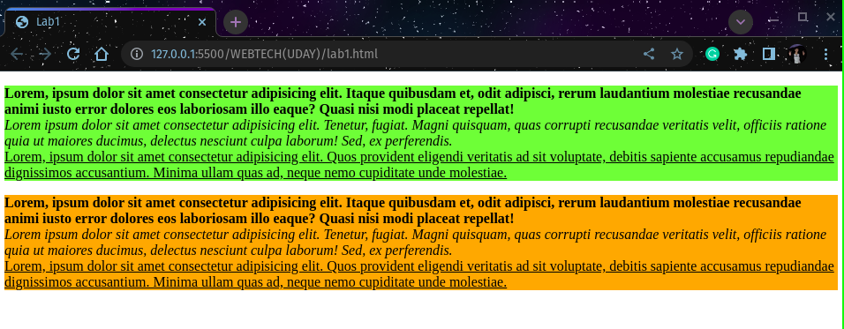

**LAB-2**

1. **Create a webpage that contains**
   * **An ordered list of 5 fruits**
   * **An unordered list of 5 vegetables**
   * **A description list containing description of 3 different Cars**
   * **A hyperlinked text that redirects to a any page available online**

**Source Code:**

<!--2.Create a webpage that contains

-An ordered list of 5 fruits

-An unordered list of 5 vegetables

-A description list containing description of 3 different Cars

-A hyperlinked text that redirects to a any page available online-->

<!DOCTYPE html>

<html lang="en">

<head>

<meta charset="UTF-8">

<meta http-equiv="X-UA-Compatible" content="IE=edge">

<meta name="viewport" content="width=device-width, initial-scale=1.0">

<title>lab-2</title>

</head>

<body>

<div>

<p><b>Ordered list of five fruits:</b></p>

<ol>

<li>APPLE</li>

<li>BANANA</li>

<li>GRAPES</li>

<li>WATERMELON</li>

<li>ORENGE</li>

</ol>

<p><b>Unordered list of five vegetables:</b></p>

<ul>

<li>POTATO</li>

<li>CAULIFLOWER</li>

<li>BRINJALI</li>

<li>CABBAGE</li>

<li>PUMPKIN</li>

</ul>

</div>

<div>

<p><b>Description list containing of 3 different cars:</b></p>

<dl>

<dt>SEDAN</dt>

<dd>- A sedan has four doors and a traditional trunk. </dd>

<dt>COUPE</dt>

<dd>- A coupe has historically been considered a two-door car with a trunk and a solid roof.</dd>

<dt>STATION WAGON</dt>

<dd>- Wagons are similar to sedans but have an extended roofline and a hatch door at the rear instead of a trunk.</dd>

</dl>

</div>

<div>

<p><b>Hyperlink:</b></p>

<a href="https://google.com">Google</a>

</div>

</body>

</html>

**Output:**

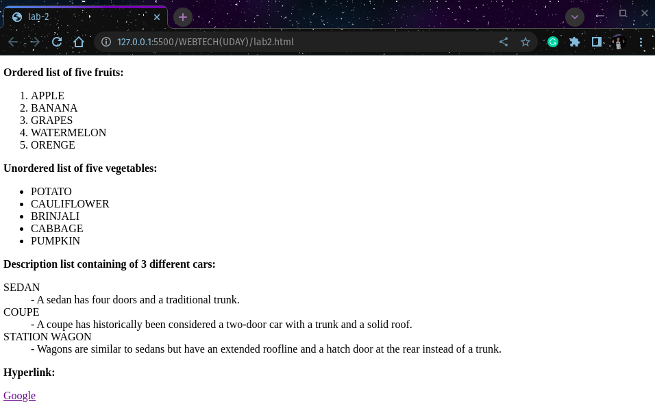

**LAB-3**

1. **Create a webpage that contains**
   * **An image of car with height 120px, width 120px and alternative text for image “Cars”**
   * **Any image that contain client side imagemap that redirects to any page available online.**
   * **Any image that returns the coordinates of the clicked area to URL (use server side imagemap)**

**Source code:**

<!--3.Create a webpage that contains

-An image of car with height 120px, width 120px and alternative text for image “Cars”

-Any image that contain client side imagemap that redirects to any page available online.

-Any image that returns the coordinates of the clicked area to URL (use server side imagemap)-->

<!DOCTYPE html>

<html lang="en">

<head>

<meta charset="UTF-8">

<meta http-equiv="X-UA-Compatible" content="IE=edge">

<meta name="viewport" content="width=device-width, initial-scale=1.0">

<title>lab-3</title>

</head>

<body>

<div>

<p><b>Image of Car:</b></p>

<img src="car.jpeg" alt="Cars" style="height: 120px;width: 120px;">

</div>

<div>

<p><b>Google pag link:</b></p>

<a href="https://google.com"><img src="google.png" alt="goole_image" style="width: 150px; height: 150px;"></a>

</div>

<div>

<p>Here's an image with a server-side image map:</p>

<img src="car.jpeg" usemap="#coords" width="200" height="120>

<map name="coords">

<area shape="rect" coords="0,0,100,100" href="coordinates.php">

</map>

</div>

</body>

</html>

**Output:**

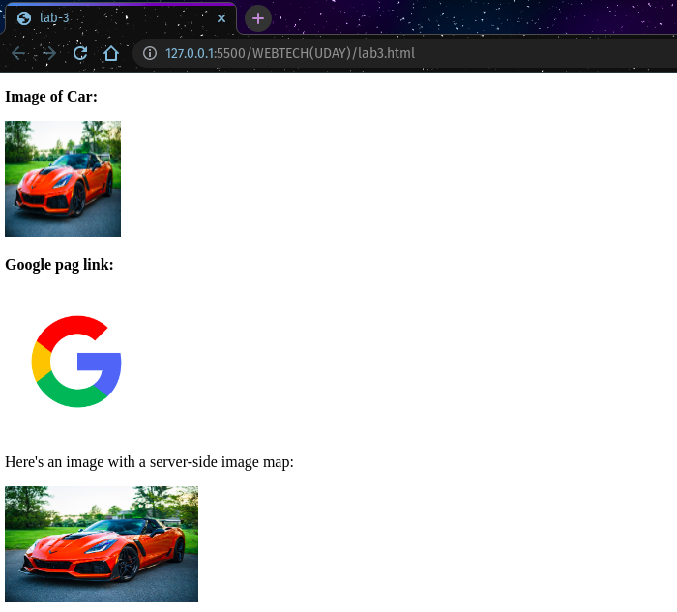

**LAB-4**

1. **Create a webpage that contains**
   * **A striped table containing information of 5 Students. The table must contain the roll no, name, address and contact number of students. The content of the first row must be horizontally aligned right, third must be aligned left and fifth must be aligned center. Also , the content of the second row must be vertically aligned top and fourth row must be vertically aligned bottom**

**Source code:**

<!--4.Create a webpage that contains

-A striped table containing information of 5 Students. The table must contain the roll no, name, address and contact number of students. The content of the first row must be horizontally aligned right, third must be aligned left and fifth must be aligned center. Also , the content of the second row must be vertically aligned top and fourth row must be vertically aligned bottom-->

<!DOCTYPE html>

<html lang="en">

<head>

<meta charset="UTF-8">

<meta http-equiv="X-UA-Compatible" content="IE=edge">

<meta name="viewport" content="width=device-width, initial-scale=1.0">

<title>lab4</title>

<style>

table,th,td{

border: 1px solid black;

border-collapse: collapse;

width: 600px;

background-color: greenyellow;

}

</style>

</head>

<body>

<div>

<p><b>Creating Table</b></p>

<table>

<tr>

<th>Name</th>

<th>Roll No.</th>

<th>Address</th>

<th>contact</th>

</tr>

<tr align="right">

<td>John</td>

<td>5</td>

<td>Kathmandu</td>

<td>981111111</td>

</tr>

<tr align="top">

<td>Jack</td>

<td>6</td>

<td>Pokhara</td>

<td>981112222</td>

</tr>

<tr align="left">

<td>John</td>

<td>7</td>

<td>Butwal</td>

<td>981113333</td>

</tr>

<tr align="bottom--">

<td>John</td>

<td>5</td>

<td>Dharan</td>

<td>9811114444</td>

</tr>

<tr align="center">

<td>John</td>

<td>5</td>

<td>Biratnagar</td>

<td>981111555</td>

</tr>

</table>

</div>

</body>

</html>

**Output:**

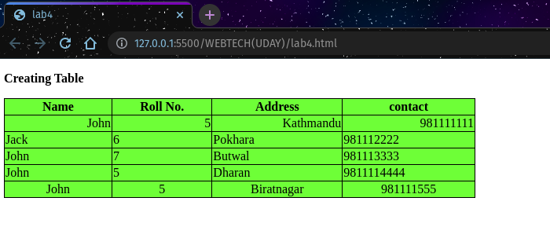

**LAB-5**

1. **Design the following using HTML using the concept of nested frameset**

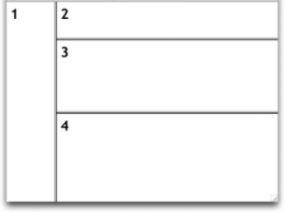

**Frame1 should contain three links, the first should be opened in frame 2, second in frame 3 and third in frame 4.**

**Source code:**

<!DOCTYPE html>

<html lang="en">

<head>

<meta charset="UTF-8">

<meta http-equiv="X-UA-Compatible" content="IE=edge">

<meta name="viewport" content="width=device-width, initial-scale=1.0">

<title>lab5</title>

</head>

<frameset cols="20%,80%">

<frameset rows="">

<frame src="lab2.html"></frame>

</frameset>

<frameset rows="20,30,50">

<frame src="lab1.html"></frame>

<frame src="lab4.html"></frame>

<frame src="lab3.html"></frame>

</frameset>

</frameset>

<body>

</body>

</html>

**Output:**

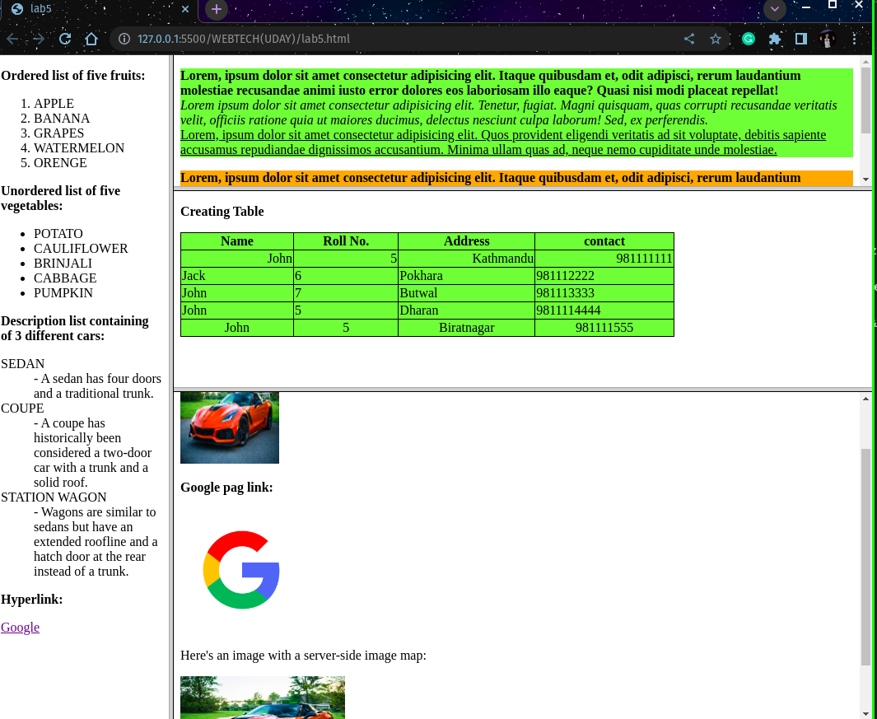

**LAB-6**

1. **Create a webpage containing paragraph and an inline frame that loads any website.**

**Source code:**

<!DOCTYPE html>

<html lang="en">

<head>

<meta charset="UTF-8">

<meta http-equiv="X-UA-Compatible" content="IE=edge">

<meta name="viewport" content="width=device-width, initial-scale=1.0">

<title>lab6</title>

</head>

<body>

<div>

<p>Lorem, ipsum dolor sit amet consectetur adipisicing elit. Provident, sapiente cumque. Quam iste distinctio doloribus rerum corrupti ipsam laborum sapiente praesentium, delectus odio cupiditate temporibus officia? Sit aliquam quo quibusdam! Lorem ipsum dolor sit, amet consectetur adipisicing elit. Neque officia excepturi aperiam nam autem quisquam. Tempore harum ex reprehenderit! Cumque odit iste quos est consequuntur dicta quas sit similique necessitatibus. Lorem ipsum dolor sit amet consectetur adipisicing elit. Repellendus eaque, aperiam sapiente error natus dolorem molestiae quibusdam et aliquam quae voluptas, quaerat vitae dignissimos quasi veritatis autem suscipit numquam temporibus! Lorem ipsum dolor sit amet consectetur, adipisicing elit. Delectus molestiae, ea, dicta dolorem suscipit sint esse asperiores provident hic ullam, consequuntur quod dignissimos! Quia molestiae voluptatibus itaque facere earum unde! Lorem ipsum dolor sit amet consectetur adipisicing elit. Dicta, error quasi officia non nemo sequi iusto accusamus, cum commodi laudantium nihil dolores repellat est ea fuga, cupiditate praesentium ut repudiandae! Lorem ipsum, dolor sit amet consectetur adipisicing elit. Corrupti voluptate eos rem quidem, velit assumenda porro, nam totam autem eius molestias veritatis eaque fugit ad quae similique, alias expedita. Quod.</p>

<iframe src="https://www.tuiost.edu.np/" title="TU IOST website"></iframe>

</div>

</body>

</html>

**Output:**

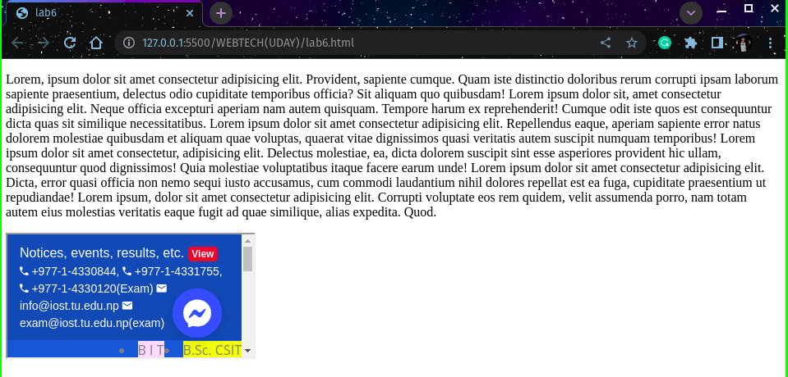

**LAB-7**

1. **Design a form in HTML using fieldset and legend that contains the following fields**
   * **Name as input type –text**
   * **Address as input type-text**
   * **A multiline text for Bio**
   * **A dropdown for address**
   * **A radio button for gender**
   * **A file input for identity upload**
   * **A password type input for contact number**
   * **A submit button**

**Source code:**

<!DOCTYPE html>

<html lang="en">

<head>

<meta charset="UTF-8">

<meta http-equiv="X-UA-Compatible" content="IE=edge">

<meta name="viewport" content="width=device-width, initial-scale=1.0">

<title>lab7</title>

</head>

<body>

<form>

<fieldset style="width: 400px">

<legend>Personal Information</legend>

<label for="name">Name:</label>&emsp;

<input type="text" id="name" name="name" required><br><br>

<label for="address">Address:</label>

<input type="text" id="address" name="address" required><br><br>

<label for="bio">Bio:</label>&emsp;&emsp;

<textarea id="bio" name="bio"></textarea><br><br>

<label for="city">City:</label>&emsp;&emsp;

<select id="city" name="city">

<option value="New York">Kathmandu</option>

<option value="Los Angeles">Bhaktapur</option>

<option value="Chicago">Butwal</option>

<option value="Houston">Pokhara</option>

<option value="Miami">Jhapa</option>

</select><br><br>

<label for="gender">Gender:</label>

<input type="radio" id="male" name="gender" value="male">

<label for="male">Male</label>

<input type="radio" id="female" name="gender" value="female">

<label for="female">Female</label><br><br>

<label for="identity">Identity:</label>

<input type="file" id="identity" name="identity" accept=".pdf,.doc,.docx"><br><br>

<label for="contact">Contact Number:</label>

<input type="password" id="contact" name="contact" required>

<br><br>

<input type="submit" value="Submit">

</fieldset>

</form>

</body>

</html>

**Output:**

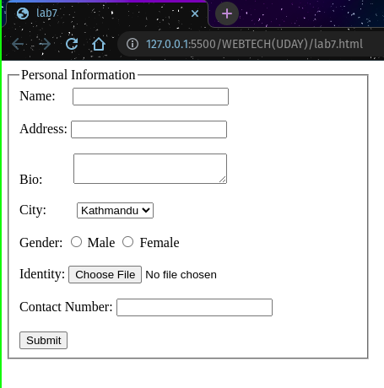

**LAB-8**

1. **Embed a video with the separate play button using HTML 5.**

**Source code:**

<!--8.Embed a video with the separate play button using HTML 5. -->

<!DOCTYPE html>

<html lang="en">

<head>

<meta charset="UTF-8">

<meta http-equiv="X-UA-Compatible" content="IE=edge">

<meta name="viewport" content="width=device-width, initial-scale=1.0">

<title>lab8</title>

</head>

<body>

<video width="600" height="409" id="videoPlayer" controls="controls">

<source src="video1.mp4" type="video/mp4">

</video>

<script>

var videoPlayer = document.getElementById('videoPlayer');

videoPlayer.play()

videoPlayer.volume = 0.5;

videoPlayer.addEventListener('click', function () {

if (videoPlayer.paused == false) {

videoPlayer.pause();

videoPlayer.firstChild.nodeValue = 'Play';

} else {

videoPlayer.play();

videoPlayer.firstChild.nodeValue = 'Pause';

}

});

</script>

</body>

</html>

**Output:**

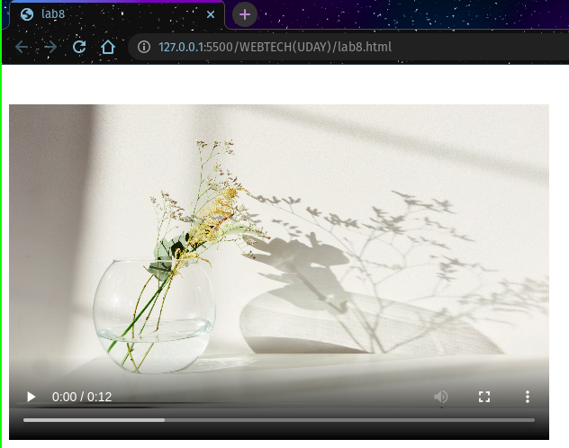

**LAB-9**

1. **Create a canvas and draw a rectangle inside it.**

**Source code:**

<!DOCTYPE html>

<html lang="en">

<head>

<meta charset="UTF-8">

<meta http-equiv="X-UA-Compatible" content="IE=edge">

<meta name="viewport" content="width=device-width, initial-scale=1.0">

<title>lab9</title>

</head>

<body>

<canvas id="myCanvas" width="200" height="100" style="border:5px solid rgb(16, 162, 219); background-color: greenyellow">

</canvas>

</body>

</html>

**Output:**

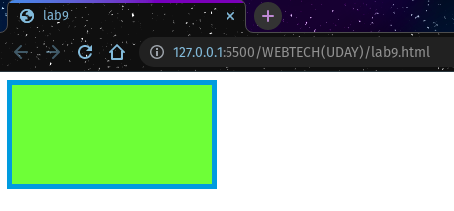

**LAB-10**

1. **Create a draggable box that can be dragged into another larger box .**

**Source code:**

<!--10.Create a draggable box that can be dragged into another larger box .-->

<!DOCTYPE html>

<html lang="en">

<head>

<meta charset="UTF-8">

<meta http-equiv="X-UA-Compatible" content="IE=edge">

<meta name="viewport" content="width=device-width, initial-scale=1.0">

<title>lab10</title>

<style>

#getData {

width: 250px;

height: 200px;

padding: 10px;

border: 1px solid #4f4d4d;

}

</style>

<script>

function allowDrop(even) {

even.preventDefault();

}

function drag(even) {

even.dataTransfer.setData("text", even.target.id);

}

function drop(even) {

even.preventDefault();

var fetchData = even.dataTransfer.getData("text");

even.target.appendChild(document.getElementById(fetchData));

}

</script>

</head>

<body>

<h3>Drag the image into the rectangle:</h3>

<div id="getData"

ondrop="drop(event)"

ondragover="allowDrop(event)">

</div>

<br>

<img id="dragData"

src="Landscape-Color.jpg"

draggable="true"

ondragstart="drag(event)"

width="250"

height="200">

</body>

</html>

**Output:**

