**Flow Chart**

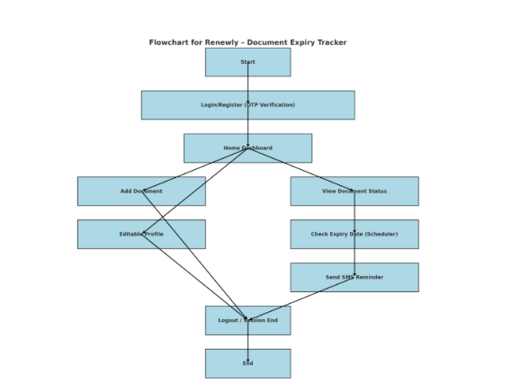

Here is the flowchart for your project, Renewly – a document expiry tracking system. It visually outlines the core user journey and backend processes:

* User starts at Login/Register via OTP
* Accesses the Home Dashboard with options to:
  + Add Documents
  + View Expiry Status
  + Edit Profile
* A scheduler checks expiries in the background
* SMS reminders are sent automatically
* User ends session by logging out