**PHARMACY MANAGEMENT SYSTEM**

***Submitted by***

**K.SRIDHAR PRASAD,**

**R.YUVARAJ,**

**WILFRED ROY**

INFORMATION TECHNOLOGY



**VEL TECH HIGH TECH**

**Dr. RANGARAJAN Dr. SAKUNTHALA ENGINEERING COLLEGE**

**An Autonomous Institution**

**JANUARY 2022**

**VEL TECH HIGH TECH**

**Dr. RANGARAJAN Dr. SAKUNTHALA ENGINEERING COLLEGE**

**An Autonomous Institution**



**BONAFIDE CERTIFICATE**

Certified that this mini project entitled **“….PHARMACY MANAGEMENT SYSTEM……”** is the bonafide work of “**………. K.SRIDHAR PRASD, R.YUVARJ,**

**WILFRED ROY…** who carried out the work under my supervision.

|  |  |
| --- | --- |
| <<Signature of the Head of the Department>> | <<Signature of the Supervisor>> |
| **SIGNATURE** | **SIGNATURE** |
| Dr.M.Malleswari M.E.,Ph.D., | Mrs.J.LAVANYA |
| **HEAD OF THE DEPARTMENT** | **SUPERVISOR** |
| Information Technology | Information Technology |
| Vel tech High tech | Vel tech High tech |

DR.Rangarjan DR.Sakuthala DR.Rangarajan DR.sakuthala

Engineering college Engineering college

# **ACKNOWLEDGMENT**

We would like to express our obeisance to the following persons for their invaluable help rendered. We wish to express our sincere thanks and gratitude to our chairman Col. Prof**. Dr. R. RANGARAJAN B.E. (Elec.), B.E. (Mech.), M.S (Auto.), DSC.** and vice- chairman **Dr. SAKUNTHALA RANGARAJAN M.B.B.S.,** for providing us with a comfort zone for doing this project work. We express our thanks to our principal, Professor **Dr. E. KAMALANABAN B.E., M.E., Ph.D.,** for offering us all the facilities to do the project.

We also express our sincere thanks to the professor**, Dr.M. MALLESWARI, M.E, Ph.D.,** Head of the Department, and Department of Information Technology for support to do this project work.

Our special thanks to our Project supervisor, **MRS.J LAVANYA..,M.E,** Associate Professor, Department of Information Technology, who provided us with full support at every stage of the project. We thank our parents, friends and supporting staff of the Information Technology Department for the help they extended for the completion of this project

**TABLE OF CONTENT**

**CHAPTER NO TITLE PG.NO**

|  |  |  |
| --- | --- | --- |
|  | ABSTRACT |  |
| **1** | **INTRODUCTION** |  |
| **1.1** | BACKGROUND |  |
| **1.2** | STATEMENT OF  PROBLEM |  |
| **1.3** | OBJECTIVE OF THE  STUDY |  |
| **1.4** | SCOPE |  |
| **1.5** | JUSTIFICATION OF THE  STUDY |  |
| **1.6** | RESEARCH QUESTIONS |  |
| **1.7** | CONCEPTUAL MODEL |  |
| **1.8** | ARCHITECTURE MODEL |  |
| **1.9** | CONCLUSION |  |
| **2** | **LITERATURE SURVEY** |  |
| **3** | **RESEARCH**  **METHODOLOGY** |  |
| **3.1** | INTRODUCTION |  |
| **3.2** | FEASIBILITY STUDY |  |
| **3.3** | TARGET POPULATION |  |
| **3.4** | SAMPLE SELECTION |  |
| **3.5** | RESEARCH PROCEDURES |  |
| **3.6** | RESEARCH FINDINGS |  |
| **3.7** | IMPLEMENTATION CODING AND TESTING |  |
| **3.8** | INTEGRATION AND SYSTEM TESTING |  |
| **3.9** | OPERATION AND MAINTENANCE |  |
| **3.10** | SYSTEM SPECIFICATIONS |  |
| **3.11** | CONCLUSION |  |
| **4** | **CURRENT SYSTEM ANALYSIS & DESIGN OF THE NEW SYSTEM** |  |
| **4.1** | INTRODUCTION |  |
| **4.2** | DATA AND DOCUMENTS  FLOW |  |
| **4.3** | REQUIREMENT ANALYSIS  AND DEFINITION |  |
| **4.4** | CONCLUSION |  |
| **5** | **PRESENTATION AND DISCUSSION OF FINDING** |  |
| **5.1** | ANALYSIS |  |
| **5.2** | PRESENTATION OF  THE SYSTEMS |  |
| **5.3** | REPORTS |  |
| **6** | **RESULTS** |  |
| **7** | **DISCUSSION, RECOMMENDATIONS AND CONCLUSION** |  |
| **7.1** | INTRODUCTION |  |
| **7.2** | DISCUSSION |  |
| **7.3** | RECOMMENDATIONS |  |
| **7.4** | CONCLUSION |  |

**ABSTRACT**

This project was aimed at designing a Pharmacy Management Information System; a system to aid in the management and operation of the pharmacy.

Methods that were used to gather information about the current system include, record review and questionnaires. From that information, requirements for the new system obtained. The new system was designed using Entity Relationship diagrams and was implanted using Visual Basic and MySQL. The system generates reports that are vital for the pharmacy administration.

**CHAPTER ONE**

**Introduction**

***1.1 Background***

Stock control and business processes have been tedious and a complicated process in many organizations today. This has been so because these processes are done manually, placing the workload on the general staff. Today’s organizations value efficiency and reliability in term of delivery and management of their products, relative to slow and inefficient manual systems in place. Manual systems are far reaching negative effects which are time consulting as the staff doesn’t have prior knowledge of available stock levels in the store hence unable to predict proper timing for new stock deliveries. This means waiting while the staff go down in the shelves to trace the product. The management also is not in a good position to monitor the profits, trends of growth, losses and development strategies to be put in place for the future, due to inconsistencies of manual record keeping systems. This project will involve design and implementation of a computerized stock control system. This is a system that will allow an easy and effective way to control and maintain business processes. For instance stock levels which were initially manual will be automated. Maximum stock levels will be computerized hence investment of inventory will be kept at minimum so that the funds are made available for more productive uses thereby avoiding borrowing and consequent loss on interest. Losses will be minimized on account of obsolescence due to overstocking. When danger levels are reached, the system will then automatically place an order to the suppLier informing him/her to supply the required product and in the required quantity (Predetermined reorder quantity).Minimum stock levels will be maintained automatically making sure that items are available in the store where and when needed.

The system is intended to run on a networked environment so information will be shared efficiently hence reducing on the time wasted by moving from one place to another hence a database will be used to capture the information. This will increase the privacy of the customer’s information since the database will be accessed by authorized personnel only.

***1.2* Statement of the Problem**

Every organization today is committing thousands of dollars in making sure it matches with the world of technology. This has made exchange of goods and services easier considering that transactions are computerized or networked to be done over the now famous Internet. It is in this wake of reality that many efforts are made to ensure efficient, reliable and cost effective means of controlling the flow of stock in an organization. Business processes are done manually which is prone to error. For instance maintaining stock levels is not an easy task as a lot of time is wasted when stock taking is in process. I.e. the store has to be closed for at least three days to allow the process to be carried out. Purchase process is done manually which wastes a lot of time and money since the procurement personnel has to travel to the supplier so as to place an order. Keeping customer’s information is also a challenge to many businesses minus the database to restrict the number of people who should have access to the information. This calls for a control system that will foresee perfect control of business transactions and ensure stock flow stability.

**1.3 Objectives of the Study**

The following main objective is to be met on completion of this research. To design and implement a computerized pharmacy management information system.

To investigate into the existing literature in order to identify requirements

1. For the proposed pharmacy management information system.

2. To design a database that can be used to store and generate periodic reports such as stock records, information and supplies and any other relevant information that may be required from time to time using MySQL.

3. To implement the pharmacy management information system at the client’s premises.

4. To test the system and ensure that it performs as expected relative to the user requirements, providing essential functionalities.

**1.4 Scope**

The project on the stock’ control activities and business processes like maintaining stock levels and automatic placement of orders which will involve the store management as the major are of concern. The system will analyze financial statements automatically to aid determine economic feasibility as well as viability of future trends of growth in the organization. However the system will also be confined to the crucial stages of system development life cycle which will include planning, analysis, design and implementation of a computerized stock control system. Costing of any kind will not be in figures but will be shallowly discussed as well as issues of user training and the whole process of transition. Since the system will be built in conjunction with the current system. a prototype of the proposed system will be produced with an implementation plan.

**1 .5 Justification of the Study**

The benefits arising from this system will go along in reshaping the flow of stock in the organization which relies heavily on strategic efficiency initiatives and reliability. It will as well cut down on the cost of all processes and eliminate several bureaucracies since the current system relies heavily on file system of record keeping which are not costellective. The system will also help to strategize and harmonize the stock management structure making it easier to manage as well as improve the standard of services offered to customers. The organization will well be able to monitor its growth and predict insufficiencies incase of under stock which may bring deficient supply to customers hence loosing on gross as well confidence to customers who constantly need reassurance of constant supply of products. Overhead costs of transport and communication will also be largely cut down because there will be less travelling expenses.

The staff which have adequate to focus on the growth of the organization and how best they can maximally utilize the available resources to steer the organization forward. This will place the organization in a better competitive position. The system will provide timely and flexible report delivery that in turn allows informed decision making at the strategic and tactical level of management of the pharmacy, There is rapid data entry, quick retrieval of common queries and reports and quick retrieval of information. This will be achieved through creation of a networked environment which promotes concurrency.

**1.7 Research Questions**

o Is it possible to improve the current system of the organization by building and implementing a reliable and efficient application that can provide staff with adequate tools to make room for smooth flow of stock and management of the organization?

o Is it possible to document the proposed research work so as to make a prototype which can be used to develop the actual application and as well serve as a platform for future adjustment if need be?

o To what extent can the organization staff be involved to help formulate policies which can foresee a turn around in performance of the organization and maximize on the profits and from the system in general?

o 1 low feasible will be the proposed new system to the organization and what is the expected rate of growth for future changes?

**1.8 Conceptual Model**

The concept of the system will involve two important applications which will include user interfaces allowing the organization staff to browse the different services available and a database housing the various details about the products to be featured in the database as other. To rollout the system, the following functionality should be put in place so as to lay foundation for the system using MySQL and Visual Basic.

o A user friendly interface to allow the staff to interact freely with the system without many complications to enhance adding, deleting and viewing of products.

o A database which will :carry details about the various products in stock and any other relevant information.

• Order processing and shipping details for products ordered client server

**Architecture model**

The system user will first interact with the user interface which will provide him/her with means to place a request to the database which maybe adding, deleting or viewing stock records. The request is passed to server which processes it and include a command to link the available database the query is executed by the database through the PHP engine which as a tool to transform the request to a format both the database and the server can understand. The resu1ts are passed to the user through the same process.

**1.9 Conclusion**

A good research stems from a proper analysis of the steps which have to be looked upon before the actual research is carried out. These steps include background of the study statement of the problem, concept model, significance of the study, research methodology all through to the development methodology and tools. The researchers have carefully and critically thought and analyzed these steps.

**CHAPTER TWO**

**Literature Review**

**TITLE:** Using intelligent systems in pharmacy

**AUTHOR**: Sagdoldanova Aiym..,Atymtayeva Lyazzat

**PUBLISHER**: IEEE

**YEAR**: 2021

**CONTEXT:**

Nowadays, science and technology are developing with a high speed. As an example we can take an artificial intelligence, task is the understanding of human intelligence. In other words, artificial intelligence is a scientific field, which develops methods, that allows electronic computers to solve intellectual problems, if they are solved by man. Furthermore, artificial intelligence as a scientific discipline consists of several major trends. It should be noted, that nowadays as a progressive direction of artificial intelligence have become expert systems. Purpose of expert system is forming and outputting the recommendations depending on the current situation, which describes a collection of data and also user input data interactively. Moreover, recommendations issued by the computer must conform to the recommendations of highly qualified specialist. Today on the pharmaceutical market we can observe a lot of different systems that work with storing and extracting the data. For example, in Kazakhstan there are some web-oriented systems like vidal.kz, i-teka.kz and eurapharma.kz, which allow searching drugs, sorting the search results by price andgive some special information about this drug. These types of systems use only data management and processing. But in the most cases the pharmacists and clients need more intelligent results and recommendations about the proposed drugs. For instance, the relevance certain type of drugs for people with some contraindications by health. Also as everyone knows, that pharmacist’s life like feeling tired or lacking of information that may lead to make an error in drug selecting or dispending. That is why the creation of expert systems in Kazakhstan’s pharmacy market will be useful for pharmacists, minimizing their efforts and time. In other words, system will greatly facilitate the decision making process of the pharmacists, especially in unusual situations when the selection needs to be more accurate and complete

**TITLE:** Structure And Operation of Pharmacy And Therapeutics Committees

**AUTHOR**: Esther Duran-Garcia..,Bernado Santos-Ramos..,Ana Ortega

**PUBLISHER**: IEEE

**YEAR**: 2017

**CONTEXT:**

To review the literature on the structure and operation of hospital Pharmacy and Therapeutics Committees from an international point of view and examine the factors that influence decision-making of these committees. We performed a literature search in the Medline and Embase databases from 1997 to January 2009 with the search terms: formulary system decision making, pharmacy and therapeutics committee, formularies hospital, drug formulary, survey, drug selection and outcome assessment health care. Inclusion criteria were the following: studies analyzing Pharmacy and Therapeutics Committees published in English or Spanish from 1997 to January 2009. Exclusion criteria were: publications which were editorials or opinion pieces, studies relating to one hospital, and studies where full text could not be attained. The analysis was divided into structural/organizational data and data on factors affecting the decision-making process. Seventeen studies met the inclusion criteria. Pharmacy and Therapeutics Committees and formularies were present in more than 90% of the hospitals in four of the five countries examined. Therapeutic interchange programs existed only in two of these countries. The mean number of committee members ranged between six and eight. More than 89% of the committees included a pharmacist. Standard operating procedures were implemented by 89% of the committees. The most influential factors in the decision-making were clinical trial results or drug costs rather than pharmacoeconomic studies. Other local organization-dependent factors were also important. The structure and operating procedures of Hospital Pharmacy and Therapeutics Committees are similar in select Western countries. Information from clinical trials is the most influential factor in the decision-making process.

**TITLE:** Using RFID Technology on Clinic’s Pharmacy Management

**AUTHOR**: S.C.Shieh..,C.C.Lin..,T.F.Yang..,

**PUBLISHER**: IEEE

**YEAR**: 2020

**CONTEXT:**

we rely on pharmacist professional servicefor a long time. This research emphasizes on how to improveTaiwan’s present clinic pharmacy dispensing system byintroducing RFID technique to assist small clinic which hiressingle pharmacist that can’t perform repetitive inspections.Human factor and new processes are took into considerationto enhance the dispensing accuracy. By installing real system and reestablishing the dispensing process, our primary goalis to ensure the medication safety and to reduce the medicinrisk. Our efforts include prescription electrolyzed at thefront end, light-indicator-aided picking system to help thepharmacist taking the exact medicine during dispensing, RFID embedded cabinet to perform the double checkprocedure, electrical weighting scale to make sure the righamount and CCD camera to reconstruct the scene when errors do happen. As an innovative technology, RFID not only ownstechnical complexity but also needs enormous installationcost. A systematic introduction approach and reliableexperimental results are needed to justify its medicalapplication on pharmacy dispensing field.In Taiwan, RFID has extended its applications onpatient ID management, blood management andchemotherapy management . But seldom found inpharmacy dispensing application, especially in urbanclinics. Due to cost effective consideration, singlepharmacist may bear high risk for making mistakes at hisworkplace. According to the existing medicine safety instructions , there are regulations for the medicinecrew to follow. The “3 read, 5 check points” are theprimary standard operational instructions . As figureshows, the first read is required when pharmacist look atthe prescription on medicine title. The second read is required when pharmacist reach the medicine container.The third read is required when the pharmacist returns themedicine container to the shelf after dispensing. The 5check points are referred as checking the right medicine title, the right does, the right time, the right treatment method (e.g. injections, pills) and the right patient according to the prescription.

**TITLE:** Pharmacy Management Using Fuzzy Analytic Hierarchy Process

**AUTHOR**: Rendra Gustriansyah..,Dana Indra Sensuse..,Arief Ramadhan

**PUBLISHER**: IEEE

**YEAR**: 2017

**CONTEXT:**

A pharmacy typically store pharmaceuticalproducts in warehouses before being sold to the customer.Stacking of products in the warehouse can reduce the efficiencyof the warehouse and increase the costs associated withinventory, which raised the problem of how to predict the stockof each product to the right in order to avoid excess/shortages.Therefore, this study aims to develop a decision support systemfor inventory management in pharmacy, especially to predictnext inventory using FAHP and SPA approach, so the prospect ofinventory management will be more optimal. The study also proposes a model to predict inventory. These results indicate thatthe inventory prediction accuracy using this model approach more accurate 18% than the inventory prediction accuracy by a pharmacy inventory manager, so this approach can be referredto as a decision support system. In the pharmaceutical world, inventory is the largest investment in a pharmacy, whose value continues to increase due to the growth of varieties and the cost of pharmaceutical products [1]. In order for the inventory to be maintained, then the pharmacy should be able to predict the next inventory quantity.Previous studies indicate that the neural network [2], [3], amathematical model [4], [5] or data mining [6-9] can be adopted to predict future inventory.In the field of data mining, Sequential Pattern Analysis (SPA) is an effective approach for identifYing recurring patterns of products included in time series [6]. But other factors affecting inventory management in pharmacy should be included in the SPA, so that inventory management can be efficient [10]. The importance ofthese factors can be identified through experts opinion [11]. Experts opinion will be analysed by the Fuzzy Analytic Hierarchy Process (FAHP) method,which can overcome the uncertainty and inaccuracy in the decision-making process [12]. FAHP method is adopted to minimize subjectivity of experts assessment matrix

**TITLE:** Chain Drugstore Management System in Pharmacy

**AUTHOR**: Yufang Zhu*

**PUBLISHER**: IEEE

**YEAR**: 2017

**CONTEXT:**

Starting from the background and practical significance of the research on the chain drugstore management system in the Internet era, this paper analyzes the business model of the chain drugstore, the relationship between the chain drugstore and the head office, the business relationship between the drugstore staff and the necessity of designing the chain drugstore management system, discusses the design objectives, principles and overall design scheme of the chain drugstore management system, and expounds the management system of the chain drugstore Design process. Through the analysis of the functional requirements of the system, the chain drugstore management system mainly includes information management module, drug management module, distribution management module, sales management module and statistical management module, so as to design the functional structure diagram and the database needed by the system. China is the second largest producer and exporter of APIs in the world [1]. As an important industry, the pharmaceutical industry occupies a certain position in the market. At present, the increasing demand for pharmaceutical products also makes the pharmaceutical industry in a period of rapid development. The rapid development and change of retail pharmacies in China has far exceeded the sum of the past years [2]. The rapid development of the industry will inevitably lead to the intensification of competition in the pharmaceutical market. In such fierce competition, in order to remain invincible, as the managers and decision makers of the pharmaceutical industry, they should constantly improve their own management system, improve their business model. In order to develop and expand the pharmaceutical company, maintain and expand their market, they should change the old business model, and the chain business model is just in line with the current situation. Chain operation is a common operation organization form of large-scale commercial retail companies at home and abroad.[3] as an advanced commodity circulation channel and enterprise organization form, chain operation has incomparable strong competitiveness in the commercial field. It is not a new and young way of operation, but it is the most dynamic and fastest-growing one in the world [4]. Therefore, it is imperative to develop branch chain drugstore

**TITLE:** Automating The Pharmacy

**AUTHOR**: Darryn Unfricht..,Dr.John Enderle

**PUBLISHER**: IEEE

**YEAR**: 2021

**CONTEXT:**

Cerner’s Health Network Architecture (HNA) Millenium F”et System was recently implemented at Metro Health System of Cleveland This cutting-edge pharmacy management system has only been installed, with limited functionality, at one site in Canada; thls was the first time it was installed in an American medical institution as well as employing the billing capability of the software. In order for this software to be successful, the entire Cemer HNA Millenium system had to be designed, installed, and maintained properly. The HNA Millenium system includes four Qstinct pieces: the front-end PC applications, the Cemer executables that access the Oracle relational database, the Oracle relational database itself, and the OpenVMS operating system and disks. The system began handling live pharmacy orders (conversion) in November of 1999 and is currently fully operational. The 3-tier CliendServer Architecture is a relational database storage and access system designed by Cerner Corporation. This system is comprised of three tiers: ftontend GUI applications, Cerner middleware, and an Oracle database. The ftont-end Pharmnet applications reside on Pentium PC’s running Windows NT/95/98 and allow the pharmacy and information services staff the ability to display patient and medication information as well as place medication orders. Cemer’s middleware directly accesses the Oracle database, provides additional database security, and passes the pat” and medication information from the database to the front-end applications. The Oracle relational database contains the patient and medication information and resides on a Compaq Alpha back-end server running the OpenVMS operating system. The Compaq Alpha server is connected to the front-end PC’s via the hospital’s lOMT3 network backbone.

**TITLE:** Pharmacy Management Based on HIS

**AUTHOR**: Tie Hong..,Man Dong..,Jing Zhao..,Yadan chen.

**PUBLISHER**: IEEE

**YEAR**: 2019

**CONTEXT:**

In order to strengthen hospital pharmacy management and guide drugs rational use, we introduce rational use and analysis software and embed it in the hospital information system (HIS). (Method] Establish drugs basic information and set using rights limit in the IDS. Implement online monitoring of antimicrobial drugs in real time and prompt rational use of tbe narcotic drugs, psychotropic drugs, and medicare drugs. [Result] The introduction of information technology in hospital makes the management for drugs using in accordance with the permission more simple and reliable especially in the narcotic drugs, psychotropic drugs, and medicare drugs using. Meanwhile, online monitoring of antimicrobial drugs in real time ensures antibiotics reasonable use. [Conclusion] The information technology makes us master the whole hospital drug use situation and achieve the goal of effective monitoring and scientific supervision on the clinical medication. The introduction of the new pharmacy administration regulations in medical institutions puts forward a higher requirement for hospital pharmacy management and sets a much higher request of normalization and rationality (safety, efficacy, scientificity) in clinical medication. We take effective use of hospital information system platform and realize part or all informatization from getting drug usage rights and opening the prescription. Meanwhile, we further introduce rational application drug software (Da Tong medicine software) and hospital of clinical drug analysis software (HYGEY A). We effectively supervise rational drug use and dynamically monitor antimicrobial drugs using in real time. Thus we effectively strengthen hospital pharmacy management.

**TITLE:** Robust Model Predictive Control In Hospital Pharmacy

**AUTHOR**: P.Velarde.,J.M.Maestre..,B.Isla Tejera..R. Del Prado

**PUBLISHER**: IEEE

**YEAR**: 2020

**CONTEXT:**

Inventory management is one of the main tasks that the pharmacy department has to carry out in a hospital.It is a complex problem that requires to establish a tradeoff between different and contradictory optimization criteria. The complexity of the problem is increased due to the constraints that naturally arise in this type of applications. In this paper,which corresponds to preliminary works performed to imple-ment robust and advanced control techniques for pharmacy management in two Spanish hospitals, we propose, assess and compare three robust model predictive control(Chance-Constraints, Multi-Scenarios approach and Tree-Based Meth-ods) as a mean to relieve this issue. Failures in the stock management in a hospital pharmacy may have catastrophic social and economical consequences. On the one hand, the clinical needs of the hospital have to be satisfied; the social cost of the unavailability of medicines may be enormous as it may lead to the loss of human lives.On the other hand, it is not possible to raise the average stock levels too much. Hospitals have tight budgets that impose constraints on the stock management. In [1] it is estimated that about 35% of hospital expenses on services and goods are due to the pharmacy department. In European countries,where the health care system is public, these expenses are millionaire. Therefore, inventory management is one of the main tasks that a pharmacy department has to carry out in a hospital. It is a complex problem because it requires to establish a tradeoff between contradictory optimization criteria. In addition, other factors that typically complicate inventory management problems have also to be taken into account in this context. For example, there are constraints on the placement of stocked drugs. Room is not endless, specially for those drugs that have to be preserved at low temperature, and thus have to be stored in a fridge. Delays on drug deliveries and non deterministic demands are also major issues in this context.

**CHAPTER THREE**

**Research Methodology**

***3.1 Introduction***

This chapter gives the details of the design, methods, instruments, data collection and analysis and presentation that were used when analyzing and evaluating the current system at the pharmacy. It also mentions the stakeholders involved and the procedures used during the research.

***3.2 Feasibility Study:***

This was the study carried out so as to check if the whole process was viable. It was a preliminary investigation which emphasized “look before you reap” approaches before starting and implementing the project, It involved determining the implications of the system technical-ly, legally in terms of operation and also economically in comparison to the system in existence.

***3.3 Target Population***

Various categories of people were featured and aired their views during the research. The current staffs in the pharmacy were the most immediate contributors, where they helped establish the weaknesses of the current system. The research involved the top manager where the research mainly dealt with the branch manager of the branch in focus , middle level staff (sales representatives) and operational staff which included store keepers and those concerned with the delivery of drugs (suppliers), ordering as well as the pharmacist who issues prescriped drugs to the customers.

***3.4 Sample Selection***

The criteria of choosing the sample heavily depended on the key responsibilities of each person expected to contribute of the research. The branch manager gave details about the policies, objectives, organizational structure and other information relevant to the research concerning his docket. The middle staff helped acquire information concerning business procedures, problems encountered during their day to day responsibilities and relevant information under their jurisdiction. The operational staff highlighted on customer relation, motivation, movement and delivery of stock as well as routine tasks that ensure that the organization is running smoothly.

***3.5 Research. Procedures***

Prior to embarking on the research, permission was sort from the relevant authorities. This was necessary because every organization has preset procedures of operation in their line of command. Later we visited the organization as a means to familiarize ourselves with the work environment as well with the organization staff before getting to interview them. This helped us to create a friendly environment so that they could also feel at ease when being interviewed. Interviews were later scheduled alongside questionnaires on a timely structure with the respondents so as to avoid inconveniences on the business. Other methods that followed later were observation and document analysis which mainly aided to counter check the facts gathered by the other research methods. The data was analyzed for documentation after which recommendations were drawn based on the facts gathered.

***3.6 Research Findings***

After carrying out the research on the current system, there were many inconsistencies and weaknesses that we. found needed corrective as well as perfective maintenance and these facts formed the basis for our system requirements. There are about four computers that are scattered in the organization’s departments. These machines are not networked and are used for usual purposes of word processing and information storage. This gives no room for efficient sharing of information across the departments which bore our first concern of data redundancies and wastage of system resources. With the increase in business anticipation and as the company grows, a lot of data is being generated and this has resulted into shortage of storage space. The clerks concerned collect data manually and sometimes information collected is incomplete because copies are lacking. This meant loss of productivity for staff, It may therefore take days for the responsible staff to collect all information like missing copies of manifests. It is therefore a tedious activity.

Data must be collected on daily basis for entry into the system. There is lack of collaboration between concerned departments when it comes to the use of data that has been collected by the various departments leading to replication and lack of integrity. A lots time could be saved in collecting the same information that may already be available in another department, This occurs because doubts are cast on the accuracy of the figures. It is important for relevant information to become only available to the relevant people. Retrieval of information was also a major concern as it was tedious and time wasting.

***3.7 Implementation Coding and Testing***

The system was developed using visual basic 6.0 in creating the user interfaces. The choice was based on user friendliness of the tool. The database was developed using MySQL. In this stage the components from the design were realized as a program unit, Each unit was either verified or tested against specifications obtained in the design stage.

***3.8 Integration and System Testing***

The individual piograni units representing the components of the system were combined and tested as a whole to ensure that the software requirements have been met. When we were satisfied with the product, it is then that we allowed the client to test the system (acceptance testing) and this was an exhaustive process as it was the stage which would prove whether the system would produce some result under known conditions.

***3.9 Operation and Maintenance***

This is where the system is installed and put into practical use. Maintenance included all changes to the product once the client agreed that it satisfied the specification document. It consisted of two phases; corrective maintenance or software repair which involved correcting errors which were discovered in earlier stages of development process while leaving the specification unchanged while secondly enhancement maintenance was done to include those elements that the client felt. should be included to improve on the specification. We expect the users to be trained on how to use the system and also offer data and physical security through passwords and usernames.

***3.10 System Specifications***

The proposed system is designed to meet the needs of Gilead pharmacy as far as independent monitoring of stock and transactions of the company is concerned; it is also designed to the required data, process, and store and make it available for manipulation by management for accurate and timely planning and control of operations. The system is designed with a user friendly interface that will ensure ease of use and avoid errors Cnd other shortfalls that arise with the classic file system.

***3.11 Conclusion***

With all these findings put into consideration, it necessitated a new system that could be more efficient and implemented using a reliable database management system implemented in the client’s premises. We therefore developed a system using MySQL as the database management system of choice, as will be seen in the next chapter.

**CHAPTER FOUR**

**Current System Analysis and Design of the New System**

***4.1 Introduction***

In this chapter we looked at the requirements needed for the new system to be implemented which included hardware, software, security and also the user requirements. Implementation deals with the process of converting the system specifications into executable programs., System specification involves processes of software design and programming.

***4.2 Data and Documents Flow***

The sales, purchase and stores department receive documents from the suppliers and customers such order requests, delivery notes and e-mail from customers who prefer to operate through these means. Thousands of these documents exist and are stored in file cabinets and contain data overtime and this has result ed in considerable physical storage space being used to store these documents. It therefore becomes difficult to get specific information and this becomes a problem.

***4.3 RequIrement Analysis and Definition***

This phase involved visiting the client company and interacting with the staff of the concerned department to try and come up with the system requirements and form a basis for our software development The system constraints and services were established in this stage and planing was underway sing on the fact gathered.

***4.3.1 Hardware and Software Requirements***

During hardware evaluation it was found that the machines in use were not enough and also very slow to match the needs of the growing business. The following hardware was recommended to be purchased either to upgrade the existing machines or to install new machines in the system.

• Six computer sets (complete with keyboard, mouse and monitors)

• Pentium IV processor with 2.40HZ processing speed

• CD-Rom chivës

• 256-512MBofRAM

• 80-12OGBharddisks

The computers were then networked with one of them acting as a central server along with other like the photocopiers, UPS and also network cables.

***4.3.2 User and Security Requirements***

These basically included use of security passwords to prevent unauthorized persons from accessing the system as well as installation of antivirus programs like A vast to prevent viruses and worms. Users were supported in antivirus ways by the system as defined during requirements analysis and so time system was able to:

• Update and delete records as required.

• Generate reports to be used by administrators for management punposes

• Give patients and staff details whenever needed.

***4.3.3 Functional and Non-functional Requirements***

The system has been created to meet the following functional requirements: Produce reports of all drugs purchased and received and sold in a given period of time

> Produce a list of all suppliers and customers and their details that have carried business With the organization.

> Monitor stock levels are Search and query for data in the database

Nonfunctional requirements included:

> Data throught validation rules

> Efficient and ease usability often system

> Controlled access to the system and determining who is responsible which type of data.

***4.4 Conclusion***

In general, the methods we used in collecting the data required were quite good and we obtained substantial information, although some questionnaires were not returned by the respondents. This data from the respondents was of great importance in coming up with the system requirments’ both functional and non—functional and also the user, hardware and software requirement. The method used by the researched in system development was quite efficient because it is a phased process and one of the methods widely used in software development.

**CHAPTER FIVE**

**Presentation and Discussion of Findings**

***5.1 Analysis***

This chapter explains how the system was developed relative to the user requirements. The system has been developed with scalability in mind and can be developed further to enhance perfomance and meet user needs as they arise. This gives space for future expansion inline with the growth of the pharmacy to meet and couter competation and ensure reliable services.

***5.2 Presentation of the System***

Below are some of the interfaces of the system.This screen is basically used for authentication purposes. The user is required to prove his/her authenticity through a username and a password as shown above. If the wrong password is entered then access to the system is denied and the user is promted to enter the correct username and password.The customer form inputs the customer’s personal data and stores them in the database in the customer’s table. It can also validate the fields incase improper data has been entered.The staff form is used to input the staff details for the pharmacy. It stores the records captured in the database. The records can as well be manipulated through the various functionalities available like; a record can be deleted, you can add a new record and save it as well as access records consecutively using the ‘next’ and ‘previous’ buttons.

***5.3Reports***

Below is a sample report of the supplier table, which gives detailed information about items supplied in a day. The report can be used to make informed decisions on when new stock is needed, which ensures constant supply of services to the customers. This report also includes the name of the supplier and the date when the items were supplied, so incase of poor quality the supplier can easily be contacted for verification.

**CHAPTER SIX**

**RESULTS**

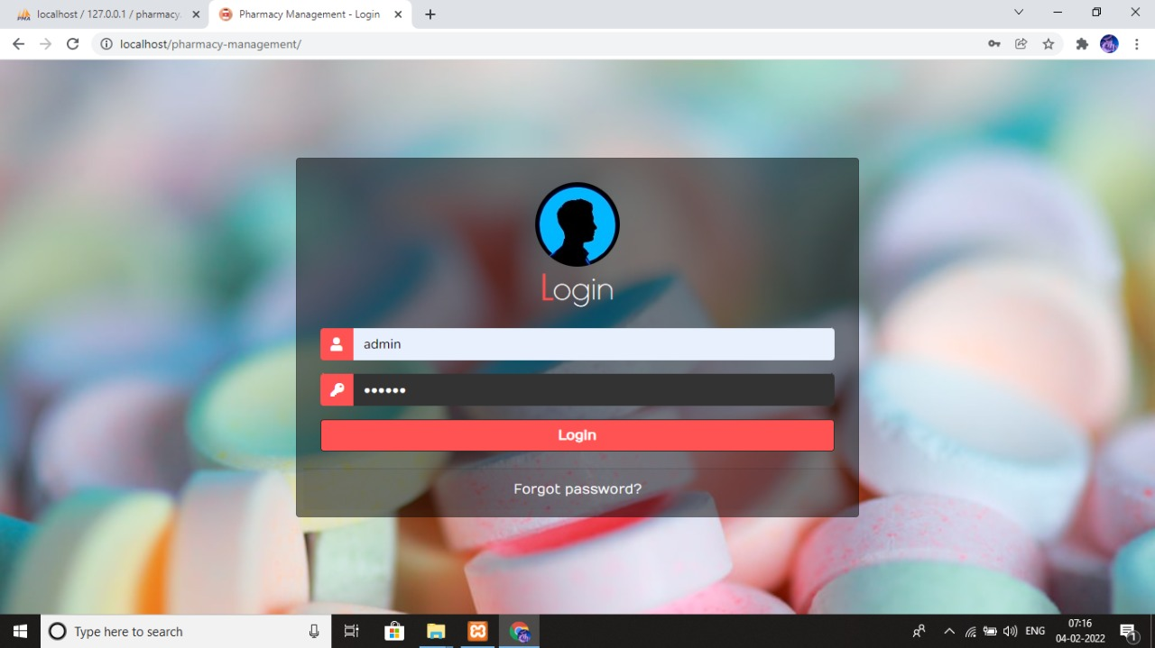

**FIG 6.1 LOGIN PAGE**

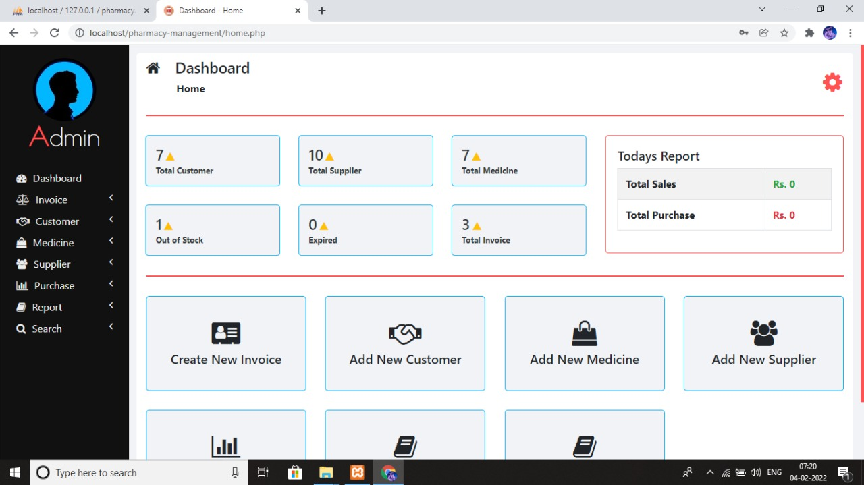

**FIG 6.2 HOME PAGE**

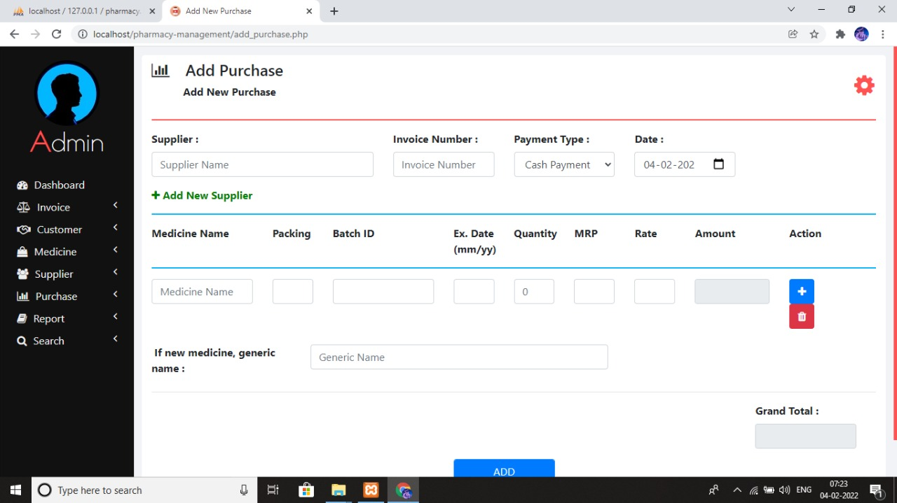

**FIG 6.3 PURCHASE DETAILS**

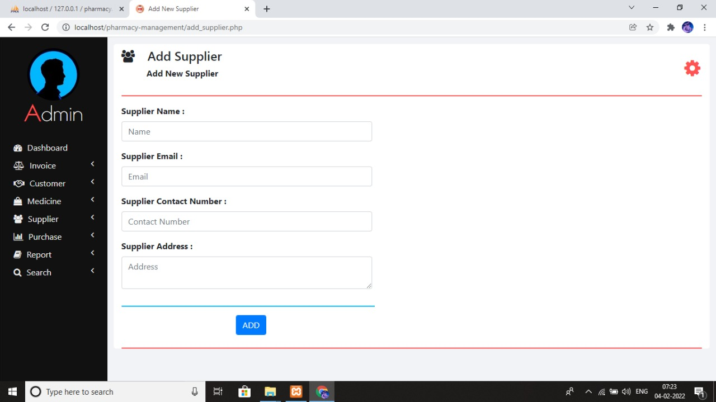

**FIG 6.4 SUPPLIER DETAILS**

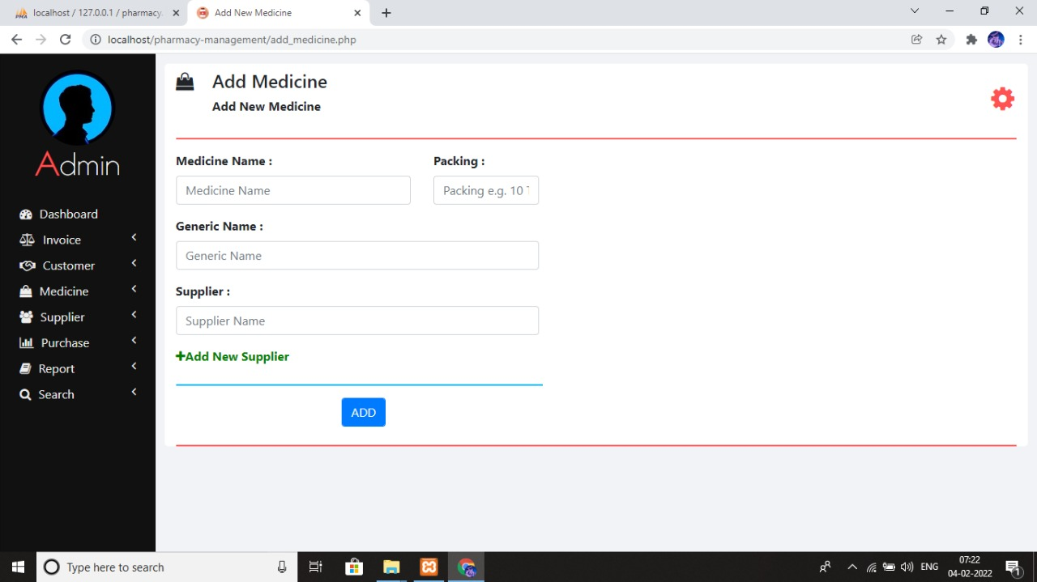

**FIG 6.5 MEDICINE DETAILS**

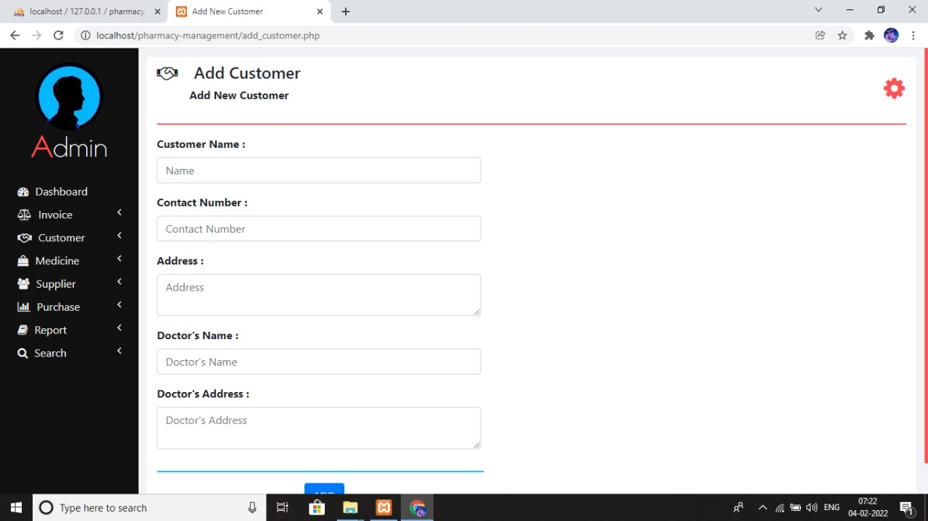

**FIG 6.6 CUSTOMER DETAILS**

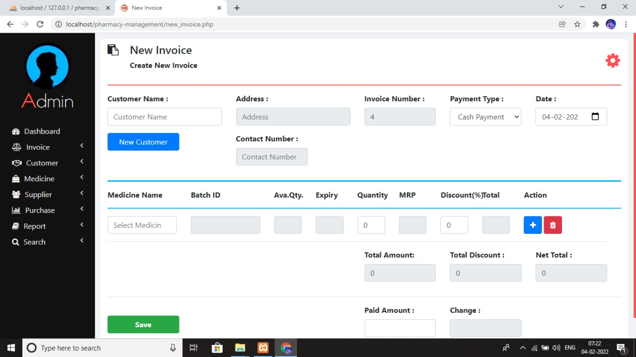

**FIG 6.7 INVOICE DETAILS**

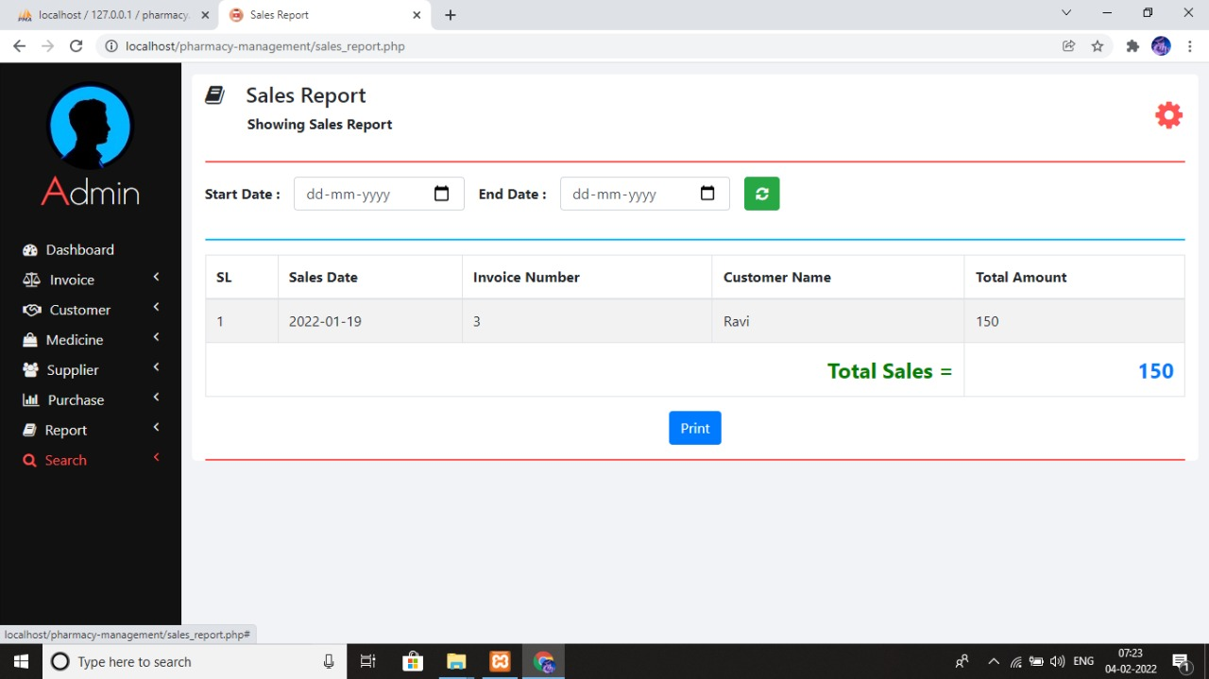

**FIG 6.8 SALES REPORT**

**CHAPTER SEVEN**

**Discussion, Recommendations and Conclusion**

***7.1 Introduction***

This chapter highlights on the discussion of recommendations and conclusion drawn as a result of completing this project.

***7.2 Discussion***

The research it a established that the current manual system had various shortcomings. There were few computers scattered over the organization premises. These machines were slow and inefficient. The- new system was implemented with six new computer sets with improved speed and relatively larger external memory. This eliminated the data storage problems and the time wasted to retrieve data as the computers were more reliable. The conWuters within the premises were also networked allowing easier sharing of information between various departments. The new system was designed with various interfaces which allowed for easy and controlled data validation and this eliminated the greatest setback of uncontrolled data access that the organization was facing, Data replication and integrity was greatly improved as it was easier to enter new records, delete redundant records and validate data stored. This in turn ensured greater productivity from the staff as little time was used to manipulate records. Reports helped the administration to make informed decision and planning strategies, placing the organization in a better competitive position.

***7.3 Recommendations*** -

~ We recommended before the application is put into full use it should be further tested in—sample field to eliminate any bugs that may not have been identified at the time of development.

~ Password levels may be increased to higher levels depending on the confidentiality of the stored data. The current system password is basically low level.

~ we hope that the features that have not been implemented in this application but were originally desired features will be implemented in order to improve on the efficiency, reliability and user friendliness of this system. These features include• external networking (the internet) which will allow automatic of orders form the suppliers.

> We recommend the appointment of a systems administrator who will be in charge ofmaintaining the system and also user training on the use ofthe new system.

***7.4 Conclusion***

Thc system the full requirements of the organization as it was required. The research was successful but with many challenges. The time frame for the research was limited and it was not easy to come up with an all inclusive list of requirements for the organization were also a great challenge as not much was available for us to carry out our mandate effectively. Software acquisition necessary to build the system like MicrosoftVisual basic and XAMPP (MySQL) server softwares were not easy to get and they also needed expertise to use. There also were great lessons learnt as well concerning 1ime management, thorough requirements analysis and preparedness in terms of tools for development.