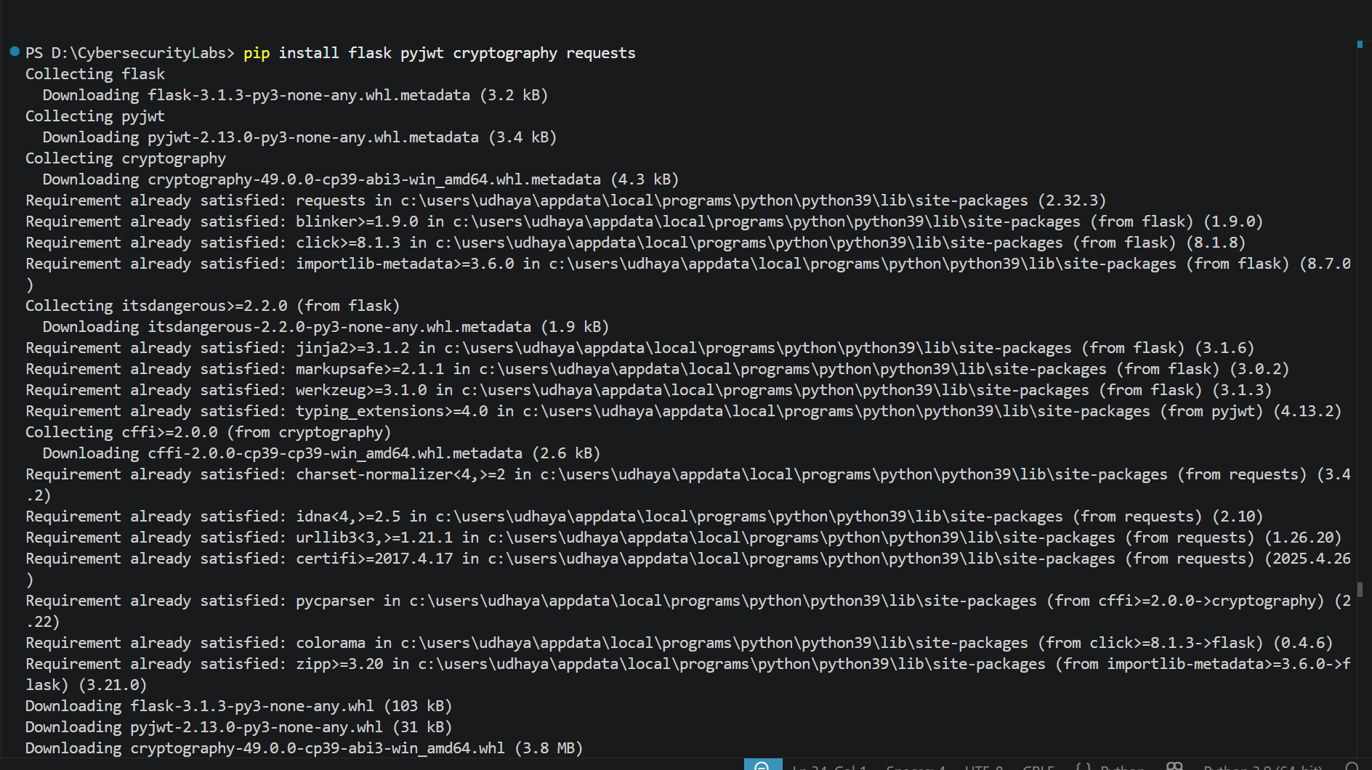
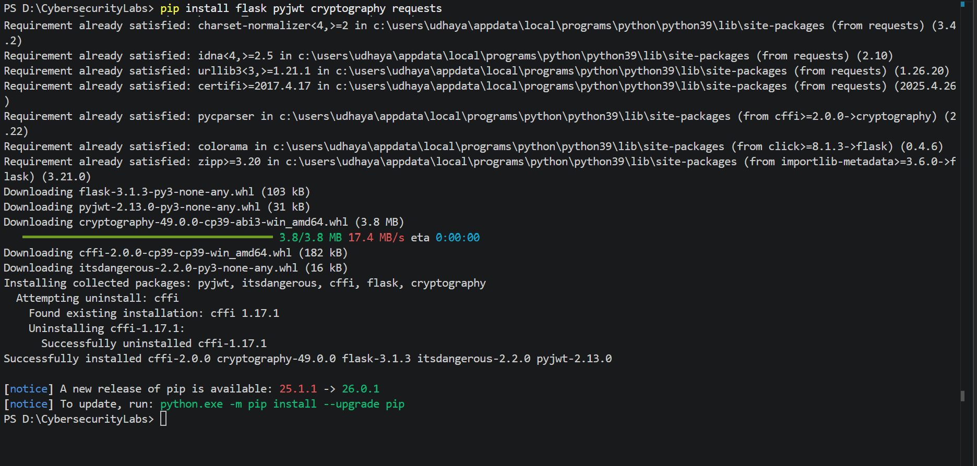
Run order
Terminal 1
python 04-application-jwt-security/vulnerable-api/generate_keys.py
python 04-application-jwt-security/vulnerable-api/vulnerable_api.py
Keep server running.

Terminal 2
python 04-application-jwt-security/attacker-tool/jwt_attack_toolkit.py

Terminal 3
python 04-application-jwt-security/secure-validator/secure_validator.py
