LAB 10
** IF YOU ARE USING ANY TABLE INFO FROM THE OUTPUTS FOR THE REPORT DOCUMENT , KINDLY INSERT IT AS A TABLE IN THE DOCUMENT U SEND ME , IF THERE IS ANY REFERNCE TO A TABLE WITHOUT IT BEING PRESENT IN TABLE FORMAT, I WONT BE INCLUDING IT IN THE LATEX REPORT
A1
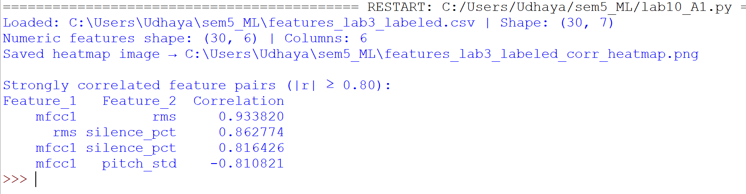

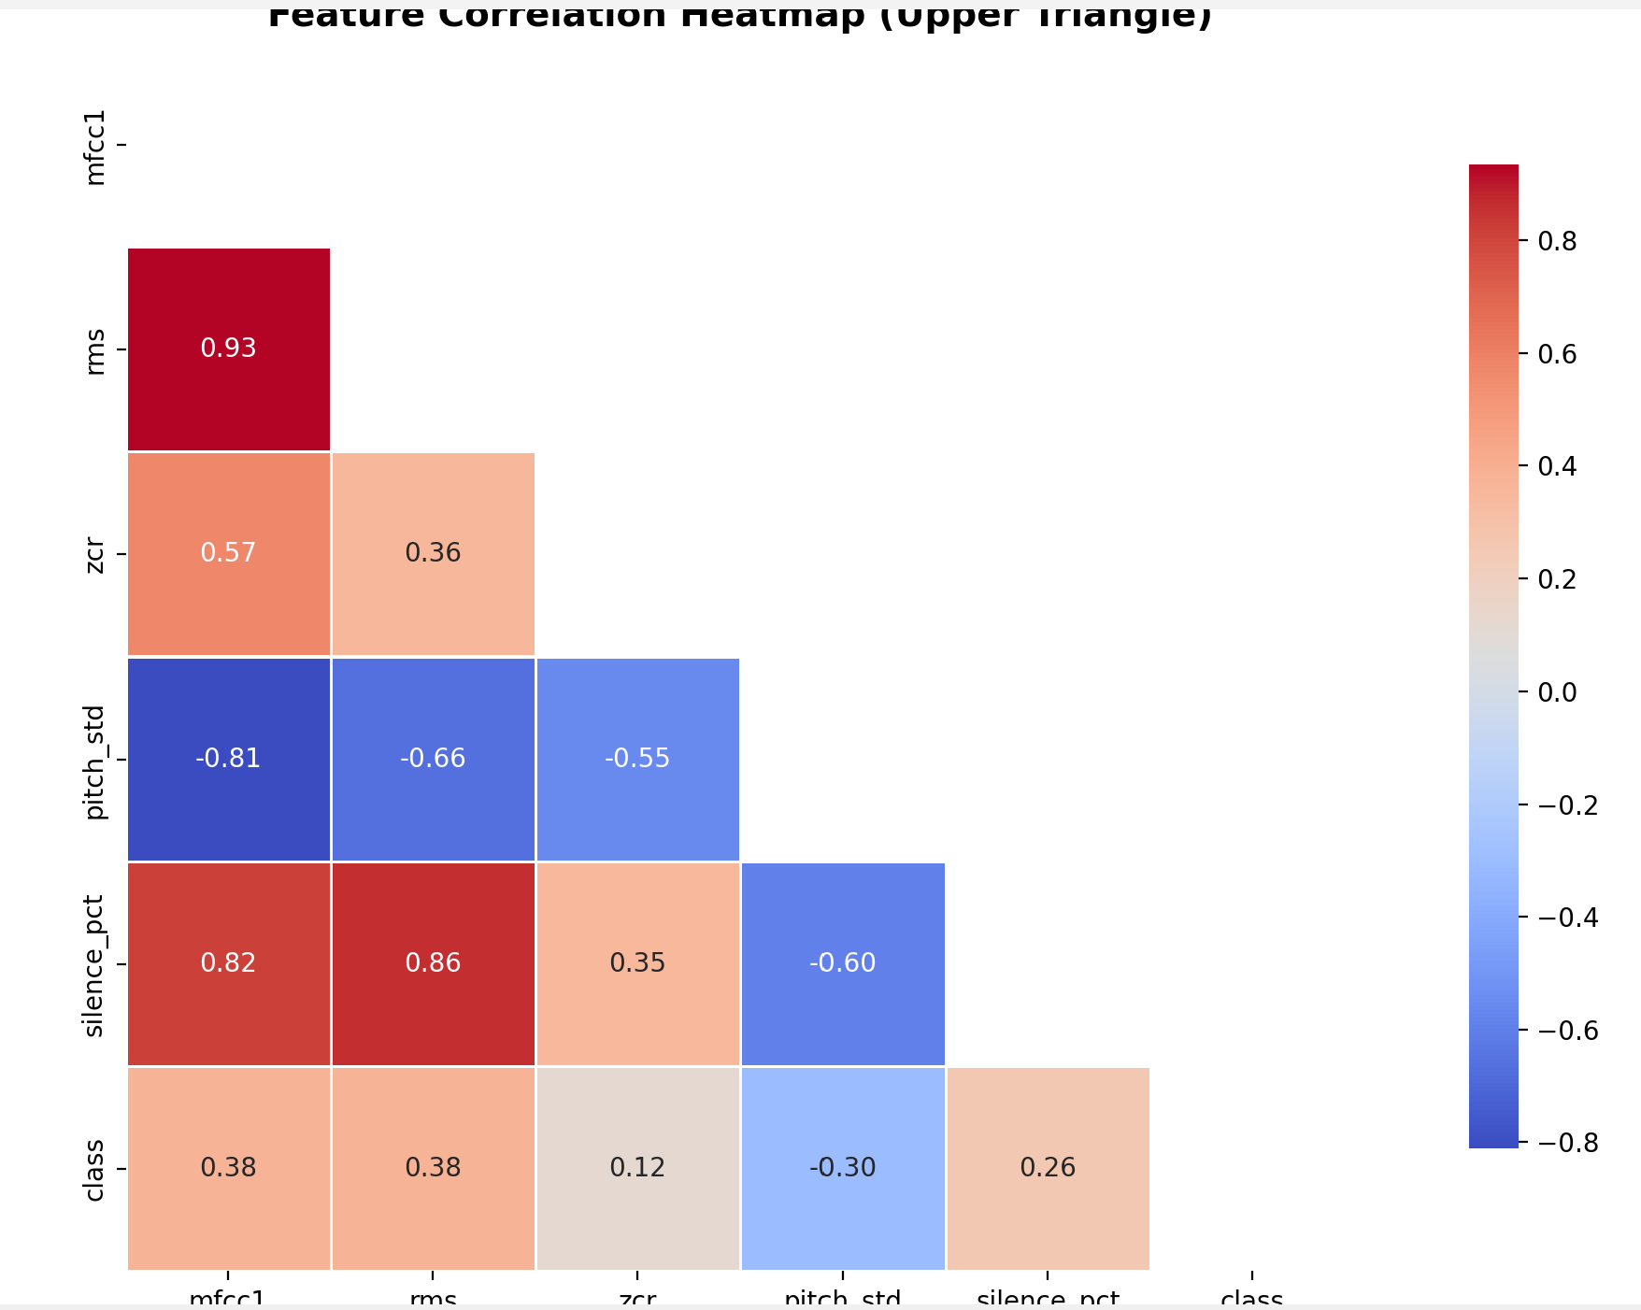
- Strong positive clusters
  - mfcc1–rms (r ≈ 0.93): almost redundant energy/low-order spectral info. Keep one.
  - rms–silence_pct (r ≈ 0.86), mfcc1–silence_pct (r ≈ 0.82): silence proportion co-moves with energy features; likely measuring speaking intensity/voicing continuity.
- Strong negative
  - mfcc1–pitch_std (r ≈ −0.81): higher spectral centroid/energy aligns with lower pitch variability (steadier prosody).
- Moderate
  - zcr correlates modestly with mfcc1 (0.57) and rms (0.36); carries some orthogonal information (voicing/transitions).
- Relation to target (class)
  - Weak–moderate associations (|r| ≤ ~0.38). Linear correlation to the label is limited—classification may rely on multivariate patterns rather than any single feature.
Implications
- Expect multicollinearity among (mfcc1, rms, silence_pct). Drop one (or two) or use PCA/regularization to stabilize models.
- Keep pitch_std despite negatives—it’s informative and not redundant with the energy cluster.
- With n=30, be cautious: estimates have higher variance; prefer cross-validated feature selection
A2
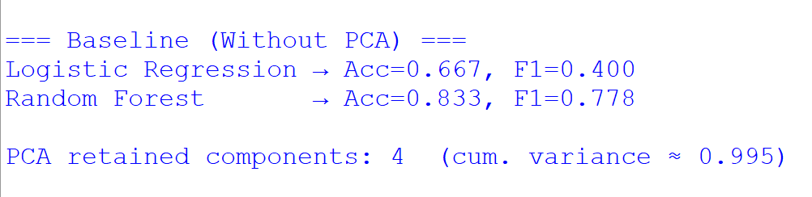
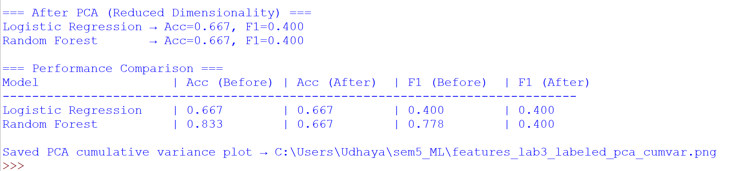
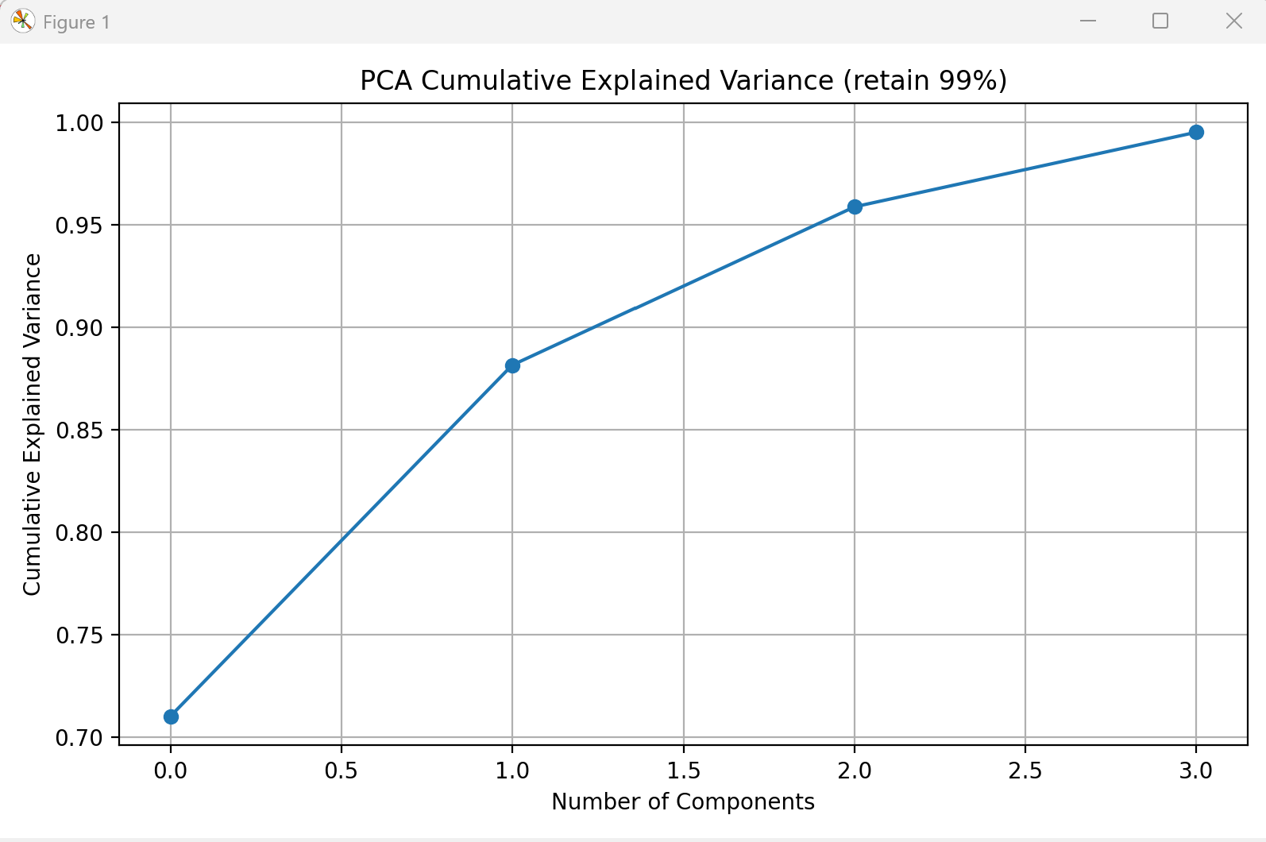

PCA kept 4 components to reach ≈99.5% cumulative variance.
LogReg: Acc 0.667 → 0.667 (no change).
Random Forest: Acc 0.833 → 0.667 (drop after PCA).
Reason: RF benefits from the original, axis-aligned features and their non-linear splits. PCA rotates/compresses features (orthogonal PCs), which can reduce tree performance on tiny datasets. LogReg, being linear, is often indifferent or slightly helped by PCA when multicollinearity exists.
The UndefinedMetricWarning appears because at least one class wasn’t predicted in the test set (tiny/imbalanced data). That’s expected with n=30.
A3
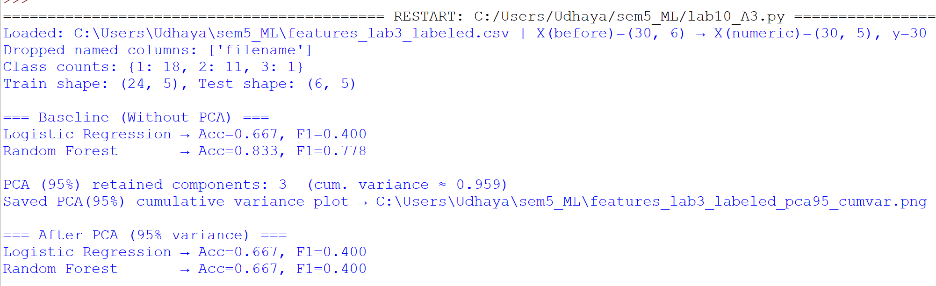
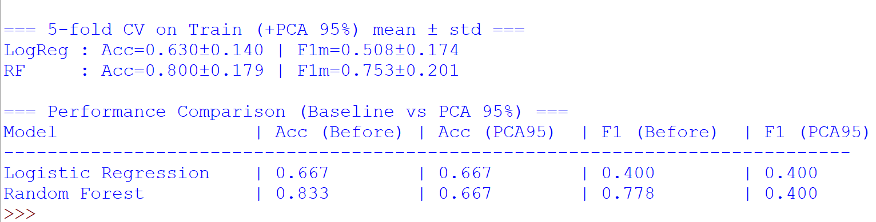
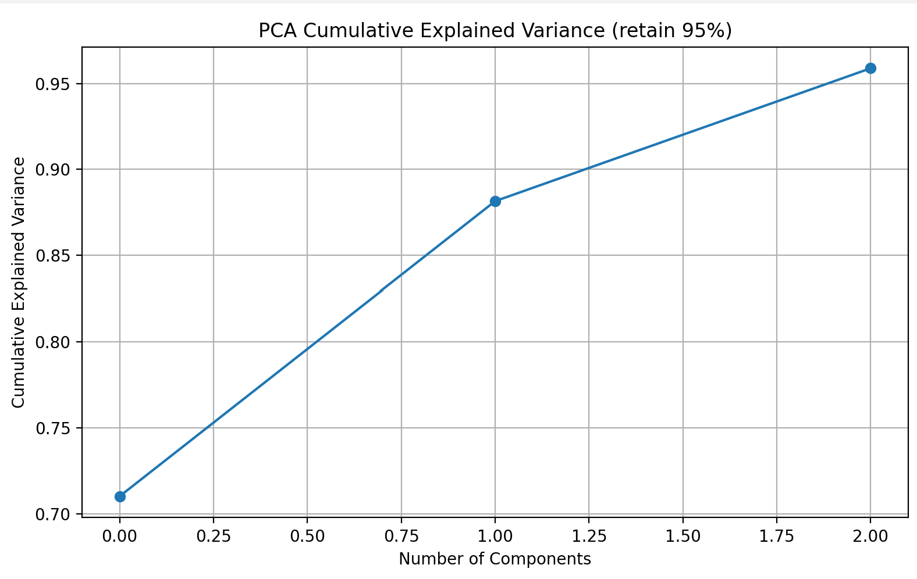
A3 — PCA at 95% variance (vs A2 at 99% and baseline)
Dataset notes: after dropping filename and non-numeric columns, classes were {1:18, 2:11, 3:1}; robust split used.
Components retained
- A2 (99%) → 4 PCs (~0.995 cum. var)
- A3 (95%) → 3 PCs (~0.959 cum. var)
Test performance (your run)
Model | Baseline Acc | Baseline F1 | PCA-99% Acc | PCA-99% F1 | PCA-95% Acc | PCA-95% F1
Logistic Regression | 0.667 | 0.400 | 0.667 | 0.400 | 0.667 | 0.400
Random Forest | 0.833 | 0.778 | 0.667 | 0.400 | 0.667 | 0.400
(You also saw CV on train with PCA-95%: LogReg ≈ 0.63±0.14 acc / 0.51±0.17 F1m; RF ≈ 0.80±0.18 acc / 0.75±0.20 F1m.)
Interpretation
- Dropping to 95% variance compressed to 3 PCs with little extra loss vs 99%.
- Trees (RF) perform best on original axis-aligned features; PCA rotations hurt splits on this small dataset → performance drop from 0.833/0.778 to 0.667/0.400.
- Linear (LogReg) is largely unchanged across baseline, 99%, and 95%—PCA mainly removes multicollinearity without improving separability here.
- Warning about undefined precision happened because a minority class wasn’t predicted in the small test fold; we already set zero_division=0 in the upgraded scorer.
What to submit
- Cumulative variance plot for 95% (saved as ..._pca95_cumvar.png).
- The table above comparing Baseline vs PCA-99% vs PCA-95%.
- 2–3 lines of discussion (you can use the interpretation block).
Recommendation
- For reporting: keep RF on original features and LogReg with/without PCA (both valid).
- If you want to squeeze more out of PCA setups, try:
  - class_weight="balanced" for both models,
  - stratified 5-fold CV as your primary metric on this small dataset,
  - optionally, keep 95% (3 PCs) rather than 99% (4 PCs) to stay simpler with similar results.
A4

