A2
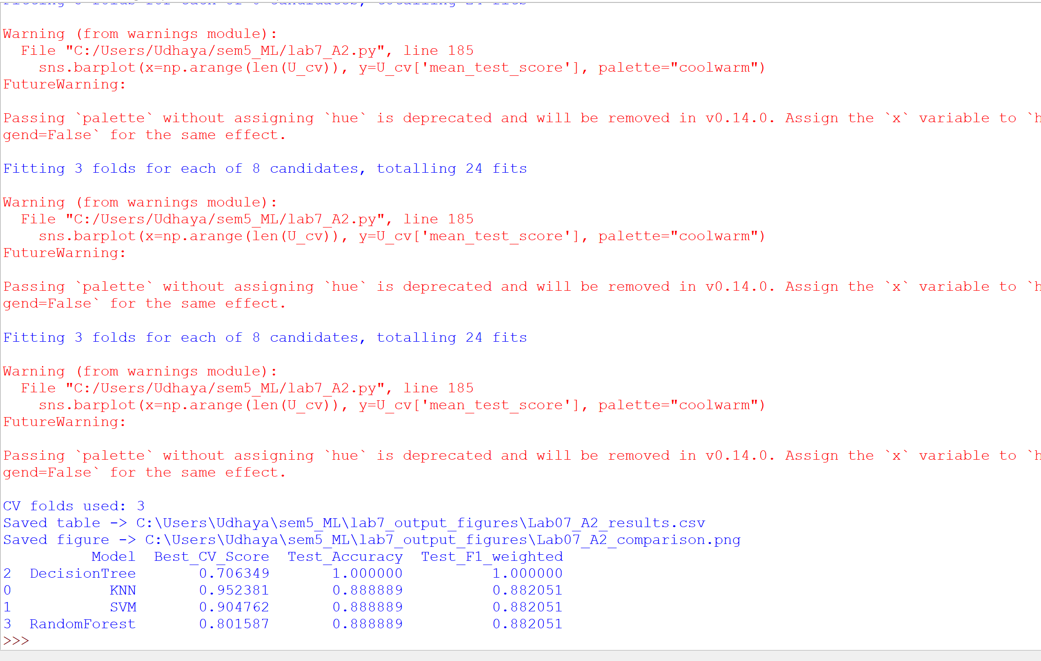
OUTPUT IMAGES SAVED IN THE FOLDER
A3
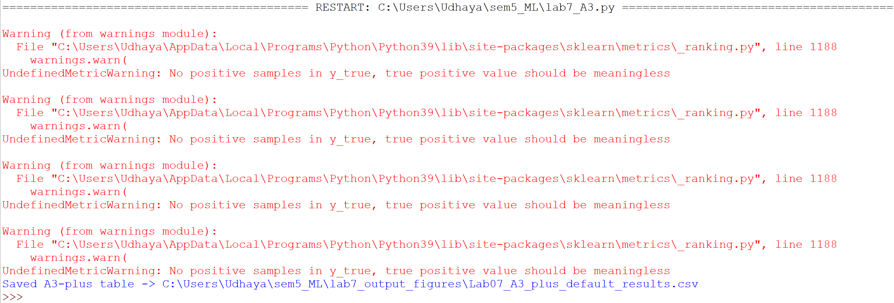
Q1
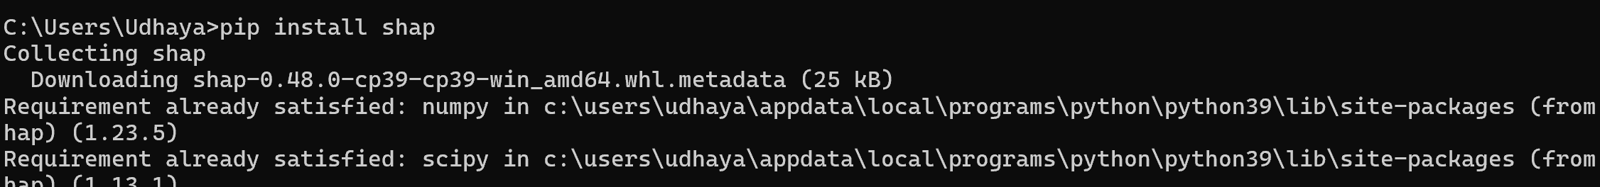
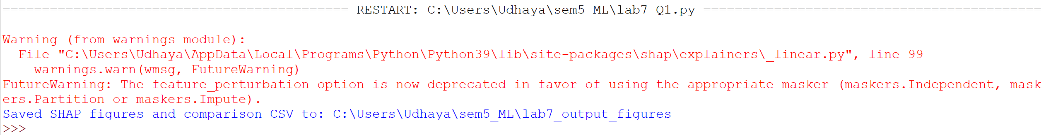
Q2
