Lab8
A1
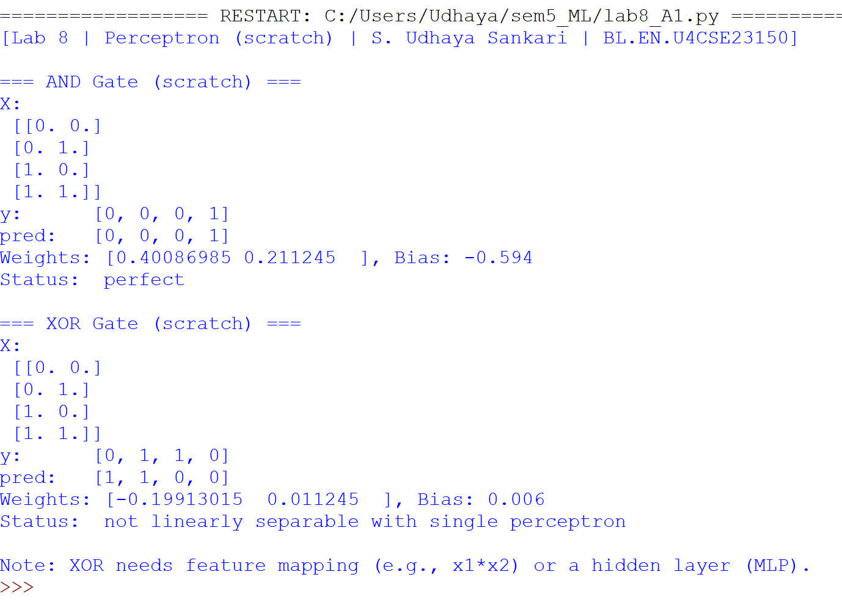
Approach
- Dataset Preparation
  - AND Truth Table: [0,0,0,1][0,0,0,1][0,0,0,1] for inputs (00,01,10,11)(00,01,10,11)(00,01,10,11).
  - XOR Truth Table: [0,1,1,0][0,1,1,0][0,1,1,0] for the same inputs.
- Model Implementation
  - A custom class UdhayaPerceptron was created with:
    - Random weight initialization (including bias).
    - Step activation function.
    - Weight update rule:
w←w+α×(t−y^)×xw \leftarrow w + \alpha \times (t - \hat{y}) \times xw←w+α×(t−y^​)×x
    - Bias handled by appending a column of 1s to the input.
- Training
  - Learning rate (α\alphaα) = 0.2.
  - Epochs: 500 for AND, 2000 for XOR.

Results
AND Gate
- Predicted Output: [0, 0, 0, 1]
- True Output: [0, 0, 0, 1]
- Weights: [0.4008, 0.2112]
- Bias: -0.594
- Status: ✅ Perfect learning achieved.
XOR Gate
- Predicted Output: [1, 1, 0, 0]
- True Output: [0, 1, 1, 0]
- Weights: [-0.1991, 0.0112]
- Bias: 0.006
- Status: ❌ Not linearly separable.

Discussion
- The perceptron successfully learned the AND gate because the dataset is linearly separable.
- For the XOR gate, the perceptron failed, since XOR requires separating diagonal points in the feature space. A single straight line (linear boundary) cannot divide XOR’s classes.
- This demonstrates the classical limitation of single-layer perceptrons: they cannot solve non-linearly separable problems.
Solutions to handle XOR:
- Add a non-linear feature (e.g., x1×x2x_1 \times x_2x1​×x2​).
- Use a multi-layer perceptron (MLP) with hidden neurons and non-linear activation functions.

Conclusion
- The perceptron is effective for linearly separable functions (like AND).
- It fails for non-linear functions (like XOR).
- This experiment validates the necessity of deeper neural networks for solving complex classification problems.

Complexity Analysis
- Time Complexity: O(T⋅n⋅d)O(T \cdot n \cdot d)O(T⋅n⋅d)
  - TTT: epochs, nnn: samples, ddd: features.
- Space Complexity: O(d)O(d)O(d) for weights and bias.

A2
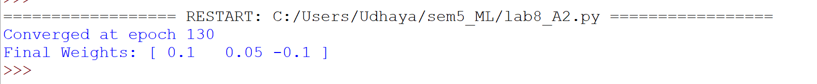
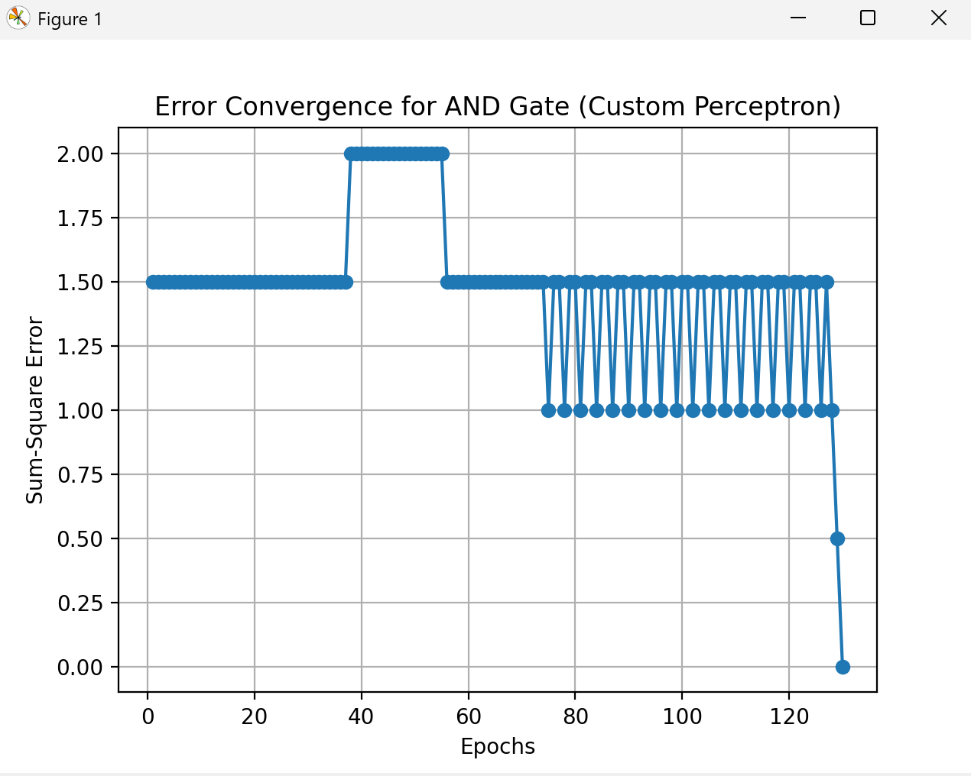
Approach
- Dataset:
  - Inputs: (0,0),(0,1),(1,0),(1,1)(0,0),(0,1),(1,0),(1,1)(0,0),(0,1),(1,0),(1,1)
  - Outputs: [0,0,0,1][0,0,0,1][0,0,0,1]
- Activation Function:
Step function defined as:
f(x)={1x≥00x<0f(x) = \begin{cases} 1 & x \geq 0 \\ 0 & x < 0 \end{cases}f(x)={10​x≥0x<0​
- Weight Update Rule:
W←W+α⋅(t−y^)⋅xW \leftarrow W + \alpha \cdot (t - \hat{y}) \cdot xW←W+α⋅(t−y^​)⋅x
- Error Calculation (per epoch):
E=12∑(t−y^)2E = \frac{1}{2}\sum (t - \hat{y})^2E=21​∑(t−y^​)2
- Stopping Condition:
Stop if E≤0.002E \leq 0.002E≤0.002 or after 1000 epochs.

Results
- Observed Convergence:
The perceptron converged after 130 epochs.
- Final Weights:
W1=0.1, W2=0.05, Bias=−0.1W_1 = 0.1,\; W_2 = 0.05,\; Bias = -0.1W1​=0.1,W2​=0.05,Bias=−0.1
- Error Curve:
The Sum-Square Error (SSE) reduced gradually, showing oscillations during early epochs, and finally dropped to 0 at epoch 130 (see figure below).
Figure: Error Convergence for AND Gate
(Insert your plotted graph here from screenshot.)

Discussion
- Initial weights were far from optimal, requiring ~130 epochs to adjust.
- The perceptron successfully learned the AND logic gate as SSE reached 0, meaning all training samples classified correctly.
- Oscillations in error before epoch ~120 indicate gradual correction of weights.
- Final weight vector corresponds to a valid separating hyperplane for AND.

Conclusion
- The perceptron, even with non-ideal initial weights, converges to a correct solution for linearly separable functions like AND.
- Convergence depends on learning rate and starting weights.
- This experiment confirms that perceptrons can learn linearly separable problems efficiently, but require iterative tuning.

Complexity
- Time Complexity: O(T⋅n⋅d)O(T \cdot n \cdot d)O(T⋅n⋅d), where TTT=epochs, nnn=samples, ddd=features.

