# University of Mumbai

PRACTICAL JOURNAL – ELECTIVE II



PSIT3P3a

Machine Learning

SUBMITTED BY

Karkera Prateek Ramesh

SEAT NO 30102

SUBMITTED IN PARTIAL FULFILLMENT OF THE REQUIREMENTS FOR QUALIFYING M.Sc. (I.T.) PART-II (SEMESTER – III) EXAMINATION

2022-2023

Department of Information Technology

3RD FLOOR, DR. SHANKAR DAYAL SHARMA BHAVAN, IDOL BUILDING, VIDYANAGRI,

SANTACRUZ (E), MUMBAI – 400098.

**University of Mumbai**



**Department of Information Technology**

**CERTIFICATE**

This is to certify that Mr. **Karkera Prateek Ramesh Seat No. 30102** studying in **Master of Science** in **Information Technology Part II Semester III** has satisfactorily completed the Practical of **PSIT3P3a Machine Learning** as prescribed by University of Mumbai, during the academic year **2022-23**.

Signature Signature Signature

Guide External Examiner Head of the Department Examined By Certified by

College Seal Date:

**INDEX**

|  |  |  |  |  |
| --- | --- | --- | --- | --- |
| Practical No. | Date | Name of Practical | Page No. | Signature |
| 1 | 14/10/2022 | Implement and demonstrate the FIND-S algorithm for finding the most specific hypothesis based on a given set of training data samples. Read the training data from a .CSV file. | 4 |  |
| 2 | 21/10/2022 | For a given set of training data examples stored in a .CSV file, implement and demonstrate the Candidate-Elimination algorithm to output a description of the set of all hypotheses consistent with the training examples | 6 |  |
| 3 | 28/10/2022 | Write a program to demonstrate the working of the decision tree based ID3 algorithm. Use an appropriate data set for building the decision tree and apply this knowledge to classify a new sample. | 9 |  |
| 4 | 04/11/2022 | Build an Artificial Neural Network by implementing the Back-propagation algorithm and test the same using appropriate data sets. | 14 |  |
| 5 | 11/11/2022 | Write a program to implement the naïve Bayesian classifier for a sample training data set stored as a .CSV file. Compute the accuracy of the classifier, considering few test data sets. | 17 |  |
| 6 | 18/11/2022 | Assuming a set of documents that need to be classified, use the naïve Bayesian Classifier model to perform this task. Built-in Java classes/API can be used to write the program. Calculate the accuracy, precision, and recall for your data set. | 23 |  |
| 7 | 25/11/2022 | Write a program to construct a Bayesian network considering medical data. Use this model to demonstrate the diagnosis of heart patients using standard Heart Disease Data Set. You can use  Java/Python ML library classes/API | 27 |  |
| 8 | 02/12/2022 | Apply EM algorithm to cluster a set of data stored in a .CSV file. Use the same data set for clustering using k-Means algorithm. Compare the results of  these two algorithms and comment on the quality of clustering. You can add Java/Python ML library classes/API in the program. | 30 |  |
| 9 | 09/12/2022 | Write a program to implement k-Nearest Neighbour algorithm to classify the iris data set. Print both correct and wrong predictions. Java/Python ML library classes can be used for this problem. | 34 |  |
| 10 | 16/12/2022 | Implement the non-parametric Locally Weighted Regression algorithm in order to fit data points. Select appropriate data set for your experiment and draw graphs | 36 |  |

**PRACTICAL 1**

**TITLE:** Implement and demonstrate the FIND-S algorithm for finding the most specific hypothesis based on a given set of training data samples. Read the training data from a .CSV file.

**CODE:**

import csv

a = []

with open('enjoysport.csv', 'r') as csvfile:

for row in csv.reader(csvfile):

a.append(row)

print(a)

num_attribute = len(a[0]) - 1

print("\n The initial hypothesis is : ")

hypothesis = ['0'] * num_attribute

print(hypothesis)

print("\n The total number of training instances are : ", len(a))

for i in range(0, len(a)):

if a[i][num_attribute] == 'yes':

for j in range(0, num_attribute):

if hypothesis[j] == '0' or hypothesis[j] == a[i][j]:

hypothesis[j] = a[i][j]

else:

hypothesis[j] = '?'

print("\n The hypothesis for the training instance {} is :\n".format(i + 1), hypothesis)

print("\n The Maximally specific hypothesis for the training instance is ")

print(hypothesis)

**OUTPUT:**

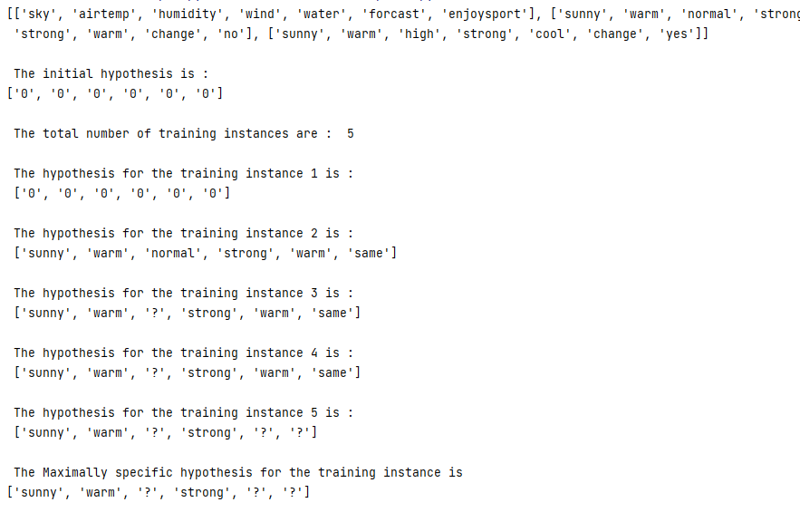

**PRACTICAL 2**

**TITLE:** For a given set of training data examples stored in a .CSV file, implement and

demonstrate the Candidate-Elimination algorithm to output a description of the set of all

hypotheses consistent with the training examples.

**CODE:**

import numpy as np

import pandas as pd

data = pd.read_csv('enjoysport.csv')

concepts = np.array(data.iloc[:, 0:-1])

print(concepts)

target = np.array(data.iloc[:, -1])

print(target)

def learn(concepts, target):

specific_h = concepts[0].copy()

print("initialization of specific_h and general_h")

print(specific_h)

general_h = [["?" for i in range(len(specific_h))] for i in range(len(specific_h))]

print(general_h)

for i, h in enumerate(concepts):

print("For Loop Starts")

if target[i] == "yes":

print("If instance is Positive ")

for x in range(len(specific_h)):

if h[x] != specific_h[x]:

specific_h[x] = '?'

general_h[x][x] = '?'

if target[i] == "no":

print("If instance is Negative ")

for x in range(len(specific_h)):

if h[x] != specific_h[x]:

general_h[x][x] = specific_h[x]

else:

general_h[x][x] = '?'

print(" steps of Candidate Elimination Algorithm", i + 1)

print(specific_h)

print(general_h)

print("\n")

print("\n")

indices = [i for i, val in enumerate(general_h) if val == ['?', '?', '?', '?', '?', '?']]

for i in indices:

general_h.remove(['?', '?', '?', '?', '?', '?'])

return specific_h, general_h

s_final, g_final = learn(concepts, target)

print("Final Specific_h:", s_final, sep="\n")

print("Final General_h:", g_final, sep="\n")

**OUTPUT:**

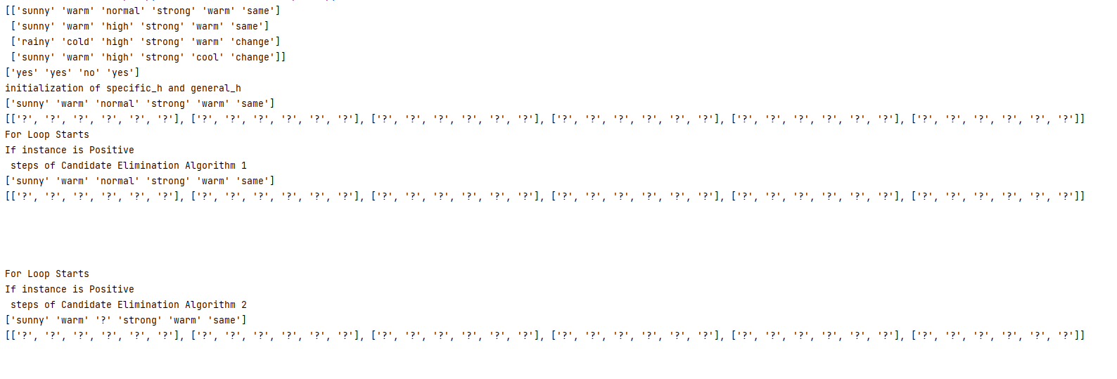

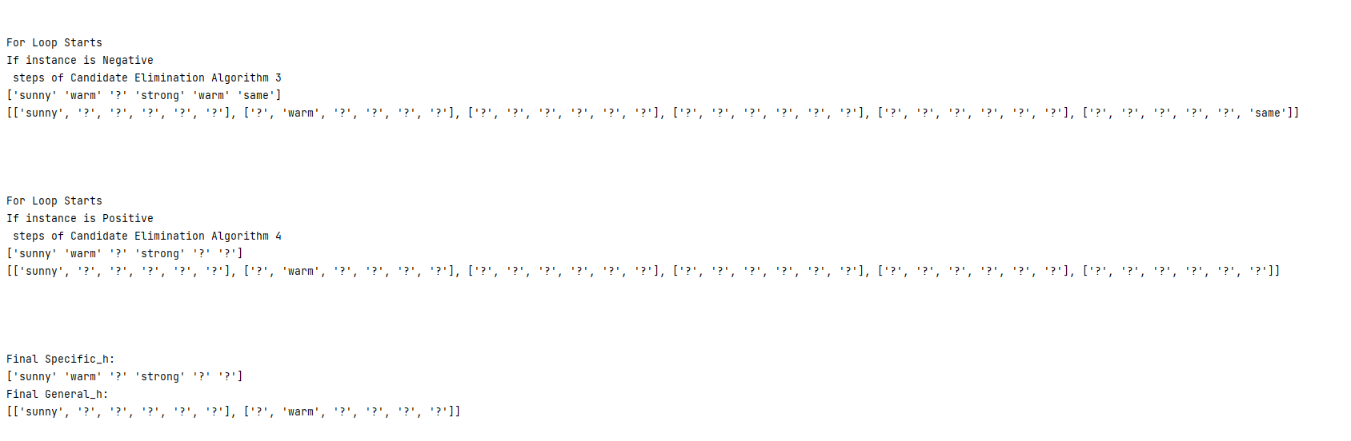

**PRACTICAL 3**

**TITLE:** Write a program to demonstrate the working of the decision tree based ID3 algorithm. Use an appropriate data set for building the decision tree and apply this knowledge to classify a new sample.

**CODE:**

import math

import csv

def load_csv(filename):

lines = csv.reader(open(filename, "r"));

dataset = list(lines)

headers = dataset.pop(0)

return dataset, headers

class Node:

def __init__(self, attribute):

self.attribute = attribute

self.children = []

self.answer = ""

def subtables(data, col, delete):

dic = {}

coldata = [row[col] for row in data]

attr = list(set(coldata))

counts = [0] * len(attr)

r = len(data)

c = len(data[0])

for x in range(len(attr)):

for y in range(r):

if data[y][col] == attr[x]:

counts[x] += 1

for x in range(len(attr)):

dic[attr[x]] = [[0 for i in range(c)] for j in range(counts[x])]

pos = 0

for y in range(r):

if data[y][col] == attr[x]:

if delete:

del data[y][col]

dic[attr[x]][pos] = data[y]

pos += 1

return attr, dic

def entropy(S):

attr = list(set(S))

if len(attr) == 1:

return 0

counts = [0, 0]

for i in range(2):

counts[i] = sum([1 for x in S if attr[i] == x]) / (len(S) * 1.0)

sums = 0

for cnt in counts:

sums += -1 * cnt * math.log(cnt, 2)

return sums

def compute_gain(data, col):

attr, dic = subtables(data, col, delete=False)

total_size = len(data)

entropies = [0] * len(attr)

ratio = [0] * len(attr)

total_entropy = entropy([row[-1] for row in data])

for x in range(len(attr)):

ratio[x] = len(dic[attr[x]]) / (total_size * 1.0)

entropies[x] = entropy([row[-1] for row in dic[attr[x]]])

total_entropy -= ratio[x] * entropies[x]

return total_entropy

def build_tree(data, features):

lastcol = [row[-1] for row in data]

if (len(set(lastcol))) == 1:

node = Node("")

node.answer = lastcol[0]

return node

n = len(data[0]) - 1

gains = [0] * n

for col in range(n):

gains[col] = compute_gain(data, col)

split = gains.index(max(gains))

node = Node(features[split])

fea = features[:split] + features[split + 1:]

attr, dic = subtables(data, split, delete=True)

for x in range(len(attr)):

child = build_tree(dic[attr[x]], fea)

node.children.append((attr[x], child))

return node

def print_tree(node, level):

if node.answer != "":

print(" " * level, node.answer)

return

print(" " * level, node.attribute)

for value, n in node.children:

print(" " * (level + 1), value)

print_tree(n, level + 2)

def classify(node, x_test, features):

if node.answer != "":

print(node.answer)

return

pos = features.index(node.attribute)

for value, n in node.children:

if x_test[pos] == value:

classify(n, x_test, features)

'''Main program'''

dataset, features = load_csv("D:/ML_Pracs/id3.csv")

node1 = build_tree(dataset, features)

print("The decision tree for the dataset using ID3 algorithm is")

print_tree(node1, 0)

testdata, features = load_csv("D:/ML_Pracs/id3_test_1.csv")

for xtest in testdata:

print("The test instance:", xtest)

print("The label for test instance:", end=" ")

classify(node1, xtest, features)

**OUTPUT:**

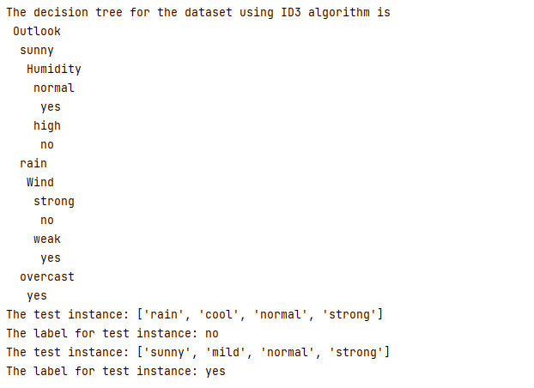

**PRACTICAL 4**

**TITLE:** Build an Artificial Neural Network by implementing the Back-propagation algorithm and test the same using appropriate data sets.

**CODE:**

import numpy as np

X = np.array(([2, 9], [1, 5], [3, 6]), dtype=float) # two inputs [sleep,study]

y = np.array(([92], [86], [89]), dtype=float) # one output [Expected % in Exams]

X = X / np.amax(X, axis=0) # maximum of X array longitudinally

y = y / 100

# Sigmoid Function

def sigmoid(x):

return 1 / (1 + np.exp(-x))

# Derivative of Sigmoid Function

def derivatives_sigmoid(x):

return x * (1 - x)

# Variable initialization

epoch = 5000 # Setting training iterations

lr = 0.1 # Setting learning rate

inputlayer_neurons = 2 # number of features in data set

hiddenlayer_neurons = 3 # number of hidden layers neurons

output_neurons = 1 # number of neurons at output layer

# weight and bias initialization

wh = np.random.uniform(size=(inputlayer_neurons, hiddenlayer_neurons)) # weight of the link from input node to hidden node

bh = np.random.uniform(size=(1, hiddenlayer_neurons)) # bias of the link from input node to hidden node

wout = np.random.uniform(size=(hiddenlayer_neurons, output_neurons)) # weight of the link from hidden node to output node

bout = np.random.uniform(size=(1, output_neurons)) # bias of the link from hidden node to output node

# draws a random range of numbers uniformly of dim x*y

for i in range(epoch):

# Forward Propogation

hinp1 = np.dot(X, wh)

hinp = hinp1 + bh

hlayer_act = sigmoid(hinp)

outinp1 = np.dot(hlayer_act, wout)

outinp = outinp1 + bout

output = sigmoid(outinp)

# Backpropagation

EO = y - output

outgrad = derivatives_sigmoid(output)

d_output = EO * outgrad

EH = d_output.dot(wout.T)

# how much hidden layer weights contributed to error

hiddengrad = derivatives_sigmoid(hlayer_act)

d_hiddenlayer = EH * hiddengrad

# dotproduct of nextlayererror and currentlayerop

wout += hlayer_act.T.dot(d_output) * lr

wh += X.T.dot(d_hiddenlayer) * lr

print("Input: \n" + str(X))

print("Actual Output: \n" + str(y))

print("Predicted Output: \n", output)

**OUTPUT:**

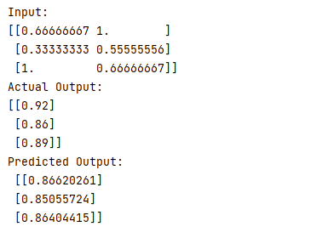

**PRACTICAL 5**

**TITLE:** Write a program to implement the naïve Bayesian classifier for a sample training dataset stored as a .CSV file. Compute the accuracy of the classifier, considering few test datasets.

**CODE:**

import csv

import random

import math

import pandas as pd

def loadcsv(filename):

lines = csv.reader(open(filename, "r"));

dataset = list(lines)

for i in range(len(dataset)):

# converting strings into numbers for processing

dataset[i] = [float(x) for x in dataset[i]]

return dataset

def splitdataset(dataset, splitratio):

# 67% training size

trainsize = int(len(dataset) * splitratio);

trainset = []

copy = list(dataset);

while len(trainset) < trainsize:

# generate indices for the dataset list randomly to pick ele for training data

index = random.randrange(len(copy));

trainset.append(copy.pop(index))

return [trainset, copy]

def separatebyclass(dataset):

separated = {} # dictionary of classes 1 and 0

# creates a dictionary of classes 1 and 0 where the values are

# the instances belonging to each class

for i in range(len(dataset)):

vector = dataset[i]

if (vector[-1] not in separated):

separated[vector[-1]] = []

separated[vector[-1]].append(vector)

print("Separated[0] : ", separated[0])

print("Separated[1] : ", separated[1])

return separated

def mean(numbers):

return sum(numbers) / float(len(numbers))

def stdev(numbers):

avg = mean(numbers)

variance = sum([pow(x - avg, 2) for x in numbers]) / float(len(numbers) - 1)

return math.sqrt(variance)

def summarize(dataset): # creates a dictionary of classes

summaries = [(mean(attribute), stdev(attribute)) for attribute in zip(*dataset)];

del summaries[-1] # excluding labels +ve or -ve

return summaries

def summarizebyclass(dataset):

separated = separatebyclass(dataset);

# print(separated)

summaries = {}

for classvalue, instances in separated.items():

# for key,value in dic.items()

# summaries is a dic of tuples(mean,std) for each class value

summaries[classvalue] = summarize(instances) # summarize is used to cal to mean and std

return summaries

def calculateprobability(x, mean, stdev):

exponent = math.exp(-(math.pow(x - mean, 2) / (2 * math.pow(stdev, 2))))

return (1 / (math.sqrt(2 * math.pi) * stdev)) * exponent

def calculateclassprobabilities(summaries, inputvector):

probabilities = {} # probabilities contains the all prob of all class of test data

for classvalue, classsummaries in summaries.items(): # class and attribute information as mean and sd

probabilities[classvalue] = 1

for i in range(len(classsummaries)):

mean, stdev = classsummaries[i] # take mean and sd of every attribute for class 0 and 1 seperaely

x = inputvector[i] # testvector's first attribute

probabilities[classvalue] *= calculateprobability(x, mean, stdev); # use normal dist

return probabilities

def predict(summaries, inputvector): # training and test data is passed

probabilities = calculateclassprobabilities(summaries, inputvector)

bestLabel, bestProb = None, -1

for classvalue, probability in probabilities.items(): # assigns that class which has he highest prob

if bestLabel is None or probability > bestProb:

bestProb = probability

bestLabel = classvalue

return bestLabel

def getpredictions(summaries, testset):

predictions = []

for i in range(len(testset)):

result = predict(summaries, testset[i])

predictions.append(result)

return predictions

def getaccuracy(testset, predictions):

correct = 0

for i in range(len(testset)):

if testset[i][-1] == predictions[i]:

correct += 1

return (correct / float(len(testset))) * 100.0

def main():

filename = 'D:/ML_Pracs/naivedata.csv'

splitratio = 0.67

dataset = loadcsv(filename);

dataset1 = pd.read_csv(filename)

for i in dataset1.columns:

print("Mean : ",mean(dataset1[i]))

print("Stdev : ", stdev(dataset1[i]))

trainingset, testset = splitdataset(dataset, splitratio)

print('Split {0} rows into train={1} and test={2} rows'.format(len(dataset), len(trainingset), len(testset)))

# prepare model

summaries = summarizebyclass(trainingset);

print("summaries[0] : ",summaries[0])

print("summaries[1] : ", summaries[1])

# test model

predictions = getpredictions(summaries, testset) # find the predictions of test data with the training data

print('Predictions : ', predictions)

accuracy = getaccuracy(testset, predictions)

print('Accuracy of the classifier is : {0}%'.format(accuracy))

main()

**OUTPUT:**

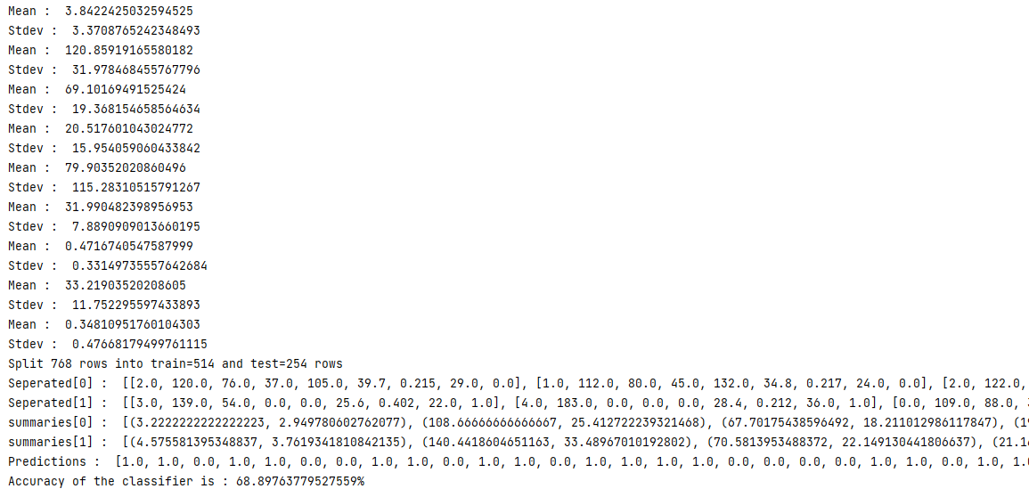

**PRACTICAL 6**

**TITLE:** Assuming a set of documents that need to be classified, use the naïve Bayesian Classifier model to perform this task. Built-in Java classes/API can be used to write the program. Calculate the accuracy, precision, and recall for your data set.

**CODE:**

import pandas as pd

msg = pd.read_csv('D:/ML_Pracs/naivetext.csv',names=['message','label'])

print('The dimensions of the dataset', msg.shape)

msg['labelnum'] = msg.label.map({'pos': 1, 'neg': 0})

X = msg.message

y = msg.labelnum

print(X)

print(y)

# splitting the dataset into train and test data

from sklearn.model_selection import train_test_split

xtrain, xtest, ytrain, ytest = train_test_split(X, y)

print('\n The total number of Training Data :', ytrain.shape)

print('\n The total number of Test Data :', ytest.shape)

# output of the words or Tokens in the text documents

from sklearn.feature_extraction.text import CountVectorizer

count_vect = CountVectorizer()

xtrain_dtm = count_vect.fit_transform(xtrain)

xtest_dtm = count_vect.transform(xtest)

print('\n The words or Tokens in the text documents \n')

print(count_vect.get_feature_names_out())

df = pd.DataFrame(xtrain_dtm.toarray(), columns=count_vect.get_feature_names_out())

# Training Naive Bayes (NB) classifier on training data.

from sklearn.naive_bayes import MultinomialNB

clf = MultinomialNB().fit(xtrain_dtm, ytrain)

predicted = clf.predict(xtest_dtm)

# printing accuracy, Confusion matrix, Precision and Recall

from sklearn import metrics

print('\n Accuracy of the classifier is', metrics.accuracy_score(ytest, predicted))

print('\n Confusion matrix')

print(metrics.confusion_matrix(ytest, predicted))

print('\n The value of Precision', metrics.precision_score(ytest, predicted))

print('\n The value of Recall', metrics.recall_score(ytest, predicted))

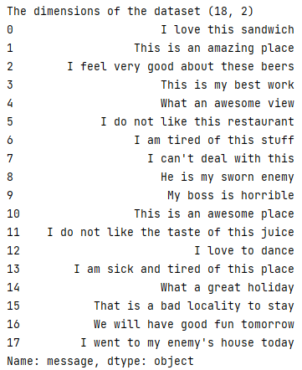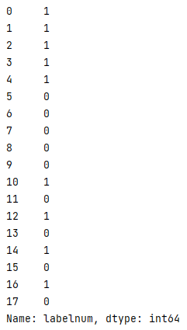**OUTPUT:**

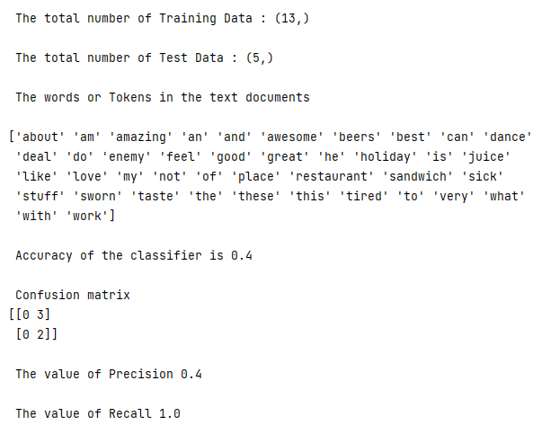

**PRACTICAL 7**

**TITLE:** Write a program to construct a Bayesian network considering medical data. Use this model to demonstrate the diagnosis of heart patients using standard Heart Disease Data Set. You can use Java/Python ML library classes/API.

**CODE:**

import numpy as np

import pandas as pd

import csv

from pgmpy.estimators import MaximumLikelihoodEstimator

from pgmpy.models import BayesianNetwork

from pgmpy.inference import VariableElimination

heartDisease = pd.read_csv('D:/ML_Pracs/heart.csv')

heartDisease = heartDisease.replace('?',np.nan)

print('Sample instances from the dataset are given below')

print(heartDisease.head())

print('\n Attributes and datatypes')

print(heartDisease.dtypes)

model = BayesianNetwork([('age','heartdisease'),('sex','heartdisease'),('exang','heartdisease'),('cp','heartdisease'),('heartdisease','restecg'),('heartdisease','chol')])

print('\nLearning CPD using Maximum likelihood estimators')

model.fit(heartDisease,estimator=MaximumLikelihoodEstimator)

print('\n Inferencing with Bayesian Network:')

HeartDiseasetest_infer = VariableElimination(model)

print('\n 1. Probability of HeartDisease given evidence= restecg')

q1=HeartDiseasetest_infer.query(variables=['heartdisease'],evidence={'restecg':1})

print(q1)

print('\n 2. Probability of HeartDisease given evidence= cp ')

q2=HeartDiseasetest_infer.query(variables=['heartdisease'],evidence={'cp':2})

print(q2)

**OUTPUT:**

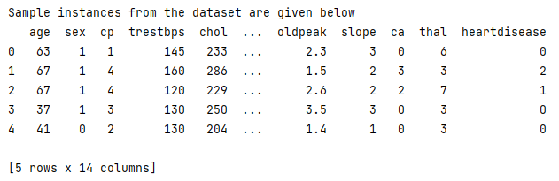

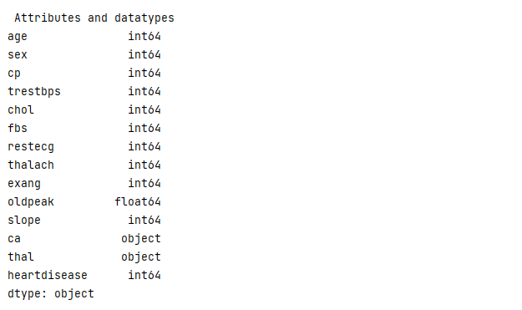

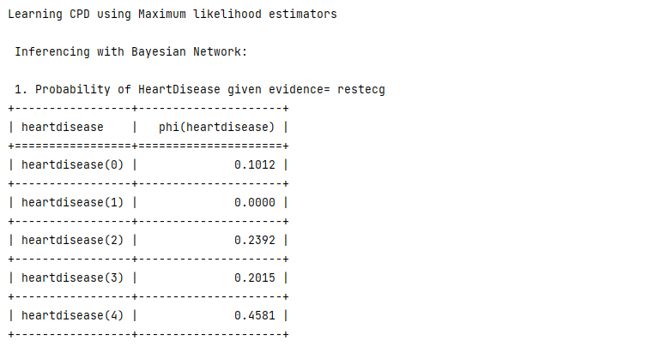

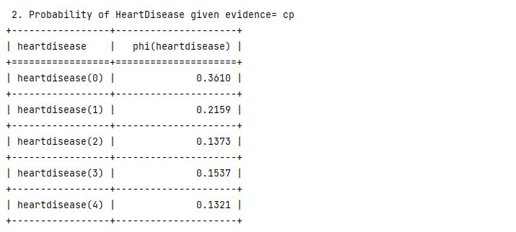

**PRACTICAL 8**

**TITLE:** Apply EM algorithm to cluster a set of data stored in a .CSV file. Use the same data set for clustering using k-Means algorithm. Compare the results of these two algorithms and comment on the quality of clustering. You can add Java/Python ML library classes/API in the program.

**CODE:**

import matplotlib.pyplot as plt

from sklearn import datasets

from sklearn.cluster import KMeans

import sklearn.metrics as sm

import pandas as pd

import numpy as np

iris = datasets.load_iris()

X = pd.DataFrame(iris.data)

X.columns = ['Sepal_Length','Sepal_Width','Petal_Length','Petal_Width']

y = pd.DataFrame(iris.target)

y.columns = ['Targets']

model = KMeans(n_clusters=3)

model.fit(X)

plt.figure(figsize=(14,7))

colormap = np.array(['red', 'lime', 'black'])

# Plot the Original Classifications

plt.subplot(1, 2, 1)

plt.scatter(X.Petal_Length, X.Petal_Width, c=colormap[y.Targets], s=40)

plt.title('Real Classification')

plt.xlabel('Petal Length')

plt.ylabel('Petal Width')

# Plot the Models Classifications

plt.subplot(1, 2, 2)

plt.scatter(X.Petal_Length, X.Petal_Width, c=colormap[model.labels_], s=40)

plt.title('K Mean Classification')

plt.xlabel('Petal Length')

plt.ylabel('Petal Width')

print('The accuracy score of K-Mean: ',sm.accuracy_score(y, model.labels_))

print('The Confusion matrix of K-Mean: ',sm.confusion_matrix(y, model.labels_))

from sklearn import preprocessing

scaler = preprocessing.StandardScaler()

scaler.fit(X)

xsa = scaler.transform(X)

xs = pd.DataFrame(xsa, columns = X.columns)

#xs.sample(5)

from sklearn.mixture import GaussianMixture

gmm = GaussianMixture(n_components=3)

gmm.fit(xs)

y_gmm = gmm.predict(xs)

#y_cluster_gmm

plt.subplot(2, 2, 3)

plt.scatter(X.Petal_Length, X.Petal_Width, c=colormap[y_gmm], s=40)

plt.title('GMM Classification')

plt.xlabel('Petal Length')

plt.ylabel('Petal Width')

print('The accuracy score of EM: ',sm.accuracy_score(y, y_gmm))

print('The Confusion matrix of EM: ',sm.confusion_matrix(y, y_gmm))

plt.show()

**OUTPUT:**

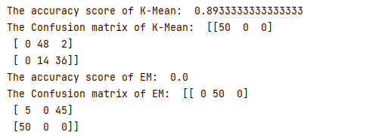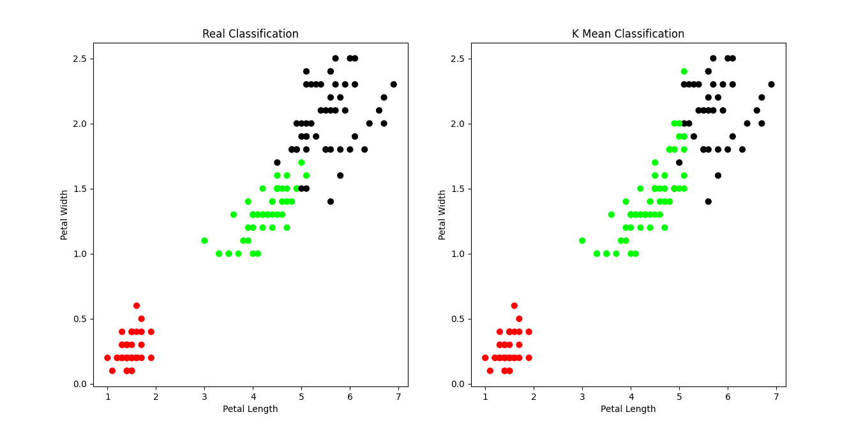

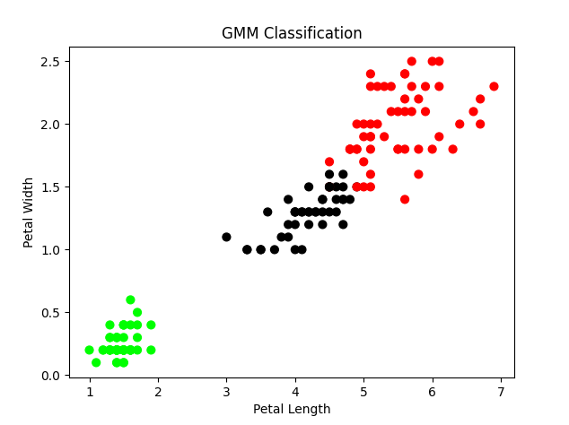

**PRACTICAL 9**

**TITLE:** Write a program to implement k-Nearest Neighbour algorithm to classify the iris data set. Print both correct and wrong predictions. Java/Python ML library classes can be used for this problem.

**CODE:**

from sklearn.model_selection import train_test_split

from sklearn.neighbors import KNeighborsClassifier

from sklearn.metrics import classification_report, confusion_matrix

from sklearn import datasets

iris=datasets.load_iris()

x = iris.data

y = iris.target

print ('sepal-length', 'sepal-width', 'petal-length', 'petal-width')

print(x)

print('class: 0-Iris-Setosa, 1- Iris-Versicolour, 2- Iris-Virginica')

print(y)

x_train, x_test, y_train, y_test = train_test_split(x,y,test_size=0.3)

#To Training the model and Nearest nighbors K=5

classifier = KNeighborsClassifier(n_neighbors=5)

classifier.fit(x_train, y_train)

#To make predictions on our test data

y_pred=classifier.predict(x_test)

print('Confusion Matrix')

print(confusion_matrix(y_test,y_pred))

print('Accuracy Metrics')

print(classification_report(y_test,y_pred))

**OUTPUT:**

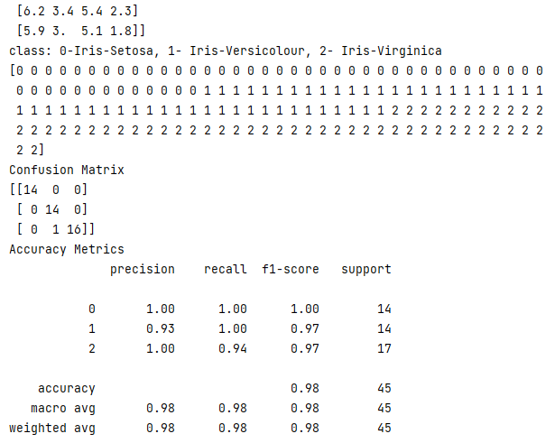

**PRACTICAL 10**

**TITLE:** Implement the non-parametric Locally Weighted Regression algorithm in order to fit data points. Select appropriate data set for your experiment and draw graphs.

**CODE:**

**A.**

import matplotlib.pyplot as plt

import pandas as pd

import numpy as np

def kernel(point, xmat, k):

m, n = np.shape(xmat)

weights = np.mat(np.eye((m)))

for j in range(m):

diff = point - X[j]

weights[j, j] = np.exp(diff * diff.T / (-2.0 * k ** 2))

return weights

def localWeight(point, xmat, ymat, k):

wei = kernel(point, xmat, k)

W = (X.T * (wei * X)).I * (X.T * (wei * ymat.T))

return W

def localWeightRegression(xmat, ymat, k):

m, n = np.shape(xmat)

ypred = np.zeros(m)

for i in range(m):

ypred[i] = xmat[i] * localWeight(xmat[i], xmat, ymat, k)

return ypred

# load data points

data = pd.read_csv('D:/ML_Pracs/tips.csv')

bill = np.array(data.total_bill)

tip = np.array(data.tip)

# preparing and add 1 in bill

mbill = np.mat(bill)

mtip = np.mat(tip)

m = np.shape(mbill)[1]

one = np.mat(np.ones(m))

X = np.hstack((one.T, mbill.T))

# set k here

ypred = localWeightRegression(X, mtip, 0.5)

SortIndex = X[:, 1].argsort(0)

xsort = X[SortIndex][:, 0]

fig = plt.figure()

ax = fig.add_subplot(1, 1, 1)

ax.scatter(bill, tip, color='green')

ax.plot(xsort[:, 1], ypred[SortIndex], color='red', linewidth=5)

plt.xlabel('Total bill')

plt.ylabel('Tip')

plt.show();

**A. OUTPUT:**

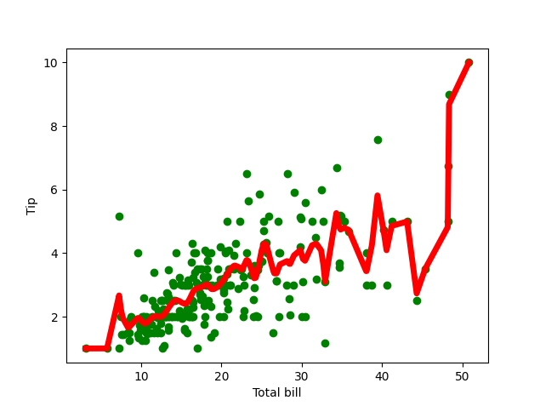

**B.**

import numpy as np

from bokeh.plotting import figure, show, output_notebook

from bokeh.layouts import gridplot

from bokeh.io import push_notebook

def local_regression(x0, X, Y, tau): # add bias term

x0 = np.r_[1, x0] # Add one to avoid the loss in information

X = np.c_[np.ones(len(X)), X]

# fit model: normal equations with kernel

xw = X.T * radial_kernel(x0, X, tau) # XTranspose * W

beta = np.linalg.pinv(xw @ X) @ xw @ Y # @ Matrix Multiplication or Dot Product

# predict value

return x0 @ beta # @ Matrix Multiplication or Dot Product for prediction

def radial_kernel(x0, X, tau):

return np.exp(np.sum((X - x0) ** 2, axis=1) / (-2 * tau * tau))

# Weight or Radial Kernal Bias Function

n = 1000

# generate dataset

X = np.linspace(-3, 3, num=n)

print("The Data Set ( 10 Samples) X :\n", X[1:10])

Y = np.log(np.abs(X ** 2 - 1) + .5)

print("The Fitting Curve Data Set (10 Samples) Y :\n", Y[1:10])

# jitter X

X += np.random.normal(scale=.1, size=n)

print("Normalised (10 Samples) X :\n", X[1:10])

domain = np.linspace(-3, 3, num=300)

print(" Xo Domain Space(10 Samples) :\n", domain[1:10])

def plot_lwr(tau):

# prediction through regression

prediction = [local_regression(x0, X, Y, tau) for x0 in domain]

plot = figure(width=400, height=400)

plot.title.text = 'tau=%g' % tau

plot.scatter(X, Y, alpha=.3)

plot.line(domain, prediction, line_width=2, color='red')

return plot

show(gridplot([

[plot_lwr(10.), plot_lwr(1.)],

[plot_lwr(0.1), plot_lwr(0.01)]]))

**B. OUTPUT:**

