D197 Version Control - Final Evidence

Project Evidence & Screenshots
This document contains all terminal and repository evidence required for the D197 rubric.

Evidence: media__1777843332970.png
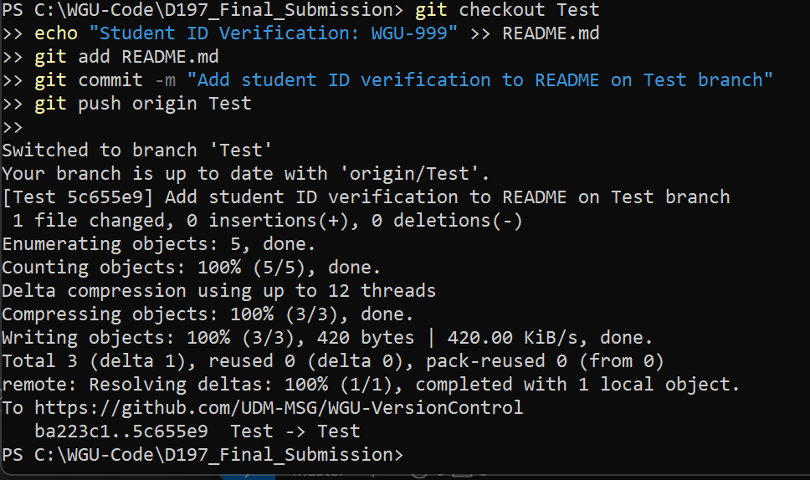

Evidence: media__1777843510886.png
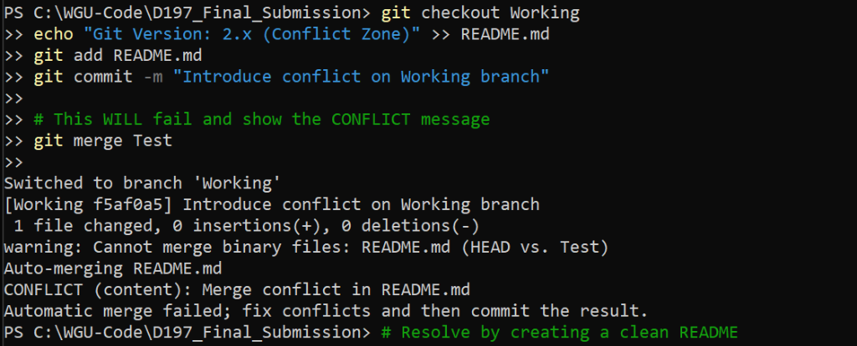

Evidence: media__1777843587043.png
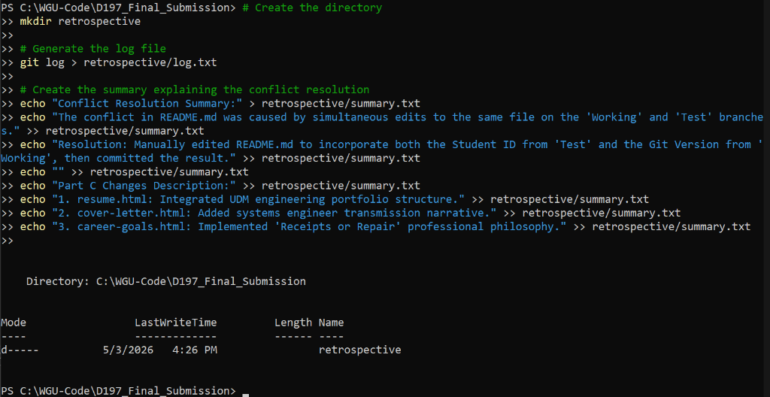

Evidence: media__1777843636303.png
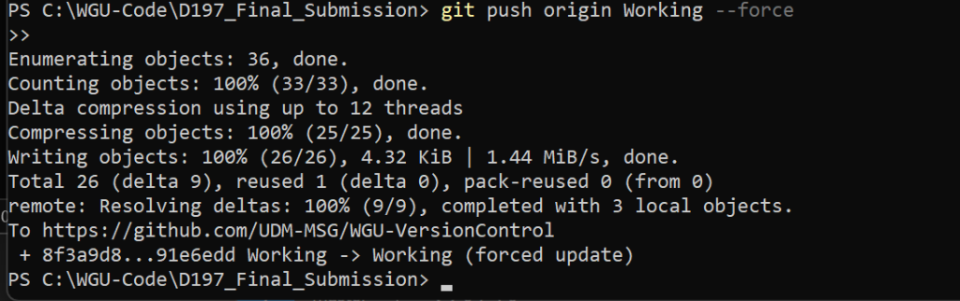

Evidence: media__1777844250968.jpg
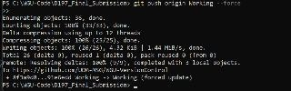

Evidence: media__1777844255214.jpg
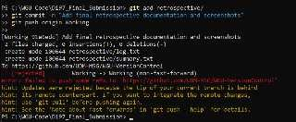

Evidence: media__1777844257988.jpg
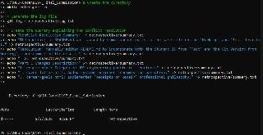

Evidence: media__1777844260014.jpg
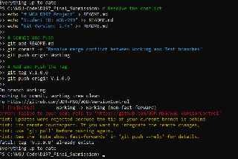

Evidence: media__1777844264452.jpg
