Document filename: Test System Configuration for ITK Trunk Messaging via TMS
Directorate / Programme | Solution Assurance | Project | Interoperability Toolkit
Project Manager | Debbie Chin | Status | Release
Owner | Richard Robinson | Version | V0.1
Author | Richard Robinson | Version issue date | 02.04.2015

Test System Configuration for ITK Trunk Messaging via TMS

Revision History
Version | Date | Summary of Changes
0.1 |  | First draft for comment

Reviewers
This document must be reviewed by the following people: author to indicate reviewers
Reviewer name | Title / Responsibility | Date | Version

Approved by
This document must be approved by the following people: author to indicate approvers
Name | Signature | Title | Date | Version

Glossary of Terms
Term / Abbreviation | What it stands for

Related Documents
These documents will provide additional information.
Ref no | Doc Reference Number | Title | Version
1 | NPFIT-SHR-QMS-PRP-0015 | Glossary of Terms Consolidated.doc | 13

Document Control
The controlled copy of this document is maintained in the HSCIC corporate network. Any copies of this document held outside of that area, in whatever format (e.g. paper, email attachment), are considered to have passed out of control and should be checked for currency and validity.

Contents
Document filename: Test System Configuration for ITK Trunk Messaging via TMS i
Test System Configuration for ITK Trunk Messaging via TMS i
Revision History 2
Reviewers 2
Approved by 2
Glossary of Terms 2
Related Documents 2
Document Control 3
Contents 4
Overview 5
System Testing 6
TKW Spine Tools 7
First use of TKW Spine Tools 12
Configuration of TKW SpineTools ITK Trunk Client 12
Configuration of TKW SpineTools ITK Trunk Host 13
Logging 13
Message Logs 14
Exception Failure Scenarios for testing Host Systems 14
SOAP Fault response 15
No Synchronous response 16
No/Delayed Asynchronous response 17
Duplicate Elimination - Host 19
Integration Testing 20
Message Validation 21

Overview
Solution providers wishing to test ITK Trunk messaging solutions must test their systems and provide test evidence in both system and integration testing environments.
This guide will concentrate on testing ITK Trunk interactions and work flows based upon the ITK SendCDADocument message pattern, where initial receipt of a SendCDADocument message is followed by transmission of an infrastructure and business acknowledgement, then proceeded by a subsequent receipt of a further infrastructure acknowledgement.
ITK Message Pattern:

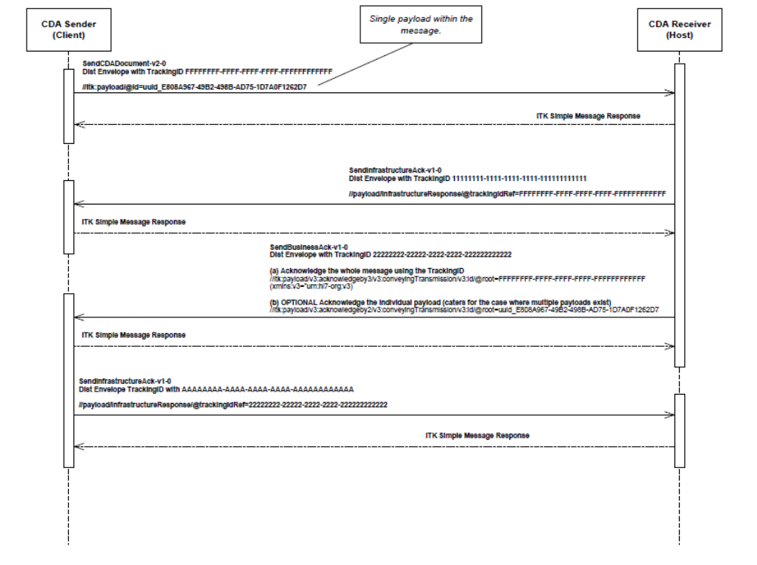Each of the Distribution Envelopes of these 4 ITK message transactions is sent over Spine TMS using a Forward Express message pattern – an asynchronous ebXML transmission which has got 4 message interactions itself.
The EIS MHS Behaviour Patterns v9.5 document contains an interaction diagram showing the Forward Express pattern below:
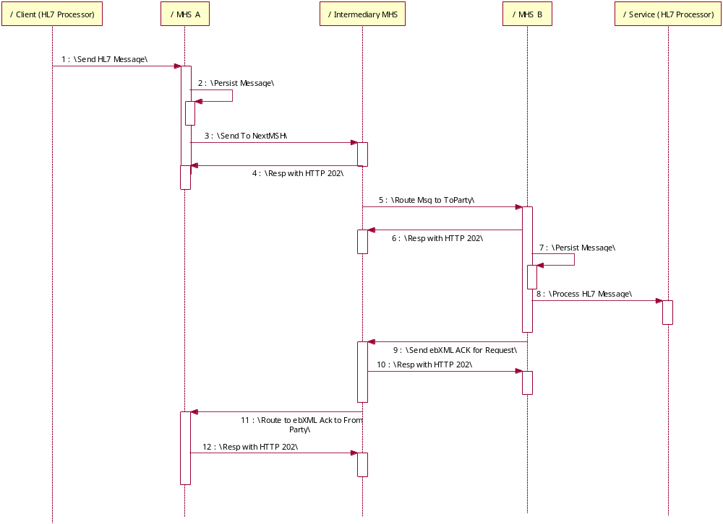
Figure 1. Reliable End-point Interaction Diagram - reproduced from EIS
Thus a full, successful SendCDA message sent over Spine TMS using ITK Trunk message will result in 16 individual messages.

Evidence will be required from testing at 2 levels: System Testing and Integration Testing

System Testing
The objective of the system tests is to prove that a System Under Test (SUT) can successfully and correctly interact with another end-point both in a “good-day” scenarios as well as in all reasonably expected exception scenarios. System testing will be performed locally using unencrypted/ in the clear messages against the Toolkit Workbench (TKW). The TKW will act as a stub for both TMS and the Client system. This is the reference test tool for ITK and Spine messaging and shall be employed here configured to use the SpineTools API. Execution in the clear allows control over address/ports and aids configuration and troubleshooting.

TKW/SpineTools has been developed to act as a Client or Host SendCDADocument stub. This means that it will perform all the interactions/responses which are necessary for the full pattern using Spine ITK Trunk message. Furthermore it can be configured to respond in failure modes in order to test an SUT in these.

TKW Spine Tools
SpineTools API works as a fully functional MHS and will communicate with Spine/SDS in production mode. In TKW SpineTools mode, TKW orchestrates the SpineTools software and in this configuration will function in the same manner as a production MHS but can do so in clear text and its responses can be configured. Here are the TKW SpineTools properties:

Parameter | Description | Mandatory | Typical Example Value
Listener Parameters
tks.SpineToolsTransport.listenaddr | The listen address on which the TKW SpineTools will receive either synchronous requests or asynchronous responses. This is required for both host or client types | Y | 0.0.0.0
tks.SpineToolsTransport.listenport | The listen port on which the TKW SpineTools will receive either synchronous requests or asynchronous responses. This is required for both host or client types | Y | 4848
Transmitter Parameters
tks.spinetools.transmit.svcia | "SvcIA" service-qualified interaction id of the message to be transmitted - may not be null | Y | urn:nhs:names:services:itk:COPC_IN000001GB01
tks.spinetools.transmit.ods | Spine ODS code may not be null | Y | RHM
tks.spinetools.transmit.asid | Spine ASID used as an additional filter if not null | N
tks.spinetools.transmit.partykey | Spine Party key used as an additional filter if not null | N | RHM-801710
tks.spinetools.messaging.asynchronouswaitperiod | When TKW SpineTools is transmitting an asynchronous message this is the period in seconds to which it will wait to allow asynchronous responses to arrive before TKW shuts the listener | Y | 10
tks.spinetools.messaging.payloadasattachment | When TKW SpineTools is used to transmit an ITKTrunk message. Yes/No to use the payload as a 3rd MIME part attachment in an ebXML message pattern. This should be set to Yes for ITK Trunk Messages | N | Yes/No
tks.spinetools.messaging.authorrole | The Author Role given to the transmitted message | N | S0080:G0450:R5080
tks.spinetools.messaging.authoruid | The Author ID given to the transmitted message | N | 687227875014
tks.spinetools.messaging.authorurp | The Author URP given to the transmitted message | N | 012345678901
SDS Parameters - Endpoint details
tks.spinetools.sds.cachedir | Directory containing the cached SDS entries. Spine Tools will look at this value preferentially before trying SDS (when appropriate) | Y | /TKW/config/SPINE_ITKTMS/transmitter_source/cache
tks.spinetools.sds.myasid | ASID for this MHS instance | Y | 866971180017
tks.spinetools.sds.mypartykey | Party Key for this MHS instance | Y | RHM-1808622
tks.spinetools.sds.urlresolver | Directory location of the urlresolver.txt file which can be used to override the target URLs of the messages | N | /TKW/config/SPINE_ITKTMS/urlresolver.txt
tks.spinetools.sds.url | URL on which to connect to SDS | Y | ldaps://ldap.vn03.national.ncrs.nhs.uk
EndPoint Mode
tks.spinetools.correspondence.client | A property to define TKW SpineTools to work in a CLIENT correspondence mode. This means that when inf and bus ack Spine ITK Trunk wrapped Distribution Envelope responses are received, it will respond with a further Inf acknowledgement.  The client and host cannot both be set to Yes | N | Yes/No
tks.spinetools.correspondence.host | A property to define TKW SpineTools to work in a HOST correspondence mode. This means that when a SendCDADocument Spine ITK Trunk wrapped Distribution Envelope request is received, it will respond with Inf and Bus acknowledgements.  The client and host cannot both be set to Yes | N | Yes/No
Messaging Parameters
tks.sender.destination | Directory location to store the full message logs in client mode | Y | /TKW/config/SPINE_ITKTMS/transmitter_sent_messages
tks.savedmessages | Directory location to store the full message logs in client mode | Y | /TKW/config/SPINE_ITKTMS/simulator_saved_messages
tks.logdir | Directory location to store the TKW logs | Y | /TKW/config/SPINE_ITKTMS/logs
tks.spinetools.messaging.messagedirectory | Directory used for persisting reliable messages | Y | /TKW/config/SPINE_ITKTMS/transmitter_source/MessageSpool
tks.spinetools.messaging.expireddirectory | Directory used by the message expiry handler to save reliable messages that have exceeded either their persistDuration or their retry counts without getting an acknowledgment or an explicit error. | Y | /TKW/config/SPINE_ITKTMS/transmitter_source/ExpiredMessages
tks.spinetools.messaging.persistdurations | Name of a file containing persistDuration values, by service/interactiontype. This is used by the Listener process so that it has information on the persistDuration value to use for an inbound reliable message (specifically, to scope de-duplication), without its having to consult SDS. If this is not set, the internal version is used which can be found at org.warlock.spine.connection.persistDurations.txt. | N | /TKW/config/SPINE_ITKTMS/persistDurations.txt
tks.spinetools.messaging.defaultebxmlhandler.filesavedirectory | Directory location where received ebXML payloads are placed | Y | /TKW/config/SPINE_ITKTMS/simulator_saved_messages/EbXml
tks.spinetools.messaging.defaultdistributionenvelopehandler.filesavedirectory | Directory location where received ITKTrunk payloads are placed | Y | /TKW/config/SPINE_ITKTMS/simulator_saved_messages/ITKtrunk
tks.spinetools.messaging.defaultsynchronousresponsehandler.filesavedirectory | Directory location where received synchronous HL7 payloads are placed | Y | /TKW/config/SPINE_ITKTMS/simulator_saved_messages/Sync
tkw.spine-test.cleartext | To set whether SpineTools transmits and receives messages in clear text. This mode can only be used when Spine Tools is used as an integrated part of TKW | Y | Yes
tks.spinetools.messaging.retrytimerperiod | This is the period in milliseconds that the "retry process" is to run to check for reliable messaging retries, and also to handle expiry. Default value is 30,000 (30 seconds). This must be less than the retryPeriod of the message being transmitted. | N | 30000
tks.spinetools.connection.myip | Value of local IP address to populate the "From" element of a Spine SOAP message. This is provided as a system property to avoid the MHS having to make an arbitrary guess on systems with multiple interfaces. | Y | 10.210.164.191
tks.spinetools.desender.auditidentity | Property to populate the sender details in the business and infrastructure acknowledgements | Y for SendCDA | urn:nhs-uk:identity:AAA:test:cdaresponder
tks.spinetools.desender. senderaddress | Property to populate the sender details in the business and infrastructure acknowledgements | Y for SendCDA | urn:nhs-uk:addressing:AAA:test:cdaresponder
Exception Scenario Behaviour
tks.spinetools.correspondenceresponder.positiveresponsetype | When set to No will force a negative Business Acknowledgement DE in the ITK Trunk Message. This is only applicable when acting as a host (tks.spinetools.correspondence.host) | N | Yes/No
tks.spinetools.correspondenceresponder.nack.errorcode | Errorcode details to use for a negative Business Acknowledgement DE in the ITK Trunk Message, when spedcified in tks.spinetools.correspondenceresponder.positiveresponsetype | Y when negative bus ack response is specified | 1000
tks.spinetools.correspondenceresponder.nack.errortext | Errortext details to use for a negative Business Acknowledgement DE in the ITK Trunk Message, when spedcified in tks.spinetools.correspondenceresponder.positiveresponsetype | Y when negative bus ack response is specified | error
tks.spinetools.correspondenceresponder.nack. disgnostictext | Disgnostictext details to use for a negative Business Acknowledgement DE in the ITK Trunk Message, when spedcified in tks.spinetools.correspondenceresponder.positiveresponsetype | Y when negative bus ack response is specified | text
tks.spinetools.connection.negativeebxmloverride | A property to force SpineTools to respond back with a negative ebXML ack and do no further processing | N | Yes/No
tks.spinetools.connection.soapfault | A property to force a soapFault response to incoming requests | N | Yes/No
tks.spinetools.syncresponsecountdown | A property to force the every second incoming message connection to timeout. This supports exception testing of the incoming ITK Trunk(infratsructure Ack) forcing the expected 202 response to timeout.  This must be set in conjunction with asynchronouswaitperiod property which should be set to a typical HTTP timeout period e.g. 30 seconds | N | Yes/No
tks.spinetools.asyncresponsedelaycountdown | A property to force a configurable pause in seconds before SpineTools responds asynchronously to an incoming Asynchronous request e.g. ITK Trunk | N | Yes/No
tks.spinetools.asynchronousebxmlreply.delay | property to configure the pause in seconds before SpineTools responds asynchronously. This must be set in conjunction with tks.spinetools.asyncresponsedelaycountdown | Y if async delay countdown is set to Y | 10
tks.xmlencryption.enable | This mode allows the manipulation of individual payloads of the Distribution Envelope in order that they can be compressed, encrypted, B64 encoded or signed. The following properties allow for payloads to be compressed, but the functionality for the other modes is present. | N | Yes/No
tks.xmlencryption.payloadwritelist | The payloadwritelist is a list of cross references (using the arbitary payload reference numbers) to each of the payload definitions | Y if xmlencryption mode is set to Y | 0
tks.xmlencryption.encrypt.ref.compress.0 | Defines whether payload 0 should be compressed | Y if xmlencryption mode is set to Y | Yes
tks.xmlencryption.encrypt.ref.b64.0 | Defines whether payload 0 should be b64 encoded. This should be set to N as we are only compressing payloads | Y if xmlencryption mode is set to Y | No
tks.xmlencryption.encrypt.ref.sign.0 | Defines whether payload 0 should be signed. This should be set to N as we are only compressing payloads | Y if xmlencryption mode is set to Y | No
tks.xmlencryption.encrypt.ref.alias.0 | Defines which certs should be used to encrypt payload 0. This should be set to N as we are only compressing payloads | Y if xmlencryption mode is set to Y | No
Cryptographic parameters for the Spine access layer
tks.tls.truststore | Location of cacerts truststore | N | /TKW/config/SPINE_ITKTMS/certs/cacerts
tks.tls.trustpassword | Password for cacerts truststore | N | Changeit
tks.tls.keystore | Location of java keystore | N | /TKW/config/SPINE_ITKTMS/certs/abaddon.jks
tks.tls.keystorepassword | Password for java keystore | N | Abaddon

First use of TKW Spine Tools
Here are detailed configuration instructions for TKW SpineTools for both Client SendCDADocument and Host SendCDADocument modes. It may be beneficial to configure both on the same physical computer in order to confirm that they operate properly before substituting in the SUT. This will also demonstrate how the tests will work. These test are executed in the clear and it is important to understand that in clear, TKW Spine Tools is not able to connect to SDS so all SDS values are taken from cached json representations of SDS data. Additionally the fully qualified url destination for the ITK Trunk message to be sent to can be overridden using the urlresolver.txt file.
First configure TKW SpineTools to operate in a “good-day” mode:

Configuration of TKW SpineTools ITK Trunk Client

Populate the “my” details for SDS (those parameters whose key starts tks.spinetools.sds.). Note that as of the current version, multiple ASIDs and party keys for a single MHS instance are not yet supported.

- Update the tks.SpineToolsTransport.listenaddr and listenport parameters for incoming sync request or async responses.
- Ensure that the svcia, Spine ODS and optionally ASID and Party key of the message to be sent are populated in the TKW SpineTools tkw.properties file. TKW SpineTools uses these to resolve a list of SdsTransmissionDetails. This is done in the first instance from the local cache and is always taken from here when executing in clear text. The cache is stored in the directory defined in tks.spinetools.sds.cachedir
- Open the cached SDS record which relates to the details mentioned in 1 (i.e. partykey defined in the directory urn=nhs=names=services=itk=COPC_IN000001GB01). Here the target ASID can be set including details such as retryInterval and no of retries. If setting retryInterval ensure that tks.spinetools.messaging.retrytimerperiod is < this value as this denotes the period of time in which SpineTools assesses whether a retry is required.
- Open the urlresolver.txt. This file contains service/interactionId and its associated url destination which can be changed and will override SDS e.g.

urn:nhs:names:services:itk:COPC_IN000001GB01 http://localhost:4848/reliablemessaging/intermediary

set this value to be the same as the listen address/port of the host system

- The tks.SpineToolsTransport.asynclistenport parameter in \TKW\config\SPINE_ITKTMS\tkw.properties controls the port on which TKW will listen for the asynchronous ebXML ACK and any incoming ITK Trunk requests when working in cleartext mode.
- Update tks.spinetools.correspondence.client Y and ensure that tks.spinetools.correspondence.host is not present to ensure running in client mode
- Update the DE sender substitutions for inf and bus acks: tks.spinetools.desender.auditidentity urn:nhs-uk:identity:AAA:test:cdaresponder
tks.spinetools.desender.senderaddress urn:nhs-uk:addressing:AAA:test:cdaresponder
- If payload encryption is to be used update the tks.xmlencryption.enable to be Y and ensure that only the tks.xmlencryption.encrypt.ref.compress.0 configuration is set to Y – all other xmlencryption configs must be set to No or NONE.
- Place one file containing the DistributionEnvelope to be transmitted into the transmitter_source directory (defined by tks.transmitter.source) and transmit in the usual manner:

java –jar TKW.jar –transmit tkwClient.properties

n.b. ensure that the host system is running first!

Configuration of TKW SpineTools ITK Trunk Host

- Set the configurations as for the client mode above but:
  - ensure that the property: tks.spinetools.correspondence.client is not present and that tks.spinetools.correspondence.host is set to Y
  - set the message override values in urlresolver.txt to be the same as the listen address/port of the client system
- Execute TKW in simulator mode:

java –jar TKW.jar –simulator tkwHost.properties

The configurations above will give you a functioning client/host for SendCDADocument sent using Spine ITK Trunk message.

Logging
Once a successful exchange of messages has occurred and the TKW SpineTools in client/host mode has completed (either through expiry of tks.spinetools.messaging.asynchronouswaitperiod or a forced shutdown of the listener – ctrl+C), the logs and output directories can be inspected.

The payloads of any ITK Trunk messages (SendCDADocument, infrastructure and Business Acknowledgements) will be extracted and placed in the directory defined by the configuration parameter tks.spinetools.messaging.defaultdistributionenvelopehandler.filesavedirectory. The files will be named in the format service+trackingId.message

Message Logs
Message logs are automatically created in the following directories:

- Client Mode: the full message logs will be in the directory defined by the configuration parameter tks.sender.destination and will be named in the format TKW_YYYYMMDDHHmmss.log

- Host Mode: the full message logs will be in the directory defined by the configuration parameter tks.savedmessages and will be named in the format TKW_YYYYMMDDHHmmss.log

These logs are populated with all inbound and outbound messaging, whether in client or in host mode, with full on-the-wire message logs. This is done by TKW SpineTools as messages are sent and received and depending on the timings of the received messages, they might not appear in request then response order. However each message is preceeded by a string announcing whether it is INBOUND or OUTBOUND and if it is a response it will also have a reference to the message ID of the requesting message e.g:
Reference to Message ID 17B6D86F-4D14-4488-98A7-B93D6FB3B65C - ON THE WIRE SYNC OUTBOUND:

Exception Failure Scenarios for testing Host Systems

The EIS MHS Behaviour Patterns v9.5 document defines all the failure modes of the Forward Express message pattern and should be read in conjunction with this guide. The following testing scenarios make reference to certain elements from the interaction diagram in the EIS – the diagram has been reproduced at the top of the document.

Each time the TKW SpineTools configuration file is changed, TKW must be restarted for the changes to take effect.

SOAP Fault response
TKW SpineTools
SUT
ITK Trunk
ITK Trunk SendCDA
202 Accepted
ebXML ack

202 Accepted

ITK Trunk Infrastructure Ack

500 SoapFault

EIS Forward Express Requirements for this failure:
2 | The Intermediary’s SOAP router receives a fatal error when attempting relay the message (for instance, a local processing error); at 3 | The Intermediary sends a SOAP Fault indicating that the service was unavailable, or sends a standard HTTP 500 error. | The Intermediary discards the message.  MHS A may decide to retry the HTTP POST. This will depend on the type of error. For instance, if redundant components are available at the Intermediary for the failed component, then a re-binding and a resend may lead to a success. If any retries fail to lead to a successful message transmission, MHS A informs its upper layer of the delivery notification failure.

Having configured TKW Spine Tools in client mode to work in a good-day manner, update the following parameters:
tks.spinetools.connection.soapfault Y

This will force TKW SpineTools to respond to every second request with a soapFault, thus responding normally to the asynchronous ebXML ack, but returning an HTTP 500 SoapFault to the ITK Trunk(Infrastructure Ack)

No Synchronous response
TKW SpineTools
SUT
ITK Trunk
ITK Trunk SendCDA
202 Accepted
ebXML ack

202 Accepted

ITK Trunk Infrastructure Ack

(no response) HTTP timeout

EIS Forward Express Requirements:
1 | MHS A receives a notification of loss of message or timeout on the transmission to the Intermediary (MHS A knows of the failure due to HTTP errors); at 3 | MHS A does not receive an HTTP 202 from Intermediary, sees a timeout on HTTP Post, or receives a lower layer protocol error. | MHS A MAY retry the HTTP POST or indicate the failure to its upper layer immediately. If the POST continues to fail, MHS A informs its upper layer of the delivery notification failure.  Intermediary has no action to perform as it did not receive the message.

Having configured TKW Spine Tools in client mode to work in a good-day manner, update the following parameters:

tks.spinetools.syncresponsecountdown Y
tks.spinetools.messaging.asynchronouswaitperiod m

When syncresponsecountdown is set to yes, TKW SpineTools is configured so that it will not respond to the incoming ITKTrunk message with a synchronous HTTP 202. TKW will then drop the connection after m seconds simulating an HTTP timeout.

*TKW must be restarted when any properties are changed in order for them to take effect

No/Delayed Asynchronous response
TKW SpineTools
SUT
ITK Trunk
ITK Trunk SendCDA
202 Accepted
ebXML ack

202 Accepted

ITK Trunk Infrastructure Ack

- /
202 Accepted
ebXML ack
/
/

EIS Forward Express Requirements:
4 | The Intermediary is advised of the loss of the message or timeout of the transmission and is UNABLE to recover (for instance, the recovery actions at described in scenario 3 fail); at 5 | Maximum retries at Intermediary expires. | The Intermediary discards message.  MHS A will enter ebXML retry mode when an ACK is not received before the RetryInterval expires.
7 | The ebXML ACK sent from MHS B can not be transmitted to the Intermediary (at 9) or can not be transmitted to the MHS A (at 11) due to a error of some type. | The MHS A expects an asynchronous ACK to be returned within the RetryInterval. | MHS B or the Intermediary will discard the ACK.  As the message ACK is asynchronous, the ebXML layer in MHS A is still looking for an ACK in the required RetryInterval. The MHS A enters ebXML retry mode.
10 | Retries from MHS A expire; | No ACK returned in response to the retries by the necessary retry intervals. | The ebXML layer must then notify MHS A application (the layer above) of the failure in some way, and/or notify a systems administrator.
9 | MHS A goes into retry mode even though the message is not actually lost; the reason being that the message has taken longer than expected to process and return to the MHS A. | MHS A expects an asynchronous ACK to be returned within the RetryInterval. | MHS B will receive a duplicate and perform standard ebXML duplicate elimination behaviour. MHS A would receive an ebXML ACK for the original message which will indicate the successful message transfer. It may then receive a second ACK for the same messageId, which can be ignored.

Having configured TKW Spine Tools in client mode to work in a good-day manner, update the following parameters:

tks.spinetools.asyncresponsedelaycountdown Y
tks.spinetools.asynchronousebxmlreply.delay n

When asynresponsedelaycountdown is set to yes, TKW SpineTools is configured such that it will delay responding to the incoming ITKTrunk message for n seconds before responding with an asynchronous ebXML ACK.
Test 1: If n is calculated w.r.t. retry period and persist duration, it can be set such that the retry mode is activated on the SUT and then as the ebXML ack is sent from TKW SpineTools the SUT can demonstrate that it can exit retry mode positively.

n >retryPeriod & <noOfRetries*retryPeriod

Test 2: Similarly n can also be set such that it will not reply within the persist duration/no of retries of the SUT and expiry mode can be tested.

n> noOfRetries*retryPeriod or n>PersistDuration

*TKW must be restarted when any properties are changed in order for them to take effect. Ensure that tks.spinetools.messaging.asynchronouswaitperiod is set long enough such that enough time is available for the retry/catch process.

Duplicate Elimination - Host
TKW SpineTools
SUT
ITK Trunk SendCDA
202 Accepted
ebXML ack

ITK Trunk SendCDA
202 Accepted
ebXML ack

EIS Forward Express Requirements:
8 | MHS A goes into retry mode (as suggested in scenario 7) and in doing so generates a duplicate message to the Intermediary and MHS B. | The Intermediary and MHS B receives a message with the same messageId | MHS B performs standard ebXML behaviour for duplicate elimination. The Intermediary merely passes the duplicate on.

Having configured TKW Spine Tools in client mode to work in a good-day manner, update the following parameters:

Test: Configure either TKW SpineTools or SUT so that the asynchronous ebXML response is sent to a port which TKW SpineTools is NOT listening. This will cause TKW SpineTools to go into retry mode and multiple ITKTrunk messages with the same messageID will be sent. Observe the SUT deduplicating incoming ITKTrunk messages with the same messageID.

*TKW must be restarted when any properties are changed in order for them to take effect.

Integration Testing

Integration testing is performed via Spine TMS using TLS Mutual Authentication.
Login to the portal on the URL below

http://rhm-hagar.cfh-nic.nhs.uk

For ITK Trunk messages (Send CDA Document) choose the link (ITK Message) from the left menu. Once the ITK page is loaded, type the destination party key you intending to send the message to. As shown below.
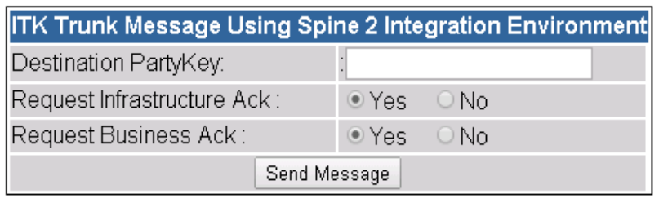
If you want to request the infrastructure acknowledgment, leave the default Yes. Do the same for Business Acknowledgment.
By choosing yes for both (Infrastructure Ack and Business Ack), the destination system must be able to send back Infrastructure Ack and Business Ack to the sender party key in the ITK Trunk messages (Send CDA Document).
If the returned Business Acknowledgment has requested the Infrastructure Acknowledgment, the portal will send back the Infrastructure Acknowledgment to the party key the message was received from.
To view the messages choose the link (Sent/Received) Messages.
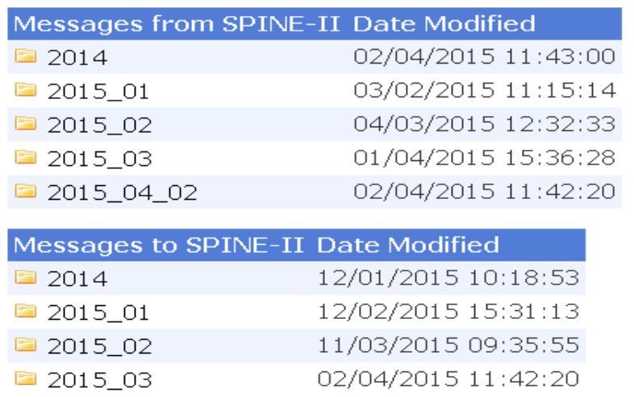

Message Validation
To perform Message validation following the transmission of a DistributionEnvelope as described in the section ‘Configuration of TKW SpineTools ITK Trunk Client’ of this document.
- The folder \TKW\config\SPINE_ITKTrunk_Client\TestRun\ contains batch files to validate ITK distribution envelopes transmitted via ITK Trunk over TMS. There is a separate batch file for each supported ITK config. e.g.:
Validate - ITK_Correspondence via ITK Trunk over TMS.bat
Validate - ITK_TransferofCare via ITK Trunk over TMS
…
- Select and run the appropriate Validate batch file for the ITK Config under test.
- The contents of the following folders are created (note: any existing contents of these folders is deleted):
\TKW\config\ SPINE_ITKTrunk_Client \message_reference\log
A copy of the TKW Log File created by the transmission message flow
\TKW\config\ SPINE_ITKTrunk_Client \message_reference\validation_ITK
ITK Distribution envelopes from the SendCDA , Infrastructure ACKs and Business ACK from the message flow
\TKW\config\ SPINE_ITKTrunk_Client \message_reference\validation_ITK\report
Validation report generated from these ITK Distribution envelopes
\TKW\config\ SPINE_ITKTrunk_Client \ message_reference\validation_SPINE
Individual ebXML messages extracted from the message flow log
\TKW\config\ SPINE_ITKTrunk_Client \ message_reference\validation_SPINE\report
Validation report generated from the ITKTrunk ebxml messages in the above extract list
- For troubleshooting, reference and message evidence, submission of a zip of the message_reference folder and subfolders will be requested.

Identical behaviour occurs in reverse at the MHS B when the MHS B does not receive and ACK for the HL7 response message.

