Feature？：As a result of continuing exposing Raspberry Pi to high temperature of 90℃ for 2 years
1. Introduction
At present, Raspberry Pi is widely used as a central component of the UECS network in the greenhouse. However, this microcomputer board was originally developed for educational use, and it is not originally intended to be used in a greenhouse. Although I examined the data sheet of this microcomputer board, there is hardly any description about the specific high temperature limit. I also checked English articles, but I did not know that there is a protection function (throttling) that lowers the temperature by dropping the operating clock of the SoC (the part corresponding to the CPU) when the temperature rises. Some documents say that the temperature is 70 ℃, but this indicates the high temperature limit of the on-board network controller LAN9514, which is slightly different from the high temperature limit of Raspberry Pi itself.

2. Experiment of “Simmering in a pot”
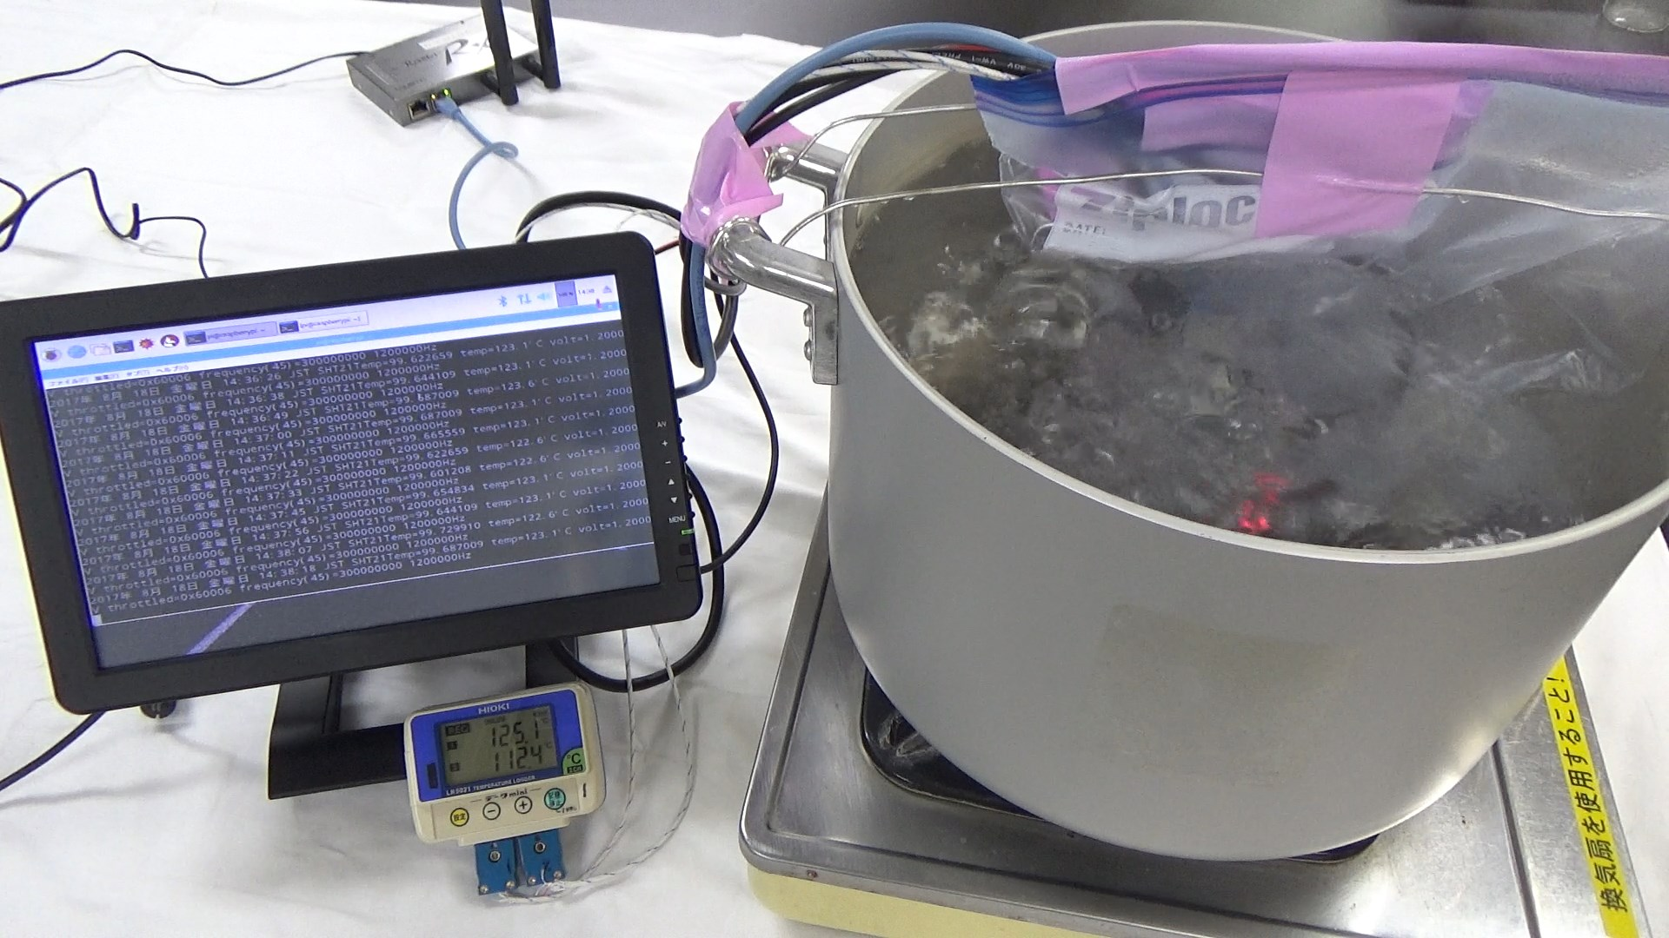

Fig.1. Raspberry Pi 3 works in boiling water

To solve the question, I experimented with cooking Raspberry Pi 3 Model B in working condition in a pot (Fig.1). The detailed results of this experiment are published in the March 2018 issue of Interface magazine. In summary, if you continue to operate for 30 minutes in boiling hot water with maximum load, no abnormality occurs, and even if you run a benchmark test for 1 hour in hot water, it will operate normally. was. The Raspberry Pi 3 starts to lower its operating clock when the SoC temperature exceeds 80 ℃, and drops to 1/4 of the maximum clock at 90 ℃. Along with that, the processing capacity is lowered and the operation is slowed, but there is no possibility of stopping, and HTTP communication and UDP communication can be executed normally. In addition, I did a preliminary experiment several times before this experiment, and I boiled in a pot each time, but I have never seen a thermal runaway. It turned out that Raspberry Pi did not have thermal runaway so easily.

3. What about long-term high temperatures?
The experiment of boiling in a pot is hard to running over one hour continuously, but Raspberry Pi actually installed in a greenhouse is required to operate stably for many years. Therefore, the following experiment was conducted.

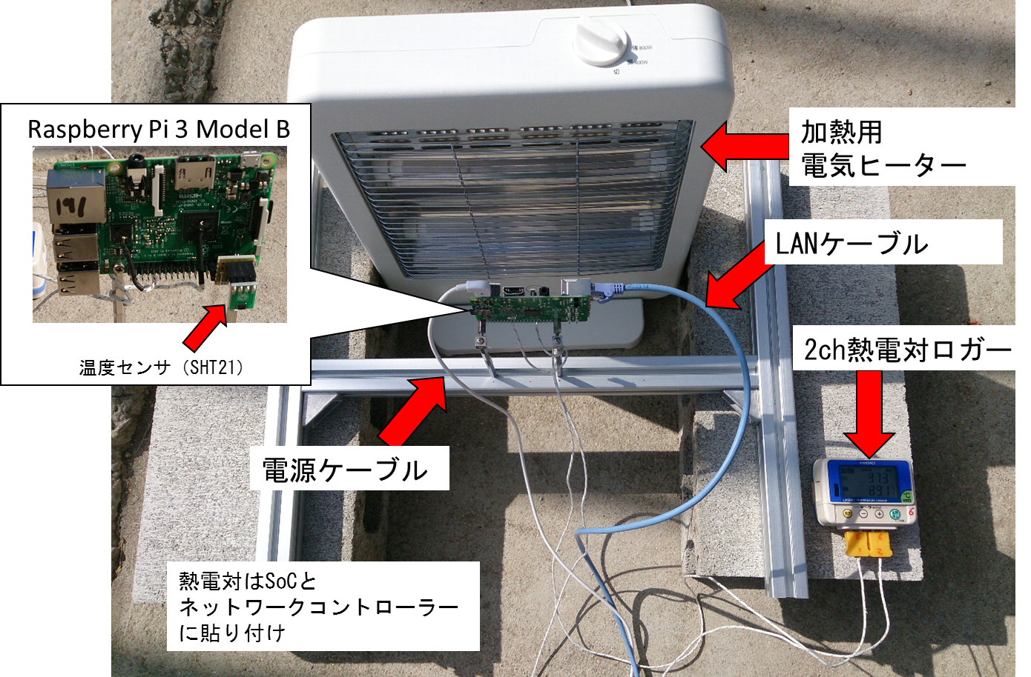

Fig.2 Heater to heat Raspberry Pi and data logger

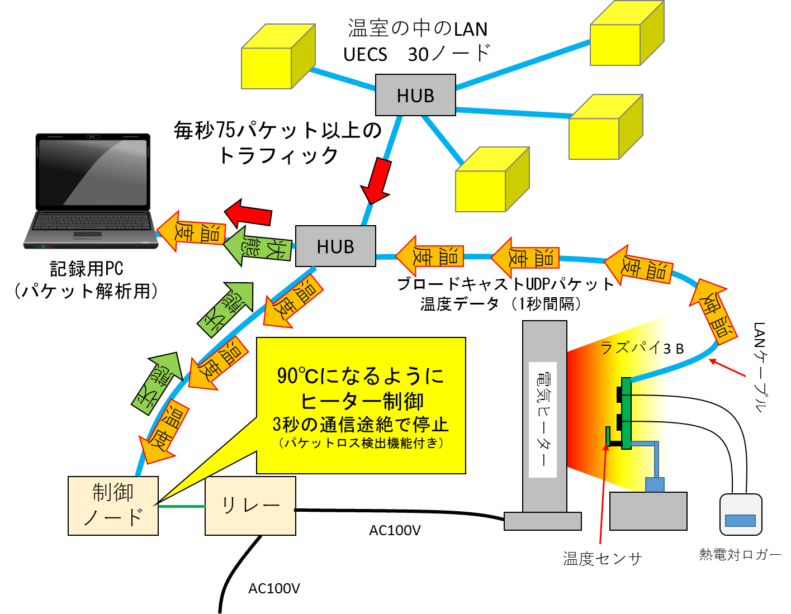

Fig.3 Whole experimental equipment

Electric heater and Raspberry Pi were installed on the concrete floor in the greenhouse (Fig.2). Fig.3 shows an overview of the experimental setup. The Raspberry Pi is placed in the immediate vicinity of the electric heater where it is exposed to radiant heat, and the temperature sensor SHT21 is attached to the heater side. In addition, a thermocouple is attached to the Raspberry Pi ‘s SoC and network controller chip, and the surface temperature is recorded by the data logger. The power supply of the heater is controlled by a relay node placed at another place. Raspberry Pi has UECS-Pi Basic installed and sends the temperature of SHT21 at 1 second intervals. The relay node receives this and controls it to be around 90 ° C. Now the Raspberry Pi will continue to burn at high temperatures all the time. If the temperature transmission of the Raspberry Pi stops for more than 3 seconds, the relay node will turn off the heater for safety. These systems were connected to the LAN of the greenhouse.

4. Progress of the experiment
The experiment began on March 7, 2017, and has continued since then, reaching two years on March 7, 2019. The experimental results are shown below.

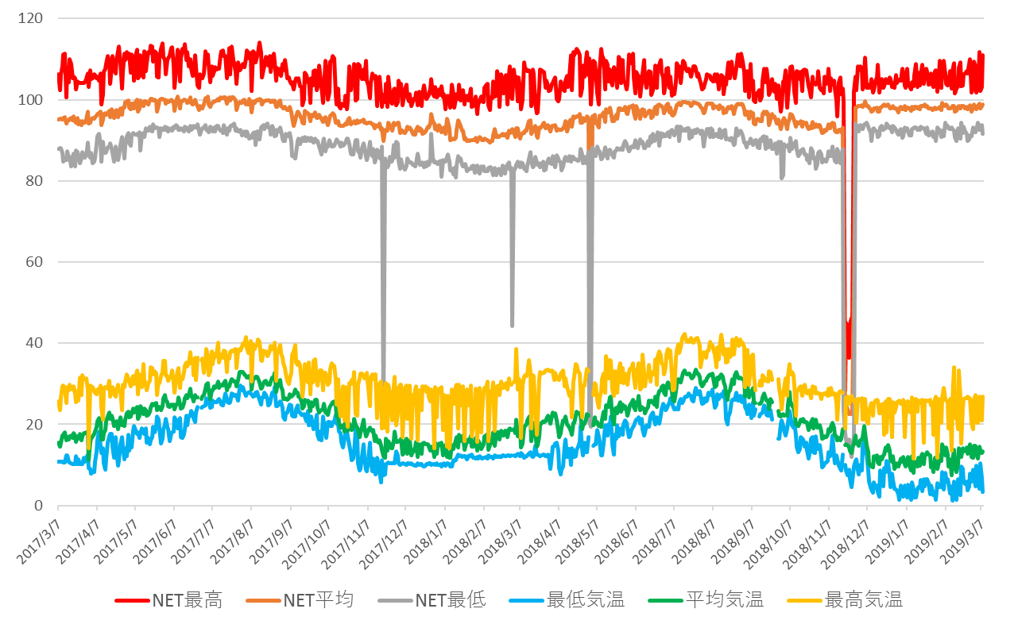

Fig.4 2-year temperature transition of the Raspberry Pi network controller (by thermocouples)

First, the temperature of the network controller recorded by the thermocouple logger changed approximately between 85 ℃ and 110 ℃ (Fig. 4). There is a place that dropped about four times, and you can see that some trouble has occurred here, but the cause will be described later. However, despite the high temperature limit of this network controller (LAN9514) being kept at 70 ℃, it continued to operate without any problems. It seems that the temperature margin is set quite large.

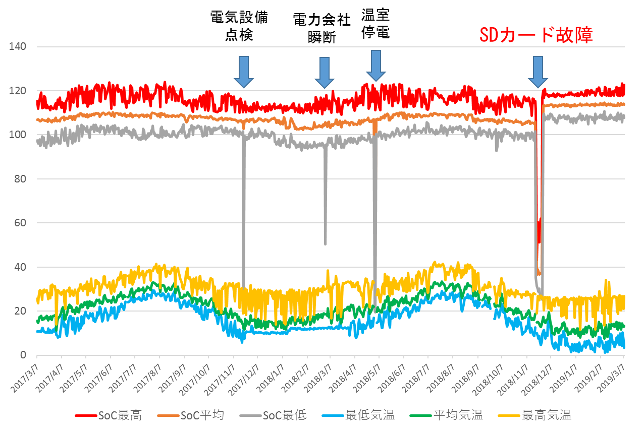

Fig. 5 2-year temperature transition of Raspberry Pi SoC (by thermocouple)

Next, the surface temperature of the SoC part is shown (Fig. 5). The range of temperature was about 95 to 120 ℃. SoC has high self-heating and shows a value higher than the target temperature of 90 ℃. The cause of the four temperature drops was the first three power outages and the last was the failure of the SD card. Therefore, it is the last one that can truly be called a failure, and the others are caused by factors unrelated to the experiment. In addition, at the time of the recovery from the blackout, Raspberry Pi automatically restarted and returned.
5. SD card failure

The failure occurred 621 days after the start of the experiment, and data transmission from Raspberry Pi stopped (Fig. 6). I extracted the SD card for investigation and ported it to another brand new Raspberry Pi and tried to start, but it turned out that it did not start properly. So, when I checked the SD card with a tool called Check Flash, 112 broken parts were detected (Fig. 7). Most of the damage is concentrated within the first 2GB of the SD card, which indicates that the written part of the OS has been destroyed. At this time, the broken SD card was called HIDISC 32GB micro SDHC Class 10, but it is not the one for industrial use or high durability. It turned out that the durability of SD cards for consumer products is limited.

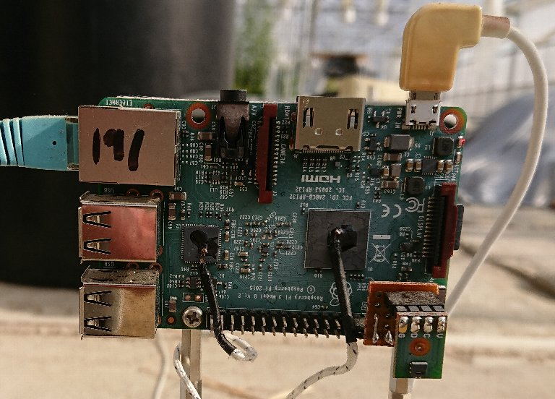

Fig.6 Raspberry Pi stopped at experiment day 621 (battered with high temperature and dust)

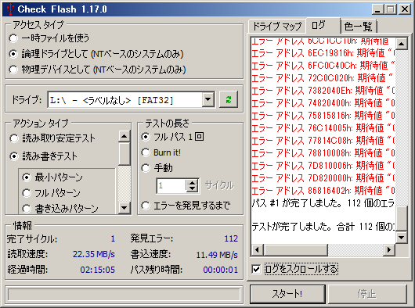

Fig. 7 Damage status of SD card

6. Revival of Raspberry Pi
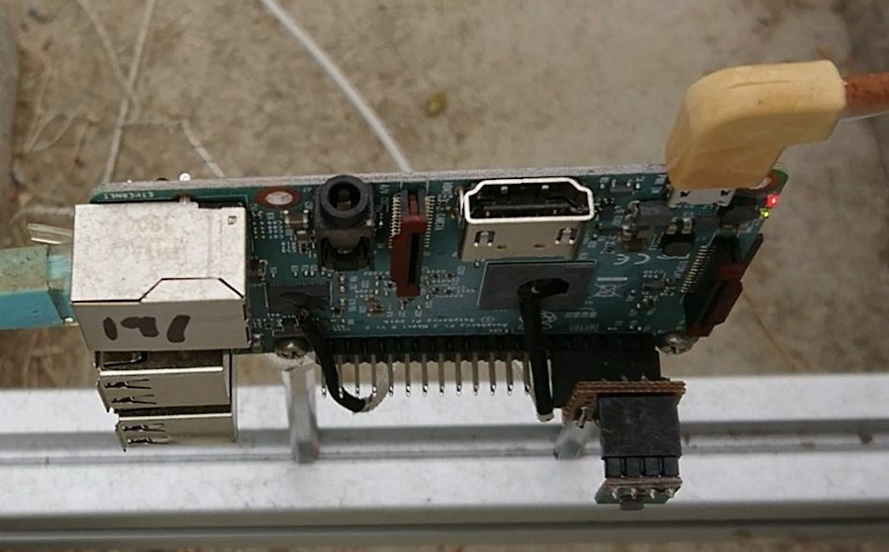

Fig. 8 Restart of Raspberry Pi with new SD card (LED is lit)

When I rewrote UECS-Pi Basic on a new SD card, attached it to the ripped Raspberry Pi and started it, it started without any problems (Fig. 8). After all, Raspberry Pi has been moving ever since, and it has been moving since July when I wrote this sentence.

7. Conclusion

Raspberry Pi has a very high temperature tolerance, from the results of experiments conducted over two years. A potential weakness is the SD card, which requires regular replacement if you want to use consumer products, and you need to use industrial durables to reduce maintenance frequency. Then, normally, we first suspect thermal runaway when the microcontroller stops, but in the case of ruspai, thermal runaway is not so easy. When trouble occurs, you should investigate the cause seriously without stopping thinking because of high temperature. In addition, although the conditions of this time were to be exposed to constant high temperature, it is generally said that the substrate becomes more fragile if there are frequent temperature changes, so verification may be necessary. As temperature changes cause the various materials used in the substrate to expand and contract repeatedly, the difference in expansion coefficients can not be tolerated and cracks may occur. In addition, we do not yet know what happens in high humidity environment. These are issues for the future.

（Western Region Agricultural Research Center, NARO Kurosaki Hideto）

