**JSP程序设计作业**

**班级： 网络20-1**

**姓名： 王冠博**

**学号： 2004020115**

**作业1**

**所属章节：第1章 JSP简介**

**题目1：输出英文字母表**

**1、文件名列表**

homework1_alphabet.jsp

**2、各文件代码**

homework1_alphabet.jsp：

<%--

Created by IntelliJ IDEA.

User: Administrator

Date: 2023/3/3

Time: 10:43

To change this template use File | Settings | File Templates.

--%>

<%@ page contentType="text/html;charset=UTF-8" language="java" %>

<html>

<head>

<title>alphabet</title>

</head>

<body>

<h1>字母表</h1>

<%

for (char x = 'A'; x <= 'Z'; x++) {

char y = (char) (x + ' ');

out.print(x + "(" + y + ") ");

}

%>

</body>

</html>

**3、运行效果图**

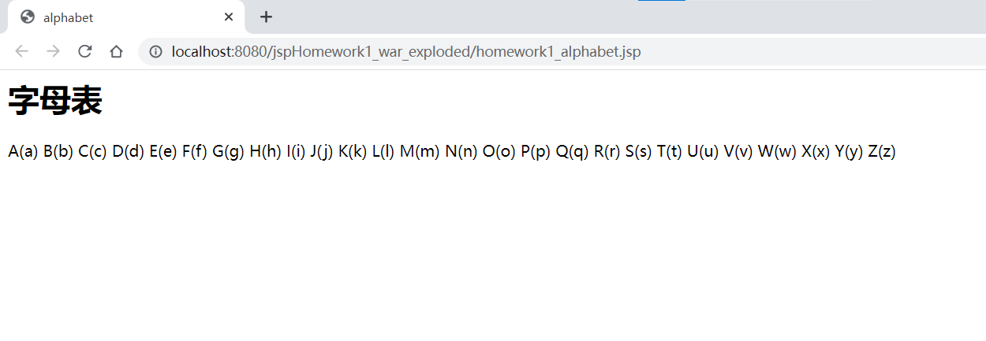

**题目2：输出九九口诀表**

**1、文件名列表**

homework2_multiplication.jsp

**2、各文件代码**

homework2_multiplication.jsp：

<%--

Created by IntelliJ IDEA.

User: Administrator

Date: 2023/3/3

Time: 10:43

To change this template use File | Settings | File Templates.

--%>

<%@ page contentType="text/html;charset=UTF-8" language="java" %>

<html>

<head>

<title>Title</title>

</head>

<body>

<h1 align="center">乘法表</h1>

<%

for (int i = 1; i <= 9; i++) {

for (int j = 1; j <= i; j++) {

out.print(i + " x " + j + " = " + i * j + " ");

}

out.print("<br>");

}

%>

</body>

</html>

**3、运行效果图**

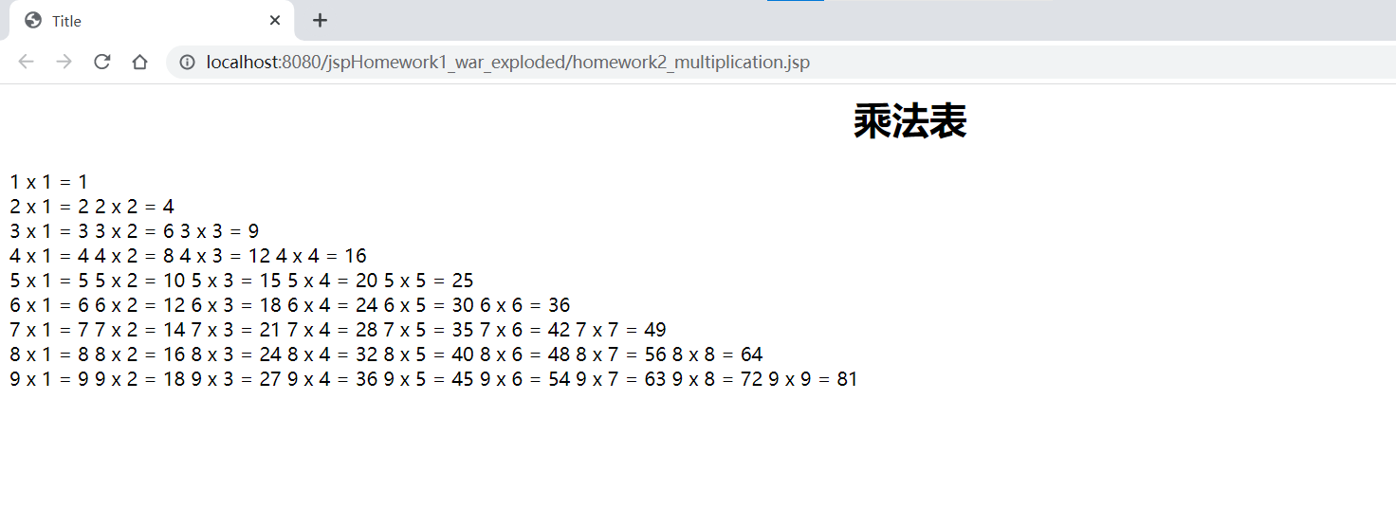

**题目3：输出成绩单**

**1、文件名列表**

homework3_report.jsp

**2、各文件代码**

homework3_report.jsp：

<%--

Created by IntelliJ IDEA.

User: Administrator

Date: 2023/3/3

Time: 10:44

To change this template use File | Settings | File Templates.

--%>

<%@ page contentType="text/html;charset=UTF-8" language="java" %>

<html>

<head>

<title>Title</title>

</head>

<body>

<h1 align="center">成绩单</h1>

<%

String[][] students = {

{"张三", "146", "75", "32"},

{"李四", "65", "111", "72"},

{"王五", "98", "56", "123"}

};

%>

<table border="1">

<tr>

<th>姓名</th>

<th>数学</th>

<th>语文</th>

<th>英语</th>

<th>总成绩</th>

</tr>

<% for (int i = 0; i < students.length; i++) { %>

<tr>

<% int total = 0; %>

<% for (int j = 0; j < students[i].length; j++) { %>

<td><%= students[i][j] %></td>

<% if (j > 0) { %>

<% total += Integer.parseInt(students[i][j]); %>

<% } %>

<% } %>

<td><%= total %></td>

</tr>

<% } %>

</table>

</body>

</html>

**3、运行效果图**

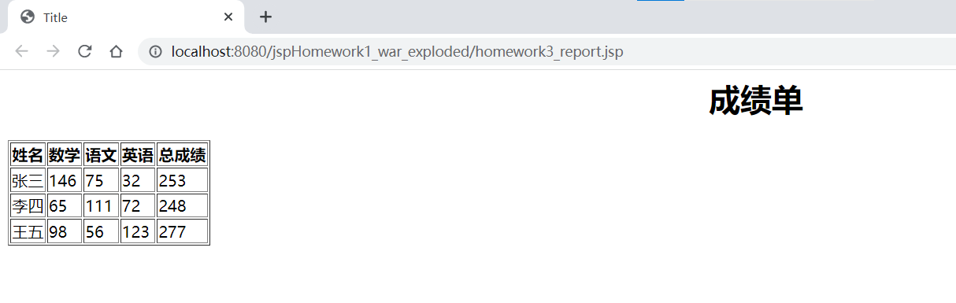

**作业2**

**所属章节：第2章 JSP语法**

**题目1：计算年货采购账单**

**1、文件名列表**

homework1_showPriceSum.jsp

**2、各文件代码**

homework1_showPriceSum.jsp：

<%--

Created by IntelliJ IDEA.

User: Administrator

Date: 2023/3/14

Time: 9:03

To change this template use File | Settings | File Templates.

--%>

<%@ page language="java" contentType="text/html; charset=UTF-8"

pageEncoding="UTF-8"%>

<%@ page import="java.util.regex.*" %>

<!DOCTYPE html>

<html>

<head>

<meta charset="UTF-8">

<title>采购账单</title>

</head>

<body>

<h1>兔年采购账单</h1>

<table>

<tr>

<td>客户</td>

<td>冰墩墩</td>

<td>|</td>

<td>雪融融</td>

</tr>

<tr>

<td>内容</td>

<td>鞭炮:386.8元,服装:2220.6元,医疗:468.9元</td>

<td>|</td>

<td>内饰:462.9元,食品:1990元,玩具:389.9元</td>

</tr>

<tr>

<td>消费总和</td>

<td><%= getPriceSum("鞭炮:386.8元,服装:2220.6元,医疗:468.9元") %></td>

<td>|</td>

<td><%= getPriceSum("内饰:462.9元,食品:1990元,玩具:389.9元") %></td>

</tr>

</table>

<%!

public double getPriceSum(String input) {//定义方法

Pattern pattern;//模式对象

Matcher matcher;//匹配对象

String regex = "-?[0-9][0-9]*[.]?[0-9]*";//匹配数字,整数或浮点数的止则表达式

pattern = Pattern.compile(regex);//初试化模式对象

matcher = pattern.matcher(input);//初始化匹配对象,用于检索input

double sum = 0;

while (matcher.find()) {

String str = matcher.group();

sum += Double.parseDouble(str);

}

return sum;

}%>

</body>

</html>

**3、运行效果图**

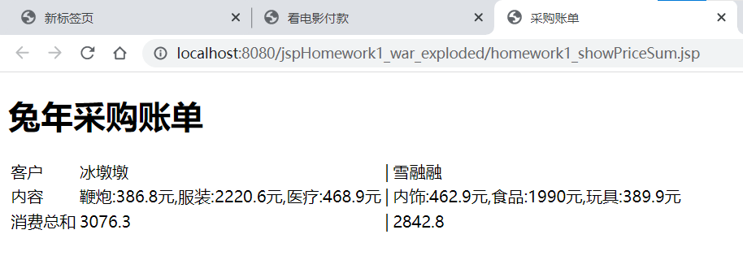

**题目2：插入当前访问时间**

**1、文件名列表**

homework2_userTime.jsp

userTime.jsp

**2、各文件代码**

homework2_userTime.jsp：

<%--

Created by IntelliJ IDEA.

User: Administrator

Date: 2023/3/15

Time: 17:43

To change this template use File | Settings | File Templates.

--%>

<%@ page contentType="text/html;charset=UTF-8" language="java" %>

<html>

<body>

<h1>显示访问网页的日期、时间</h1>

<%@ include file="userTime.jsp" %>

用户在 <%=date.toString() %> <%=time.toString()%> 访问了网页。

<h1>静态嵌入文件完毕</h1>

</body>

</html>

userTime.jsp：

<%--

Created by IntelliJ IDEA.

User: Administrator

Date: 2023/3/15

Time: 17:52

To change this template use File | Settings | File Templates.

--%>

<%@ page contentType="text/html;charset=UTF-8" language="java" %>

<%@ page import="java.time.LocalDate" %>

<%@ page import="java.time.LocalTime" %>

<%

LocalDate date = LocalDate.now( );

LocalTime time = LocalTime.now().withNano(0);

%>

<!DOCTYPE html>

<html>

<head>

<meta charset="UTF-8">

<title>访问时间</title>

</head>

<body>

**3、运行效果图**

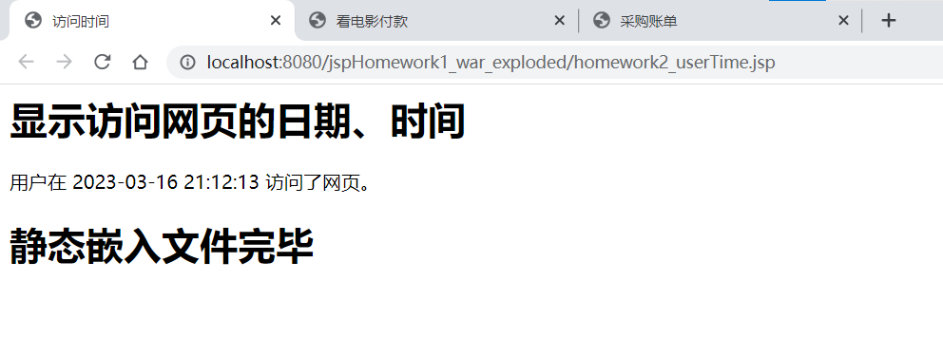

**题目3：加载英文学习资料**

**1、文件名列表**

homework3_listenEnglish.jsp

english-audio.jsp

**2、各文件代码**

homework3_listenEnglish.jsp：

<%--

Created by IntelliJ IDEA.

User: Administrator

Date: 2023/3/16

Time: 10:47

To change this template use File | Settings | File Templates.

--%>

<%@ page contentType="text/html;charset=UTF-8" language="java" %>

<!DOCTYPE html>

<html>

<head>

<meta charset="UTF-8">

<title>Dynamic File Embedding Example</title>

<style>

h1, audio {

display: block;

margin: 0 auto;

text-align: center;

}

</style>

</head>

<body>

<h1>English Text</h1>

<jsp:include page="english.txt" />

<br>

<h1>English Audio</h1>

<jsp:include page="english-audio.jsp" />

</body>

</html>

english-audio.jsp：

<%--

Created by IntelliJ IDEA.

User: Administrator

Date: 2023/3/16

Time: 13:45

To change this template use File | Settings | File Templates.

--%>

<%@ page contentType="text/html;charset=UTF-8" language="java" %>

<audio controls>

<source src="english.mp3" type="audio/mpeg">

</audio>

**3、运行效果图**

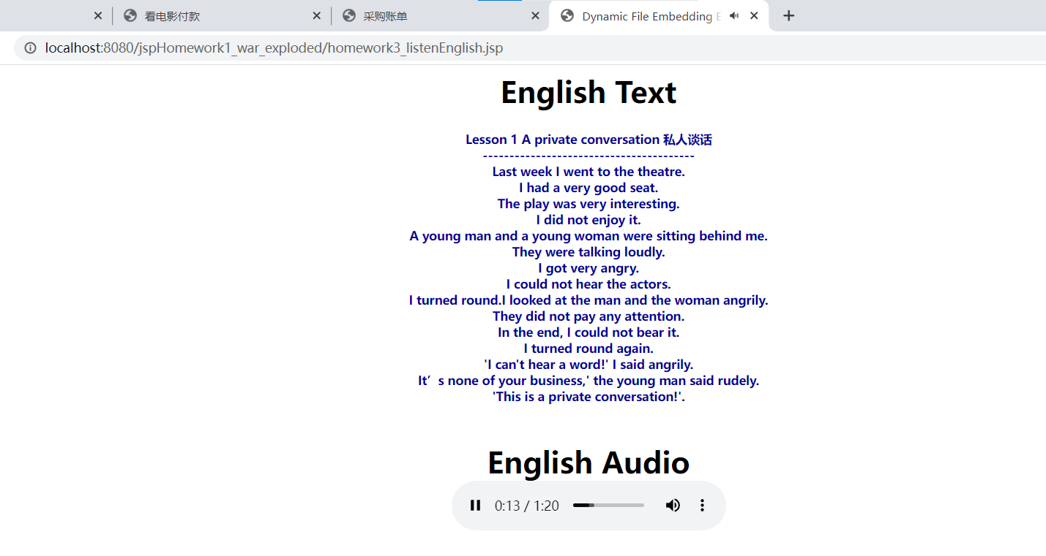

**题目4：买票看电影**

**1、文件名列表**

homework4_watchMovie.jsp

homework4_change5.jsp

homework4_change2.jsp

homework4_change1.jsp

**2、各文件代码**

homework4_watchMovie.jsp：

<%--

Created by IntelliJ IDEA.

User: Administrator

Date: 2023/3/16

Time: 14:36

To change this template use File | Settings | File Templates.

--%>

<%@ page contentType="text/html;charset=UTF-8" language="java" %>

<html>

<head>

<title>看电影付款</title>

</head>

<body>

<h1>欢迎来看电影！</h1>

<div style="text-align: center">

<%-- 定义价格为27元 --%>

<% int price = 27; %>

<%-- 定义付款金额为100元 --%>

<% int payment = 100; %>

<%-- 计算需要找零的金额 --%>

<% int change = payment - price; %>

<%-- 转发到homework4_change5.jsp，传递找零金额 --%>

<jsp:include page="homework4_change5.jsp">

<jsp:param name="change" value="<%=change%>"/>

</jsp:include>

</div>

</body>

</html>

homework4_change5.jsp：

<%--

Created by IntelliJ IDEA.

User: Administrator

Date: 2023/3/16

Time: 14:36

To change this template use File | Settings | File Templates.

--%>

<%@ page contentType="text/html;charset=UTF-8" language="java" %>

<html>

<head>

<title>找零</title>

</head>

<body>

<%

request.setCharacterEncoding("utf-8");

int change = Integer.parseInt(request.getParameter("change"));

if (change >= 5) {

out.print("<div>找赎" + (change - change % 5) / 5 + "张面值5元的钞票</div>");

change = change % 5;

}

%>

<jsp:include page="homework4_change2.jsp">

<jsp:param name="change" value="<%=change%>"/>

</jsp:include>

</body>

</html>

homework4_change2.jsp：

<%--

Created by IntelliJ IDEA.

User: Administrator

Date: 2023/3/16

Time: 14:36

To change this template use File | Settings | File Templates.

--%>

<%@ page contentType="text/html;charset=UTF-8" language="java" %>

<html>

<head>

<title>找零</title>

</head>

<body>

<%

request.setCharacterEncoding("utf-8");

int change = Integer.parseInt(request.getParameter("change"));

if (change >= 2) {

out.print("<div>找赎" + (change - change % 2) / 2 + "张面值2元的钞票</div>");

change = change % 2;

}

%>

<jsp:include page="homework4_change1.jsp">

<jsp:param name="change" value="<%=change%>"/>

</jsp:include>

</body>

</html>

homework4_change1.jsp：

<%--

Created by IntelliJ IDEA.

User: Administrator

Date: 2023/3/16

Time: 14:36

To change this template use File | Settings | File Templates.

--%>

<%@ page contentType="text/html;charset=UTF-8" language="java" %>

<html>

<head>

<title>找零</title>

</head>

<body>

<%

request.setCharacterEncoding("utf-8");

int change = Integer.parseInt(request.getParameter("change"));

if (change > 0) {

out.print("<div>找赎" + change + "张面值1元的钞票</div>");

}

%>

<video width="640" height="480" controls>

<source src="movie.mp4" type="video/mp4">

您的浏览器不支持 HTML5 视频。

</video>

</body>

</html>

**3、运行效果图**

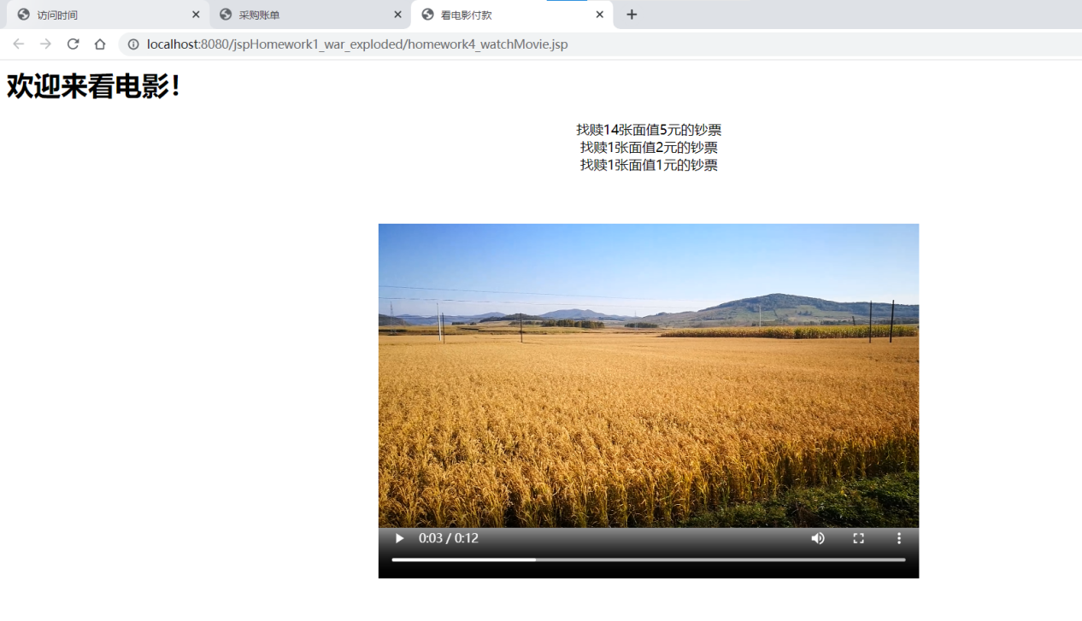

**作业3**

**所属章节：第3章 Tag文件与Tag标记**

**题目1：解析句子中单词的组成**

**1、文件名列表**

homework1_backWords.jsp

backWords.tag

1. **Pattern 和Matcher 以及正则表达式的简单使用**

正则表达式（Regular Expression，简称Regex或RegExp）是一种用来匹配、查找、替换文本的表达式语言。它具有强大的文本处理能力，被广泛应用于计算机领域中各种文本处理软件和编程语言中。

在Java中，Pattern和Matcher是用于处理正则表达式的类。Pattern类代表一个正则表达式的编译后的表示形式，而Matcher类则用于在输入字符串中查找匹配该正则表达式的子串。

Pattern类提供了多个静态方法用于编译正则表达式，并返回Pattern对象。而Matcher类则提供了多个方法用于在输入字符串中查找匹配的子串，并返回匹配的结果。

1、Pattern complie(String regex)：编译正则表达式，并创建Pattern类。

由于Pattern的构造函数是私有的，不可以直接创建，所以通过静态的简单工厂方法compile(String regex)方法来创建，将给定的正则表达式编译并赋予给Pattern类。

2、Matcher matcher(CharSequence input)。

Pattern.matcher(CharSequenceinput)返回一个Matcher对象。Matcher类的构造方法也是私有的，不能随意创建，只能通过Pattern.matcher(CharSequence input)方法得到该类的实例。Pattern类只能做一些简单的匹配操作，要想得到更强更便捷的正则匹配操作，那就需要将Pattern与Matcher一起合作。Matcher类提供了对正则表达式的分组支持，以及对正则表达式的多次匹配支持。

使用正则表达式可以进行各种模式匹配操作，如查找某个单词出现的次数、验证输入是否符合指定的格式等。正则表达式中的特殊字符可以表示某些字符集、重复次数、边界等，具有很强的灵活性和表达能力。

**3、各文件代码**

homework1_backWords.jsp:

<%--

Created by IntelliJ IDEA.

User: Administrator

Date: 2023/3/21

Time: 9:03

To change this template use File | Settings | File Templates.

--%>

<%@ page import="java.util.HashSet" %>

<%@ page import="java.util.Iterator" %>

<%@ page contentType="text/html;charset=UTF-8" language="java" %>

<%@ taglib prefix="word" tagdir="/WEB-INF/tags" %>

<html>

<head>

<title>解析句子中单词的组成</title>

<meta http-equiv="Content-Type" content="text/html; charset=UTF-8">

</head>

<body>

<h1 align="center">解析句子中单词的组成</h1>

<%

String text = "How are you,are you a student? where are you from?";

%>

<p align="center"><%= text %></p>

<word:backWords str="<%= text %>"/>

<p align="center">使用了<%= ((HashSet<String>) pageContext.getAttribute("words")).size() %>个单词：</p>

<p align="center"><%

Iterator<HashSet<String>> iterator = words.iterator();

while (iterator.hasNext()) {

out.print(iterator.next() + " ");

}

%></p>

</body>

</html>

backWords.tag:

<%@ tag import="java.util.HashSet" %>

<%@ tag import="java.util.regex.Pattern" %>

<%@ tag import="java.util.regex.Matcher" %>

<%@ tag pageEncoding="UTF-8" %>

<%@ attribute name="str" type="java.lang.String" required="true"

目录

**1、文件名列表 2**

**2、各文件代码 2**

**3、运行效果图 2**

**1、文件名列表 3**

**2、各文件代码 3**

**3、运行效果图 3**

**1、文件名列表 3**

**2、各文件代码 4**

**3、运行效果图 5**

所属章节：第2章 JSP语法 6

**1、文件名列表 6**

**2、各文件代码 6**

**3、运行效果图 7**

**1、文件名列表 7**

**2、各文件代码 7**

**3、运行效果图 8**

**1、文件名列表 9**

**2、各文件代码 9**

**3、运行效果图 10**

**1、文件名列表 10**

**2、各文件代码 10**

**3、运行效果图 13**

所属章节：第3章 Tag文件与Tag标记 14

**1、文件名列表 14**

**2、 Pattern 和Matcher 以及正则表达式的简单使用 14**

**3、各文件代码 14**

**4、运行效果图 17**

**1、文件名列表 17**

**2、各文件代码 17**

**3、运行效果图 19**

题目1：选择夏季奥运会项目，并给与答案 20

**1、文件名列表 20**

homework1_Oly.jsp 20

**2、各文件代码 20**

**3、运行效果图 22**

题目2：填写基本信息表单，提交并显示 22

**1、文件名列表 22**

**2、各文件代码 22**

**3、运行效果图 24**

题目3：196算法之谜 24

**1、文件名列表 24**

**2、各文件代码 24**

**3、 运行效果图 26**

题目1：数据分析 28

**1、文件名列表 28**

**2、各文件代码 28**

**3、 运行效果图 34**

题目2：计算前n项数列和 35

**1、文件名列表 35**

Proble2.jsp 35

**2、各文件代码 35**

ServletController.java 38

**3、运行效果图 39**

="true" %>

<%@ variable name-given="words" variable-class="java.util.HashSet" scope="AT_END" %>

<%

HashSet<String> set = new HashSet<String>(); //集合不允许有相同的元素

Pattern pattern; //模式对象

Matcher matcher; //匹配对象

String regex = "[a-zA-Z]+"; //匹配英文单词

pattern = Pattern.compile(regex); //初始化模式对象

matcher = pattern.matcher(str); //初始化匹配对象，用于检索mess

while (matcher.find()){

String s = matcher.group();

set.add(s);

}

//将返回的arrayList对象放在jspContext中:

jspContext.setAttribute("words",set);

%>

**4、运行效果图**

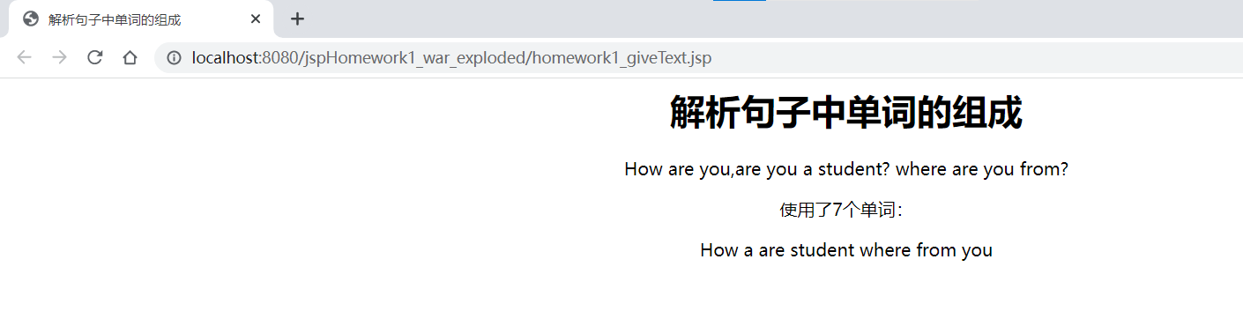

**题目2：显示日历**

**1、文件名列表**

homework2_useCalendar.jsp

calendar.tag

**2、各文件代码**

homework2_useCalendar.jsp:

<%--

Created by IntelliJ IDEA.

User: Administrator

Date: 2023/3/23

Time: 22:36

To change this template use File | Settings | File Templates.

--%>

<%@ page contentType="text/html;charset=UTF-8" language="java" %>

<%@ taglib prefix="mytag" tagdir="/WEB-INF/tags" %>

<html>

<%

String year = "2023";

String mouth = "3";

%>

<head>

<title><%= year%>年<%= mouth%>月日历</title>

</head>

<body>

<h1 style="text-align: center"><%= year%>年<%= mouth%>月日历</h1>

<mytag:calendar year="<%=year%>" month="<%=mouth%>" />

</body>

</html>

calendar.tag

<%@ tag import="java.time.LocalDate" %>

<%@ tag language="java" pageEncoding="UTF-8" %>

<%@ attribute name="year" required="true" type="java.lang.String" %>

<%@ attribute name="month" required="true" type="java.lang.String" %>

<%

int Year = Integer.parseInt(year);

int Month = Integer.parseInt(month);

LocalDate date = LocalDate.of(Year, Month, 1);

int firstDayOfWeek = date.getDayOfWeek().getValue() % 7;

int daysOfMonth = date.lengthOfMonth();

%>

<div style="display: flex;justify-content: center">

<table>

<tr>

<th>星期日</th>

<th>星期一</th>

<th>星期二</th>

<th>星期三</th>

<th>星期四</th>

<th>星期五</th>

<th>星期六</th>

</tr>

<%

int day = 1;

for (int i = 0; i < 6; i++) {

out.print("<tr>");

for (int j = 0; j < 7; j++) {

if (i == 0 && j < firstDayOfWeek) {

out.print("<td>--</td>");

} else if (day > daysOfMonth) {

out.print("<td></td>");

} else {

out.print("<td>" + day + "</td>");

day++;

}

}

out.print("</tr>");

}

%>

</table>

</div>

**3、运行效果图**

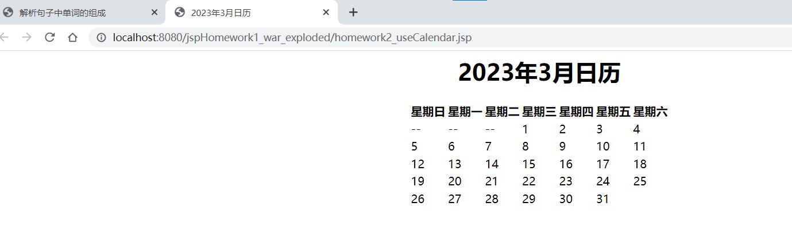

**作业4**

**所属章节：第4章 JSP 内置对象（4题），第5章JSP 与Java bean （2题）**

**题目1：选择夏季奥运会项目，并给与答案**

**1、文件名列表**

**homework1_Oly.jsp**

**homework1_receive.jsp**

**2、各文件代码**

**homework1_Oly.jsp：**

<%--

Created by IntelliJ IDEA.

User: 147

Date: 2023/4/4

Time: 8:30

To change this template use File | Settings | File Templates.

--%>

<%@ page contentType="text/html;charset=UTF-8" language="java" %>

<html>

<head>

<title>多选题</title>

</head>

<body>

<form method="post" action="homework1_receive.jsp">

<p>选择夏季奥运会项目</p>

<input type="checkbox" name="answer" value="A">A.football<br>

<input type="checkbox" name="answer" value="B">B.volleyball<br>

<input type="checkbox" name="answer" value="C">C.iceball<br>

<input type="checkbox" name="answer" value="D">D.basketball<br>

<br>

<input type="submit" value="提交答案">

</form>

</body>

</html>

**homework1_receive.jsp**

<%--

Created by IntelliJ IDEA.

User: 147

Date: 2023/4/6

Time: 20:54

To change this template use File | Settings | File Templates.

--%>

<%@ page contentType="text/html;charset=UTF-8" language="java" %>

<html>

<head>

<title>答案结果</title>

</head>

<body>

<%

String[] selectedAnswers = request.getParameterValues("answer"); // 获取用户提交的选项

String correctAnswer = "ABD"; // 正确答案

boolean isCorrect = true; // 判断是否所有正确答案都被选择了

if(selectedAnswers != null) { // 用户选择至少一个选项

for(String answer : selectedAnswers) {

if(!correctAnswer.contains(answer)) { // 只要有一个错误答案被选中，就是回答错误

isCorrect = false;

break;

}

//少选也为错误

if(correctAnswer.length() != selectedAnswers.length) {

isCorrect = false;

break;

}

}

} else { // 用户未选择任何选项

isCorrect = false;

}

// 根据正确与否，显示不同的消息

if(isCorrect) {

//输出用户输入的答案

out.print("您的答案是：");

for(String answer : selectedAnswers) {

out.print(answer);

}

out.println("回答正确！");

} else {

out.print("您的答案是：");

for(String answer : selectedAnswers) {

out.print(answer);

}

out.println("回答错误！");

}

%>

</body>

</html>

**3、运行效果图**

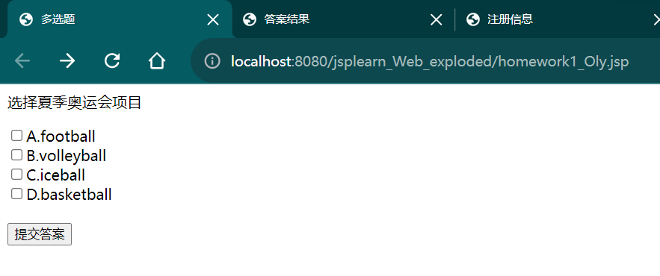

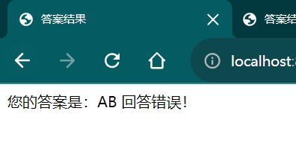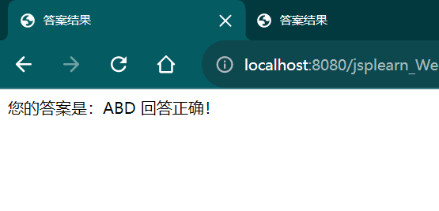

**题目2：填写基本信息表单，提交并显示**

**1、文件名列表**

**homework2_register.jsp**

**homework2_showInfo.jsp**

**2、各文件代码**

**homework2_register.jsp:**

<%--

Created by IntelliJ IDEA.

User: 147

Date: 2023/4/6

Time: 21:11

To change this template use File | Settings | File Templates.

--%>

<%@ page language="java" contentType="text/html; charset=UTF-8"

pageEncoding="UTF-8"%>

<!DOCTYPE html>

<html>

<head>

<meta charset="UTF-8">

<title>注册</title>

<style>

label {

display: inline-block;

width: 80px;

text-align: right;

margin-right: 10px;

}

</style>

</head>

<body>

<h1>注册</h1>

<form method="post" action="homework2_showInfo.jsp">

<label for="username">用户名：</label><input type="text" name="username"><br>

<label for="password">密码：</label><input type="password" name="password"><br>

<label for="age">年龄：</label><input type="text" name="age"><br>

<label>爱好：</label>

<input type="radio" name="hobby" value="足球">足球

<input type="radio" name="hobby" value="篮球">篮球

<input type="radio" name="hobby" value="排球">排球<br>

<input type="submit" value="提交">

</form>

</body>

</html>

**homework2_showInfo.jsp:**

<%--

Created by IntelliJ IDEA.

User: 147

Date: 2023/4/6

Time: 21:11

To change this template use File | Settings | File Templates.

--%>

<%@ page language="java" contentType="text/html; charset=UTF-8"

pageEncoding="UTF-8"%>

<!DOCTYPE html>

<html>

<head>

<meta charset="UTF-8">

<title>注册信息</title>

<style>

label {

display: inline-block;

width: 80px;

text-align: right;

margin-right: 10px;

}

span {

font-weight: bold;

}

</style>

</head>

<body>

<h1>您的注册信息如下：</h1>

<label><span>用户名：</span></label><%= request.getParameter("username") %><br>

<label><span>密码：</span></label><%= request.getParameter("password") %><br>

<label><span>年龄：</span></label><%= request.getParameter("age") %><br>

<label><span>爱好：</span></label><%= request.getParameter("hobby") == null ? "无爱好" : request.getParameter("hobby") %><br>

</body>

</html>

**3、运行效果图**

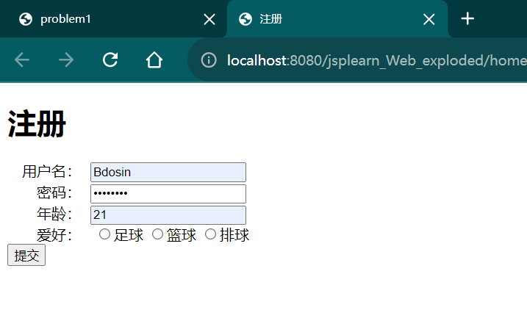

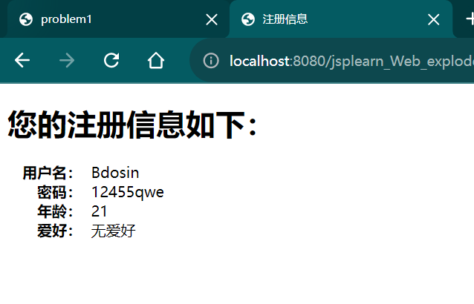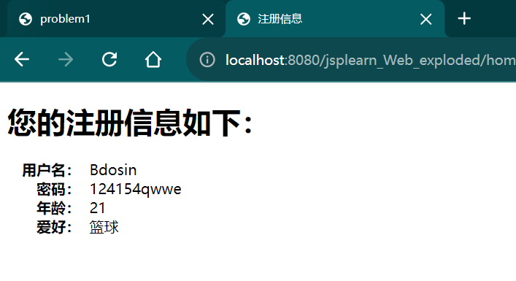

**题目3：196算法之谜**

**1、文件名列表**

**homework3_inputNumber.jsp**

**homework3_huiwenNumber.jsp**

**2、各文件代码**

**homework3_inputNumber.jsp:**

<%--

Created by IntelliJ IDEA.

User: 147

Date: 2023/4/6

Time: 21:50

To change this template use File | Settings | File Templates.

--%>

<%@ page contentType="text/html;charset=UTF-8" language="java" %>

<html>

<head>

<title>回文数</title>

</head>

<body>

<div align="center">

<h1>

输入一个整数<br>

<form action="homework3_huiwenNumber.jsp" method="post">

<input type="text" name="number">

<input type="submit" value="开始计算">

</form>

</h1>

</div>

</body>

</html>

**homework3_huiwenNumber.jsp:**

<%--

Created by IntelliJ IDEA.

User: 147

Date: 2023/4/6

Time: 21:50

To change this template use File | Settings | File Templates.

--%>

<%@ page import="java.math.BigInteger" %>

<%@ page contentType="text/html;charset=UTF-8" language="java" %>

<%!

String reverse(String str){

StringBuffer rs = new StringBuffer(str);

return rs.reverse().toString();

}

%>

<html>

<head>

<title>huiwen</title>

</head>

<body>

<div align="center">

<%

request.setCharacterEncoding("utf-8");

String regex = "[1-9][0-9]*";

String startNumber = request.getParameter("number");

if(startNumber == null || startNumber.length() == 0){

startNumber = "520";

}

if(!startNumber.matches(regex)){

response.sendRedirect("problem3.jsp");

return;

}

int step = 1;

BigInteger number = new BigInteger(startNumber);

BigInteger resNumber = new BigInteger(reverse(startNumber));

BigInteger result = number.add(resNumber);

out.println("<br>" + number + "+" + resNumber + "=" + result);

resNumber = new BigInteger(reverse(result.toString()));

while (!resNumber.equals(result)){

step ++;

number = result;

resNumber = new BigInteger(reverse(number.toString()));

result = number.add(resNumber);

out.println("<br>" + number + "+" + resNumber + "=" + result);

resNumber = new BigInteger(reverse(result.toString()));

}

out.println("<h3>" + step + "步得到回文数" + result + "<h3>");

%>

</div>

</body>

</html>

1. **运行效果图**

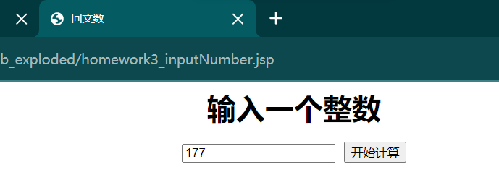

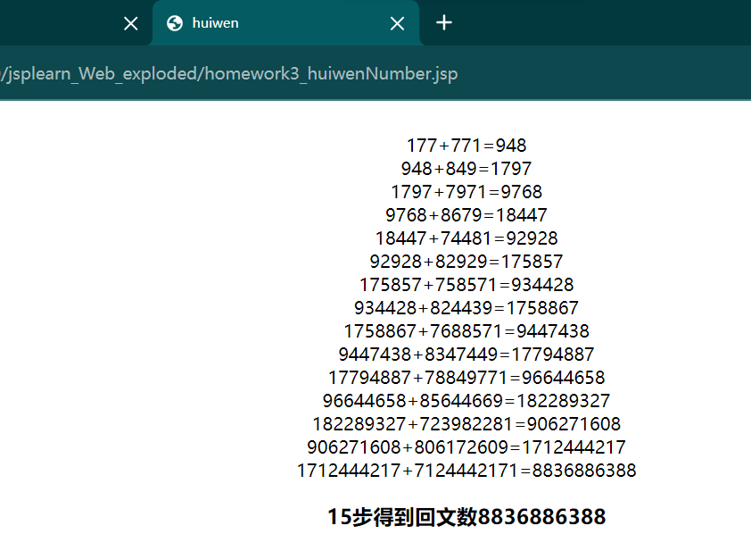

**作业5**

**所属章节：第6章 Java Servlet基础（2题），第7章 MVC模式（1题）**

**题目1：数据分析**

**1、文件名列表**

**Problem1.jsp  
Subtotal1.jsp  
Subtotal2.jsp**

**Control.java**

**Subtotal1.java**

**Subtotal2.java**

**web.xml**

**2、各文件代码**

**Problem1.jsp:**<%--

Created by IntelliJ IDEA.

User: 147

Date: 2023/5/19

Time: 13:03

To change this template use File | Settings | File Templates.

--%>

<%@ page contentType="text/html;charset=UTF-8" language="java" %>

<html>

<head>

<title>输入整数</title>

</head>

<body>

<div align="center">

<form action="/Control" method="post" accept-charset="UTF-8">

<label for="message">请输入整数，用逗号或非数字字符隔开</label><br>

<textarea id="message" name="message" rows="5" cols="40"></textarea><br>

<input type="submit" name="subtotal1" value="subtotal1">

<input type="submit" name="subtotal2" value="subtotal2">

</form>

</div>

</body>

</html> **Subtotal1.jsp:**<%--

Created by IntelliJ IDEA.

User: 147

Date: 2023/5/19

Time: 12:52

To change this template use File | Settings | File Templates.

--%>

<%@ page contentType="text/html;charset=UTF-8" language="java" %>

<html>

<head>

<title>subtotal1</title>

</head>

<body>

<%

request.setCharacterEncoding("utf-8");

%>

<div align="center">

<h3>奇数:</h3>

<% int[] numsOdd = (int[]) request.getAttribute("numsOdd");

for (int num : numsOdd) { %>

<%= num %>,

<% } %>

<h3>偶数:</h3>

<% int[] numsEvent = (int[]) request.getAttribute("numsEvent");

for (int num : numsEvent) { %>

<%= num %>,

<% } %>

</div>

</body>

</html> **Subtotal2.jsp:**<%--

Created by IntelliJ IDEA.

User: 147

Date: 2023/5/19

Time: 13:02

To change this template use File | Settings | File Templates.

--%>

<%@ page contentType="text/html;charset=UTF-8" language="java" %>

<html>

<head>

<title>subtotal2</title>

</head>

<body>

<%

request.setCharacterEncoding("utf-8");

%>

<div align="center">

<h3>3的整数倍:</h3>

<% int[] nums0 = (int[]) request.getAttribute("nums0");

for (int num : nums0) { %>

<%= num %>,

<% } %>

<h3>模3余数为1的数:</h3>

<% int[] nums1 = (int[]) request.getAttribute("nums1");

for (int num : nums1) { %>

<%= num %>,

<% } %>

<h3>模3余数为2的数:</h3>

<% int[] nums2 = (int[]) request.getAttribute("nums2");

for (int num : nums2) { %>

<%= num %>,

<% } %>

</div>

</body>

</html>

**Control.java:**package servlet;

import javax.servlet.*;

import javax.servlet.http.*;

import javax.servlet.annotation.*;

import java.io.IOException;

@WebServlet(name = "Control", value = "/Control")

public class Control extends HttpServlet {

@Override

protected void doGet(HttpServletRequest request, HttpServletResponse response) throws ServletException, IOException {

doPost(request, response);

}

@Override

protected void doPost(HttpServletRequest request, HttpServletResponse response) throws ServletException, IOException {

// 获取用户提交的整数字符串

String input = request.getParameter("message");

if (request.getParameter("subtotal1") != null) {

// 将整数字符串转发给 SubTotal1 Servlet 进行奇偶数统计

request.setAttribute("message", input);

request.getRequestDispatcher("/SubTotal1").forward(request, response);

} else {

// 将整数字符串转发给 SubTotal2 Servlet 进行模3统计

request.setAttribute("message", input);

request.getRequestDispatcher("/SubTotal2").forward(request, response);

}

}

}

**Subtotal1.java:**package servlet;

import javax.servlet.*;

import javax.servlet.http.*;

import javax.servlet.annotation.*;

import java.io.IOException;

@WebServlet(name = "SubTotal1", value = "/SubTotal1")

public class SubTotal1 extends HttpServlet {

@Override

protected void doGet(HttpServletRequest request, HttpServletResponse response) throws ServletException, IOException {

doPost(request, response);

}

@Override

protected void doPost(HttpServletRequest request, HttpServletResponse response) throws ServletException, IOException {

// 获取提交的整数数据

String message = request.getParameter("message");

// 将数据转换为整数数组

String[] numbers = message.split(",");

int[] nums = new int[numbers.length];

int evenCount = 0;

int oddCount = 0;

for (int i = 0; i < numbers.length; i++) {

nums[i] = Integer.parseInt(numbers[i]);

if (nums[i] % 2 == 0) {

evenCount++;

} else {

oddCount++;

}

}

int evenidx = 0;

int oddidx = 0;

int[] numsEvent = new int[evenCount];

int[] numsOdd = new int[oddCount];

for (int i = 0; i < nums.length; i++) {

if (nums[i] % 2 == 0) {

numsEvent[evenidx++] = nums[i];

} else {

numsOdd[oddidx++] = nums[i];

}

}

// 将统计结果保存到 request 对象中

request.setAttribute("numsEvent", numsEvent);

request.setAttribute("numsOdd", numsOdd);

// 转发到结果页面

RequestDispatcher dispatcher = request.getRequestDispatcher("Subtotal1.jsp");

dispatcher.forward(request, response);

}

}

**Subtotal2.java:**package servlet;

import javax.servlet.*;

import javax.servlet.http.*;

import javax.servlet.annotation.*;

import java.io.IOException;

@WebServlet(name = "SubTotal2", value = "/SubTotal2")

public class SubTotal2 extends HttpServlet {

@Override

protected void doGet(HttpServletRequest request, HttpServletResponse response) throws ServletException, IOException {

doPost(request, response);

}

@Override

protected void doPost(HttpServletRequest request, HttpServletResponse response) throws ServletException, IOException {

// 获取提交的整数数据

String message = request.getParameter("message");

int count = 0;

int count1 = 0;

int count2 = 0;

// 将数据转换为整数数组

String[] numbers = message.split(",");

int[] nums = new int[numbers.length];

for (int i = 0; i < numbers.length; i++) {

nums[i] = Integer.parseInt(numbers[i]);

if (nums[i] % 3 == 0) {

count++;

} else if (nums[i] % 3 == 1) {

count1++;

} else {

count2++;

}

}

// 统计模3的个数

int idx = 0, idx1 = 0, idx2 = 0;

int[] nums0 = new int[count];

int[] nums1 = new int[count1];

int[] nums2 = new int[count2];

for (int i = 0; i < nums.length; i++) {

if (nums[i] % 3 == 0) {

nums0[idx++] = nums[i];

} else if (nums[i] % 3 == 1) {

nums1[idx1++] = nums[i];

} else {

nums2[idx2++] = nums[i];

}

}

// 将统计结果保存到 request 对象中

request.setAttribute("nums0", nums0);

request.setAttribute("nums1", nums1);

request.setAttribute("nums2", nums2);

// 转发到结果页面

RequestDispatcher dispatcher = request.getRequestDispatcher("Subtotal2.jsp");

dispatcher.forward(request, response);

}

}

**web.xml:**<?xml version="1.0" encoding="UTF-8"?>

<web-app xmlns="http://xmlns.jcp.org/xml/ns/javaee"

xmlns:xsi="http://www.w3.org/2001/XMLSchema-instance"

xsi:schemaLocation="http://xmlns.jcp.org/xml/ns/javaee http://xmlns.jcp.org/xml/ns/javaee/web-app_4_0.xsd"

version="4.0">

<servlet>

<servlet-name>Control</servlet-name>

<servlet-class>servlet.Control</servlet-class>

</servlet>

<servlet-mapping>

<servlet-name>Control</servlet-name>

<url-pattern>/Control</url-pattern>

</servlet-mapping>

<servlet>

<servlet-name>SubTotal1</servlet-name>

<servlet-class>servlet.SubTotal1</servlet-class>

</servlet>

<servlet-mapping>

<servlet-name>SubTotal1</servlet-name>

<url-pattern>/SubTotal1</url-pattern>

</servlet-mapping>

<servlet>

<servlet-name>SubTotal2</servlet-name>

<servlet-class>servlet.SubTotal2</servlet-class>

</servlet>

<servlet-mapping>

<servlet-name>SubTotal2</servlet-name>

<url-pattern>/SubTotal2</url-pattern>

</servlet-mapping>

</web-app>

1. **运行效果图**

**Problem1**

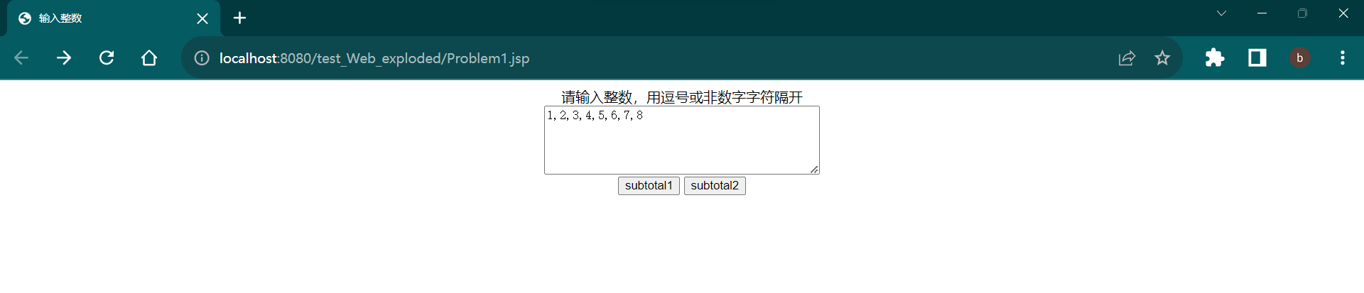

**Subtotal1**

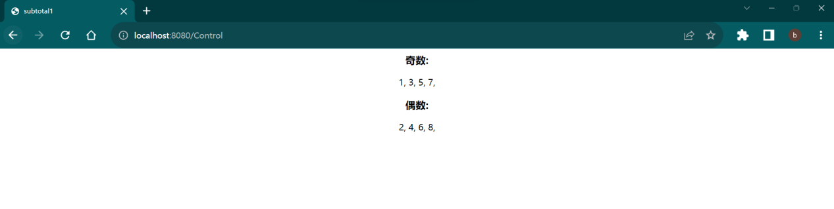

**Subtotal2**

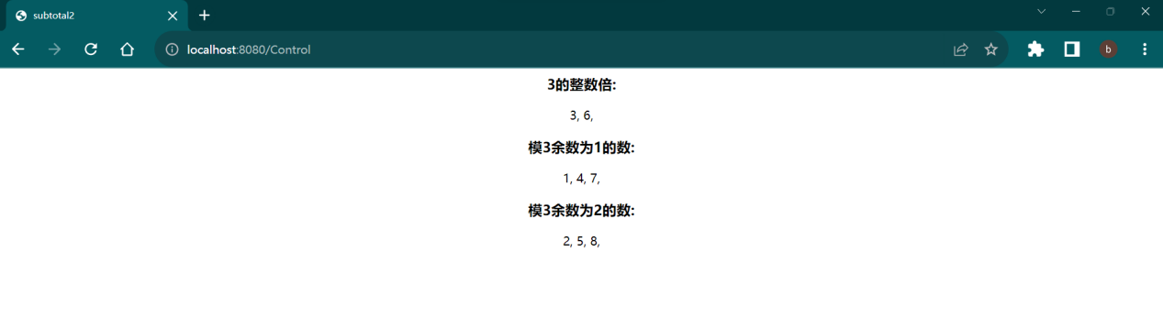

**题目2：计算前n项数列和**

**1、文件名列表**

**Proble2.jsp**

**Num.java**

**ServletController.java**

**2、各文件代码**

**Proble2.jsp:**

<%--  
 Created by IntelliJ IDEA.  
 User: zls  
 Date: 2023/5/16  
 Time: 9:11  
 To change this template use File | Settings | File Templates.  
--%>  
<%@ page contentType="text/html;charset=UTF-8" language="java" %>  
  
<html>  
<head>  
 <title>Title</title>  
</head>  
<body>  
<%  
 request.setCharacterEncoding("utf-8");  
%>  
  
<jsp:useBean id="num" class="Bean.Num" scope="application"/>  
<div align="center">  
 <h1>等差级数求和</h1>  
  
  
<form action="/ServletController" method=post accept-charset="UTF-8" >  
 <table>  
 <tr>  
 <th>首项</th>  
 <td><input type=text name="a"  
 value=<jsp:getProperty name="num" property="a1"/> /></td>  
  
 <th>公差/公比</th>  
 <td><input type=text name="d/q"  
 value=<jsp:getProperty name="num" property="dq"/> /></td>  
  
 <th>项数</th>  
 <td><input type=text name="n"  
 value=<jsp:getProperty name="num" property="n"/> /></td>  
  
  
 <td><input type="submit" name="d" value="前n项等差数列和" ></td>  
 <td><input type="submit" name="q" value="前n项等比数列和" /></td>  
 </tr>  
 </table>  
  
</form>  
</div>  
  
<table align="center" border="1">  
 <tr>  
 <th>首项</th><th>公差/公比</th><th>项数</th><th>前n项和</th>  
 </tr>  
  
 <tr>  
  
 <th><jsp:getProperty name="num" property="a1"/></th>  
 <th><jsp:getProperty name="num" property="dq"/></th>  
 <th><jsp:getProperty name="num" property="n"/></th>  
 <th><jsp:getProperty name="num" property="sum"/></th>  
  
 </tr>  
</table>  
  
</body>  
</html>

**Num.java**

package Bean;  
  
public class Num {  
 private double a1;  
 private double dq;  
 private int n;  
  
 @Override  
 public String toString() {  
 return "Num{" +  
 "a1=" + a1 +  
 ", dq=" + dq +  
 ", n=" + n +  
 ", op=" + op +  
 ", sum=" + sum +  
 '}';  
 }  
  
 private int op;//1公比 0公差  
  
 private double sum;  
  
 public double getA1() {  
 return a1;  
 }  
  
 public void setA1(double a1) {  
 this.a1 = a1;  
 }  
  
 public double getDq() {  
 return dq;  
 }  
  
 public void setDq(double dq) {  
 this.dq = dq;  
 }  
  
 public int getN() {  
 return n;  
 }  
  
 public void setN(int n) {  
 this.n = n;  
 }  
  
 public int getOp() {  
 return op;  
 }  
  
 public void setOp(int op) {  
 this.op = op;  
 }  
  
 public double getSum() {  
 return sum;  
 }  
  
 public void setSum(double sum) {  
 this.sum = sum;  
 }  
}

**ServletController.java**

package controller;  
  
import Bean.Num;  
import javax.servlet.*;  
import javax.servlet.http.*;  
import javax.servlet.annotation.*;  
import java.io.IOException;  
@WebServlet(name = "ServletController", value = "/ServletController")  
public class ServletController extends HttpServlet {  
 @Override  
 protected void doGet(HttpServletRequest request, HttpServletResponse response) throws ServletException, IOException {  
 doPost(request, response);  
 }  
 @Override  
 protected void doPost(HttpServletRequest request, HttpServletResponse response) throws ServletException, IOException {  
 response.setCharacterEncoding("utf-8");  
 response.setContentType("text/html;charset=utf-8");  
 try{  
 String op1 = request.getParameter("d");  
 String op2 = request.getParameter("q");  
 Num num = new Num();  
 request.setAttribute("num", num);  
 if (num == null) {  
 return;  
 }  
 num.setA1(Double.parseDouble(request.getParameter("a")));  
 num.setDq(Double.parseDouble(request.getParameter("d/q")));  
 num.setN(Integer.parseInt(request.getParameter("n")));  
 double sum = 0;  
 if(op1 != null){  
 num.setOp(0);  
 sum = (2 * num.getA1() + (num.getN() - 1) * num.getDq()) * num.getN() / 2;  
 }else{  
 num.setOp(1);  
 sum = num.getA1() * (Math.pow(num.getDq(), num.getN()) - 1) / (num.getDq() - 1);  
 }  
 num.setSum(sum);  
 //response.sendRedirect("/fifth/problem2/problem2.jsp");  
 RequestDispatcher dispatcher = request.getRequestDispatcher("/fifth/problem2/problem2.jsp");  
 dispatcher.forward(request, response);  
 }catch (Exception e){  
 e.printStackTrace();  
 }  
  
 }  
}

**3、运行效果图**

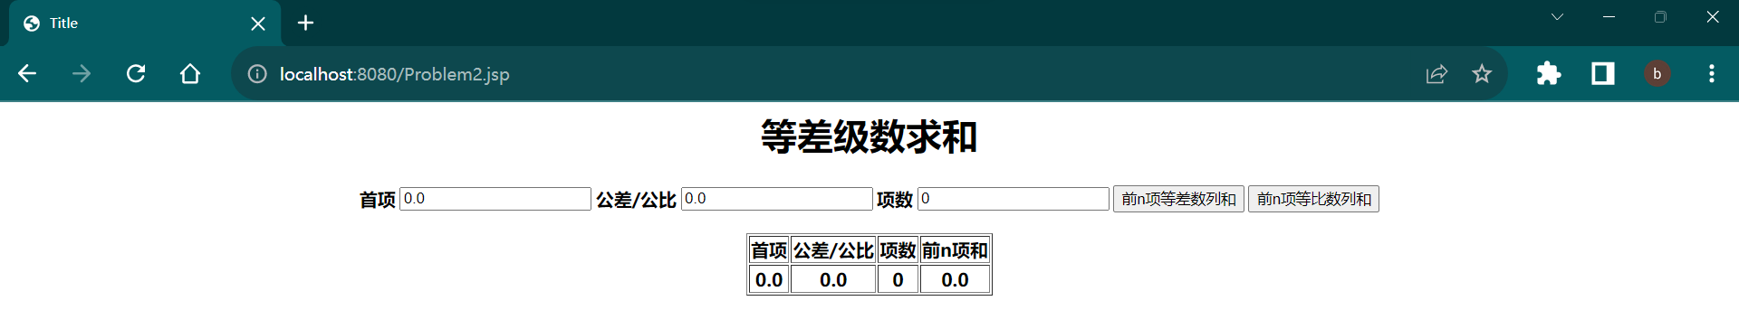

等差

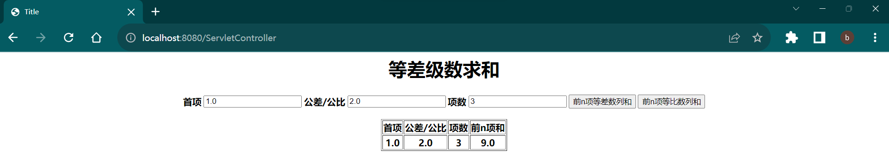

等比

