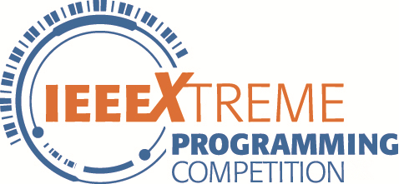
Choose Better

Problem Statement

There are moments in life when you miss someone so much that you just want to pick them from your dreams and hug them for real! Dream what you want to dream;go where you want to go;be what you want to be,because you have only one life and one chance to do all the things you want to do.

Now you are very lucky.You have a chance to choose 3 partners to help you achieve your dream.You think strength,intelligence and agility is very important.So you want to choose a strong man,a man of wisdom and a man of agility.

Your aim is to make the sum of the strength of the first person you choose ,the intelligence of the second person,and the agility of the third peoson is biggest.So there is a question:what is the biggest sum?

There are n person you can choose.Different person may have different strength ,different intelligence and different agility.So it may be difficult. Don’t worry,you can solve it.

Input Format

The first line contains an positive integer T, represents there are T test cases.

For each test case:

The first line contains an positive integer n, represents the number of the people is n.

The second line contains n number S[i],represents the strength of each person.

The third line contains n number G[i],represents the intelligence of each person.

The fourth line contains n number A[i],represents the agility of each person.

1<=T<=10,1<=n<=100000,1<=S[i],G[i],A[i]<=1000000000
​​ .
Output Format

For each test case,output in line a non-negative integer, repersent the value of the answer.

Sample Input


1

3

1 2 3
2 1 3
3 1 2

Sample Output

8

