
Strange triangle

Problem Statement

At the edge of this mysterious city, there is a mysterious Pyramid. Pyramid is full of thorns, and the wild beasts.
As a member of the adventure team, Tom is not afraid of these and bound to explore Pyramid.

Suffered all kinds of hardships during the explore., Tom finally entered the pyramid.And he obtained the Pharaoh’s treasure —— A strange magic cube.

The magic cube master space magic, there are many and many rows in the cube.There are i number of the i-th row.each row is began to 1, and then continue to increase by 2.

Like the following:
1
1 3
1 3 5
1 3 5 7
1 3 5 7 9
......
When Tom observed the Rubik's cube, the cube of the number of columns into a line: 1 1 3 1 3 5 1 3 5 7 1 3 5 7 9......

Now Tom is very curious.After rearranging these number into a row, what is the nth number?

Input Format

The first line contains an positive integer T, represents there are T test cases.

For each test case:

The first line contains an integer n, represents the number is n.

1<=T<=1000,1<=n<=1000000000
​​ .
Output Format

For each test case,output in line a non-negative integer, represent the value of the answer.

Sample Input
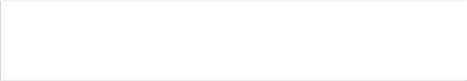
5
1
2
3
4
5

Sample Output

1
1
3
1
3

