
Choose Bigger

Problem Statement

Under the huge city , there is a mysterious casino.The casino is filled with strange people.

In the corner of the casino, there is a person squatting, who everyone don’t know what he was doing.

As a member of the adventure team, Tom certainly was curious about what the man was doing. So he went up and approached.

This strange man also found Tom, he said to Tom: "if you play a game with me, then I will tell you what I am doing?"

Tom promised.

This game is like this:

This strange man, gave Tom N number, but Tom did not know the specific size of the N number. Then tells the Tom M relationships, each pair of relationships give Tom two numbers A and B, indicating that the Ath number is greater than or equal to the Bth number.

Then this strange man will ask Tom Q question. The strange man will give Tom two numbers A and B for each question. and asked Tom the relative size relationship between a and B, the answer is one of "> =", "<", "=", "?",the four relations.It represents A is greater than or equal to B,A is less than or equal to B, A is equal to B and Tom didn't know the relationship between the two numbers.

Tom can't solve it now, can you help him?

Input Format

The first line contains an positive integer T, represents there are T test cases.

For each test case:

The first line contains an integer n, represents the number is n.

1<=T<=1000,1<=n<=1000000000
​​ .
Output Format

For each test case,output in line a non-negative integer, represent the value of the answer.

Sample Input
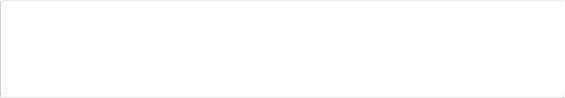
5
1
2
3
4
5

Sample Output

1
1
3
1
3

