- AC
Ends in: 0 Days 03:15:07
- Rank: 535 Score: 113.33
Solving this puzzle will improve your rank to 354
Description:
Meet Lakshya, he is one of the best cubers of the world. He has this unique talent to solve a Rubik's cube with his eyes blindfolded! He has recently been experimenting a lot to improve his timing. Lakshya has been following Singmaster's notation of moves to memorize a lot of standard solving techniques. To assist him in his pursuit, you offer to help him. Lakshya has now given you the following description of the tool that he needs:
A tool which will take the initial configuration of rubik's cube (in its solved state) followed by a set of moves, denoted in Singmaster's notation and generate as output the colors of the tiles present on the front face of the rubik's cube.
Constraints:
The input will always be a proper list of moves in Singmaster's notation.
Color code is a string of length 6. Moves can be of any length.
INPUT:
Input consists of two lines, first line will contain the configuration of the cube which has color codes for faces in the following order: Up-Left-Front-Right-Back-Down
Next line will consist of the moves in Singmaster's notation (Only Basic)
OUTPUT:
A matrix of 3x3 with color code for the tiles in the front face after the moves have been made.
Example
Input
YRBOGW
R2
Output
B B G
B B G
B B G
Analysis
Initial state After R2 ( R applied twice )
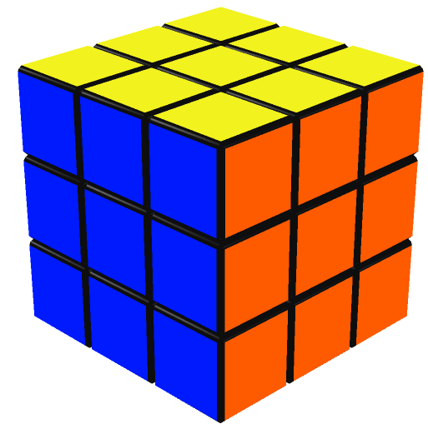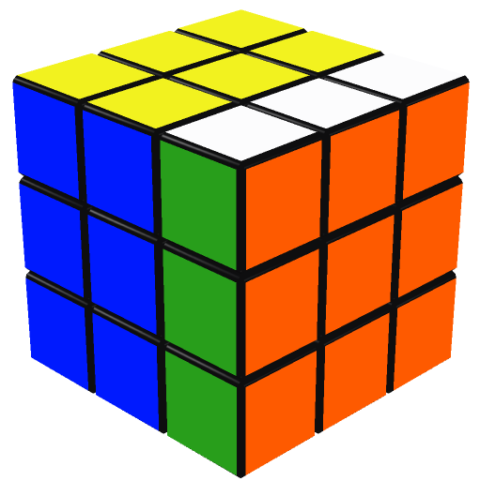
Input 2
YORBWG
RL'
Output 2
G R G
G R G
G R G
Analysis 2
Initial state After R After RL' (L applied anti-clockwise)
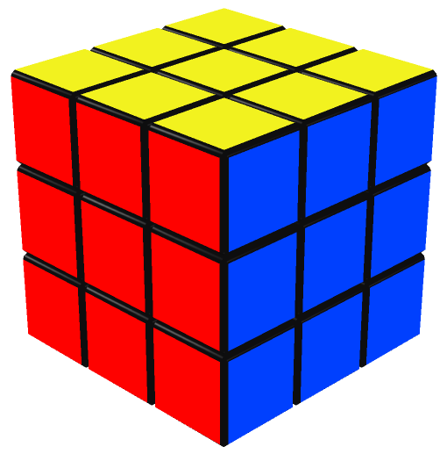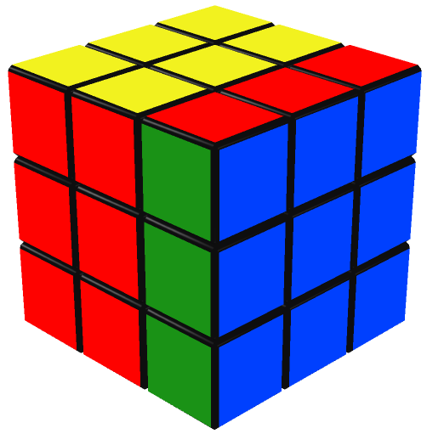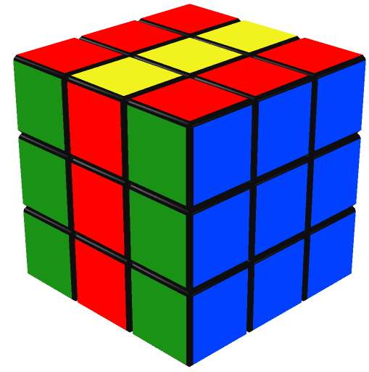
Download sample testcases as zip

