Info-miner
Architecture Design Specification

Project 2

Info-miner – A Web Search engine

CS 6362 - Software Architecture
Dr. Lawrence Chung

Athrey Joshi axj39000@utdallas.edu
Divya ChanneGowda dhc042000@utdallas.edu
Tarun Belagodu trb033000@utdallas.edu

TABLE OF CONTENTS

1. REQUIREMENT SPECIFICATION 3
1.1 Functional requirements 3
1.2 Non-functional requirements: 4
2. Architectural Specification 4
2.1 Components 4
2.2 Connections 5
2.3 Constraints 6
2.4 Pattern 6
2.5 Add KWIC Index Component 8
3. Class Diagram 9
3.1 InfoMiner 9
3.2. AddKwicIndex 10
4. Rationale 11

REQUIREMENT SPECIFICATION

Functional requirements

- Info-miner shall accept a list of keywords and return a list of URL’s whose descriptions contain any of the given keywords.

- Info-miner shall use another software system as a component, KWIC, in order to efficiently maintain a database of URL’s and the corresponding descriptions.

- KWIC shall accept an ordered set of lines, where each line consists of two parts:

- the URL part, whose syntax is

URL::=’http://’identifier’.’identifier’.’[‘edu’ | ‘com’ | ‘org’ | ‘net’]

Identifier ::= {letter|digit}+

letter ::= [‘a’ | ‘b’ | … | ‘y’ | ‘z’ | ‘A’ | ‘B’ | … | ‘Y’ | ‘Z’]
digit ::= [‘1’ | ‘2’ | … | ‘9’ | ‘0’]

- The syntax of the descriptor is as follows
descriptor::= Identifier{“ “Identifier}*

- The descriptor part of any line shall be “circulated shifted” by repeatedly removing the first word and appending it at the end of the line. The KWIC index system shall output a list of all circular shifts of the descriptor parts of all lines in alphabetically ascending order, together with their corresponding URLs. No line in the output list shall start with any noise word such as “a”, “the”, and “of”.
- KWIC shall allow for two modes of operation:

- for building an initial KWIC indices;

- for growing the indices with later indices

- Case sensitive search: The system shall store the input as given and retrieve the input also as such

Non-functional requirements:

• Easily understandable – the system should be easy to learn and understand

• Portable – the system should run on many platforms, browsers and operating
Systems

• Enhanceable – the system should allow for enhancement without major code
rewrites or architectural changes

• Reusable – the components of the system should be reusable

• Good performance – the system should provide good performance on all
Platforms

• User-friendly – the system should be intuitive and easy to use

• Responsive – the system should respond to user actions quickly

• Adaptive – the system should be able to adapt to changes

2. Architectural Specification

The system is designed using the Object Oriented architectural style. It is also called Abstract Data Type (ADT). This style includes encapsulating data representations and their associated operations in abstract data type. The overall architecture is a client server using the J2EE framework. The system consists of the Client component, Web component, Business component and Database component.

2.1 Components
The various components of the architecture are
a. Input Module – This module contains the html and JSP pages which take input the search keywords and URL and descriptor pairs to be added to the database. The JSP pages also validate the input search string. This module also takes Cleanup request from a html page for cleaning up URL, descriptor pairs and the corresponding circularly shifted lines.
b. AddKwicIndex Module – This module is responsible for creating KWIC indices for adding the descriptors of the URLs input. This module contains the following modules for creating sorted circularly shifted lines for the descriptors input.
- Line storage module – This module is responsible for storing the lines accepted into the system. It has the interfaces to get the input lines stored. It also stores the URL for the corresponding descriptor.
- Circular Shift Module - This is the core module of the Add Kwic Index module which actually produces the circularly shifted lines from the input line. This also eliminates the lines generated which starts with a noise word.
- Sorter Module – This module sorts the generated lines in alphabetic order. The module then calls the DBHelper module’s method for inserting records into the database.

c. Search Module - This module is called when the user wishes to search for URLs using keywords. The input keywords are parsed and SQL query is built according to the search string given with AND, OR, NOT operators. It calls the DBHelper module’s methods for fetching the records.

d. CleanUp Module – This module handles the cleanup request given by the user. It creates SQL query for getting URLs older than 3 minutes. And then creates SQLs for deleting the URL, descriptors pairs and corresponding circularly shifted lines from the database. It calls the DBHelper module’s methods for deleting the records.

e. DBHelper Module – This module acts as interface to the database. It has methods to query the 2 tables – URLMaster and CSDescriptors for fetching records, inserting and deleting records.

f. Output Module – This module consists of the JSP pages which output the search results and success messages on adding URL, Descriptors and cleaning DB.

2.2 Connections

The connections which bind the different components together are
1. Subprogram calls
- Saving lines input in the input module by the Line storage module.
- Accessing lines from Line storage module by the Circular shift.
- Accessing lines from Circular shift by the Sorter module.
- AddKwicIndex accessing the DBHelper module for inserting records into Database
- Search module accessing DBHelper module for fetching records from Database
- CleanUp module accessing DBHelper module for deleting records records from Database
2. System I/O
- The input and output through html pages constitute the System I/O connections.

2.3 Constraints
The various constraints on the components and connections are
- Circular shift module can only process the line after the Input module has finished reading it.
- The Sorter module sorts the lines after they are generated by Circular shift module.
- The AddKwicIndex, Search and Cleanup modules all access the DBHelper module for accessing the database.

2.4 Pattern
Pattern of the software architecture is shown below

Validate URL Desc

Line Storage
Master Control
Input Medium
Output Medium
Input
//GUI
Output

DB Helper

Line Storage

Add KWIC Index

CLEAN UP

Update table

Fetch records
ADD
URL

Clean DB

Search

SEARCH

Validate descriptor

Validate URL
DATABASE
Fig1: Architecture for Info Miner

2.5 Add KWIC Index Component

Add Kwic Index

Line Storage

Circular Shift

Sorter

generateCSLines

Sort

getCS
Lines

set
Input
Lines

get
Input
Lines

SubProgram Call

System I/O

Fig2: Architecture for Add Kwic Index Sub Component

3. Class Diagram

3.1 InfoMiner
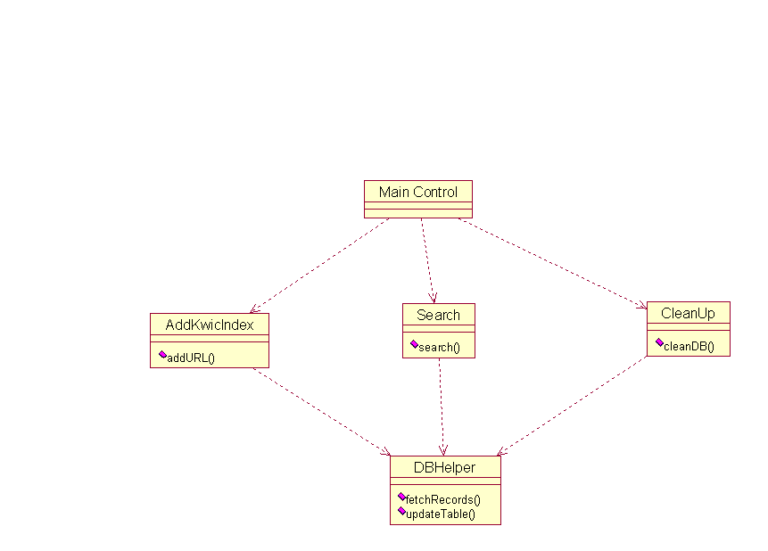

Fig3: Info-miner class diagram

3.2.AddKwicIndex
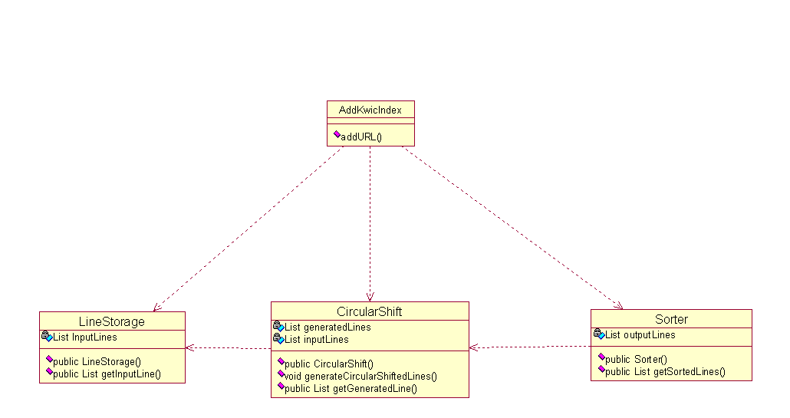

Fig4: AddKwicIndex Class Diagram

4. Rationale

The Abstract Data Type (ADT) is the most widely used architecture design. By using this pattern, both algorithms and data representations can be changed in individual modules without affecting others. Independent modules are easier to manage and implement. This design style also supports reuse and extensibility.
Client Server architecture is supported by J2EE framework. This is the most preferred architecture for web applications and it also provides concurrency where multiple clients can connect the system and use it.
HTML pages support hyperlinks to be displayed and provide good user interface.
Cloudscape is default database present within the J2EE server.

The major disadvantage of the Abstract Data Type is while adding new functionality. To add new functions, the existing modules need to be changed which results in performance overheads.

