Data Visualization Homework 1
Title: Exploring Iris Dataset: Visualizing Species Differentiation
Professor: Dr. Hao Yanbin
Contents
1. Introduction: 2
2. Preprocessing: 3
3. Visualization: 4
I. Histogram: 4
II. Scatter Plots: 6
III. Box Plots: 7
IV. Violin Plots: 9
V. Linear Regression Analysis: 11
4. Conclusion: 11

Introduction:
This report presents the visual analysis of the Iris dataset, aiming to differentiate between three species of Iris flowers: Setosa, Virginica, and Versicolor. The Iris dataset comprises 150 samples, with 50 samples for each species, and includes measurements of four attributes: sepal length, sepal width, petal length, and petal width, all in centimeters.
The objective of this analysis is to leverage data visualization techniques using Python libraries such as NumPy, Pandas, Seaborn, and Matplotlib, to gain insights into the dataset's nature, distribution, and relationships between variables. Through a series of visualizations including histograms, scatter plots，box plots, violin plots, and linear regression, I aim to explore the characteristics unique to each species of Iris flower.

Preprocessing:
In the preprocessing section, I began by loading the Iris dataset from a CSV file and inspected its structure to ensure proper data loading. Next, I computed descriptive statistics, including counts, means, and quartiles, to understand the distribution and variability of numerical attributes. I also grouped the dataset by species to calculate minimum and maximum values for each attribute within each species. Additionally, I checked for any missing values and counted the number of samples for each species. These preprocessing steps provided a foundation for subsequent data visualization and analysis tasks.

Visualization:
In the data visualization section, I employed various techniques to explore the Iris dataset and gain insights into the characteristics unique to each species of Iris flower. Through histograms, scatter plots, box plots, violin plots, and linear regression analysis, I visualized the distribution of data, relationships between variables, and variations among different species.

Histogram:
Histograms provided insights into the distribution of individual features and their variations across different species.
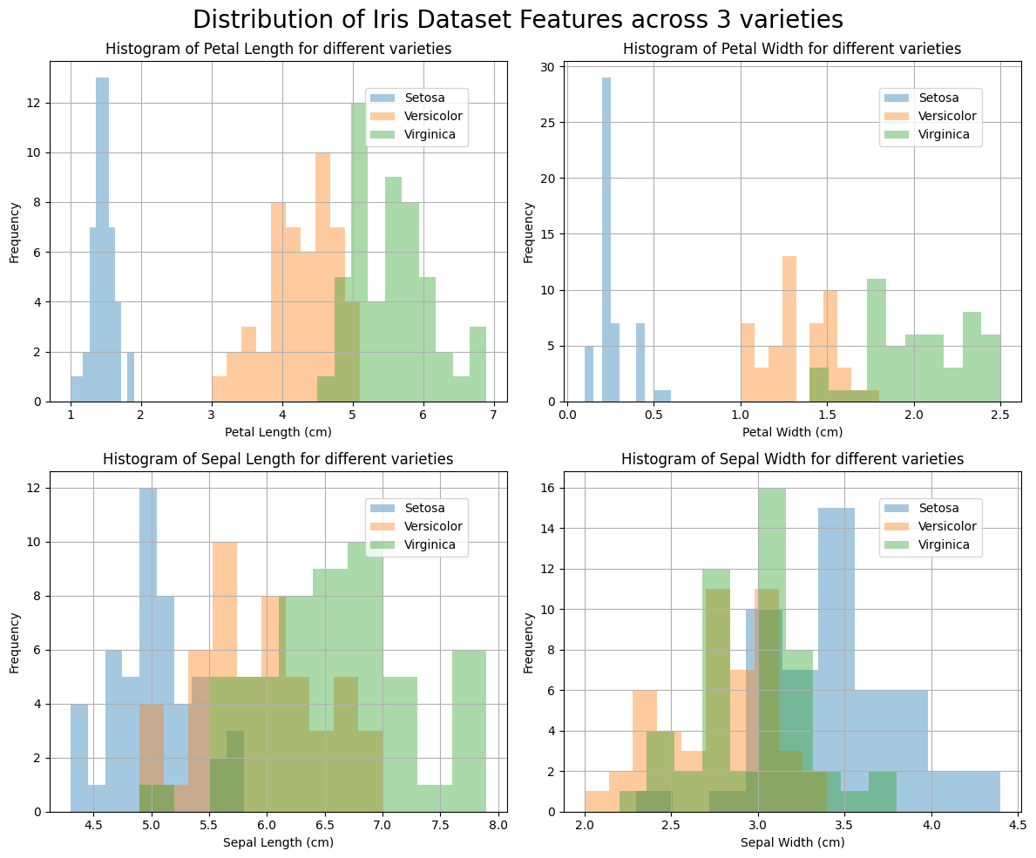

Code:
# Visualizing the distribution of Iris dataset features for different species
iris_subset = iris.groupby('variety')

# Plotting histograms for Petal Length, Petal Width, Sepal Length, and Sepal Width
plt.figure(figsize=(12, 10))

plt.suptitle('Distribution of Iris Dataset Features across 3 varieties', fontsize=20) # Add this line for the overall subtitle

plt.subplot(221)
iris_subset['petal.length'].plot.hist(alpha=0.4)
plt.xlabel('Petal Length (cm)')
plt.ylabel('Frequency')
plt.title('Histogram of Petal Length for different varieties')
plt.legend(loc=(0.69, 0.75))
plt.grid()

plt.subplot(222)
iris_subset['petal.width'].plot.hist(alpha=0.4)
plt.xlabel('Petal Width (cm)')
plt.ylabel('Frequency')
plt.title('Histogram of Petal Width for different varieties')
plt.legend(loc=(0.69, 0.75))
plt.grid()

plt.subplot(223)
iris_subset['sepal.length'].plot.hist(alpha=0.4)
plt.xlabel('Sepal Length (cm)')
plt.ylabel('Frequency')
plt.title('Histogram of Sepal Length for different varieties')
plt.legend(loc=(0.69, 0.75))
plt.grid()

plt.subplot(224)
iris_subset['sepal.width'].plot.hist(alpha=0.4)
plt.xlabel('Sepal Width (cm)')
plt.ylabel('Frequency')
plt.title('Histogram of Sepal Width for different varieties')
plt.legend(loc=(0.69, 0.75))
plt.grid()

plt.tight_layout()
plt.show()

Scatter Plots:
Scatter plots enabled visualization of relationships between pairs of variables, revealing patterns and clusters that differentiate species.
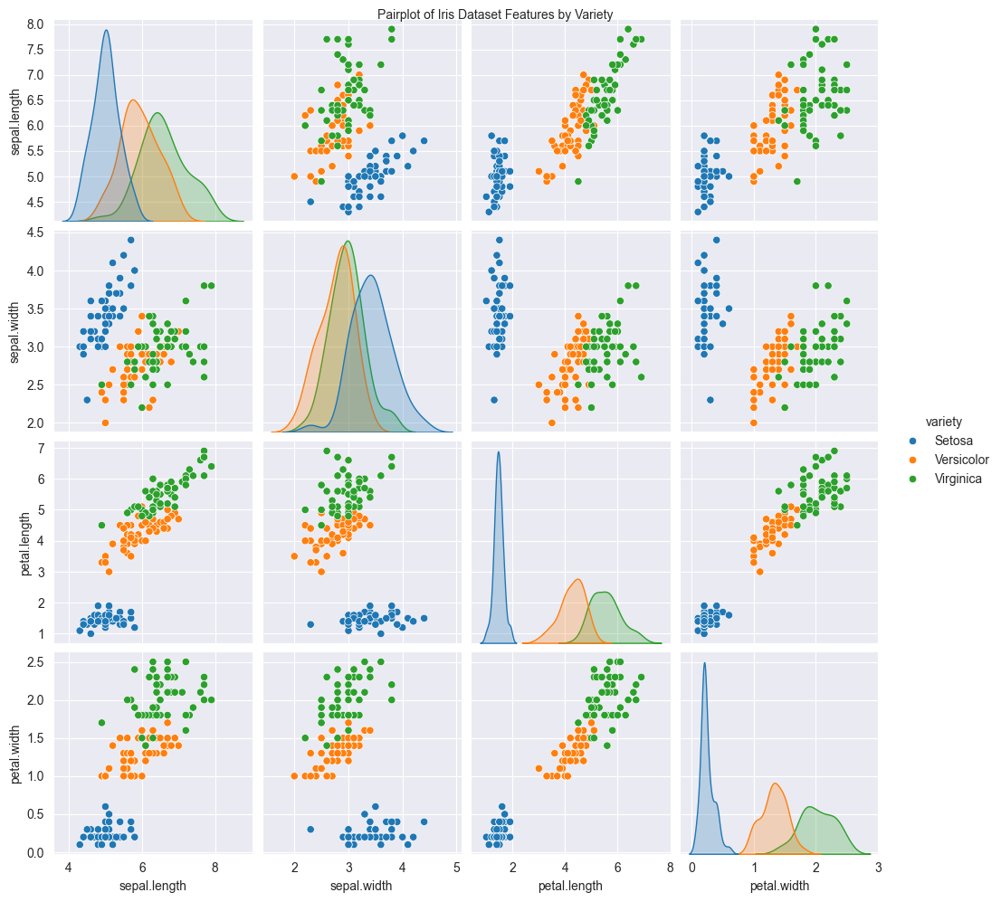
Code:
# Using Pairplot to analyze relationships between features
sns.pairplot(data=iris, hue='variety')
plt.suptitle('Pairplot of Iris Dataset Features by Variety', fontsize=10, ha='center', va='bottom')
plt.show()

Box Plots:
Box plots offered a comprehensive view of feature distributions, highlighting differences and similarities among species.
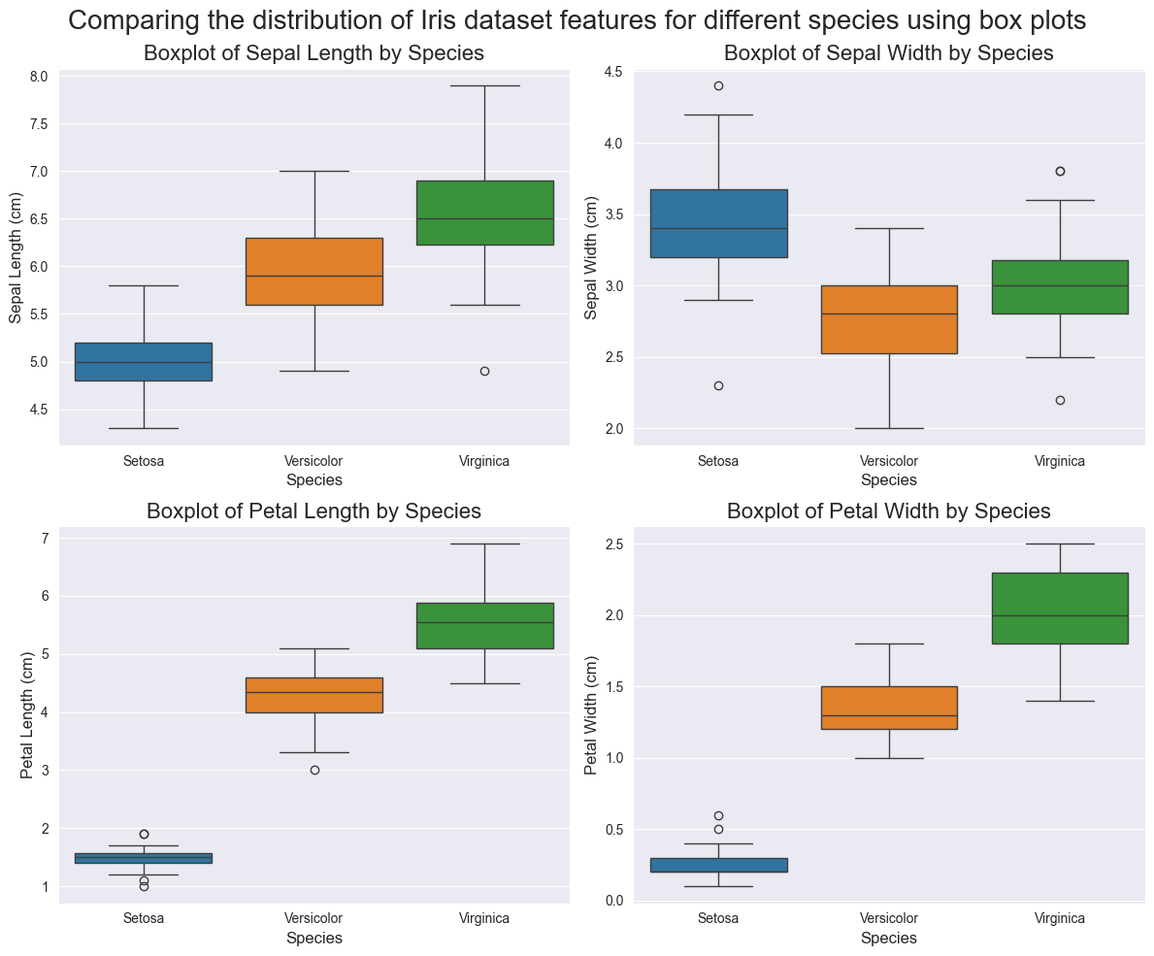

Code:
# Plotting histograms for Petal Length, Petal Width, Sepal Length, and Sepal Width
plt.figure(figsize=(12, 10))

plt.suptitle('Comparing the distribution of Iris dataset features for different species using box plots', fontsize=20) # Add this line for the overall subtitle

# Boxplot of Sepal Length by Species
plt.subplot(221)
sns.boxplot(data=iris, x='variety', y='sepal.length', hue='variety')
plt.title('Boxplot of Sepal Length by Species', fontsize=16)
plt.xlabel('Species', fontsize=12)
plt.ylabel('Sepal Length (cm)', fontsize=12)

# Boxplot of Sepal Width by Species
plt.subplot(222)
sns.boxplot(data=iris, x='variety', y='sepal.width', hue='variety')
plt.title('Boxplot of Sepal Width by Species', fontsize=16)
plt.xlabel('Species', fontsize=12)
plt.ylabel('Sepal Width (cm)', fontsize=12)

# Boxplot of Petal Length by Species
plt.subplot(223)
sns.boxplot(data=iris, x='variety', y='petal.length', hue='variety')
plt.title('Boxplot of Petal Length by Species', fontsize=16)
plt.xlabel('Species', fontsize=12)
plt.ylabel('Petal Length (cm)', fontsize=12)

# Boxplot of Petal Width by Species
plt.subplot(224)
sns.boxplot(data=iris, x='variety', y='petal.width', hue='variety')
plt.title('Boxplot of Petal Width by Species', fontsize=16)
plt.xlabel('Species', fontsize=12)
plt.ylabel('Petal Width (cm)', fontsize=12)

plt.tight_layout()
plt.show()

Violin Plots:
Violin plots also offered a comprehensive view of feature distributions, highlighting differences and similarities among species.
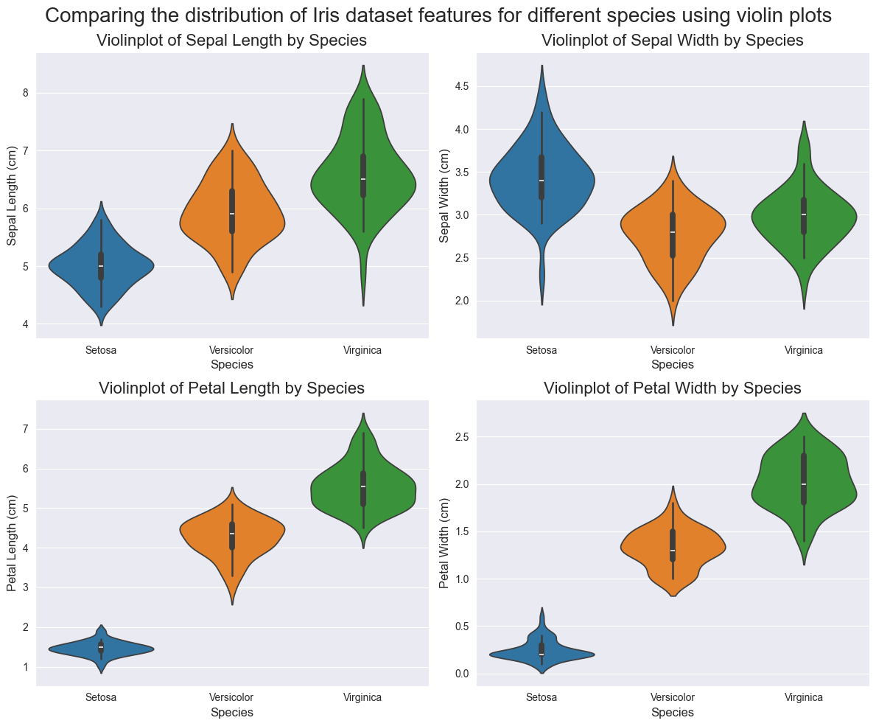

Code:
# Plotting histograms for Petal Length, Petal Width, Sepal Length, and Sepal Width
plt.figure(figsize=(12, 10))

plt.suptitle('Comparing the distribution of Iris dataset features for different species using violin plots', fontsize=20) # Add this line for the overall subtitle

# Boxplot of Sepal Length by Species
plt.subplot(221)
sns.violinplot(data=iris, x='variety', y='sepal.length', hue='variety')
plt.title('Violinplot of Sepal Length by Species', fontsize=16)
plt.xlabel('Species', fontsize=12)
plt.ylabel('Sepal Length (cm)', fontsize=12)

# Boxplot of Sepal Width by Species
plt.subplot(222)
sns.violinplot(data=iris, x='variety', y='sepal.width', hue='variety')
plt.title('Violinplot of Sepal Width by Species', fontsize=16)
plt.xlabel('Species', fontsize=12)
plt.ylabel('Sepal Width (cm)', fontsize=12)

# Boxplot of Petal Length by Species
plt.subplot(223)
sns.violinplot(data=iris, x='variety', y='petal.length', hue='variety')
plt.title('Violinplot of Petal Length by Species', fontsize=16)
plt.xlabel('Species', fontsize=12)
plt.ylabel('Petal Length (cm)', fontsize=12)

# Boxplot of Petal Width by Species
plt.subplot(224)
sns.violinplot(data=iris, x='variety', y='petal.width', hue='variety')
plt.title('Violinplot of Petal Width by Species', fontsize=16)
plt.xlabel('Species', fontsize=12)
plt.ylabel('Petal Width (cm)', fontsize=12)

plt.tight_layout()
plt.show()

Linear Regression Analysis:
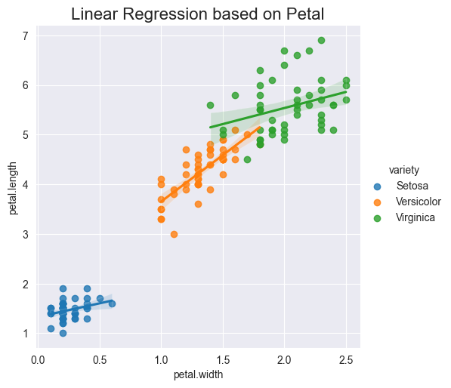
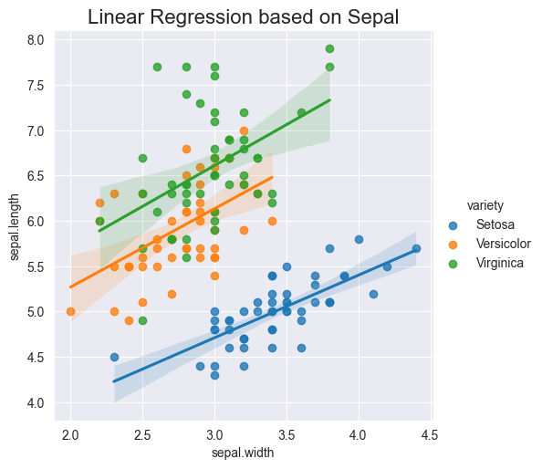
Furthermore, linear regression analysis allowed for exploration of the linear relationship between certain features, providing insights into how they may vary together within each species.

Code:
# Linear regression based on sepal
g = sns.lmplot(x="sepal.width", y="sepal.length", hue="variety", data=iris)
plt.title('Linear Regression based on Sepal', fontsize=16)

# Linear regression based on petal
g = sns.lmplot(x="petal.width", y="petal.length", hue="variety", data=iris)
plt.title('Linear Regression based on Petal', fontsize=16)

Conclusion:
These visualizations provided a deeper understanding of the Iris dataset and facilitated the identification of distinguishing characteristics among the Setosa, Virginica, and Versicolor species. Such insights are valuable for further analysis and classification tasks in data science and machine learning applications.

