AIBHS Faculty Handbook
How do I request a Canvas course?
How do I set up my Canvas course?
How do I create Canvas assignments?
Creating Pages
Editing Pages
How do I change my course home page?
How do I add TAs to Canvas?
Student Accommodations
Disability Resource Center
Extra time
Deadline extensions
Zoom Conferences
Finalizing and Submitting Grades
Importing from a Previous Canvas Course
External Tools
Course Communication
EdStream
Automated Grading
Gradescope
Kaizen
Proctoring
Honorlock
Accessibility
Ally Accessibility Report
Recommended Workflow
College of Medicine Syllabus Template
Office Hours Guidelines
Important Dates and Policies
Academic Calendar
Add Drop
Religious Holidays
Reading Days

How do I request a Canvas course?
To create a new canvas course, instructors will need to submit a request. The link below offers resources for requesting both registrar and non-registrar courses. Registrar courses are tied to a course being taught, while non-registrar courses may be used as a sandbox to experiment with Canvas or try new tools.

Request_Canvas_Shell.pdf

https://elearning.ufl.edu/instructor-help/instructor-course-request/course-request-process/

How do I set up my Canvas course?
https://community.instructure.com/en/kb/articles/660621-instructor-getting-started-resources

How do I create Canvas assignments?
https://community.instructure.com/en/kb/articles/660665-how-do-i-create-an-assignment

Creating Pages
https://community.instructure.com/en/kb/articles/660947-how-do-i-create-a-new-page-in-a-course

Editing Pages
https://community.instructure.com/en/kb/articles/660949-how-do-i-edit-a-page-in-a-course

How do I change my course home page?
https://community.instructure.com/en/kb/articles/660743-how-do-i-change-the-course-home-page

How do I add TAs to Canvas?
Instructor tools » Manage Users » Add Users
- In the navigation bar on the left side of your course, click on “Instructor Tools”
- Go to the “Manage Users” tools
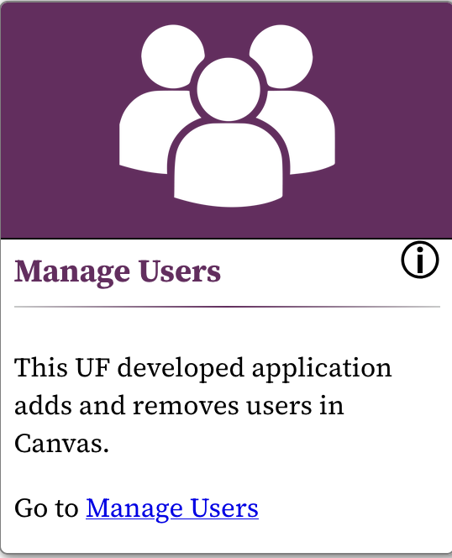
- Select “Add Users”
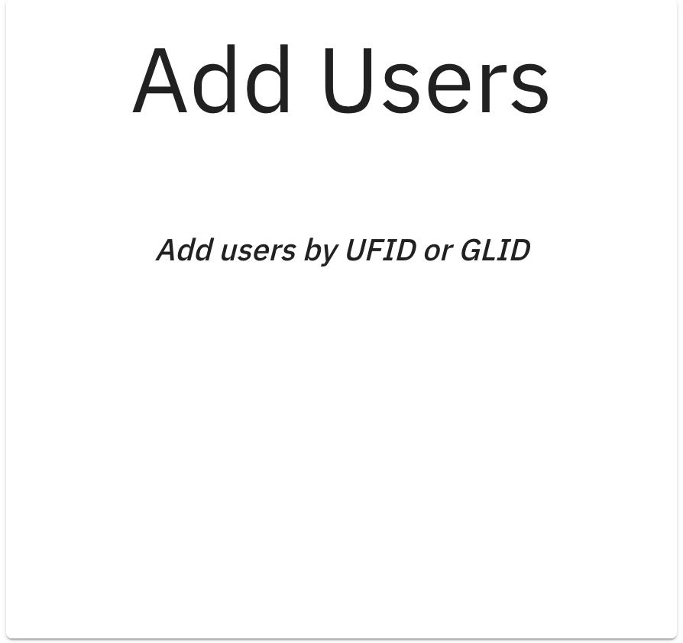
- Enter the UFID for everyone that you want to add as a TA to the course
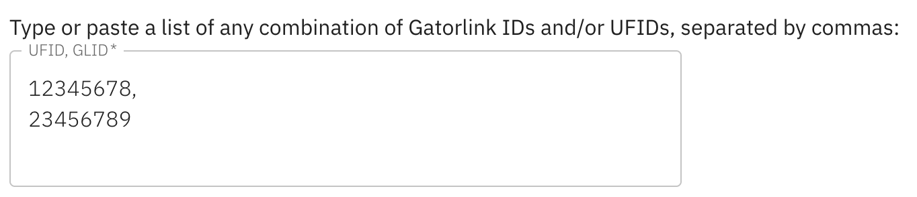
- Under the section drop-down, select the section you would like to add the TAs to
- Under the role drop-down, select TA
- Select an option for the “Limit privileges to a Section?” drop-down.
- Select next.

Student Accommodations

Disability Resource Center
Accommodations for students with disabilities are handled by the Disability Resource Center (DRC). The instructions for the DRC’s accommodations portal can be accessed on the DRC website below:
https://disability.ufl.edu/faculty/accommodated-testing-instructors/

How do I give students extra time on quizzes?
Some students may require extended time on quizzes and exams as part of their accommodations. The guide below explains the steps for modifying the time for an individual student on canvas quizzes. If the extended time goes beyond the marked due date for the quiz, you will also need to modify the quiz due date.
https://community.instructure.com/en/kb/articles/661034-once-i-publish-a-timed-quiz-how-can-i-give-my-students-extra-time

To automatically extend time for a student across all quizzes, you can use the Quiz Extension tool.
https://elearning.ufl.edu/instructor-help/teaching-and-learning-tools/tool-finder/items/quiz-extension.html

Deadline extensions
Canvas assignment due dates can be modified for an individual student, or for a specific course section. You may need to do this to accommodate for extended time on exams, or for students who need to make up an assignment. Follow the guide below, and select the student or section in the “Assign To” box.
https://community.instructure.com/en/kb/articles/660688-how-do-i-assign-an-assignment-to-everyone-individual-students-differentiated-tags-or-sections

Zoom Conferences
Zoom conferences can be used to hold both virtual lectures and office hours. The UF IT department provides a comprehensive set of tutorials for working with Zoom.
https://elearning.ufl.edu/instructor-help/zoom/

Finalizing and Submitting Grades
https://elearning.ufl.edu/instructor-help/finalizing-gradebook/

Resources on finalizing and submitting grades may be found at the site below, inside the “Instruction Guides” dropdown box.
https://hr.ufl.edu/professional-development/toolkits/student-information-systems/grades/

Importing from a Previous Canvas Course
The course import tool can be used to copy content from one canvas course to another. The guides below provide instructions on how to use the course import tool.
https://community.instructure.com/en/kb/articles/662748-what-is-the-course-import-tool
https://community.instructure.com/en/kb/articles/660727-how-do-i-copy-content-from-another-canvas-course-using-the-course-import-tool

External Tools
https://elearning.ufl.edu/instructor-help/teaching-and-learning-tools/tool-finder/

Course Communication

EdStream

Automated Grading

Gradescope
https://guides.gradescope.com/hc/en-us/articles/23586543164173-Using-Gradescope-LTI-1-3-with-Canvas-as-an-instructor

Kaizen

Proctoring

Honorlock
https://pfs.tnt.aa.ufl.edu/teaching-and-technology-resources/online-proctoring/honorlock-instructor-guide/

Accessibility

Ally Accessibility Report
https://www.uhd.edu/computing/training-lms/ally-accessibility-report-in-canvas.aspx

Recommended Workflow
Google Docs/Slides

College of Medicine Syllabus Template
TODO

Office Hours Guidelines
https://aa.ufl.edu/policies--guidelines/office-hours-guidance/

Important Dates and Policies

Academic Calendar
The University of Florida Academic Calendar can be found here:
https://gradcatalog.ufl.edu/graduate/calendar/

Add Drop
At the beginning of each semester, there is a brief window where students may drop and add courses without penalty. The window for each semester may be found on the academic calendar, but will typically be the first week of the semester during the Fall and Spring.

Religious Holidays
Students wishing to observe a religious holiday must provide notice well in advance. Those students are still responsible for completing any missed material, but should be provided with a reasonable amount of time to make up the work.

The full policy may be found below:
https://policy.ufl.edu/regulation/4-052/

Reading Days
In the Fall and Spring semesters, the University of Florida provides students with reading days to prepare for final exams. During reading days, nothing mandatory can be scheduled. Optional office hours and review sessions may be held. Additionally, final exam and project due dates may not be scheduled during the final 3 days of classes.

Reading days can be found in the academic calendar linked above, and the full reading day policy may be found below:
https://policy.ufl.edu/regulation/7-055/

