Fundamentals of Application Development
Library System

Team : Gatito – Gato – Gato
Member : Xabbi Alghifari Agratama (25523211)
Muhammad Malik Firdaus (25523002)

Use Case Diagram
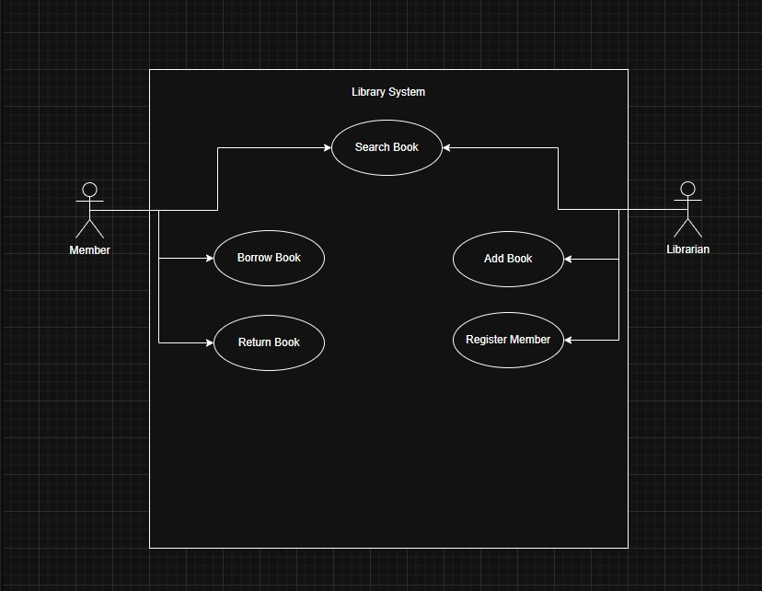

Class Diagram
Actors The system involves two main users. The primary actor is the Member, who interacts with the system to search, borrow, and return books. The secondary actor, or Admin, is the Librarian, who manages the system by adding new books and handling user memberships.
System Boundary The box drawn in the diagram separates the internal features of the application from the outside users. This visual boundary confirms that the system is strictly focused on handling book circulation and managing library data.
Use Cases There are four main features in this system. The Search Book feature can be used by both Members and Librarians to find books or check inventory. The Borrow Book feature is the core action, where the system actively checks if a book is available and blocks the transaction if the book is already checked out. The Return Book feature updates a book's status back to available, ensuring the library's data remains accurate. Finally, the Add Book and Register Member features are restricted to Librarians only, preventing unauthorized users from altering sensitive library records.
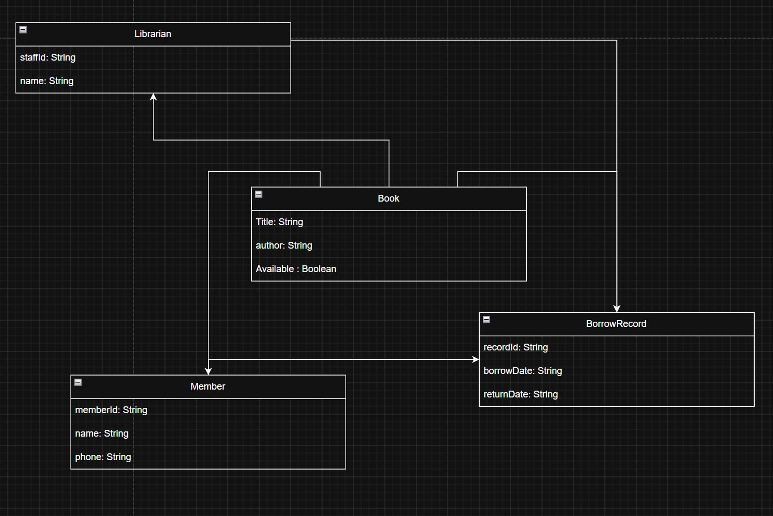
Reasoning:
Book
We use Title as a String, Author as a String so the user or the librarian can enter the book name and author without our system crashing in the process. Available is a Boolean because if the librarian or the user want to check the book availability the system is only going to check the Boolean value and not try to matches a word like “Available” so it is just easier for the system.
Librarian
We use Name as a String so the user can input their name to the system. For the Staff Id we also use String because so the user can use letter in the Staff Id.
Member
We use Name and Member Id as a String is the same reason for the librarian class. And we also use String on the phone number class as well because if the user make a typo and accidentally put a letter there the whole program wont just crash.
BorrowRecord
We use record Id and Borrow Date as a String so the user can input letter into the class without the system crashing. We also use Return Date as a String for the same reason

Design Decision
We split the code into three parts so it does not become a disorganized mess. The Book and Member files act as blank forms. They guarantee that every book has a title and every person has a name, keeping all those details securely locked in their own separate boxes so nothing gets mixed up.
The Main file acts as the library's front desk. It does not hold the raw data, but it handles the menus and the storage boxes where all the forms are kept. When someone wants to borrow a book, the Main file checks the Member box to log them in, searches the Book box for the title, and then grabs a pen to update that specific book's availability stamp. They work as a team where the forms quietly hold the information and the Main file actively manages it based on what the user types.

